How to install & program a BCM 2050 Soft Phone V2 onto a computer

Install the software in the usual way under “C:\Program Files\Nortel Networks\IP Softphone 2050” etc, using the defaults given where required after clicking on the Setup.bat file. If you already have the older I2050 softphone installed, then you must uninstall it first!. A DOS screen will appear to make sure that you have understood this part. Key in “YES” to enable the program installation to continue.

Once completed, You will then be able to configure the IP settings. A 2050 icon will appear on the desktop.
If the 2050 softphone program has not started, then double click on the link to activate it. You will be presented with the “Quick start” help screen. I personally select the option to “Never show Quick Start at startup”. You will probably get a error message because the IP settings have not been entered in yet.

Select from the top left hand side of the screen, “File” & then click on the “Settings” option.

Under "Settings”, select “Server" & Untick the “Automatic DHCP” box . Below that line, select “Primary” against “server” In the IP box, use the following servers address information & enter in the IP address of your configured Signalling Server or ITG Line card. E.g. 10.2.0.250

The port should be 7000. The BCM system uses Port 7000. (CS 1000M or Meridian 1 uses 4100)
You may need to check the “Sound Devices” section. Make sure that they are correctly configured. Against “Advanced Audio”, you may want to change the Jitter to 4 frames.
You can select the “Sounds” box to select a compatible sound file to be played when the 2050 softphone is enabled during startup. The “Lamp Sounds” section can be set-up to play a sound, when a message has been left in your mailbox.
Finally, if you have a USB Headset, then you can use the “USB Headset” options to enable it.

On the initial 2050 power up sequence, you will have to enter in the BCM passcode and the default is 2264 (It means BCMI on the keypad) Nortel Meridian 1 / Avaya CS1000 uses Node ID & TN number. i.e.

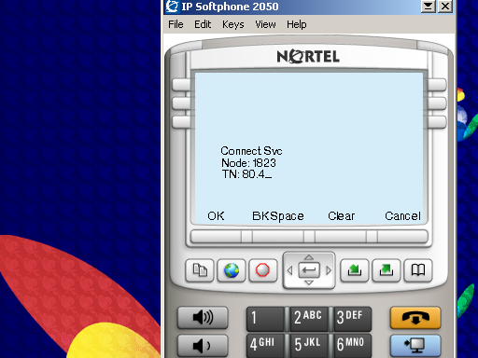
For BCM connections, it might auto assign a DN or you can enter in one such as 3903 etc.

Use the 2050 Phones keypad & digits to enter in the required details. Press OK when completed.
If you are normally connected to a LAN, then you can get the 2050 softphone to work when the P.C. powers up.
The other settings within the tool should be ok as they are.

