BCM 3.5 BT RACE Patch
Field Installation Guide

Overview

The installation process for the BT-RACE 3.5 uses the standard BCM patching process. The BCM 3.5 BT Race Patch can downloaded from the BCM.

DO NOT install earlier versions of BCM BTRACE software on BCM3.5 systems.

Before proceeding please read the table of known installation issues and limitation. If you believe that you have a problem, then contact the Technical Support Group.
Known Installation Issues and Limitations

- This BT Race software should only be applied to BCM 3.5 systems.

- DO NOT use earlier versions of BCM BTRACE software on BCM3.5 systems.

- The BT Race 3.5 software installation is also required when upgrading to BCM 3.5 from earlier software releases.

- The installation process must be performed using the primary LAN adapter.

- The Administrator password "ee_admin" must be set to PlsChgMe!.

- Password complexity must be reduced to "0" (via Unified Manager) before installing the BT Race patch to allow the BTRemoteIsdn user account to be created with the default password.

- The software can only be installed once – If re-installation is required then contact the 1st Line Support.

- Do not open any Windows, VNC or Unified Manager sessions while you perform the upgrade. These sessions can interfere with the progress of the upgrade.

- Browser - Internet Explorer 5.00 is not supported.

- ISDN30 (DASS2) and DPNSS will not support dialup/RAS connections.

.

Step 1 - BT Race Software Download

To install the BT Race software you must first download the software to your laptop or PC, which should be connected to the primary LAN adapter on the BCM (LAN1).

- To download the BT RACE software, log on to the BCM using the IE browser and the following URL https://xx.xx.xx.xx/Clients/BT/btrace35.html (Note: If you use HTTP then the security alert and SSL certificate will be displayed first.)

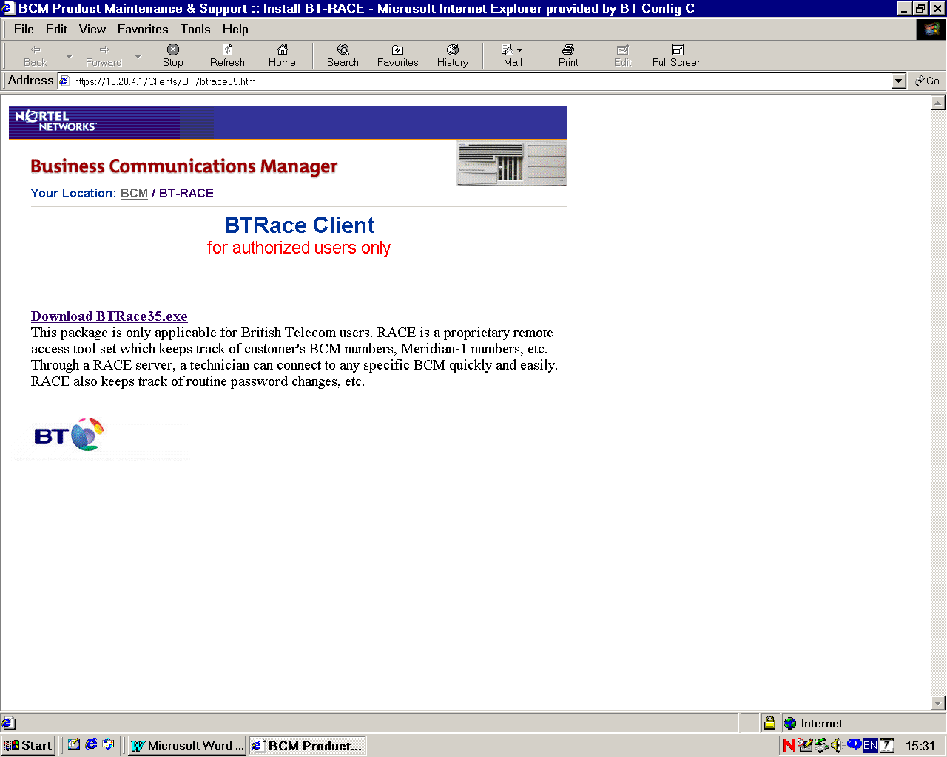
- Security window appears.

- Enter an Administrator Username (ee_admin) and Password (default password -PlsChgMe!)

- BTRace Client Window is displayed.

- Download the BT Race software to a folder on your laptop or PC by Clicking “Download the BT Race35.exe”

- The software can now be installed on to the BCM 3.5 system by using the normal BCM patch installation process which is outlined below

Step 2 – Upgraded BCM 3.5 systems

If you are upgrading a BCM to 3.5 software from an earlier version of BCM you will also need to apply the BCM 3.5 Race Patch. However before completing the 3.5 Race Patch you must remove the old race installation by doing the following:

ISDN Dial Up Interface Removal process
This step should only be completed on Upgraded BCM3.5 system.

Access the BCM through Unified Manager to see if there is an ISDN interface called ‘BTRemoteIsdn’. If there is such an interface, please delete it using Unified Manager.

- Go to the  Resources  Dial Up +ISDN <BTRemoteISDN>.
- Right Click and delete the interface.

Un-installation of an existing ‘BCM Security Service’ is not required as the BCM 3.5 Race patch will handle its un-installation.

MANDATORY: - Contact the BCM Advice Line on Tel 01142591456, as they will need to reinstall the interface configurations and reset the RACE account password to default.

Step 3 - BT Race Software Installation
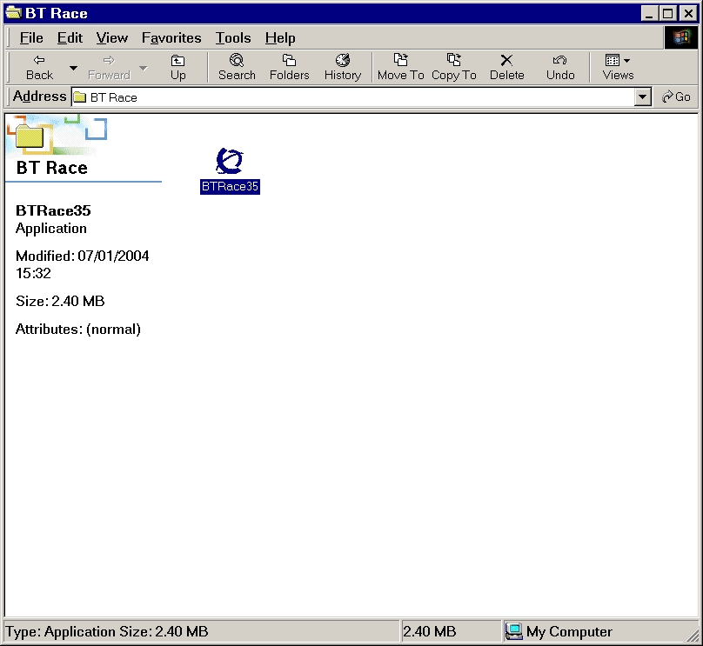
3.1 - Run BTRACE Software

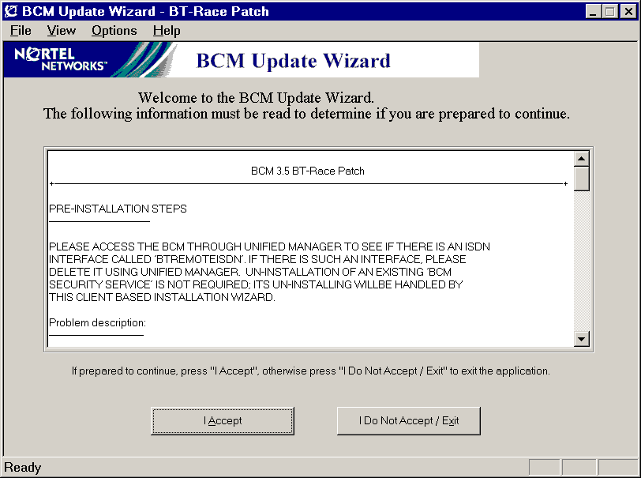
The BCM BTRace installation process must be performed using the primary LAN adapter on the BCM, which is located in the rightmost LAN slot. The administrator account "ee_admin" must be configured to its default password before beginning the update.

- Run the application “BTRace35" by double clicking the icon.

- BCM Update wizard notes will be displayed

- 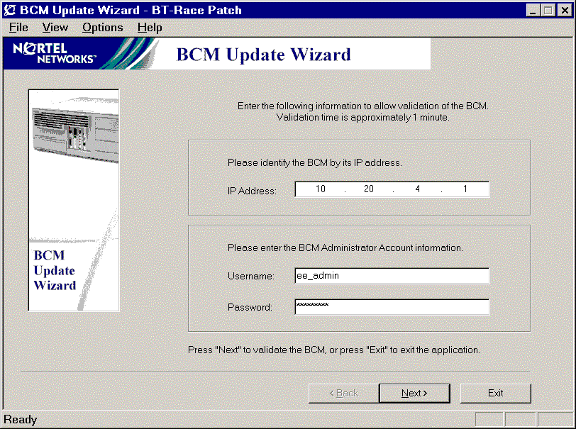Click “I Accept “

- BCM Update Wizard Configuration is displayed.

- Enter the BCM IP Address, Username and Password and click "Next" and the BCM will complete a System Status Validation.

3.2 - System Status Validation

The BTRACE software update will not be performed until certain information has been verified about the existing status of the BCM. This will include confirming the BCM software release, BTRace version, the available disk space, the MSC card and MS-PECs, and information from telephony services.

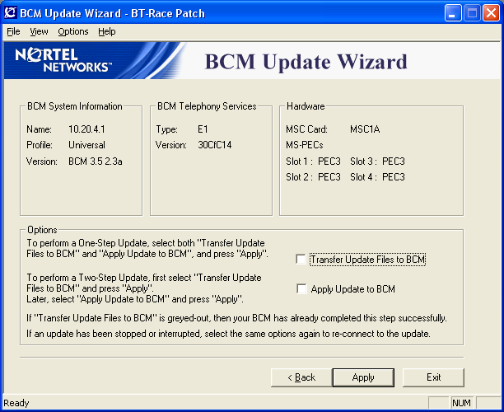
- If the middle button displays “apply” then you may continue with the Update.

Middle Button Displays “Reconnect”

If the BTRace software has been previously transferred and installed on to the system, then the tick box “Transfer Update Files to BCM”, will be greyed out and the middle button will display “Reconnect”.

“DO NOT DELETE THE BTRACE DIAL-UP INTERFACE”

STOP THE INSTALLATION and Contact the 1ST Line Technical Support for further guidance.

3.3 - System Update Steps

Warning: - Do not attempt to stop or interrupt the Update once it has started, as this will leave the BCM in an unusable state.
☞

- Select and Tick the two boxes “Transfer Update File to BCM & Apply Update to BCM”.

- This will use the “One Step Update” to transfer and apply the BTRace software.

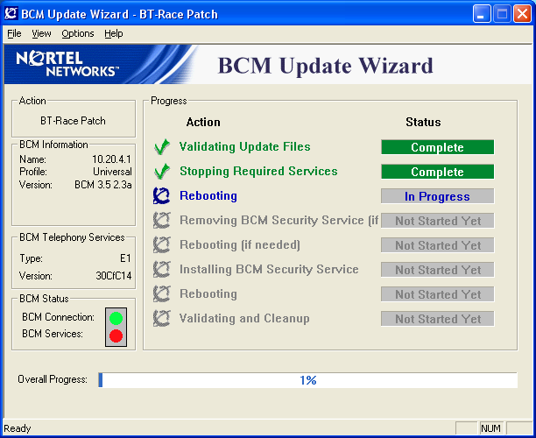

- The Installation progress is reported within the IE Browser and can be closed when completed (100%).

- On successful completion the BT-RACE software is now installed and will have created a Dialup ISDN Interface call BTRemoteIsdn.

One-Step Update This method performs the Update in one step - once started, the update will continue until completion. Use this method by selecting both "Transfer Update Files to BCM" and "Apply Update to BCM" from the options page after the BCM Patch Wizard has confirmed that the BCM is ready for the BCM 3.5 Update. The BCM will not be operational once the "Transfer Update Files to BCM" activity is complete and the "Apply Update to BCM" activity has started.

Two-Step Update Use this method by selecting "Transfer Update Files to BCM" from the options page after the BCM Wizard has confirmed that the BCM is ready for the BCM 3.5 Update. The BCM will remain operational and unchanged throughout this activity.

When prepared to update and reboot the BCM, run the BTRace software detailed in section 1 and select "Apply Update to BCM" from the options page. Since it has already been performed, the "Transfer Update Files to BCM" activity will not be available. The BCM will not be operational once the "Apply Update to BCM" activity has started.

Performing the Two-Step Update allows for more accurate scheduling of the timeframe when the BCM will not be operational.

Step 4 - Configuration of MSC Resources

☞ | There are NO MCS WAN resources allocated to the BCM 3.x system at default.

The BCM 3.x systems have no MSC WAN (dialup WAN) resources allocated at default. Resources will need to be allocated or there will be no connection between the ISDN interface and BCM data module or network. You must first create a Custom MSC configuration and then apply the new configuration to the MSC.

4.1 Creating a Custom MSC configuration.

- On the navigation tree, click the  Resources key and click the Media Services Card.
- Click the  MSC Configuration heading. The Configurations screen appears.
- Click the Custom1 tab to change the first custom configuration. The Custom1 screen appears.
- Click the component you want to change. In this case WAN.
- On the Configuration menu, click Modify Custom 1 or right click the component you want to change and click Modify Custom 1.The Custom 1 screen appears.
- Configure the WAN Component parameters.
Below is the suggested settings for stand-alone BCM’s, though these will be dependent on other resource allocations.
Minimum = 2
Maximum = 2
License Limit = maximum number of resources for this component
Hardware Limit = maximum number of resources for this component
- Click the Save button.
After you have completed the changes to the Custom configuration, you must change the active configuration and apply these changes to the MSC.

4.2 Changing the MSC configuration

- On the navigation tree, click the  Resources key and click the  Media Services Card.
- Click the  MSC Configuration heading. The Configurations screen appears.
- In Active Configurations parameters select the MSC configuration you want to use.

- Select Custom 1 to use the customised MSC configuration you created.
- Check the “Update or Reboot Required” field. This will shows if a system reboot is required before the selected configuration can be applied.
- Modify the Custom 1 Name Field. Enter a name for the first custom MSC configuration. If the system is a stand alone BCM then change the Custom 1 Name to <BTRACE>.
- Note that you do not have to change the Custom name to use or apply a Custom Configuration.
- Press the Tab key to save your changes.
- Reboot the Business Communications Manager
- Check that the customer configuration is active. On the navigation tree, click the  Resources key and click the  Media Services Card Click the  MSC Configuration heading. The Configurations screen appears.
- Click on the Current tab. The display will show the new WAN settings.

Step 5 - Installation of Data Networking Resources

- Using the web browser log onto Unified Manager.
- Check the data module configurations.
- Go to the  Resources Media Bay Module  Bus 08 (This is the Data Module in the BCM)
- Confirm that BUS 8 Module 8 is <Enabled>. If not reboot the BCM. If the problem persists contact the 1st Line Support Group.
- Go to  Data Module
- Communications Manager automatically configures the Module 8 as a Data Module and sets the Data module type to Baystack.
- Confirm that Module 8 is <Baystack> If not reboot the BCM. If the problem persists contact the 1st Line Support Group.
- Configure an ISDN data connection for use by BT RACE.
- Line (241) should be used for BT Race access, though this may not be possible in all circumstances.
- Go to the  Resources Media Bay Module  Bus 08 (This is the Data Module in the BCM)  Data Module  Line assignment .
- Add a line to the module line assignment.

Step 6 - BT RACE ISDN Dial-Up Interface
The installation of the BT-RACE patch should have created a Dialup ISDN Interface call BTRemoteISDN.
- Go to the  Resources  Dial Up +ISDN <BTRemoteISDN>.
Step 7 - Enable (Default) NAT Rules on BTRemoteIsdn interface.
- Go to the  Services NAT  ISDN1 (BTRemoteIsdn)” Node.
- Set the Rule Order tab to “Enabled - do not include IP phones”. Hit the keyboard TAB key.
- Rule Order R1 & R2 should be displayed.
- Check “Rule Settings”
Rule Name | Direction | Protocol | Private IP Type | Private IP | Private Range Mask | Private Port Range | Public IP Type | Public IP | Public Range Mask | Public Port Range
R1 | Out | TCP/UDP | Fix | 0.0.0.0 | 0.0.0.0 | All | Dynamic | Note 1 | Note 1 | All
R2 | Out | IP | Fix | 0.0.0.0 | 0.0.0.0 | All | Dynamic | Note 1 | Note 1 | All
Note 1 = IP Address and Mask of Dial Up Interface (default 10.197.0.17)
- Go to  Services  NAT
- Under “Summary Sheet tab”, set Status to “Enabled” if it is not “Enabled” already. Hit the keyboard TAB key.
Step 8 - BT Race Validation Testing
! Mandatory Option
You MUST Contact the BCM Advice Line
- Call the BCM Advice Line on Tel 01142591456
- Provide them with the following details:-
BCM Domain name (if programmed)
Customer site ID
DDI Telephone Number (ISDN data connection)
- Additional BT RACE functionality, including any Firewall Security will be programmed remotely.
- The field installation process for BT RACE is now completed.
- Before leaving the customer’s site, you MUST contact the BCM Advice Line and confirmation that the BT RACE access is working correctly.

