BCM 3.6 BT RACE Patch
Field Installation Guide

Overview

Before proceeding please read the information on known installation issues and limitations. If you believe that you have a problem with the BCM system or BT Race installation, then contact the BCM Technical Support Group.

Installation of the BT RACE client uses the standard BCM software patching process.

Known Installation Issues and Limitations 

- Only ONE version of BT Race client software MUST be applied to the BCM 3.6 system.

- DO NOT use earlier versions of BCM BTRACE software on BCM3.6 systems.

- The BCM 3.6 BT Race Client software MUST NOT be installed on earlier versions of BCM software.

- The BT Race 3.6 software installation may be required when upgrading to BCM 3.6.

- The installation process MUST be performed using the primary LAN adapter.

- The software can only be installed ONCE – If re-installation is required then contact the 1st Line Support.

- Do not open any Windows, VNC or Unified Manager sessions while you perform the upgrade. These sessions can interfere with the progress of the upgrade.

- Browser - Internet Explorer 5.00 is not supported.

- Do not install the software on ISDN30 (DASS2) and DPNSS only BCM systems.

Step 1 - BT Race Software Download

To install BT Race you must first download the correct software client to your laptop or PC, which should be connected to the primary LAN adapter on the BCM (LAN1).

- To download the BT RACE software client, log on to the BCM using the following URL https://xx.xx.xx.xx/Clients/BT/btrace.html (Note: If you use HTTP then the security alert and SSL certificate will be displayed first.)

- Security window appears.

- Log on using an Administrator Username (ee_admin) and Password (default password -PlsChgMe!)

- BTRace Client Window is displayed with two versions of the BT Race client.

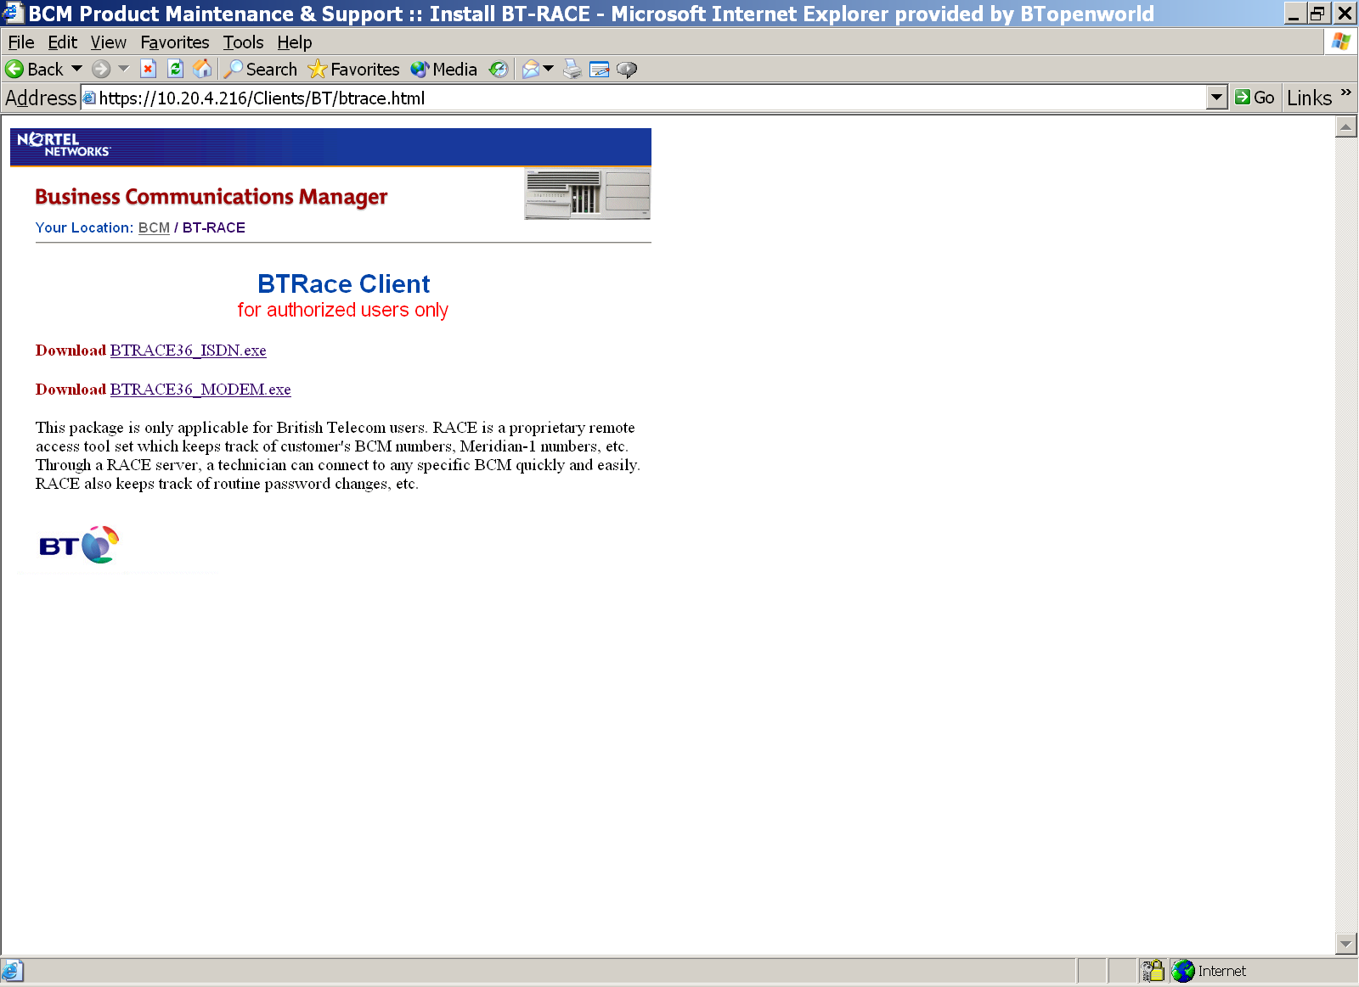

- Download (save) the required version of BT Race software to your laptop --- Click “one of the xxxx.exe”

- The software can now be installed onto the BCM 3.6 system by using the normal BCM patch installation process.
For Analogue trunk only BCM Installations download the "BTRACE36_MODEM.exe.
=========
For ISDN or mixed trunk BCM installations download BTRACE36_ISDN.exe

- For new BCM installations proceed to step 3 and for Upgraded BCM installations proceed to step 2

Step 2 – Upgraded BCM 3.6 Systems

If you are upgrading from an earlier version of BCM system then you need to confirm that the BT RACE access is still working correctly.

- Confirm that BT Race Access is working correctly (! Mandatory) !

- To check that BT Race Access is working correctly, call the BCM Race Help Line on Tel 01142591456
- Working Correctly  STOP - The field installation process for BT RACE is complete and no further action is required.

- Not Working Correctly  CONTINUE to the next step.

This step MUST only be completed on Upgraded BCM3.6 systems where the BT Race fails to work correctly.

DO NOT COMPLETE THIS STEP AFTER THE BCM 3.6 RACE PATCH IS INSTALLED


ISDN Dial Up Interface Removal

- Access the BCM through Unified Manager and delete the ISDN interface called ‘BTRemoteIsdn’.

- Go to the  Resources  Dial Up +ISDN <BTRemoteISDN>.
- Right Click and delete the interface.

- Proceed to Step 3

Step 3 - BT Race Client Installation

DO NOT install both versions of the BCM BTRACE client on the same BCM3.6 system.


DO NOT install earlier versions of BCM BTRACE software on BCM3.6 systems.


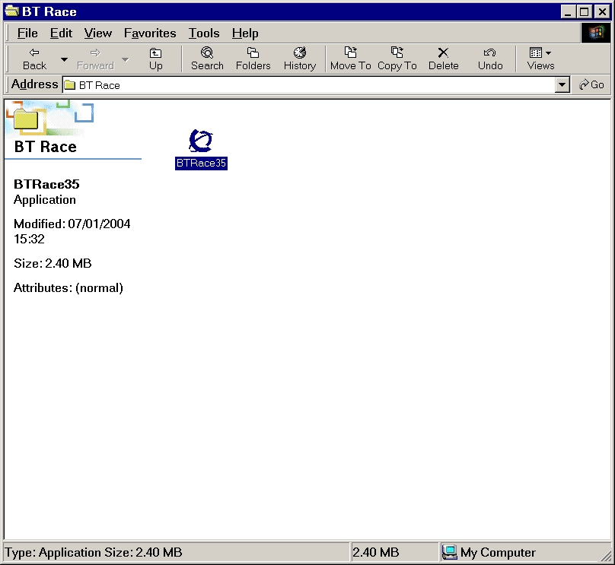
3.1 - Run BTRACE Software

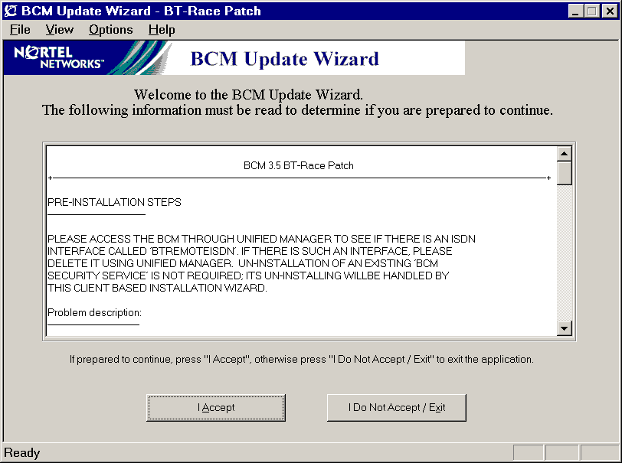
The BCM BTRace installation process must be performed using the primary LAN adapter on the BCM, which is located in the rightmost LAN slot.

- Run the client application “BTRace36_xxxxxxx" by double clicking the icon.

- BCM Update wizard notes will be displayed

- 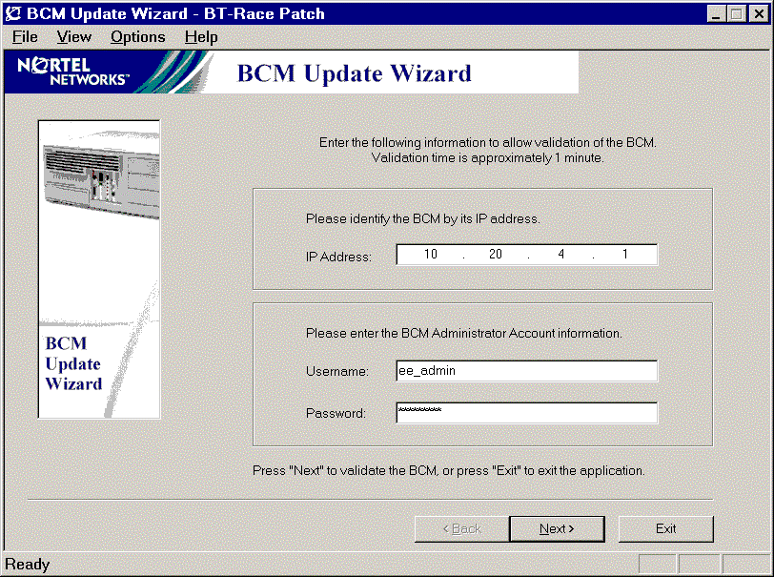Click “I Accept “

- BCM Update Wizard Configuration is displayed.

- Enter the BCM IP Address and the EE_ADMIN Username and Password combination.

- Click "Next" and the BCM will complete a System Status Validation.

3.2 - System Status Validation

The BTRACE software update will not be performed until certain information has been verified about the existing status of the BCM. This will include confirming the BCM software release, BTRace version, the available disk space, the MSC card and MS-PECs, and information from telephony services.

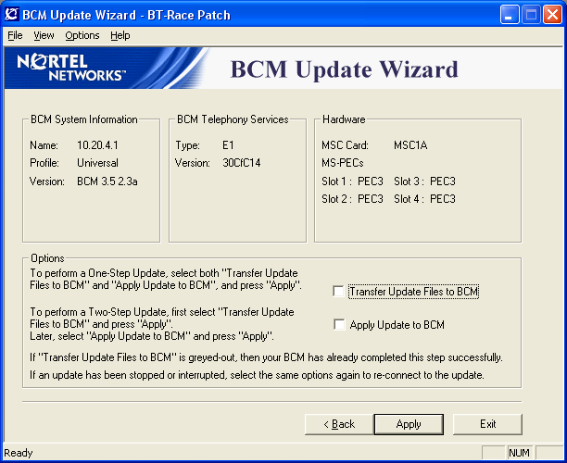
- If the middle button displays “apply” then you may continue with the Update.

Middle Button Displays “Reconnect”

If the BTRace software has been previously transferred and installed on to the system, then the tick box “Transfer Update Files to BCM”, will be greyed out and the middle button will display “Reconnect”.

“DO NOT DELETE THE BTRACE DIAL-UP INTERFACE”

STOP THE INSTALLATION and Contact the 1ST Line Technical Support for further guidance.

3.3 - System Update Steps

Warning: - Do not attempt to stop or interrupt the Update once it has started, as this will leave the BCM in an unusable state.
☞

- Select and Tick the two boxes “Transfer Update File to BCM & Apply Update to BCM”.

- This will use the “One Step Update” to transfer and apply the BTRace software.

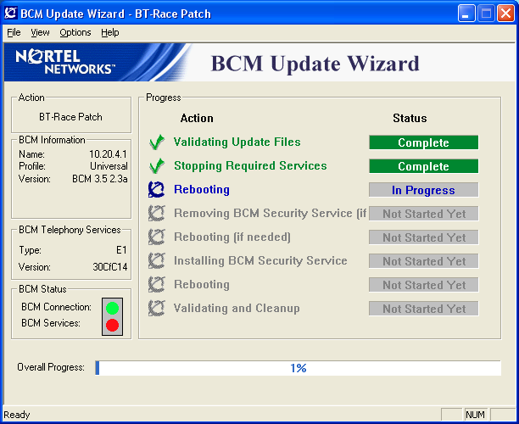

- The Installation progress is reported within the IE Browser and can be closed when completed (100%).

- On successful completion the BT-RACE software is now installed and will have created a Dialup ISDN Interface call BTRemoteIsdn.

One-Step Update This method performs the Update in one step - once started, the update will continue until completion. Use this method by selecting both "Transfer Update Files to BCM" and "Apply Update to BCM" from the options page after the BCM Patch Wizard has confirmed that the BCM is ready for the BCM 3.6 Update. The BCM will not be operational once the "Transfer Update Files to BCM" activity is complete and the "Apply Update to BCM" activity has started.

Two-Step Update Use this method by selecting "Transfer Update Files to BCM" from the options page after the BCM Wizard has confirmed that the BCM is ready for the BCM 3.6 Update. The BCM will remain operational and unchanged throughout this activity.

When prepared to update and reboot the BCM, run the BTRace software detailed in section 1 and select "Apply Update to BCM" from the options page. Since it has already been performed, the "Transfer Update Files to BCM" activity will not be available. The BCM will not be operational once the "Apply Update to BCM" activity has started.

Performing the Two-Step Update allows for more accurate scheduling of the timeframe when the BCM will not be operational.
STOP :-
If you are installing BTRACE_Modem.exe (Analogue Only BCM) then go directly to step 6.
Steps 4 and 5 are only required for ISDN data connections.

Step 4 - Configuration of MSC Resources(not required for Analogue Only Installations )

☞ | There are NO MCS WAN resources allocated to the BCM 3.x system at default.

The BCM 3.x systems have no MSC WAN (dialup WAN) resources allocated at default. Resources will need to be allocated or there will be no connection between the ISDN interface and BCM data module or network. You must first create a Custom MSC configuration and then apply the new configuration to the MSC.

4.1 Creating a Custom MSC configuration.

- On the navigation tree, click the  Resources key and click the Media Services Card.
- Click the  MSC Configuration heading. The Configurations screen appears.
- Click the Custom1 tab to change the first custom configuration. The Custom1 screen appears.
- Click the component you want to change. In this case WAN.
- On the Configuration menu, click Modify Custom 1 or right click the component you want to change and click Modify Custom 1.The Custom 1 screen appears.
- Configure the WAN Component parameters.
Below is the suggested settings for stand-alone BCM’s, though these will be dependent on other resource allocations.
Minimum = 2
Maximum = 2
License Limit = maximum number of resources for this component
Hardware Limit = maximum number of resources for this component
- Click the Save button.
After you have completed the changes to the Custom configuration, you must change the active configuration and apply these changes to the MSC.

4.2 Changing the MSC configuration

- On the navigation tree, click the  Resources key and click the  Media Services Card.
- Click the  MSC Configuration heading. The Configurations screen appears.
- In Active Configurations parameters select the MSC configuration you want to use.
- Select Custom 1 to use the customised MSC configuration you created.
- Check the “Update or Reboot Required” field. This will shows if a system reboot is required before the selected configuration can be applied.
- Modify the Custom 1 Name Field. Enter a name for the first custom MSC configuration. If the system is a stand alone BCM then change the Custom 1 Name to <BTRACE>.
- Note that you do not have to change the Custom name to use or apply a Custom Configuration.
- Press the Tab key to save your changes.
- Reboot the Business Communications Manager
- Check that the customer configuration is active. On the navigation tree, click the  Resources key and click the  Media Services Card Click the  MSC Configuration heading. The Configurations screen appears.
- Click on the Current tab. The display will show the new WAN settings.

Step 5 - Installation of Data Networking Resources (not required for Analogue Only Installations )

- Using the web browser log onto Unified Manager.
- Check the data module configurations.
- Go to the  Resources Media Bay Module  Bus 08 (This is the Data Module in the BCM)
- Confirm that BUS 8 Module 8 is <Enabled>. If not reboot the BCM. If the problem persists contact the 1st Line Support Group.
- Go to  Data Module
- Communications Manager automatically configures the Module 8 as a Data Module and sets the Data module type to Baystack.
- Confirm that Module 8 is <Baystack> If not reboot the BCM. If the problem persists contact the 1st Line Support Group.
- Configure an ISDN data connection for use by BT RACE.
- Line (241) should be used for BT Race access, though this may not be possible in all circumstances.
- Go to the  Resources Media Bay Module  Bus 08 (This is the Data Module in the BCM)  Data Module  Line assignment .
- Add a line to the module line assignment.

Step 6 - Dial-Up Interfaces
The installation of the BT-RACE patch should have created a Dialup ISDN Interface call BTRemoteISDN in either the V90 or ISDN.
- Go to the  Resources  Dial Up V90 or ISDN <BTRemoteISDN>.

If you are using the V90 interface, then enable the Modem Status
- Go to the  Resources  Dial Up  V90 Modem Status < Enabled >

If you have a "BTRemoteISDN" interface in the incorrect location, then contact the BCM Technical Support Group.

Step 7 - Enable (Default) NAT Rules on BTRemoteIsdn interface.
- Go to the  Services NAT  V90 or ISDN1 (BTRemoteIsdn)” Node.
- Set the Rule Order tab to “Enabled - do not include IP phones”. Hit the keyboard TAB key.
- Rule Order R1 & R2 should be displayed.
- Check “Rule Settings”

Rule Name | Direction | Protocol | Private IP Type | Private IP | Private Range Mask | Private Port Range | Public IP Type | Public IP | Public Range Mask | Public Port Range
R1 | Out | TCP/UDP | Fix | 0.0.0.0 | 0.0.0.0 | All | Dynamic | Note 1 | Note 1 | All
R2 | Out | IP | Fix | 0.0.0.0 | 0.0.0.0 | All | Dynamic | Note 1 | Note 1 | All
Note 1 = IP Address and Mask of Dial Up Interface (default 10.197.0.17)
- Go to  Services  NAT
- Under “Summary Sheet tab”, set Status to “Enabled” if it is not “Enabled” already.
- Press the keyboard TAB key.

Step 8 - Installation of Analogue Only BCM's
- Install hardware configuration (see the section on BT Race Analogue Connectivity).

Step 9- BT Race Validation Testing
! Mandatory !
You MUST Contact the BCM Race Help Line
- Call the BCM Race Help Line on Tel 01142591456
- Provide them with the following details:-
BCM Domain name (if programmed)
Customer site ID
DDI Telephone Number (ISDN data connection)
- Additional BT RACE functionality, including any Firewall Security will be programmed remotely.
- The field installation process for BT RACE is now completed.
- Before leaving the customer’s site, you MUST contact the BCM Race Help Line and confirmation that the BT RACE access is working correctly.

BT Race Analogue Connectivity

This section describes the BCM BT Remote access installation practice to be adopted by field engineers for Analogue only BCM systems (Modem).

The following is required :

- Spare digital extension port (TDM). For identification the 8th port on the system, with a DN of 299 must be used. However, if this is not possible, then you MUST contact the BCM RACE Help Line for alternative arrangements.
- Analogue Terminal Adapter ATA or Analogue Station Module (ASM) extension.
- Analogue BCM200/400 system (preinstalled Modem Module)

- Install an Analogue Terminal Adapter (ATA) or an ASM extension near to the BCM.

- Use a double ended RJ11 cord and connected one end into the ATA modular socket identified for a telephone.

- Connected the other end of the line cord into the Modem socket (RJ11) located on the front of the BCM base function tray.

Note: A master LJU is not required, as the Modem detects ringing between the pair. If a double ended RJ11 cord is unavailable, then alternative cabling arrangements will be required.

- Ring the BT Race Analogue extension from another BCM extension.

The call should be answered and you should receive Modem tones.
If the modem fails to answer, check that the modem is enable ( Unified Manager  Resources  Dial Up  V90 ) and that the Modem Status LED is Green.

- Complete BT Race (Analogue Modem) Validation
- Call the BCM Race Help Line on Tel 01142591456
- Provide them with the following details:-
BCM Domain name (if programmed)
Customer site ID

- The BCM Race Help Line will call into the BCM system.

- You will need to Answer the incoming call.

- On hearing modem tones transfer (on ringing), the incoming call to the Analogue extension that is connected to the Modem.

- The transferred called will now be answered by the BCM V90 Modem.

- When the testing is completed the BCM Race Help Line will contact you.

Appendix A (information)

Check Modem Status

Modem status LED
Led Status | Green | Flashing | Off
6 | Modem is active | Modem Driver is not running | Device is defective or not present

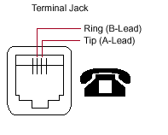
RJ11 Socket PIN's layout for ATA and Modem

