To make CDR function correctly on Win9x/ME, the released CDR patch sets RPC call's authentication level back to the one that previous version of CDR uses. The consequence of this change is that unauthorized RPC connections to BCM can be initialized and established after CDR object is created on BCM by authorized users.

By enabling and setting the firewall IP filter rules correctly, BCM administrators can restrict clients that are able to establish TCP/IP connections and launch RPC calls only at certain permission granted computers. As a result, the number of unauthorized calls is minimized.

Following are an example of configuring an interface filter using the BCM’s built-in firewall rules for limiting RPC access to known trusted endpoints:

Allow DCOM access by the client with a selected IP address the IP address of the BCM is 10.10.10.1. The client IP address is 10.10.10.2.

Solution: Adding the following rules
:

Rule: IR1
Direction: In
Stateful: Yes
Disposition: Block
Protocol: IP
Source IP: 0.0.0.0
SourceMask: 0.0.0.0
Source Port: Any
Destination IP: 0.0.0.0
DestinationMask: 0.0.0.0
Destination Port: Any

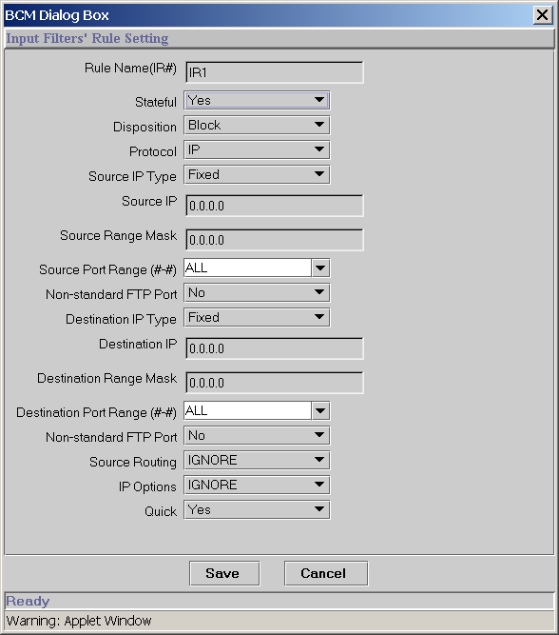

Rule: IR2
Direction: In
Stateful: Yes
Disposition: Pass
Protocol: TCP/UDP
Source IP: 0.0.0.0
SourceMask: 0.0.0.0
Source Port: Any
Destination IP: 10.10.10.1
DestinationMask: 255.255.255.255
Destination Port: 443 (HTTPS)

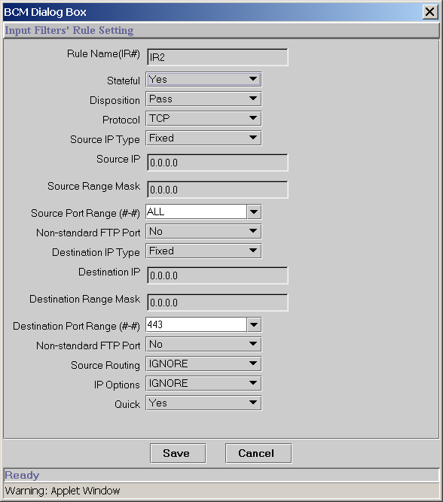

Rule: IR3
Direction: In
Stateful: Yes
Disposition: Pass
Protocol: TCP/UDP
Source IP: 10.10.10.2
Source Mask: 255.255.255.255
Source Port: Any
Destination IP: 10.10.10.1
Destination Mask: 255.255.255.255
Destination Port: 54051-54100 (DCOM range)

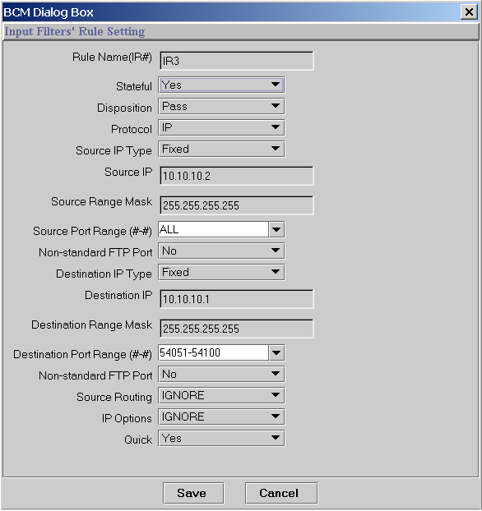

Rule: IR4
Direction: In
Stateful: Yes
Disposition: Pass
Protocol: TCP/UDP
Source IP: 10.10.10.2
SourceMask: 255.255.255.255
Source Port: Any
Destination IP: 10.10.10.1
DestinationMask: 255.255.255.255
Destination Port: 135 (RPC port)

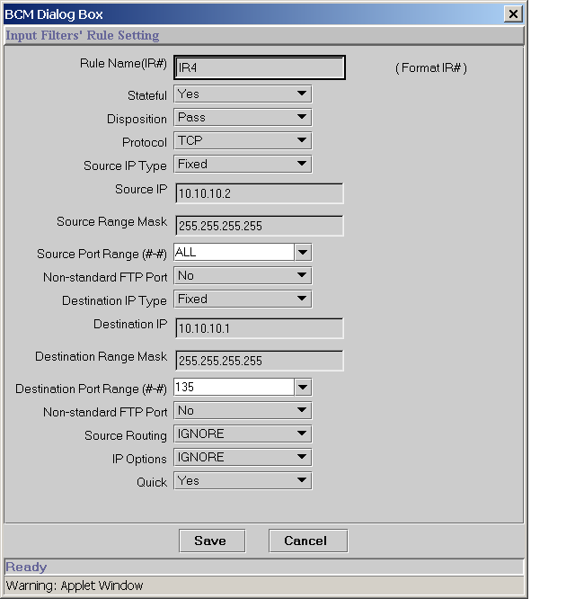

After all rules above are added, the order in which the rules are applied should be defined.

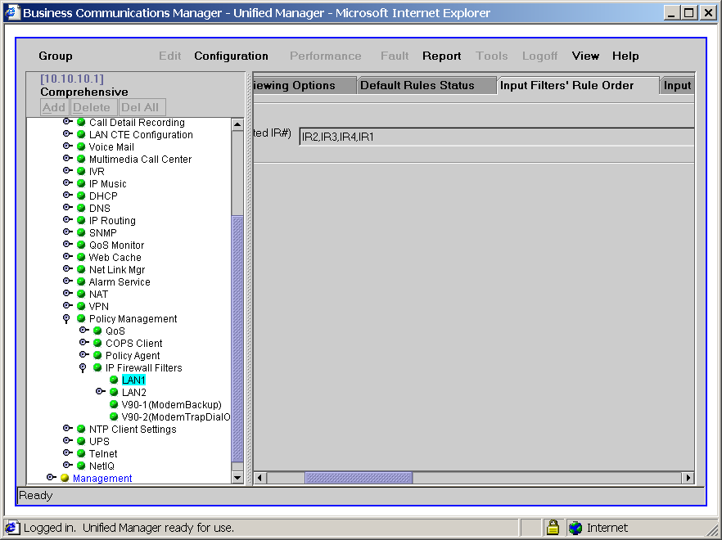

By default the firewall IP filter module is disabled, so after the rules are added, BCM administrator(s) should enable the firewall IP filter module to make it take into effect.

