Apply the following procedure to resolve Report Server errors when using RCC with French Language settings in Windows 7.

1. Click on Start > Control Panel > Administrative Tools > Internet Information
Services (IIS) Manager. The Internet Information Services (IIS) Manager window will
open.

2. A Windows confirmation dialog box will open. Click on Continue to open the Internet
Information Services (IIS) Manager window.

3. From the left-hand pane, expand the node [PC name] ([localhost]).
Expand Web Sites > Default Web Site.
Select ReportServer$RCCSQLEXPR.

4. Ensure Features View is selected and double-click Handler Mappings in the centre
pane of the figure below:

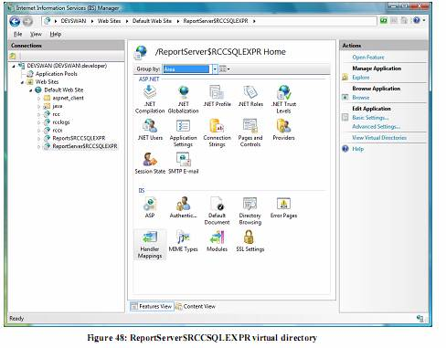

5. The Handler Mappings feature will be displayed in the center pane.
From the right-hand pane under Actions, click on Edit Handler Permissions

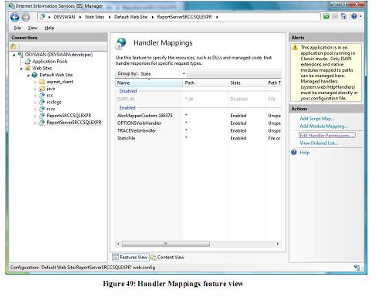
6. Select Script and Execute as shown in the figure below:

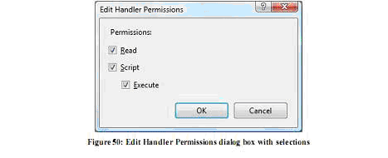

Click OK to execute the Handler Mappings permissions in the virtual directory.

7. Close the Internet Information Services (IIS) Manager window.

