Product Support Note

i2002-i2004 Phase 2 Telsets and Key Expansion Module (KEM) & i2001 Telsets.

Go to Contents

Contents

- Introduction
- Safety
- Security
- Product overview
- Product description
  - Features, functionality and benefits
  - Hardware and software
5.2.1 IP i2002 Telset.

5.2.2 Power over Ethernet
5.2.3 Power Requirements
5.2.4 KeyCaps: Icon or Text Label
5.2.5 Key Cap Kits, Accessories, & Pieceparts
5.2.6 Key Expansion Module (KEM).

  - Manufacturer
  - Supplier to BT
- Marketing strategy
  - Existing offering
  - Rationale
  - Marketing opportunities/target customers
  - Competitor equivalents
- Requirements
  - Compatibility
7.1.1 Succession 1000 / 1000M / Meridian 1 on Succession 3.0
7.1.2 Meridian 1 and X11 Release 25.40/ 25.40B
7.1.3 IP Phone firmware
7.1.4 Survivable Remote Gateway
7.1.5 Business Communications Manager and Survivable Remote Gateway
7.1.6 Software/Loadware Delivery
7.1.6.1 Succession 1000/ 1000M / Meridian 1

  - Equipment supplied with offering
  - Packaging
  - CSS codes
  - Equipment to be sourced from elsewhere
  - Tools
- Delivery
  - Lead-time
  - Sales responsibility
  - Customer responsibility
  - Service wrap/BT engineering responsibility
  - External parties responsibility
- Operational strategy
  - Pricing
  - Order process
  - Delivery
  - Design
  - Planning/installation
  - DOA procedure
  - Configuration
  - Maintenance
  - Maintenance parts
  - Upgrade process
- Documentation
  - Customer
  - Sales
  - Engineering
- Training
  - Customer
  - Customer trainer training
  - Sales
  - Engineering
  - Consultancy opportunities
- Support
  - Fault reporting
  - Fault escalation
  - RACE access
- Credits and document history

1 Introduction
This document provides marketing, sales and operational support information for the i2002-i2004 Phase 2 Telsets and Key Expansion Module (KEM) and i2001 telsets. It also defines the BT processes used in the ordering, delivery, installation and maintenance of this product.
Back to contents

2 Safety
Note: - It is not advised to connect a local power adapter in addition to power over Ethernet to the IP Phones. Using power splitters with Phase II 200x IP Phones is not required.
Back to contents

3 Security
None identified at this time.
Back to contents

4 Product Overview

The IP Phone 200x Phase II Series add enhanced features and integrated capability for more convenience, and more cost effective IP Phone deployments. Phase II brings the addition of the IP Phone 2001 to the BT portfolio.
Back to contents

5 Product Description

5.1 Features, functionality & benefits
The IP Phone 200x Phase II Series adds enhancements including integrated support for power over Ethernet and full VLAN capability, support for improved call quality reporting, and increased security capabilities.

Changes from the Phase I series are hardware and phone-firmware based. Although Phase II sets (2004 and 2002) look like Phase I sets, they can be identified by the product codes on the label on the back of the set. A full list of product codes is included in a later section of this Product Bulletin.

IP Phone 200x Phase II Hardware enhancements include:

- Integrated hardware to support power over Ethernet - support for 802.3af standard power and other powering options including ongoing support for PowerDsine Power over LAN Hub powering, Cisco proprietary powering as tested with specific Cisco Ethernet Switch equipment. (no longer need power splitters to support power over Ethernet ; optional AC adapters are the same as earlier 200x IP phones).

- Full VLAN capability, including a manageable integrated switch in the IP Phones (2002 and 2004) for VLAN & priority tagging for PC and IP Phone traffic. (replaces port-based support for VLAN tags where phone traffic is tagged, and PC traffic is not tagged - which required specific (not the default) settings at Ethernet Switch. Better VLAN coverage across all scenarios, with separation of traffic end to end starting at the desktop device.

- Larger memory footprint to support future SIP standard protocol firmware stacks & general future proofing.

- Increased processing power due to silicon evolution, also required for media path encryption

Phase II firmware enhancements
The Phase II IP Phones will support all the features & capabilities of current IP Phones available today. General Availability of the phones themselves, and future firmware upgrades and feature support is dependent on specific Nortel Networks Communications Systems’ or Application Server availability planning.

Upcoming firmware enhancements available post GA include
- Manual settings for 10Mbps/100Mbps Full Duplex as “nailed up” connections
- Enhanced Security support for 802.1x, Extensible Authentication Protocol (EAP), Voice & media encryption
- Real-time QoS monitoring and set diagnostics to enable Proactive Voice Quality Management (Post GA, first supported with CS 1000 Rls 4.0)
- NET6 Application Gateway “Push” functionality to IP Phones.
- SIP stack extending native access to SIP-based application services on Phase II IP Phones (Separate program to deliver SIP stack is POI)
- Support for Asian character set (IP Phone 2001)

NOTE: Phase I IP sets cannot be upgraded to be Phase 2 sets due to the hardware enhancements in Phase 2 sets. Phase I IP sets will continue to be supported in the future, and can co-exist in mixed environments with Phase II sets. Phase I IP sets will be moved to Manufacture Retire Stock Depletion (MRSD) status upon the availability of Phase II sets, and will be available for sale until inventory is depleted.

Phase II also introduces pre-printed English text-based keycaps on the IP Phone – straight from the factory, in addition to the icon-based keycaps currently available, for all three IP Phone models. Existing separately orderable key cap kits are also supported, for further personalization for BCM supported features and keycap label alternatives.
Back to contents

5.2 Hardware and software

5.2.1 IP i2001 Telset.

- Nortel suite of rich and reliable telephony features
- Small device footprint
- Fixed Feature keys
  - Hold, Goodbye, Line/Listen speaker, Services, Messages
  - Up/down navigation keys for LCD display
- Four soft keys
- “Listen” speaker
- Message Waiting LED Indicator
- LAN or AC local power options
- Colours at GA: Charcoal and Ethergray

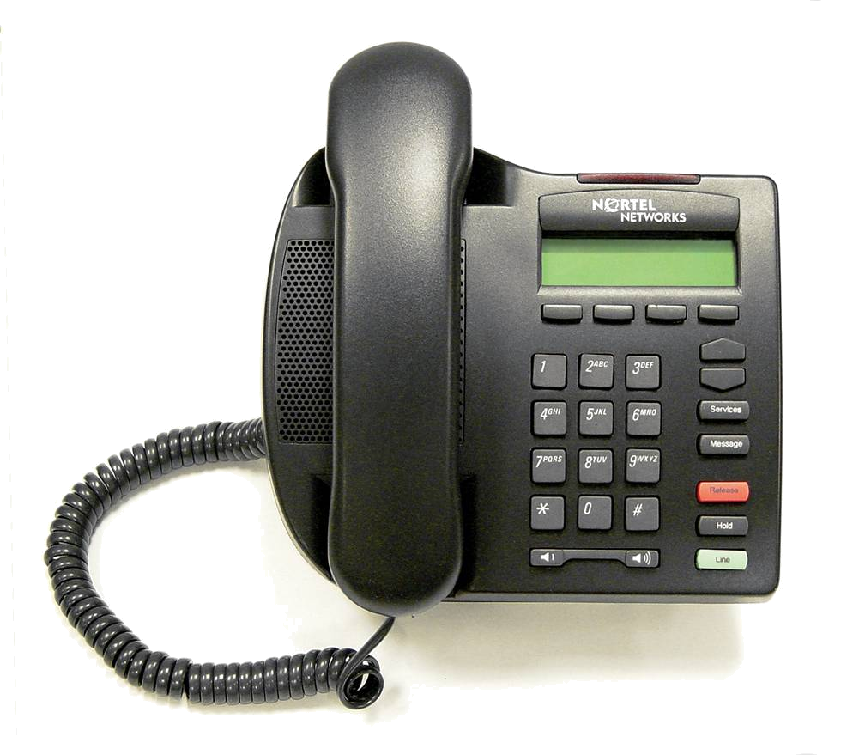

As part of the Phase II initiative is the introduction of the IP Phone 2001.

Within the IP Phone portfolio, the 2001, has a small footprint for space limited environments. Fixed keys on the 2001 include those for Hold, Goodbye, Line/Listen speaker, Services and Messages, along with up/down navigation keys, a volume bar for handset and speaker audio and ringer volume control. Four soft label keys below the display allow quick access and control for the popular telephony features and capabilities enabled by the Communications Systems.

The “Listen” speaker enables zone paging and on-hook dialling. Users can quickly access Voicemail and listen to messages. To be heard, the 2001 user must use the handset. The 2001 support’s Message Waiting Indication consistent with other models in the IP Phone portfolio. The red alerting lamp positioned at the top of the set can also support visual ringing.

The IP Phone 2001 set will support local AC or LAN power. Like all IP Phones within the Phase II series, the 2001 does not require a power splitter to support Power over LAN options. Consistent with entry level offerings in the industry.

Note: - the 2001 does not support
- An integrated switch
- Connection of a co-located PC.
- Direct headset connections
- Add on Key Modules

The set can be either desk or wall mounted.
Back to contents

5.2.2 Power over Ethernet

The Phase II 200x IP Phones have integrated hardware to support power over Ethernet for 802.3af standard power and other powering options including ongoing support for PowerDsine Power over LAN Hub powering, and Cisco proprietary powering as tested with specific Cisco Ethernet Switch equipment.

Power splitters required with Phase I phones are no longer required with Phase 2 sets. Power over Ethernet deployment is recommended since it allows Telephony-grade reliability levels to be achieved due to power back up in case of power failures.

The Phase II 200x IP phones also support AC local power – 5 adapters are available for global coverage and are separately orderable. The same power adapters are used with all models of Nortel Networks IP Phones.

Note: - It is not advised to connect a local power adapter in addition to power over Ethernet to the IP Phones. Using power splitters with Phase II 200x IP Phones is not required.
Back to contents

5.2.3 Power Requirements

Environmental concerns and power budgets and capabilities of Ethernet Switch gear make power requirements for IP Phones and other network devices important. The following table provides power requirements per phone type, across the different Phases of the IP Phones. Power management is further enabled with support for IEEE 802.af Power Classification. Please contact your Nortel Networks representative for more info.

Phone Type | Conditions
Phase 0 (Without integrated switch) | without External 3 Port Switch | with External 3 Port Switch
i2004-NTEX00Bx / NT7B10AACH | ~3 W | ~10 W
Phase I | 48V Supply* | 16VAC Supply*
i2002-NTDU76AB/BB | 2.87W | 3.55W
i2004-NTDU82AA/BA | 2.87W | 3.3W
* Measured with ringing on speaker
Phase II (PoE Classification 2) | Heavy Load** | Normal Load**
IP Phone 2001-NTDU90BA | 5.0 W | 3.2 W
IP Phone 2002-NTDU91BA | 5.0 W | 3.2 W
IP Phone 2004-NTDU92BA | 5.5 W | 3.3 W
**Heavy load-All LEDs on and 1kHz tone on speaker
**Normal Load-set powered up
Note: See the PoE Reference Sheet Document for more detailed information on Power over Ethernet information & options

Back to contents
5.2.4 KeyCaps: Icon or Text Label
Phase II also introduces pre-printed English text-based keycaps on the IP Phone – straight from the factory, in addition to the icon-based keycaps currently available, for all three IP Phone models. *Note: EMEA is not introducing top-level codes with pre-installed English text label keys. Existing separately orderable key cap kits are supported in EMEA
Back to contents

5.2.5 Key Cap Kits, Accessories, & Pieceparts
Key cap kits are globally available for further personalization for BCM supported features and keycap label alternatives for all systems. Product codes for optional IP Desktop accessories including English text-labelled Key Cap Kits, key cap removal tool, and 2004 Wall Mount Kit are listed below.
Back to contents

5.2.6 Key Expansion Module (KEM).
The IP Phone Key Expansion Module (KEM) is a hardware component that attaches to Nortel Networks IP Phone types 2002 and 2004 and provides additional line appearances and feature keys.
Note: -
- The IP Phone KEM is not supported on the IP Phone 2001.
- Up to two IP Phone KEMs can be attached to an IP Phone type 2002 or 2004.
- With two IP Phone KEMs attached, the IP Phone 2004 can have up to 60 lines/feature keys, while the IP Phone 2002 can have up to 52 lines/feature keys.

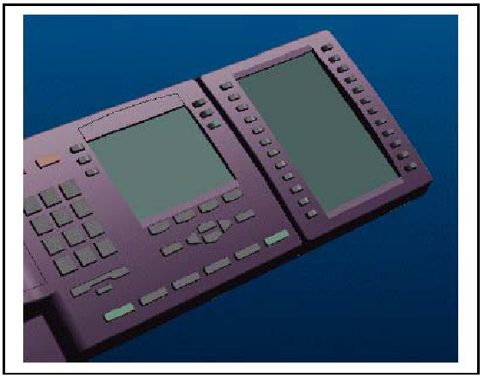

Note: The IP Phone 2004 can also have up to 60 lines/feature keys using the shift key and one IP Phone KEM. With two IP Phone KEMs attached, the shift key does not affect the IP Phone KEMs since the maximum number of lines/feature keys is already available.
The IP Phone 2002 does not support shift key functionality.
When an IP Phone KEM is installed on an IP Phone type 2002 or 2004, the controls on the IP Phone affect both the IP Phone itself and the IP Phone KEM.

IP Phone 2004 with one IP Phone KEM attached

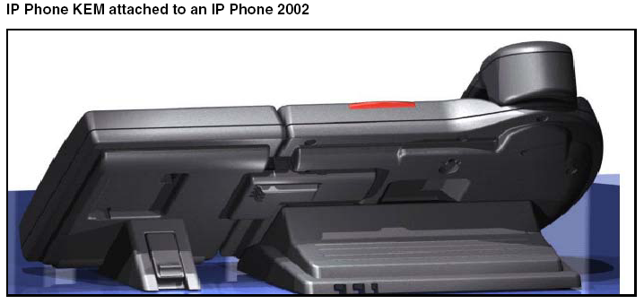

Features
The IP Phone KEM has the following features:
- • 24 keys in two columns on either side of an LCD provide up to 48 additional logical self-labeled lines/feature keys.
- A desk-mount bracket and structural base plate connect the IP Phone KEM to an IP Phone type 2002 or 2004, or to another IP Phone KEM.
- A wall-mount bracket installs the IP Phone KEM alongside a wall-mounted IP Phone type 2002 or 2004.

Display characteristics
The IP Phone KEM has one LCD between two rows of 12 lines/feature keys as shown in above. Each of the 24 physical keys on the IP Phone KEM can have a 10-character display label. This label is set using the controls on the IP Phone type 2002 or 2004.

Key number assignments
Since the IP Phone type 2002 and 2004 have key number assignments from 0 to 31, the IP Phone KEM key number assignments begin at 32. Therefore, the first IP Phone KEM has key number assignments from 32 to 55, and the second IP Phone KEM has key number assignments from 56 to 79.

Configuration
The IP Phone KEM must be configured in LD 11 before it can be used.
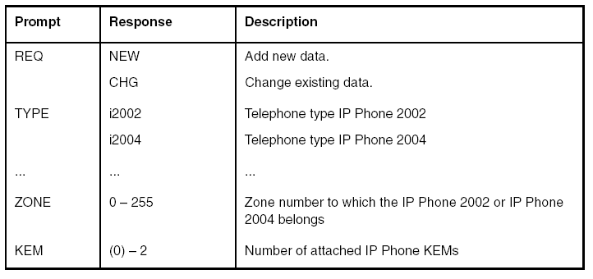
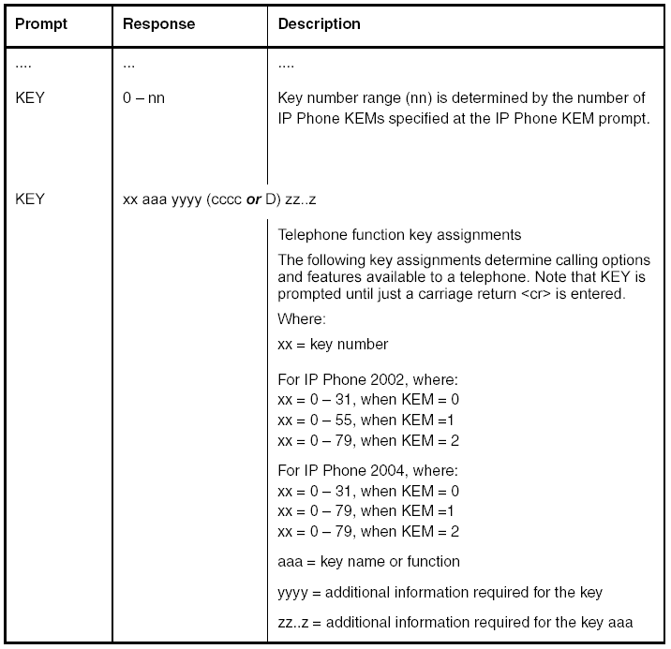
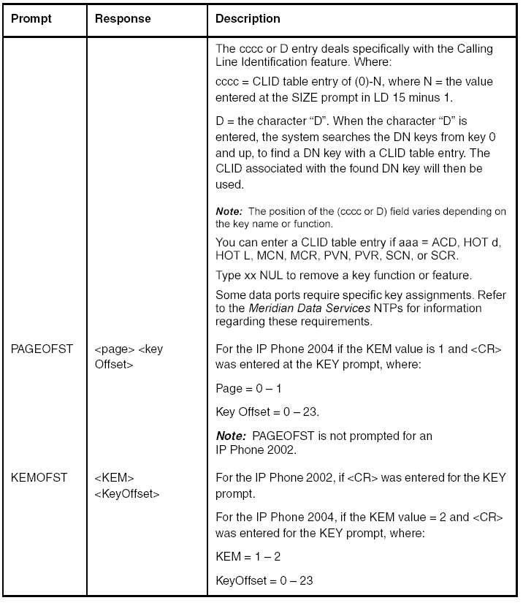

KEM Installation
The IP Phone KEM mounts on the right side of an IP Phone type 2002 or 2004. The IP Phone KEM snaps into the receptacle on the back of the IP Phone using the desk-mount bracket and structural base plate supplied with the IP Phone KEM.
.
The IP Phone KEM is cabled to the IP Phone type 2002 or 2004 using the Accessory Expansion Module (AEM) port on the IP Phone.

Connecting the IP Phone KEM to an IP Phone type 2002 or 2004
1 While pressing the telephone tilt handle, pull the telephone away from the tilt base until it clears the final stop.
2 Place the telephone and the IP Phone KEM face down on a non-abrasive surface and align them.
3 Plug the 10-pin female header from the IP Phone KEM into the AEM port on the IP Phone.
4 Wrap the clamp around the cable and screw the clamp into the back of the telephone with a 3 mm and 8 mm screw.
5 Thread the cable through the opening in the side of the IP Phone.
6 Optional: If attaching a second IP Phone KEM, plug the 10-pin female header from the second IP Phone KEM into the 10-pin recessed male header of the first IP Phone KEM.
7 Insert the clips on the IP Phone into the hinges on the footstand and then press onto the front of the footstand until it snaps into place.
8 While squeezing the telephone tilt handle, swing the footstand into the desired position.
9 Insert the clips on the IP Phone KEM into the hinges on the IP Phone KEM footstand. Repeat for the second IP Phone KEM, if required.
10 While squeezing the IP Phone KEM tilt handle, swing the footstand into the desired position. Repeat for the second IP Phone KEM, if required.

The IP Phone KEM powers up.
Note: The IP Phone KEM uses the electrical connection of the IP Phone type 2002 or 2004 for power. It does not have its own power source.
End of Procedure

Initialization
Once the IP Phone KEM has been installed and powered up, the IP Phone KEM initializes. See Table 2 for a description of the initialization process. When the three phases complete successfully, you are ready to use the additional lines/feature keys on your IP Phone KEM.

Note: If you have more than one IP Phone KEM installed on your IP Phone, the one to the immediate right of the telephone (KEM1) must be functional for the subsequent IP Phone KEM (KEM2) to work. This is because the second IP Phone KEM gets its power and communicates with the IP Phone through the first IP Phone KEM.

IP Phone KEM Initialization process Phase Description

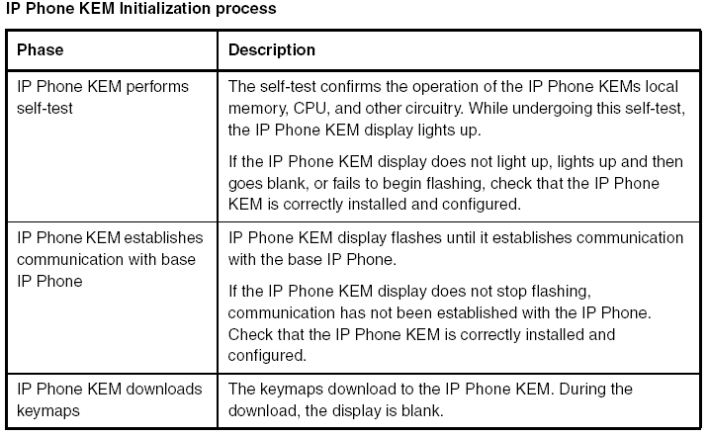

Operating parameters General
If an IP Phone KEM is not responding, and lines/features are configured on keys 32-79, calls can be directed to those keys which the user cannot access.
This means the IP Phone type 2002 or 2004 rings but the call cannot be answered. In such cases, the incoming call receives Call Forward No Answer (CFNA) treatment.

IP Phone 2002
If only one IP Phone KEM is configured in LD 11 but two IP Phone KEMs are detected on an IP Phone 2002, the second IP Phone KEM is ignored. An error message displays to alert the user that the actual configuration does not match the administered configuration.
If two IP Phone KEMs are configured in LD 11 but only one IP Phone KEM is responding, the keys on the second IP Phone KEM are available to call processing but not accessible to the user. This means that lines/feature keys on keys 56 - 79 can cause the IP Phone 2002 to ring, but there is no way to answer it. An error message displays to alert the user that the actual configuration does not match the administered configuration.

IP Phone 2004
If only one IP Phone KEM is configured in LD 11 but two IP Phone KEMs are detected on an IP Phone 2004, the Terminal Proxy Server (TPS) assigns keys 56 - 79 to the second IP Phone KEM. An error message displays to alert the user that the actual configuration does not match the administered configuration.
If two IP Phone KEMs are configured in LD 11 but only one IP Phone KEM is responding, the TPS assigns keys 32 - 79 to the single IP Phone KEM (using the shift key). An error message displays to alert the user that the actual configuration does not match the administered configuration.
When a second IP Phone KEM is detected, the TPS changes the key assignments to display
across both IP Phone KEMs, as expected.

Virtual Office
When a Virtual Office (VO) login occurs from an IP Phone type 2002 or 2004 that does not have the same number of IP Phone KEMs responding as configured on the IP Phone used to log in, call processing may terminate on a key that is not physically available to answer. In other words, the IP Phone rings but the call cannot be answered.
During the VO login process, the existence of any IP Phone KEM is verified.
If a mismatch is detected, the login still proceeds normally, although an error message is generated.

Firmware
The IP Phone KEM firmware is not downloadable. In the event that the IP Phone KEM firmware must be upgraded or changed, the IP Phone KEM must be replaced with a new IP Phone KEM containing the updated firmware.

5.3 Manufacturer
Nortel Networks.
Back to contents

5.4 Supplier to BT
Nortel Networks.
Back to contents

6 Marketing Strategy

6.1 Existing offering
Back to contents

6.2 Rationale
Back to contents

6.3 Marketing opportunities/Target customers
Back to contents

6.4 Competitor Equivalents
Not applicable
Back to contents

7 Requirements

7.1 Compatibility
7.1.1 Succession 1000 / 1000M / Meridian 1 on Succession 3.0 :

Succession 3.0 (minimum release)
- Signalling Server 2.10.81
- IP Line Application 3.10.81
Back to contents
7.1.2 Meridian 1 and X11 Release 25.40/ 25.40B
- The IP Line Loadware application for Meridian 1 25.40/ 25.40B must be upgraded.

- IP Line Application 3.05.2

This Loadware and the corresponding ReadMe First document may be downloaded from the Nortel Networks software download web site.
Back to contents

7.1.3 IP Phone firmware
- It is necessary to ensure the latest version of IP Phone firmware is downloaded and installed on the Phase II IP Phones.

  - IP Phone firmware 0604D31 or later
Back to contents

7.1.4 Survivable Remote Gateway
The IP Phones 2002 and 2004 are supported on SRG 1.0 with the application of a software patch.
Note: - The IP Phone 2001 is not supported on SRG 1.0 at this time.
Back to contents

7.1.5 Business Communications Manager and Survivable Remote Gateway
For Business Communication Manager (BCM), all Phase II sets inclusive of the IP Phone 2001 will be generally available as of July 30th, 2004. Full support for Phase II functionality, including the 2001, will be provided on BCM Release 3.6 or later.

Note:
- Phase II 2004 and 2002 sets are backward compatible to BCM 3.0 for Phase I functionality only.
- The IP Phone 2001 is not supported on previous BCM releases other than 3.0 & 3.6.

IP Phone 2001
- Requires BCM 3.6 (GA – May 2004) system software (or later) with an IP Telephony seat license for each telephone.
- The IP Phone 2001 is not supported on SRG 1.0 at this time.

IP Phone 2002 and 2004
- Requires BCM 3.0 (GA – December 2002) system software (or later) with an IP Telephony seat license for each telephone.
- Are supported with SRG 1.0 with the application of a software patch.

IP Phone firmware
- IP Phone firmware (from factory) 0604D31 or later
- To support backward compatibility for BCM systems, the IP Phone firmware delivered on the phone from the factory may be higher than the IP Phone firmware that came with the BCM system software. If this is the case, the IP Phone firmware will not be downgraded by the BCM, but the IP Phone will instead run the higher level of firmware.
Back to contents

7.1.6 Software/Loadware Delivery
7.1.6.1 Succession 1000/ 1000M / Meridian 1

System and IP Phone software is downloadable from the Nortel Networks Web site. IP Phone firmware is available free of charge and can be retrieved from the Nortel Networks Electronic Software Delivery (ESD) web site. To access this web site, follow these instructions:
1. Access the www.nortelnetworks.com web site.
2. Select “Software Downloads” from the “Support” section.
3. Select “Meridian” or “Succession” to select by Product Family
4. Then make the appropriate selection under “IP Line and Internet Telephony Gateway (ITG) Line” or Under “Succession Enterprise”
Back to contents

7.2 Equipment supplied with offering
Not applicable
Back to contents

7.3 Packaging
Not applicable
Back to contents

7.4 CSS Codes
IP Phone 200x (Phase II) Orderable Product Codes

PEC | CPC | Product Description | CSS Codes
IP Phone 2001
NTDU90AA16 | A0533387 | IP Phone 2001 (Ethergray) with Icon keycaps, without power supply
NTDU90BA16 | A0533388 | IP Phone 2001 (Ethergray) with English Text label keycaps, without power supply
NTDU90AA70 | A0533389 | IP Phone 2001 (Charcoal) with Icon keycaps, without power supply
NTDU90BA70 | A0533390 | IP Phone 2001 (Charcoal) with English Text label keycaps, without power supply
IP Phone 2002
NTDU91AA16 | A0533404 | IP Phone 2002 (Ethergray) with Icon keycaps, without power supply
NTDU91BA16 | A0533405 | IP Phone 2002 (Ethergray) with English Text label keycaps, without power supply
NTDU91AA70 | A0533406 | IP Phone 2002 (Charcoal) with Icon keycaps, without power supply
NTDU91BA70 | A0533407 | IP Phone 2002 (Charcoal) with English Text label keycaps, without power supply
IP Phone 2004
NTDU92AA16 | A0533408 | IP Phone 2004 (Ethergray) with Icon keycaps, without power supply
NTDU92BA16 | A0533409 | IP Phone 2004 (Ethergray) with English Text label keycaps, without power supply
NTDU92AA70 | A0533410 | IP Phone 2004 (Charcoal) with Icon keycaps, without power supply
NTDU92BA70 | A0533411 | IP Phone 2004 (Charcoal) with English Text label keycaps, without power supply

NOTE: Phase II sets include integrated support for a number of power over LAN options, including support for IEEE 802.3af standard power. If local power via the AC adapter is required with Phase II set, the AC adapter must be ordered separately. Local AC power adapter product codes is listed below.

Top Level Product Code – Package Contents
Each top-level product code includes the phone unit, phone stand, handset, handset cord, 1 Ethernet cable, Getting Started Card.

Separately orderable items for use with the IP Phones

All separately orderable pieceparts and accessories, including the local AC power adapters, are the same for all previous and Phase II IP Phones.

AC Power Adapters
Note 1: Same power adapters are used for original i2004, i2002, and i2004 with integrated switch, and 200x Phase II IP Phones

Note 2: If your network LAN infrastructure supports Power over Ethernet, you may not require an AC adapter. If local power via the AC adapter is required with Phase II sets, the AC adapter must be ordered separately.

Ireland / UK: 3 prong AC to AC, 8W, 240 VAC, 50Hz, to 16 VAC / 500mA | A0656598
Europe: AC to AC, 8W, 230 VAC, 50/60Hz, to 16 VAC at 500mA | A0619635
ANZ: 2 prong, AC to AC, 8W 240 VAC, 50Hz, to 16 VAC at 500mA | A0647042
Japan: AC to AC, 8W, 100 VAC, 50Hz, to 16 VAC at 500 mA | A0828858
Text Label Key Cap Kits & Tweezer Key Removal tool

Note 1: A tweezer key removal tool is required to remove the existing keycaps from the IP Phones and not damage the phone.

Note 2: Specific i2002 Phase I IP phones do not support having their keycaps removed. Note special instructions for key cap removal and specific i2002 related product codes that support key removal, detailed in IP Phone Accessories Product Bulletin.

Key Cap Kit i2002/1 BCM English | NTDU0007 / A0506957
Key Cap Kit i2002/1 Generic English | NTDU0003 / A0506953
Key Cap Kit i2004 BCM English | NTDU0005 / A0506955
Key Cap Kit i2004 Generic English | NTDU0001 / A0506951
Key Removal Tweezer Tool (required for Key Cap removal) | NTMN19AA / A0779712
Wall Mount Kit (2004)
IP Phone 2004 Wall mount kit (Charcoal*) – for use with previous i2004 variants and the Phase II IP Phone 2004 | NTMN15BA70 / A0503076
* Charcoal wall mount is used with Ethergray and Charcoal units, since the backs of both colour variants is Charcoal.
Back to contents

7.5 Equipment to be sourced from elsewhere
None
Back to contents

7.6 Tools

None
Back to contents

8 Delivery

8.1 Lead-time
Not applicable
Back to contents
8.2 Sales responsibility
To advise on minimum System software requirements for Phase 2 and I2001 Telsets.
Back to contents
8.3 Customer responsibility
None.
Back to contents
8.4 Service wrap/BT engineering responsibility
None.
Back to contents
8.5 External parties responsibility
None.
Back to contents

9 Operational Strategy
9.1 Pricing
Enhancements and expansions to the mail systems refer to the pricing manual and Messia tool.
Back to contents
9.2 Order process
As per Telsets ordering.
Back to contents
9.3 Delivery
Not applicable
Back to contents
9.4 Design
As per Telsets ordering.
Back to contents
9.5 Planning/Installation
Not applicable
Back to contents
9.6 DOA Procedure
Normal DOA processes will apply.
Back to contents
9.7 Configuration
Not applicable
Back to contents
9.8 Maintenance
Maintenance will be completed as per Normal Maintenance processes and as documented by training course notes & Northern Telecom Practices (NTP’s) documentation.
Back to contents
9.9 Maintenance parts
All Mail maintenance parts will be available via BT Stock Points.
Back to contents
9.10 Upgrade process
None.
Back to contents

10 Documentation
10.1 Customer documentation
Not applicable
Back to contents
10.2 Sales documentation
Sales breifings and documentation will be available via the Convergent Solutions Web Site.
Back to contents

10.3 Engineering documentation
All NTPs can also be accessed on the Nortel Networks web site, at
http://www.nortelnetworks.com/helmsman
Registration is required for access, but there are no charges.

In addition, this site will be posting monthly “Release Notes”, which will detail changes to existing NTPs, made as a result of customer input and internal testing. These will accumulate until the following full up-issue of the relevant documents.
Back to contents

11 Training
11.1 Customer training
Not applicable
Back to contents
11.2 GCS Customer trainer training
Not applicable
Back to contents
11.3 Sales training
Not applicable
Back to contents
11.4 Engineering training
Not applicable
Back to contents
11.5 Consultancy opportunities
None identified.
Back to contents

12 Support
Normal Support processes will apply.

12.1 Fault reporting
Normal fault reporting processes will apply.
Back to contents
12.2 Fault escalation
Normal fault escalation processes will apply.
Back to contents
12.3 RACE Access
No changes are planned to the normal RACE access process for Meridian Mail.
Back to contents

13 Credits and document history
Document author: Paul Andrews | Version no: Issue 1
Document owner: Roger Holmes | Date: 28th -July –2004
Update: | Reason for update: Notification
Back to contents

