CallPilot Language Configuration Utility

The CallPilot language configuration feature can be applied to a CallPilot server by using the Language Configuration GUI application. This application can be run on Windows platforms and its main purpose is to install the necessary language files to the CallPilot server.

The Language Configuration application will be shipped with the same CD that includes the available language files. This CD will contain one language file for each language. Each language file will be the merged version of the necessary four smaller language files and will have a “.lang” extension.

As a first step, the user needs to run the Language configuration application in a Windows environment. Language configuration, displayed in the next figure, is designed as an install wizard type application. The first page requires either the Server Name or the Server IP Address information of the CallPilot server. The user can make either one of these options available by clicking on the appropriate radio buttons. The “Server Name” option is the default selection.

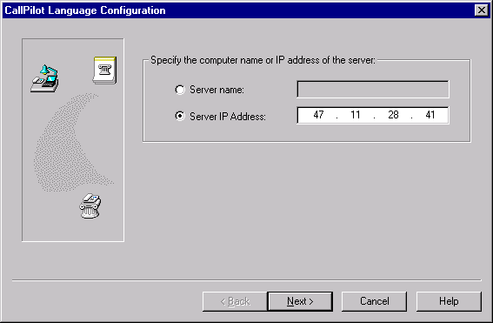

After the necessary information is entered, clicking on “Next” button tries to make a connection to the server to confirm the availability of the server and to get the detailed information about the current language settings of the server.

After the server information is confirmed, the following page is displayed.
On this page, the “Language To Remove” combo box contains the list of installed languages on the specified server while the “Language To Install” combo box provides the list of the available languages to install.

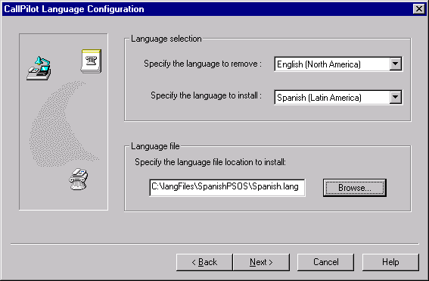

The user needs to choose a language to remove and install from these combo boxes as well as to specify the location of the “.lang” file. The “Browse” button displays the following dialog to help the user specify the location of this language file.

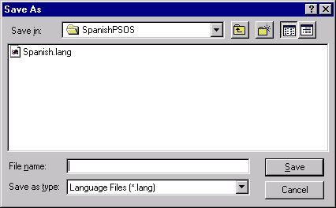

Selecting the “Next” button on the language page displays the following final summary page. This page provides a read-only summary for the options selected by the user so far. If the user wants to change/modify any of these options, he/she can use the “Back” and “Next” buttons to navigate on the previous pages.

Selecting the “Finish” button on this page starts the installation operation.

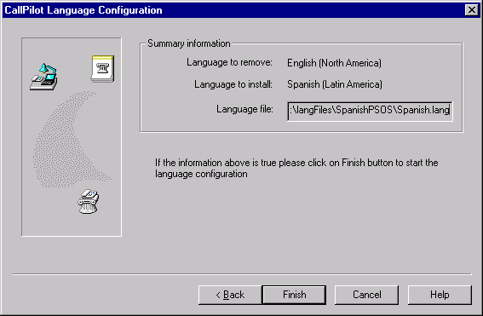

During the installation process, a progress dialog is displayed to inform the user about the status of the operation.

If the operation is successful, the language configuration application ends by displaying the following message.

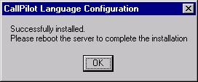

As mentioned in this message dialog, the user needs to reboot the CallPilot server to complete the language configuration operation.

