Here are a list of Call Pilot PEP’s that I’ve installed on a system rebuild recently.
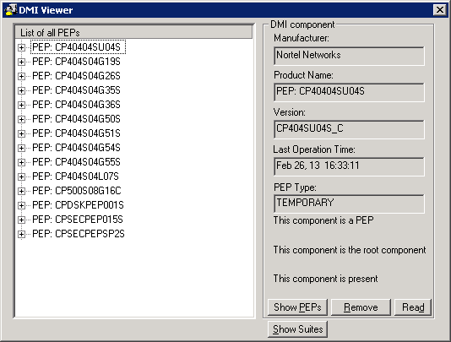
Older PEP’s installed recently on another system
