
Distributor Technical Reference Bulletin

Bulletin Number: DTR-2007-0069-Global

Date: June 29, 2007

CallPilot Release 5.0

Introduction

This Distributor Technical Reference (DTR) bulletin provides information that supplements the formal documentation for the purpose of installing, upgrading, and supporting CallPilot Release 5.0 (05.00.41.20) systems. It provides updated procedures, limitations, known problems, workarounds, and documentation addenda. This is an important information resource for Channel Partner field operations and support personnel involved with CallPilot 5.0.
For more details on feature installation and operation, refer to the CallPilot 5.0 Customer Documentation.

This document, as well as other Customer Documentation, may be updated periodically as needed. It’s recommended to always reference the Partner Information Center and Helmsman Express websites for the latest information in updated NTPs or other documents.

Nortel reserves the right to add, delete, or change features and packages in accordance with contractual obligations.

*Nortel, the Nortel logo, the Globemark, How the World Shares Ideas, Unified Networks, CallPilot, Communication Server 1000, Meridian, and Symposium Messenger are trademarks of Nortel.

LOTUS NOTES is a trademark of IBM Corporation.

PENTIUM is a trademark of Intel Corporation.

MICROSOFT EXCHANGE, MS-DOS, INTERNET EXPLORER, OFFICE 2000, OFFICE XP, OUTLOOK 97, OUTLOOK 98, OUTLOOK 2000, OUTLOOK 2002 (XP), OUTLOOK EXPRESS, WINDOWS 95, WINDOWS 98, WINDOWS NT, WINDOWS 2000, WINDOWS XP, WINDOWS 2003 and Windows Vista are trademarks of Microsoft Corporation.

NETSCAPE COMMUNICATOR is a trademark of Netscape Corporation.

NOVELL GROUPWISE is a trademark of Novell Corporation.

EUDORA PRO is a trademark of Qualcomm Corporation.

pcANYWHERE32 is a trademark of Symantec Corporation
Revision history

Issue Number / Date | Type of Review / Reason(s) for Issue | Author
Standard / Revision 1.0 | Initial release of the 5.0 GA DTR in support of the IS Beta Trial sites. Based on 4.0 DTR, version 1.0 of the release notes and internal review feedback from PLM, MDS, and Technology. | David Saunders, Kathy Burt,  Roger Brassard
1.1 / March 22, 2007 | Added Q01487471 CPMgr installation on IE7 popup possible message. | David Saunders
1.2 / March 29, 2007 | Added Appendix C – High Availability Troubleshooting Reference | David Saunders
1.3 / April 2, 2007 | Added HA nightly failover due to old clock controller on Option 61/81 switches issue | David Saunders
2.0 / April 12, 2007 | Updated HA procedures to address multi-CPU switch nightly audits and AML link failure. Added feedback updates from Roger Brassard. Added T1 Remote Notification PEP installation sequencing. | David Saunders
3.0 / April 30, 2007 | Updated HA procedures to address the installation of PEP CP500S00G09S, configuring email addresses for switch ping over the ELAN, configuring failover on switch ping over the ELAN. Added desktop client limitation using Outlook and selecting message store folder. GA localization view. | David Saunders
4.0 / May 23, 2007 | Modified wording to reference ‘the PEP’ instead of CP500S00G09S, since now PEP to reference is CP500S00G013S, and may change again to another PEP or an SU. Also updated the ‘currently available PEPs section | Kathy Burt
5.0 / June 20, 2007 | Added work around for Q01664924 1002rp image has incorrect elan setting in DNS and WNS field | Kathy Burt
5.0 / June 29, 2007 | Added work around for Several Cr’s Several Cr’s  Q01411001 Uninstalling CallPilot Reporter causes TM application failed  Q01670017 No extension file cannot be attached to message in external email  Q01653667 Upgrade from 4.0 to 5.0 not deleting old "One-Number Voice/Fax Call Answering  Q01637360 CallPilot desktop upgrade to 5.0 fails from CD-R | Kathy Burt

Table of contents

CallPilot Release 5.0 1
1 The Distributor Technical Reference Bulletin 6
1.1 Purpose 6
1.2 What’s new in CallPilot 5.0 and Available in this Release 6
2 Product Requirements 13
3 Meridian 1 switch requirements 24
4 Communication Server 1000 switch requirements 25
5 CallPilot software 27
6 Feature Information & Limitations 28
6.1 General Limitations 28
6.2 Language Availability 28
6.3 Speech Activated Messaging and Custom Commands 29
6.4 Meridian Mail Migration 29
6.5 Upgrade and Setup Wizards 29
6.6 Installation & Upgrades 30
6.7 Drivers/Firmware 30
6.8 Backup/Archive/Restore 30
6.9 CallPilot Manager/Config Wizard 30
6.10 High Availability 31
6.11 Unified Messaging 31
6.12 My CallPilot & Desktop Messaging 32
6.13 Shared Telephone/Dorm Room 32
6.14 Remote Access 32
6.15 Reporter 33
6.16 Message Forwarding Rules 35
6.18 Delayed CallPilot Manager Online Help Guides Content 37
6.19 Desktop Messaging Outlook Message Store 37
Procedures 38
6.20 Upgrade Guide 38
6.21 Upgrade Wizard 38
6.22 RAID Updates & the Upgrade Wizard 38
6.23 Setup Wizard and Config Wizard 39
6.24 High Availability 39
6.25 Changes in T1/SMDI and CallPilot Server Configuration 59
6.26 PEPs 60
6.27 Reboot After Setup Wizard 60
6.28 Re-Installation of Software 60
6.29 Change in location of various Windows OS-centric utilities 62
7 Known Problems / Issues 63
7.1 Server 63
7.2 CallPilot Manager 72
7.3 Event Monitor/Viewer 74
7.4 My CallPilot 74
7.5 Desktop Messaging 74
7.6 Reporter 76
7.7 Networking 76
7.8 Shared Telephone/Dorm Room 77
7.9 High Availability 77
7.10 T1 Systems 78
7.11 600r Platform 78
7.12 Backup and Restore 78
7.13 Alternate User Interface 78
8 PEP/Service Update application overview 80
8.1 PEP Numbering Format 80
8.2 CallPilot 5.0 Service Updates and Individual PEPs 81
9 Documentation References 104
Appendix A CallPilot/SCCS Integration 105
Appendix B CallPilot performance and recommended measurements 110
Appendix C CallPilot High Availability Troubshooting Reference 111

The Distributor Technical Reference Bulletin

  - Purpose

The purpose of the Distributor Technical Reference bulletin (DTR) is to provide the user with information for CallPilot 5.0 that is not covered by the NTP documentation supplied with the system. This DTR is intended for use in conjunction with the latest CallPilot 5.0 (05.00.41.20) software CDs. Refer to the complete listing in CallPilot Software.

  - What’s new in CallPilot 5.0 and Available in this Release

Meridian Mail Parity
- CallPilot Voice Forms
  - Allows for collection of specific information from customers, etc., via the telephone
  - Callers are prompted to enter verbal responses to questions/prompts
  - Responses are recorded and compiled for retrieval/transcription
  - Used in various vertical markets but predominant in Healthcare for prescription refills and retrieving medical information from patients
  - Provides a Web interface in CallPilot Manager for easy set-up of Voice Forms
- Shared Telephone Messaging Service
  - AKA Dorm Room or Family Mailbox
  - Provides messaging service for users who share a telephone
  - Multiple mailboxes can be assigned to a shared DN by bulk loading
  - The service answers and presents the available mailbox options to callers: for Brian, press 1, for James, press 2, etc.
  - MWI for shared DN remains on if a new messages is remain in any of the assigned mailboxes
- Nested System Distribution Lists (SDLs)
  - Allows system distribution lists to contain other system distribution lists
- Block user from receiving compose messages
  - If enabled, users can block the receipt of messages that were created using compose and send options. This includes broadcast messages.
- Near end record time warning beep
  - Configurable warning beep will sound when a certain percentage of recording capacity has been reached (i.e. 80%)
- Dual language prompting
  - Available today as an option with call answering but will be extended to express messaging and logon services

Unified Messaging Enhancements
- Message forwarding rule (MFR) enhancements
  - For Outlook users, MFR messages will be displayed using the CallPilot custom form if the desktop client is installed. For Notes and Groupwise users, MFR messages will continue to be displayed using the standard e-mail form.
  - Unique telephone , fax and text icons in inbox for Outlook users
  - Option to delete message on CallPilot once message is read in email via read receipt functionality of the e-mail server
  - Support for GSM 6.10 format (on the new platforms, the 1005r and the 600r) – smaller file size than .wav
  - Added link to configure MFR from Desktop Messaging properties
  - Ability for the user to enable and disable their MFR from the telephone.
  - Value: Improves CallPilot support of using e-mail as message store
- Global address book
  - A combined address book for customers with multiple CallPilot servers for desktop and My CallPilot users.
  - Alternatively, a Nortel Common Network Directory can be configured on a separate server to provide a combined address book for all networked CallPilot servers.
  - Value: power of voice messaging conveniently extended to network
- Message Waiting Indicator in “System Tray”
  - Gives My CallPilot and Desktop Messaging users at-a-glance status of mailbox whether My CallPilot or Desktop Messaging is active or not via an icon in the Windows’ system tray.
  - Value: More timely response to voice messages
- Unified Inbox view for Outlook users
  - Option to have CallPilot messages delivered to e-mail Inbox instead of a separate CallPilot message store
  - CallPilot Messages remain on CallPilot server
  - Ability to access messages via OWA or a PDA.
  - Option to utilize GSM 6.10 codec in addition to WAV PCM and VBK
  - Value: Single message store option via Outlook’s e-mail inbox.
  - Requirement: The Outlook CallPilot desktop client must be running
- Desktop Messaging user interface changes
  - From, To, CC, BCC address fields enhancements
  - A Microsoft Word based Spell Checker for text portion of the CallPilot message
  - Mark messages as read or unread Users can now turn the light on their phone back on from the desktop.
  - The My CallPilot URL is now provided to desktop clients by the administrator.. Updates to the URL are handled automatically by the clients.
  - Value: further increases user productivity and more closely integrates to e-mail functionality
- My CallPilot Enhancements
  - Ability to block creating and sending text messages via My CallPilot and Desktop Messaging
  - Value: enables SOX compliance strategy of avoiding archiving voice messages while giving users web access to voice messages.
  - Increased My CallPilot timeout session
  - Ability for the administrator to extend the timeout session from 1 hour to 24 hours
  - Value: allows user constant access to messages and improving response times
  - New Browser support
  - FireFox for Windows
  - Safari for Mac OS X

New Server Offer Refresh
- New platforms offer superior value
  - 600r
    - Low-end rack mount server (IPE or Tower replacement)
    - 96 channels
    - Pricing is similar to the IPE but you get so much more!
    - Nortel Applications Center ready – A platform for the future
  - 1005r
    - High-end rack mount server (703t or 1002rp replacement)
    - 288 MPU/192 channel capacity
    - 2nd server for high availability – manual/automatic failover
    - Nortel Applications Center ready – A platform for the future
- Discontinued Servers*
  - 201i IPE
  - 703t
  - 1002rp (for CS1000 only; still offered with T1-SMDI)
- All discontinued servers can be upgraded to 5.0

Large Enterprise
- Network Name Dial/Address with Spoken Name Confirmation
  - Name dialing for Auto-attendants
  - Name Addressing for Voice Messages
  - All users on CallPilot systems networked by VPIM
  - No admin effort to maintain
- Shared Distribution List (SDL) Enhancements
  - Network Shared Distribution List Nesting
  - Allows a local SDL to contain remote nested SDLs
  - Value:
  - Large distributed distribution lists can be implemented with minimum complexity and effort
- SDL passwords
  - Security option which protects SDLs from being viewed/modified
  - Value: enables customer to allow “end-user” administrators to access only their SDLs and no one else’s; thus moving SDL maintenance to business functions which use them
- Lowered effort to Assign New Users to Multiple SDLs

Enhanced Security Configuration
  - Test and document configurations to meet high security requirements where much functionality is locked down
  - Ability to enable certain options to tighten security on CallPilot
  - Some internal changes to the server has been enhanced, such as password encryption

High Availability
- Available on the 1005r rack mount server
- An automatic and manual failover from a primary CallPilot server to a back-up server to prevent loss of data or services
- Automates replication of database and message store between the primary and back-up server (mirroring)
- Failure in the primary server triggers automatic failover to the back-up server
- Primary and back-up servers must be co-located
- No support for Contact Center integration with this configuration
- No support for T1/SMDI integration
- Available on the 1005r 96 or 192 channel capable systems

Vertical Market Enhancements
- User Privacy Option for FERPA compliance
  - Users do not appear in directory for name dialing or addressing in any context (thru-dialer, voice mail, desktop messaging, My CallPilot) that external callers or users could access them by name
- Retail: 1000 NMS Locations
  - Increased from 60 available today

Customer Satisfaction Improvements
- Last logon time displayed on My CallPilot
  - New mailbox class option to display last login date and time on My CallPilot
  - Ensures security of mailbox
- Reporter Enhancements
  - Criteria and Options have been enhanced to be more user friendly
  - Better support of modern Java environments
- Prevent Backups During Audits
  - Guardrail added so backups cannot start while audits are running
  - Back-ups and audits running simultaneously can jeopardize the system

Serviceability and Robustness
- SCCS integration robustness
  - Improved boot sequence eliminating the need for a 5 minute delay
  - TSP enhancements to allow SCCS to determine if CallPilot is ready to accept calls
  - Multiple CR fixes
- Enhancements to current support tools
  - SLEE/Unified Trace usability enhancements
  - Sort by CLID/ Called DN
  - Ability to stop and save all traces at once

Supported Operations

    - Features on Controlled Release

The following is a list of 5.0 features that are on controlled release.
- Speech Recognition and Custom Commands for languages other than North American English and German
- Email-by-Phone languages other than Dutch, English, French, German, Italian, Russian, and Spanish, (using either Western European ISO-8859-1 or UTF-8 message encoding)

    - Switch Integration supported

The following switch integrations are supported:
- Meridian 1, Option 11C to 81C
- Communication Server 1000 family of switches
- Meridian SL-100
- Communications Server 2100, 2200

    - Switch Integrations deferred
- None at this time

    - Server and Client Upgrades supported

Upgrades to CallPilot 5.0 are supported directly from CallPilot versions 2.02, 2.5, 3.0 and 4.0. Minimum SU levels required are; 2.02 SU4 and 2.5 SU2. Upgrading to CallPilot 5.0 from CallPilot version 1.07 requires an upgrade from 1.07 to 2.02 and then to 5.0.

  - About Customer Documentation

The starting point for all CallPilot activities is the customer NTP documentation. For the Beta trials, this information is only available through the Technical Support Portal (http://www.nortel.com/support) in zip format.

Once CallPilot reaches GA status, a CD-ROM titled “CallPilot Product Release 5.0 Documentation on CD-ROM” will be available.

The NTP documentation can be viewed on any PC using Adobe Acrobat Reader 5.0 or later (the Adobe software is included on the CD).
Note: These documents, as well as other Customer Documentation, may be updated periodically as needed. It’s always recommended to reference the Technical Support Portal, Partner Information Center and Helmsman Express websites for the latest information in updated NTPs or Release Notes documents.

  - Software Updates/Enhancements

After completing the upgrade, verify whether there are any additional PEPs to be installed. Refer to PEP/Service Update application overview for additional information.
  - Localized Media

The table below summarizes the localized CallPilot 5.0 media available as of the GA date:

Language | Voice Prompts | Desktop Messaging | My CallPilot | Speech Activated Messaging | E-mail by Phone | End User Docs
Cantonese | ✓
Danish | ✓
Dutch | ✓ |  |  |  | ✓
English, American (US) | ✓ | ✓ |  | ✓ | ✓
English, Australian | ✓ | ✓ |  |  | ✓
English, Canadian | ✓ | ✓ |  | ✓ | ✓
English, Irish | ✓ | ✓ |  |  | ✓
English, UK (female) | ✓ | ✓ |  | ✓ | ✓
French, Canadian | ✓ | ✓
French, European | ✓ | ✓ |  | ✓ | ✓
German | ✓ | ✓ |  | ✓ | ✓
Greek | ✓
Italian | ✓ |  |  | ✓ | ✓
Japanese | ✓
Mandarin, PRC | ✓
Mandarin, Taiwanese | ✓
Portuguese, Brazilian | ✓
Russian | ✓ |  |  |  | ✓
Spanish, Latin American | ✓ | ✓ |  |  | ✓

Product Requirements

  - CallPilot 5.0 Compatibility

The following tables define CallPilot 5.0 compatibility with other products and environments it is likely to encounter.

Product / Function | CallPilot 5.0 Compatibility
Meridian Mail | - Co-existence with Meridian Mail on Meridian 1 or Communication Server 1000 family is supported. Networking to Meridian Mail available with AMIS-A and Enterprise networking protocols or via VPIM with Meridian Mail Net Gateway. However, there are limitations.
Meridian Mail Reporter | - Cannot be used to generate reports from a CallPilot server. Meridian Mail Reporter only supports Meridian Mail and CallPilot Reporter only supports CallPilot.
Telephony Manager (OTM) | - Co-existence of CallPilot Application Builder client with TM 1.x, 2.x and 3.x clients on the same PC is supported..
Custom Controlled Routing (CCR) | - Co-existence of CCR and CallPilot on the same Meridian 1 is supported.  - CallPilot does not support CCR command: Give IVR.
Symposium Call Center Server 4.2, 5.0, 6.0 | - Co-existence with Symposium Call Center Server or Express on the same M1/CS 1000 and ELAN is supported.  - CallPilot 5.0 supports Symposium Call Center Server 4.2 and later integration for voice processing script commands: “Give IVR”, “Give Controlled Broadcast”, “Collect Digits”, “Play Prompt”, “Open…End Voice Session” but requires PEP SU-07 or later.  - CallPilot 5.0 supports Symposium Express 4.2 integration for voice processing script commands “Give IVR” also requires PEP SU-08 or later.
Microsoft Office 2002 (XP), 2003 and 2007 | - CallPilot 5.0 Desktop Messaging client is compatible  - CallPilot 5.0 Application Builder client is compatible

    - Migration from Meridian Mail

Migration from Meridian Mail systems to CallPilot 5.0 is supported using the Meridian Mail migration utility tape NTUB25AC (available within NTUB24BA Migration Package). This supports migration from all Meridian Mail MM11, MM12, and MM13 releases for all Meridian Mail platforms except the MSM and Card Option running MM13.11.2. It is required for all Meridian Mail releases including MM13.14 as this tape supersedes the migration utility available in the TOOLS level.

Note: Previous 1.07 versions of the migration utility NTUB24AA, NTUB24AB or NTUB24AC cannot be used with CallPilot 5.0. The Migration guide should be consulted for limitations.

Note: CallPilot requires use of the NTRB18CA MGate card for connectivity. Systems migrated from Meridian Mail must ensure only the updated MGate cards are used.

Note: Unlike Meridian Mail where calls were directly routed to the main ACD-DN (queue) feeding Meridian Mail ports, a CDN is used to route calls to CallPilot. It is imperative that all calls be routed through the CDN and not directly to the ACD-DN associated with CallPilot channels. See the Migration guide for details.

    - Application Builder client / Operating System (OS) compatibility

Operating Systems: | 2.02/2.5 | 3.0 | 4.0 | 5.0
Windows 2000 Professional  (ISO-8859-1, Latin-1 character set versions) | Note 1 | Note 1 | Note 1 | Note 1
Windows 2000 Server and Advanced Server
Windows XP Home
Windows XP Professional | ✓ | ✓ | ✓ | ✓
Windows 2003 Server
Macintosh OS 9.0 or 9.1
Macintosh OS X

Notes:
- ISO-8859-1 (Latin-1) character sets cover most West European languages including but not limited to: English, French, Spanish, Catalan, Basque, Portuguese, Italian, Albanian, Rhaeto-Romanic, Dutch, German, Danish, Swedish, Norwegian, Finnish, Faeroese, Icelandic, Irish, Scottish, Afrikaans, and Swahili.
- CallPilot 5.0 Application Builder clients are backward compatible for use with a CallPilot 2.5/SU02 and later servers.
- CallPilot 1.07, 2.0, 2.5 and 4.0 clients are not compatible with 5.0.

    - Desktop Messaging / Groupware compatibility

CallPilot Desktop Messaging and My CallPilot support the following Groupware e-mail clients, Internet mail clients, Web clients, and thin clients:

Groupware E-mail clients | 2.50.06.17 and later | 04.04.04.18 | 05.00.41.02
Microsoft Outlook 98  (Corporate Mode) | ✓
Microsoft Outlook 2000 | ✓ | ✓
Microsoft Outlook 2002 (XP) | ✓ | ✓ | ✓
Microsoft Outlook 2003 | ✓ | ✓ | ✓
Microsoft Outlook 2007 |  |  | ✓
Lotus Notes 5.0x | ✓
Lotus Notes 6.0 | ✓ | ✓ | ✓
Lotus Notes 6.5 | ✓ | ✓ | ✓
Lotus Notes 7.0 |  | ✓ | ✓
Novell GroupWise 6.0x | ✓
Novell GroupWise 6.5 | ✓ | ✓ | ✓
Novell GroupWise 7.0 |  | ✓ | ✓
Internet Mail clients | 2.50.06.17 | 04.04.04.18 | 05.00.41.02
Microsoft Outlook Express 5.x | ✓
Microsoft Outlook Express 6.x | ✓ | ✓ | ✓
Vista Windows Mail |  |  | ✓
Microsoft Outlook 98  (Internet Mail Mode) | ✓
Microsoft Outlook 2000 (XP) (Internet Mail Mode) | ✓ | ✓
Microsoft Outlook 2002 (XP) (Internet Mail Mode) | ✓ | ✓ | ✓
Microsoft Outlook 2003  (Internet Mail Mode) | ✓ | ✓ | ✓
Microsoft Outlook 2007  (Internet Mail Mode) |  |  | ✓
Netscape 6.2x | ✓ | ✓
Netscape 7.0, 7.1, and 7.2 | ✓ | ✓
Qualcomm Eudora Pro 5.x | ✓
Qualcomm Eudora Pro 6.0 | ✓ | ✓
Qualcomm Eudora Pro 6.1 | ✓ | ✓
Thin clients | 2.50.06.17 | 04.04.04.18 | 05.00.41.02
Citrix Metaframe 1.8 on Windows 2000 Server, Windows 2000 Advanced Server, or Windows 2000 Datacenter Server | ✓
Citrix MetaFrame XP (Standard, Enterprise, or Advanced Editions) on Windows 2000 Server, Windows 2003 Server ( All Editions) | ✓ | ✓ | ✓
Citrix Metaframe Presentation Server 3.0 on Windows 2003 Server (All Editions) |  | ✓ | ✓
Citrix Presentation Server 4.0 on Windows 2003 Server (All Editions) |  |  | ✓

Notes:
1. Support for Vista Windows Mail and Microsoft Outlook 2007 will be 3 to 6 months after these product’s respective GA dates.

Supplemental Version Notes:
Desktop Messaging client version 2.50.06.17 and later:
- Is supported for use with CallPilot 4.0, 3.0, 2.02, and 2.5 servers.
- Offers localization.

1.05/1/06/1.07 Desktop Messaging clients:
  - Are not supported for use with a 4.0, 3.0, 2.5 or 2.03 servers

5.0 Desktop Messaging and 5.0 My CallPilot
  - Are not supported with 2.02 and earlier versions of the CallPilot server

    - Desktop Messaging client / Operating System (OS) compatibility

Desktop Messaging clients are supported for use on the following Operating Systems:

Operating Systems | 2.50.06.17 and later | 4.0  04.04.04.18 | 5.0 05.00.41.02
Windows 98SE (Second Edition) | ✓
Windows NT 4.0 Workstation (Service Pack 6A) | ✓
Windows NT 4.0 Server
Windows 2000 Professional | ✓ | ✓ | ✓
Windows 2000 Server, Advanced, or
Data Center Server
Windows XP Professional (Service Pack 2) | ✓ | ✓ | ✓
Windows 2003 Server
Windows Vista |  |  | ✓
Macintosh OS 9.0 or 9.1
Macintosh OS X
Linux

Notes:
1. Support for Windows Vista will be 3 to 6 months after the Vista GA.

    - My CallPilot / Browser Compatibility

My CallPilot Web Messaging supports the following Internet browsers:

Internet Browsers |  | 2.5 (2.50.06.23) | 4.0  (04.04.04.20) | 5.0  (05.00.41.02)
Netscape 6.2x for Windows or Mac |  | ✓ | ✓
Netscape 7.0, 7.1, and 7.2 for Windows or Mac |  | ✓ | ✓
Microsoft Internet Explorer 5.x for Windows |  | ✓
Microsoft Internet Explorer 6.0 for Windows |  | ✓ | ✓ | ✓
Microsoft Internet Explorer 7.0 |  |  |  | ✓
Firefox 2.0 for Windows |  |  |  | ✓
Microsoft Internet Explorer 5.x for Mac |  | ✓ | ✓
Safari 1.3.x for Mac |  |  |  | ✓
Mozilla 1.7.x for Linux |  |  | ✓ | ✓
Mozilla FireFox 2.0, 1.5 for Linux |  |  | ✓ | ✓

    - My CallPilot client / Operating System compatibility

My CallPilot clients are supported for use on the following Operating Systems:

Operating System | 2.5 (2.50.06.23) | 4.0  (04.04.04.20) | 5.0  (05.00.41.02)
Windows 98 | ✓
Windows 98SE (Second Edition) | ✓
Windows NT 4.0 Workstations (Service Pack 6A) | ✓
Windows NT 4.0 Server | ✓
Windows 2000 Professional | ✓ | ✓ | ✓
Windows 2000 Server SP1 and above (w/ IIS 5) | ✓ | ✓ | ✓
Windows XP Professional | ✓ | ✓ | ✓
Windows 2003 Server (w/ IIS 6) | ✓ | ✓ | ✓
Windows Vista |  |  | ✓
Macintosh OS 9.0 or 9.1 | ✓ | ✓
Macintosh OS X | ✓ | ✓ | ✓
 |  |  | ✓

Notes:
- Partial support for Mac OS X is supported with My CallPilot version 2.50.06.11 and later. No CallPilot Player, CallPilot Fax Viewer, or interaction with the TUI will be available. Listening to and viewing of CallPilot messages will be accessed via desktop only and handled by the resident audio player and picture viewer of the MAC OS.
- Windows Vista will be supported 3 to 6 months after the Vista GA.

    - Supported server OS and Internet Browsers for use with My CallPilot, CallPilot Manager, and Reporter

CallPilot 5.0 My CallPilot, CallPilot Manager, and Reporter support the following operating systems and browsers:

Product / Function | CallPilot 5.0 Compatibility
Server side details:
Operating Systems | - Windows 2000 Server with Service Pack 1 or later  (Note: Standard version only.)  - Windows 2003 Server , Service Pack 1 or later (Note: Standard version only)
Internet Service software | - Internet Information Server 5.0 (Service Pack 1 or later)  - Internet Information Server 6.0
Client side details:
Operating Systems | - Windows 2000 Professional  - Windows XP Professional  - Windows Vista  - MAC OS X (for My CallPilot only)  - Linux (for My CallPilot only)
Browsers | - Internet Explorer 6.x (with proper Java J2SE extension. See note.)  - Firefox 2.0 for Windows (for My CallPilot only)  - Safari 1.3.x for Mac (for My CallPilot only)  - Mozilla 1.7.x for Linux (for My CallPilot only)  - FireFox 2.0 for Linux (for My CallPilot only)

Notes:
  - When using CallPilot Reporter, for proper operation of Java on Microsoft Internet Explorer 6.x, J2SE version 1.3.1 must be installed. If you have an earlier or later version of J2SE, it must be uninstalled first. J2SE versions can be downloaded from http://www.nortel.com , http://www.java.com or the CallPilot 5.0 Application CD.
  - Javascript and Cookies must be enabled in the web browser.
  - Support for localized browsers is not supported at this time, but will be available in a future up-issue.
  - Windows Vista support 3 to 6 months after Vista GA
    - Requirements for CallPilot Manager stand-alone web servers

The requirements for the stand-alone web server for installing CallPilot Manager (with or without CallPilot Reporter) and My CallPilot are as follows.

Supported Operating Systems | Supported
Windows NT 4.0 server with SP6a and Microsoft Internet Information Server (IIS) 4 | No
Windows 2000 server with SP1 or SP2 and Microsoft Internet Information Server (IIS) 5 | Yes
Windows 2003 Standard Edition and Microsoft Internet Information Server (IIS) 6 | Yes
Windows 2003 Web Edition and Microsoft Internet Information Server (IIS) 6 | Yes
Windows 2003 Enterprise Edition and Microsoft Internet Information Server (IIS) 6 | Yes

    - Platform Hardware/BIOS/Software requirements

This list is intended to be used in addition to the requirements that are captured in the current issue of the CallPilot 5.0 NTP documentation.

Platform | Component | Version
201i | BIOS | 6.0.3
703t (CP3.0 – CP4.0) | BIOS | 16 Build 75
703t (CP3.0 – CP4.0) | Firmware | FRU SDR 5.5  BMC 1.18
703t (CP2.02 – CP2.5) | BIOS | 7 Build 64
1002rp | BIOS ¹ | NNCXUA07
600r | BIOS
 | Firmware
LSI MegaRaid 1600 | Firmware | 111U ¹
LSI MegaRaid 320-2 | Firmware | 1L37
1005r | BIOS | 10 build 87
1005r | Firmware | FRU/SDR 6.6.5  BMC 0.50
Note 1: Please refer to the NTP Server Maintenance and Diagnostics guides for configuration details, NN44200-701 1002rp Rackmount, NN44200-702 703t Tower, NN44200-705 201i IPE, NN44200-703 1005r and NN44200-703 600r.

    - Supported Customer LANs

Product / Function | CallPilot 5.0 Compatibility
10Base-T | All platforms
100Base-T | 201i (IPE), 703t (Tower), 600r, 1005r and 1002rp (Rackmount) without additional hardware (see note)
1000Base-T | 703t (Tower), 600r (Rackmount) and 1005r (Rackmount)

Notes:
- All other platforms include 10/100Base-T Ethernet LAN NIC cards except 703t, 600r and 1005r, which includes 10/100/1000Base-T Ethernet LAN NIC.
- Token Ring (4 or 16 Mbps) LAN is not supported in CallPilot 5.0.
- ELAN must be configured the same as the switch configuration.
- If a switch is used for ELAN or CLAN, “Spanning Tree” must be turned off.
- CLAN should be configured for Auto-Detect.

    - Supported LAN/WAN Networking Protocols

CallPilot supports only TCP/IP (internet) networking protocols. Novell’s IPX/SPX protocol is not supported.

  - Operational Requirements

    - 3rd-party Software and Hardware

The addition of any 3rd-party software or hardware to the CallPilot server is not supported other than approved anti-virus applications (Refer to Product Bulletin P-2003-0151-Global – CallPilot Support for Anti-Virus Applications for details) or approved Microsoft security updates (Refer to Product Bulletin P-2006-0011-Global – CallPilot Server Security Update or published Clarify Bulletin System - Product Security Advisory Alerts). Doing so can destabilize the system; degrade its mission of providing real-time call processing performance, and cause future upgrades to fail. Refer to Product Bulletin 99067 – CallPilot Unauthorized Hardware and Software for more information.

    - Software dongle installation

The CallPilot dongle must be properly installed in the server prior to accessing CallPilot Manager. High Availability systems, which consist of 2 - 1005r servers, have only 1 dongle installed on the active server. Some management functions are restricted on the standby server.

    - Proper Power and Grounding

All CallPilot server installations (201i, 703t, 1002rp, 600r and 1005r) must follow the Meridian 1 and/or Communication Server 1000/1000M/1000E and CallPilot NTP guidelines for proper power and grounding, specifically, adhering to the Single-Point Ground Reference requirement. Failure to follow these guidelines makes Meridian 1/Communication Server 1000/1000M/1000E and CallPilot susceptible to damage from electrical transients resulting from lightning and other power-ground disturbances.

The Single-Point Ground Reference includes all powered devices that attach directly to the PBX and its ancillary equipment. For a typical CallPilot installation, the following components are included:
  - PBX
  - CallPilot server
  - Uninterruptible Power Supply (UPS) (if installed)
  - Remote maintenance modem
  - ELAN and CLAN hubs
  - Administration/Maintenance PC (and associated monitor and printer)
  - External CD-ROM and Tape drives (201i IPE servers)
  - Symposium Call Center Server (if installed)

As well, in CallPilot Rackmount server installations, the following supplemental information applies:
  - Ensure the CallPilot server chassis and equipment racks are isolated from other foreign sources of ground
  - Acceptable isolation methods include: isolation pads, grommet washers, chassis side rail strips and non-conducting washers, etc
  - Where other equipment is also installed in the same 19" rack, ensure that all equipment derives ground from the same service panel as CallPilot and the switch, whether or not the equipment is AC or DC powered.
  - In DC-powered server installations, ensure the PDU (Power Distribution Unit for DC applications) is installed on the same rack as the CallPilot server. This is required since the main ground wire for the PDU is not insulated from the metal enclosure.

It’s also highly recommended that a UPS be equipped on Tower/Rackmount installations.

Important Note: Adherence to a Single-Point Ground reference applies to all existing installed-base systems as well as new CallPilot server installations. Whether working on a new install or performing maintenance on an existing system, verifying the system is properly grounded can help avoid damage or system outage from electrical transients.

    - Shutdown/Restart required after PBX maintenance procedures
To ensure proper operation of the CallPilot server after performing a SYSLOAD or Parallel Reload of the PBX, the CallPilot server must be rebooted to ensure all resources are properly re-acquired. As well, when possible, it’s preferred that the CallPilot server be taken offline during the maintenance procedure and then restarted once the PBX work has been completed.

To shutdown the CallPilot system either of the following 2 methods are supported.
To Use “Ctrl-Alt-Delete” or Start/Shutdown and select “Shutdown” from the Windows Security window. Then from the Shutdown Computer dialog box that appears, select either “Shutdown” or “Shutdown and Restart” as appropriate. Enter a reason for shutting down the Computer in the reason field.

    - 201i IPE recommended handling procedures
To minimize data loss or damage to the drive media, when removing power from the 201i IPE server, ensure the system avoids excessive vibration until the hard drive heads have parked using the recommending handling procedure below. Refer to CR # Q00959066 .
1. Perform a shutdown
2. Remove power by gently unseating the server from the backplane
3. Allow the server to remain still for approximately 15 seconds. This allows the disk to spin down (i.e. stop rotating), allowing the heads to come safely to rest on the platter surface.
4. Remove the IPE server as handle as normal following ESD guidelines.

Meridian 1 switch requirements

As of CallPilot 5.0, Meridian 1 X11 software releases are no longer officially supported.

Communication Server 1000 switch requirements

Communication Server 1000 (a.k.a. CS1000 or Succession 1000) is a communications system that provides a single solution for telephony and data capabilities. Communication Server 1000 provides a full suite of industry-leading voice features and uses global software. The software stream used on a Communication Server 1000 is X21, which delivers software with equivalent features and functionality to Meridian 1 X11 25.30 and later. This software stream provides the same seamless integration between CallPilot and Communication Server 1000 as between CallPilot and Meridian 1.

  - CallPilot Platforms Supported

- 201i IPE
- 703t Tower
- 1002rp, 600r and 1005r Rackmount
Please refer to NTP NN44200-312 CallPilot Installation and Configuration Guide – Part 3 – Succession 1000 and CallPilot Server Configuration, for further details on Communication Server 1000 and the installation and configuration of CallPilot with this switch.

  - Software Releases supported

- X21 release 3.0 and later
- CallPilot 5.0 with the CallPilot Integration/Connectivity Code: NTZE39JB

  - X21 Packages required for CallPilot 5.0

Pkg # | Description |  | Package 324 requirements
41 | ACDB (ACD Package B) |  | Pkg # | Description
46 | MWC (Message Waiting Center) |  | 77 | CSL (Command Status Link)
214 | EAR (Enhanced ACD Routing) |  | 153 | X25AP (Application Module Link – AML)
215 | ECT (Enhanced Call Treatment) |  | 164 | LAPW (Limited Access to Overlays)
218 | IVR (Hold in Queue for IVR) |  | 242 | MULI (Multi-User Login)
247 | Call ID |  | 243 | Alarm Filtering
324 | NGEN (CallPilot Connectivity)  See next table |  | 296 | MAT (Meridian Administration Tool)
364 | NMCE (CallPilot)
254 | PHTN (Phantom TN)

All the above software packages are already included in the Communication Server 1000 Basic Software Service package. However, if you also need the CallPilot Network Message Service (NMS) feature, you need to order either the Advanced Software Service package or the Premium Software Service package.

  - X21 PEPs to support CallPilot 5.0
It is highly recommended to review the following bulletins located at http://www.nortel.com/espl for supplemental PEPs that might be applicable.

- X21 DepList Integration Bulletin

CallPilot software

  - CallPilot CD suite

The table below identifies the CDs contained in the CallPilot 4.0 Software packages. Ensure you have the full set of CDs prior to performing any maintenance activity.

PEC | CPC | Label | Version | Date | Notes
NTUB50MA | N0102464 | 201i Platform 5.0 Image (3 CD set) | 05.00.41.20 | 16-Jan-07 | 1
NTUB50NA | N0119717 | 703t Platform 5.0 Image (3 CD set) | 05.00.41.20 | 16-Jan-07 | 1
NTUB50PA | N0119718 | 1002rp Platform 5.0 Image (3 CD set) | 05.00.41.20 | 16-Jan-07 | 1
NTUB50QA | N0119719 | 1002rp T1 Platform 5.0 Image (4 CD set) | 05.00.41.20 | 22-May-07 | 1
NTUB50SA | N0119714 | 600r Platform 5.0 Image (1 DVD set) | 05.00.41.20 | 16-Jan-07 | 1
NTUB50RA | N0119713 | 1005r Platform 5.0 Image (1 DVD set) | 05.00.41.20 | 16-Jan-07 | 1
NTUB40KA | N0119704 | 5.0 Applications CD | 05.00.41.20 | 16-Jan-07
NTUB41EA | N0119705 | Desktop Messaging software CD | 05.00.41.10 | 10-May-07
NTUB48CA | N0119706 | My CallPilot software/updates CD | 05.00.4110 | 15-May-07
NTUB44GA | A0119707 | 5.x Language Prompts – Americas | 05.00.41.00 | 11-Jan-07 | 2
NTUB44HA | N0119709 | 5.x Language Prompts – EMEA | 05.00.42.00 | 20-April-07 | 2
NTUB44JA | N0119710 | 5.x Language Prompts – Asia/Pac | 05.00.42.00 | 01-May-07 | 2

Notes:
- Which platform-image CDs are shipped, NTUB50MA, NTUB50NA, NTUB50PA, NTUB50QA, NTUB50SA or NTUB50RA depends on which platform was ordered.
- Updated language CDs will be made available periodically as language localization completes. Refer to the Language Availability table for details. CallPilot 5.0 language CDs are NOT interchangeable for use with 2.x, 3.0 and 4.x servers.

  - Default Passwords

CallPilot servers are shipped from the factory with the Windows 2003 Operating System and CallPilot application software pre-installed with the default passwords listed below. These default passwords also apply if re-installing CallPilot software via the “Image” CDs.
Description | Account | Default Password
Windows Administrator | Administrator | Bvw250
CallPilot Manager | 000000 | 124578
pcAnywhere | CallPilotDist | <configured by installer>

Notes:
- When logging into an account, or running Configuration Wizard for the first time, you must change the passwords.
- Strong passwords have been enabled for Windows 2003 Administrator account. When you change this password using Configuration Wizard, you can no longer use simple passwords. As with all accounts, it is highly recommended that strong passwords be utilized.
- CallPilot has strong passwords configured to contain a minimum of 6 characters plus at least 3 of the following; uppercase, lowercase, symbols and numerals. For example *p2leO4>F.

Feature Information & Limitations

  - General Limitations
Firefox browser cannot be used to play/record greetings or personal verifications from CallPilot Manager. It gives you a “not supported” type of message which is incorrect.

  - Language Availability

At the time of this printing, CallPilot 5.0 provides support for the following languages:

CD version | Language filename | Language
Americas (05.00.41.00) | Lang1033 | English (American)
 | Lang4105 | English (Canadian)
 | Lang3084 | French (Canadian)
 | Lang3082 | Latin American Spanish
 | Lang1046 | Brazil Portuguese
EMEA  (05.00.42.00) | Lang1043 | Dutch (Standard)
 | Lang1031 | German (Standard)
 | Lang2057 | UK English (Female)
 | Lang1036 | French
 | Lang6153 | English (Irish)
 | Lang1040 | Italian
 | Lang25 | Russian
 | Lang6 | Danish
 | Lang1032 | Greek
Asia/Pacific (05.00.42.00) | Lang3081 | English (Australian)
 | Lang1028 | Taiwan Mandarin
 | Lang3076 | Cantonese
 | Lang2052 | PRC Mandarin
 | Lang17 | Japanese

  - Speech Activated Messaging and Custom Commands

The Speech Activated Messaging and Custom commands features are currently only supported using North American English and Canadian English languages (found on the Americas language CD) and German (found on the EMEA language CD).

The following Speech Activated Messaging and Custom Commands languages remain on controlled release. The language CDs will be up-issued at a later date:
- Euro French
- UK English
- Italian
- Japanese

  - Meridian Mail Migration

Migration from Meridian Mail systems to CallPilot 5.0 is supported using the Meridian Mail migration utility tape NTUB25AC (available within NTUB24BC Migration Package). This supports migration from all Meridian Mail MM11, MM12, and MM13 releases for all Meridian Mail platforms except the MSM and Card Option running MM13.11.2. It is required for all Meridian Mail releases including MM13.14 as this tape supersedes the migration utility available in the TOOLS level.

Notes:
- Previous versions of the migration utility NTUB24AA, NTUB24AB, NTUB24AC cannot be used with CallPilot 5.0. The Migration guide should be consulted for limitations.
- It is highly recommended the latest Meridian Mail to CallPilot Migration Utility Guide, Release 5.0 documentation be referenced when performing a migration. Check the Helmsman site for the latest version of this document. Today, the latest version is NTP NN44200-502: Meridian Mail to CallPilot Migration Utility Guide Release 4.0, Standard 01.01.
- The Mailbox Number is a unique identifier on both the Meridian Mail and CallPilot voice mail systems. If the migration utility encounters a CallPilot mailbox with the same number as a Meridian Mail mailbox, then the utility will overwrite the existing mailbox in order to avoid a duplicate.
- CallPilot requires use of the NTRB18CA MGate card for connectivity. Systems migrated from Meridian Mail EC11 must use only the updated MGate cards are used.

  - Upgrade and Setup Wizards
    - Security enhancements – As of CP5.0, the Challenge Response Authentication option for IMAP or SMTP is no longer supported. The Upgrade Wizard notifies/warns, before doing the back up, that these options are selected and will no longer be supported. However the craftsman may not change anything so it is desired to warn them again during the Setup Wizard that the option is still set but will not be used. This is done after the restore but before the data base upgrade

  - Installation & Upgrades
- MyCallPilot 05.xx cannot be loaded onto a standalone server running release 2.5 of CallPilot Manager.
- Using the wrong image CD on a server (i.e. 201i on a 1002rp) will cause unpredictable results i.e. the image will install but the system will not work correctly. The Upgrade Wizard will check that you have the correct CDs.
- For the directory sync feature, CallPilot will add a directory sync admin mailbox. If your system has maxed out the number of users allowed by your keycode it will fail to add the dirsync admin mailbox. Before upgrading your system, you should free up 1 mailbox or request a keycode with additional mailboxes

  - Drivers/Firmware

- WARNING: Do not use the Windows Device Manager to update or uninstall the MPB16 or MPB96 drivers. The device manager will not configure the drivers correctly, resulting in a blue screen. The drivers come pre-installed on the CallPilot server and are re-installed when the CallPilot server software is re-installed either via re-imaging or the Applications CD.

  - Backup/Archive/Restore

- It is recommended that after the CallPilot system is brought in-service, a new full-system backup and/or user archive is done.
- Restored customized prompts from CP 2.02 or CP 2.5 to CallPilot 5.0 are only supported if the customized archive is performed with CallPilot 2.02 + SU3 or later or CallPilot 2.5 + SU1 or later.

  - CallPilot Manager/Config Wizard

- The CallPilot Manager software provided with CP 5.0 can be used to administer CallPilot servers running releases 2.5, 3.0 and 4.0. In order to use CallPilot Manager 5.0 to administer a 2.5 release CallPilot server, the PEP CP250S02L06S must be installed on CallPilot server.
- CallPilot 5.0 uses the strong password option on Windows 2003 for the administrator account. When you change the password using the Config Wizard you can no longer use simple passwords. For a strong password, you must have 3 out of the following rules;
  - A lower case character
  - An upper case character
  - A number
  - A special character (punctuation)
- Do not set the Windows 2003 security policy "Minimum Password Age" to anything but a value of 0. This will force you to change your passwords everyday. Setting this value to one, could result in the config wizard failing when it attempts to update the password.
- If you have a Citrix client installed on your standalone web server, you must install MyCallPilot and Reporter using the Add/Remove option of Windows. This is a Citrix requirement.
- Web client browsers can only view CallPilot on-line help if a Java Virtual Machine (JVM) is installed on the client PC. Microsoft no longer distributes their own JVM in Windows products. The JVM is included in the JRE (Java Runtime Environment) downloadable from the following site; http://www.java.com/en/download/windows_ie.jsp
- Outlook
  - Adding / Updating recipients to contact list fails to update recipient in original message under the following condition:
    - CallPilot Message resides in MS Outlook Exchange InBox
    - User is running MS Outlook 2002 / XP
(This is likely a bug with MS Outlook as MS Outlook 2003 works properly)
- Lotus Notes
  - Support for the latest Lotus Notes 6.0 (6.0.5) was added in this release. V&V can test against Notes 6.0.5/6.5/7.0.

- GroupWise
  - The latest GroupWise 7.0 (3/30/2006) client release does not support the CallPilot address book from CallPilot Desktop client. Novell confirmed that this is a GroupWise client problem and it will be fixed in GroupWise 7.01. The GW 7.01 is scheduled for release in May or June. Development has confirmed that this issue is indeed fixed in the GroupWise 7.01 release

  - High Availability
- The high availability feature is only supported on the 1005r platform.

  - Unified Messaging
- In order to receive full functionality, the MWI icon must be connected to a CallPilot 5.0 server. If logged into a 4.0 or earlier server, only partial functionality will be provided as described in the FS.
- The following features require a 5.0 CallPilot Server:
Update Existing Outlook Contacts, New Check Names Capability, Spell Checker, Mark Messages as unread, My CallPilot URL Update, Ping on Startup, Text Capability COS, Access to Lotus Notes Public Address Book COS, and Printing Desktop Client COS settings.
- Desktop Link to Greetings requires a 5.0 My CallPilot server
- Desktop Link to Configure MFR requires a 5.0 CallPilot server and 5.0 My CallPilot server
- Firefox Browser support on Windows
My CallPilot 5.0 will support the Firefox browser on the Windows OS. The embedded CallPilot audio player will not be available in this browser
- Safari Browser support on Mac OS X no CallPilot fax driver or CallPilot Audio Player is provided). Users can use the QuickTime Player to listen to WAV audio attachments
- Mozilla Browser support on Linux No CallPilot fax driver or CallPilot Audio Player is provided. Users can use the QuickTime Player to listen to WAV audio attachments

  - My CallPilot & Desktop Messaging

- My CallPilot and Desktop use the first extension DN associated with a mailbox for the Call Sender feature. If this field is blank, then a blank DN will be presented to the user. The user can simply enter the extension DN to call the user. Note: this only needs to be done once. My CallPilot and Desktop will remember what is entered and use it in the future.

  - Shared Telephone/Dorm Room
- Limitation: With dual language prompting, if the Shared DN System Greeting is recorded in both (primary & secondary) languages, the customized greeting is played only in the primary language, and the default "No one is available …." is played for the 2nd language.
- Limitation: For users that shared a DN, they cannot use the “#” as the mailbox number during login. The system used to use the calling DN to find the mailbox, but now, there is no way to determine to the mailbox number as there will be more than 1 mailbox found.
Workaround: Enter the mailbox number.
      - Items not Completed for Shared Telephone
My CallPilot & desktop/IMAP clients work has not been completed for the Shared DN feature. (see known problems for more details

  - Remote Access

- When logged in through Microsoft RDC remote desktop you must be connected to the root console to use any CallPilot tools. This requires running the ‘shadow 0’ command when connecting when you connect using "Method-1/Private" or "Method-2/Shared’. For more information see: Product Bulletin P-2005-0026-Global "CallPilot 3.0 and the 201i IPE Platform - Using Microsoft Remote Desktop Connection".

- When trying to connect to a 201i from a desktop using Microsoft RDC remote desktop, an error may occur which may block connecting to the server. This is a Microsoft problem as outlined in "The RDP protocol component "DATA ENCRYPTION" detected an error in the protocol stream and has disconnected the client "Microsoft Knowledge Base Article - 323497" You can read the solution here: http://support.microsoft.com/?kbid=323497.

- It is recommended not to use RDC to connect to CallPilot systems in service. RDC is known to lock activity on the ELAN therefore causing the data on the AML link to the switch to freeze, causing the switch and CallPilot to go out of sync and possible dropped calls or RNA conditions. RDC may still be used for remote maintenance if the system is not in active service. This is a known issue with Microsoft, without any estimated time of resolution.

- Nortel supports the use of WebEx for remotely supporting customer sites. This is an option for Nortel support organizations to remotely access customer CallPilot systems.

  - Reporter

- If you have a Citrix client installed on your standalone web server, you must install My CallPilot and Reporter using the Add/Remove option of Windows. This is a Citrix requirement.
- Reporter has a limitation when selecting start and end times to generate reports. The start time of the report should be on the full hour but the end time is not critical, as long as it is after the end of the time period that the report is requested. If the start time is not on the full hour (i.e. 1:00, 11:00), then any events that occur from the start time to the next full hour will be missed.
Example 1: assume you want to report on events from 2:02pm to 3:45pm. Any events occurring between these 2 times will not be reported in your report(s). To successfully report between these 2 times, you must enter 2:00pm to 3:45pm.
Example 2: assume that you want to report on events from 12:15pm to 3:25pm. Any events occurring between 12:15pm and 1:00pm will be missed. Any events occurring from 1:00pm and 3:25pm will be displayed.
This issue is a legacy issue and also occurs in previous versions of CallPilot.
- CallPilot 5.0 has introduced a Reporter Database Backup tool. This tool is a standalone tool that is installed with Reporter that allows customers to backup their Reporter yellow database. Due to CallPilot’s architecture of operational measurements (OM) capture and Reporter, there are some rules and constraints around restoring this backup data. This information will be included within the NTP’s once available, but noting these limitations for Beta trials seemed prudent.
The backup tool may be used at anytime to perform a backup. Transactions may still be active on the database (i.e. pegging from CallPilot) and a backup initiated. The limitations are with respect to restoring your data. The key to what is supported is that restoration of the data must be completed before logging into the Reporter system. When you restore your data, vital connection information to the CallPilot servers is also restored and then re-used upon login. If you login and then restore your data, the restore brings back the old login information to the CallPilot server, while the CallPilot server now has new login information, and the systems will not allow any pegging of OM data or reporting.
To further clarify the supported procedures, the following tested scenarios have been included;
- Restore after system is recovered without a logout and erase having been performed and no login performed prior to restore.
  - Perform backup
  - Uninstall reporter and ensure yellow database is not present on system
  - Install reporter (Do not log in to system)
  - Restore data
  - Log in and connect to system
  - Ensure connection is established
  - Run a report to ensure restored data is available
- Restore after system is recovered with a logout and erase having been performed after backup and no login performed prior to restore.
  - Perform backup
  - Perform logout and erase
  - Uninstall reporter and ensure yellow database is not present on system
  - Install reporter (Do not log in to system)
  - Restore data
  - Log in and connect to system
  - Ensure connection is established
  - Run a report to ensure restored data is available
- Restore without system recovery without logout and erase having been performed after backup.
  - Perform backup
  - Restore data
  - Log in and connect to system
  - Ensure connection is established
  - Run a report to ensure restored data is available
- Restore without system recovery with logout and erase having been performed after backup.
  - Perform backup
  - Perform logout and erase
  - Restore data
  - Log in and connect to system
  - Ensure connection is established
  - Run a report to ensure restored data is available

Included below are unsupported scenarios of restoring Reporter data from the yellow database. These procedures will not successfully restore your data and will leave your system without any OM data. These are listed for customers to better understand these described limitations.

- Restore after system is recovered without a logout and erase having been performed and login is performed prior to restore.
  - Perform backup
  - Uninstall reporter and ensure yellow database is not present on system
  - Install reporter
  - Log in to system to create new system id
  - Restore data
  - Log in and connect to system
  - Ensure connection is established
  - The data will not be available
- Restore after system is recovered with a logout and erase having been performed after backup and login is performed prior to restore.
  - Perform backup
  - Perform logout and erase
  - Uninstall reporter and ensure yellow database is not present on system
  - Install reporter
  - Log in to system to create new system id
  - Restore data
  - Log in and connect to system
  - Ensure connection is established
  - The data will not be available

- If you upgrade your Reporter software to a later version, then you must create a new backup of your Reporter data. Changes to the database architecture may have occurred in the new version of the software, which may render your previous backup inoperable.

- Do not use a Reporter backup created on a previous version of the Reporter software. Changes to the database architecture may have occurred in the new version of the software, which may render your previous backup inoperable.

  - Message Forwarding Rules
    - Mark Original Message as Read when Opened by Recipient:
- The feature makes use of the Read Receipt capability of the e-mail server the message was forwarded to. With this option enabled, a Read Receipt will be requested to be returned to the CallPilot system when the forwarded message is Read. CallPilot will recognize the returned Read Receipt when either:
1. A MIME message with "Content-Type: multipart/report; report-type=disposition-notification" is received, AND, an "In-Reply-To:" or "References:" field is found containing the Message ID of the original message,
-or-
2. A MIME message with "Content-Type: text/plain" is received, AND, a subject field is found containing the string:
"[MsgId="the Message ID of the original message, and the string "]". For example:
If CallPilot is able to extract the Message ID from an incoming Read Receipt, CallPilot will mark the message with that Message ID as Read. If this was the only message in the user’s mailbox that was Unread, the MWI light on the user's phone will be turned off. If the message had already been marked Read then no action will be taken.
Not all e-mail servers support Read Receipts. For example, at the time the document was written, Yahoo Mail and other popular e-mail servers did not support Read Receipts. It is up to the user to determine if their e-mail system supports Read Receipts.
To determine if the user's e-mail server supports Read Receipts, follow these steps:
1. Configure a CallPilot mailbox to forward to an account on the desired email server.
2. Send a message to that mailbox. Verify that the MWI goes on at the corresponding phone (MWI DN).
3. Verify that the message is received at the email account. (If possible, verify that a Read Receipt is requested.)
4. Read the message. (If possible, verify that a Read Receipt is sent out.)
5. Verify that the MWI light goes out on the phone (may have to wait a minute or so).
If the MWI goes out, this email server currently supports Read Receipts.

Also, some systems give Read Receipts a lower priority than other messages, and Read Receipts may not be returned to the CallPilot system immediately.
This Read Receipt feature is not supported when forwarding messages to a CallPilot mailbox. The option is disabled if a CallPilot mailbox address is selected as the forwarding target.

    - Troubleshooting:
The administrator can troubleshoot this feature by asking the user to check her CallPilot mailbox for Read Receipts from the external e-mail server. If a Message ID is not found, the message is treated as a normal Read Receipt and deposited into the user's mailbox (without error). If the feature is working properly, there will be no Read Receipts deposited into the user's mailbox because Read Receipts are deleted when the associated message is marked as Read.
If the event 54865 parsing error is present in the Event log, a valid Read Receipt was received but a corresponding CallPilot message was not found. This is because the message had already been deleted.
The Event Log can be accessed in 2 manners:
1. The Windows Start button → Programs → Administrative Tools → Event Viewer
2. CallPilot Manager: System tab → Event Browser
If Read Receipts are not reliably returned or do not contain the information required to match them with the originally forwarded message, then the Message Forwarding Rule should be configured to either Mark the message as being Read when the message is forwarded or uncheck the ‘Mark original message as Read’ checkbox.

  - Directory Synchronization
- Q01164105, Documentation CR: Directory Synchronization does not support the synchronization of a single user in the Active Directory to multiple CallPilot systems. If you try to do this, the user will only be added or updated on one CallPilot system.

  - Delayed CallPilot Manager Online Help Guides Content
The CallPilot online help guides will not be available in CallPilot Manager until early April for download from Enterprise Solutions PEP Library (ESPL) at http://www.nortel.com/espl.

For CallPilot 5.0, the behavior of the CallPilot help pages are such that if the PDF files are not currently available in help directory, the links to the help will not be displayed. In the past if the help files were not yet available, the links would be displayed but when selected, an error would be displayed.

This delay is for Nortel to make its best effort to make sure that the guides contain the most current and accurate information.

  - Desktop Messaging Outlook Message Store

The first time that CallPilot 5.0 desktop is installed and run on a client desktop running Microsoft Outlook, the user will be presented with the option to select their message store in Outlook. The options presented are a separate CallPilot messaging store folder or the Outlook email message store folder. If Outlook email message store is selected, the CallPilot message store folder is displayed in Outlook even though the email folder was selected. Messages are not directed to this CallPilot. To remove the CallPilot message store folder from Outlook, exit and re-run Outlook and the CallPilot message store folder will not be displayed.

This procedure only needs to be executed once. Future execution of the desktop client will not have the CallPilot message store folder visible. This behaviour is a Microsoft Outlook limitation.

Procedures

This section describes any key steps or last minute changes to the upgrade procedure for CallPilot 5.0. To ensure a smooth upgrade to CallPilot, it is imperative that you review all of the information contained in this section.

  - Upgrade Guide

Before upgrading your system, make sure that you have the latest copy of the Upgrade Guide NTP, available for download from the Technical Support Portal at: http://www.nortel.com/support

  - Upgrade Wizard

When upgrading a system to 5.0, you must run the Upgrade Wizard on your current system to ensure that your current hardware and data is valid to upgrade to CallPilot 5.0. Failure to run the upgrade wizard may result in a failure in the upgrade process or an unstable system.

You can retrieve the latest Upgrade Wizard from the Enterprise Solutions PEP Library (ESPL) at http://www.nortel.com/espl, using PEP ID “CP500_UpgradeWizard” or by searching using the following parameters
- Product = CallPilot
- Platform = Server
- Release = 5.00.41
- Status = Released

If a previous version of the upgrade wizard has been installed, uninstall it first, then install the latest one.

  - RAID Updates & the Upgrade Wizard

On 1002rp and 703t systems running CallPilot Releases 2.02 (2.01.27) or 2.5, you must update your RAID firmware, driver and power console prior to splitting the RAID and creating your backup. This will ensure that you can safely boot from the 2..02/2.5 side of the RAID in the event that you must back out of the 2..02/2.5 → 5.0 upgrade. If you attempt to run the Upgrade Wizard prior to updating your RAID software, it will warn you but allow you to continue to check your system. However, the Upgrade Wizard will not allow you to proceed to the upgrade portion of the wizard (i.e. create your backup) until you have updated the RAID software. The RAID software is available from the Nortel Enterprise Solutions PEP Library (ESPL) at http://www.nortel.com/espl using PEP ID “CP40_RAIDUpgrade” or by searching using the following parameters:
- Product = CallPilot
- Platform = Server
- Release = 4.04.04
- Status = Released

  - Setup Wizard and Config Wizard

The Setup Wizard will walk you through the setup of your system. It runs automatically when you reboot your system the first time (and until you have completed it). It will launch Config Wizard at the end. Do not try to run Config Wizard until the Setup Wizard has been run.

The first time that you run Internet Explorer (IE) to access CallPilot Manager and the Config Wizard, it will access the Windows Update page.

  - High Availability
    - CallPilot-to-Switch Ping Timeout PEP
For CallPilot High Availability (HA) installations, upgrades and migrations, a PEP is available and required in order to address an issue with CallPilot-to-switch ping over the ELAN (CR Q01434608), this PEP is included in SuperPEP CP500S00G14S, and all later server SuperPEPs. This procedure only needs to executed one time after the installation of a SuperPEP. Future SuperPEPs or SUs will contain this fix, but this procedure will not need to be executed again, unless specifically instructed to do so in the PEP readme or DTR. Without the PEP installed, the Autostart software on a CallPilot pings the switch over the ELAN every 5 seconds to make sure that the ELAN/AML link is still active. If a response from the switch is not received in 5 seconds, the CallPilot HA system fails over to the other CallPilot server. It was discovered that switches with dual CPUs that switch over during their midnight audit routines or manually initiated, causes the ELAN AML link to go out of service for a very short period of time, causing a potential trigger for the CallPilot HA pair to initiate switchover. This CallPilot HA switchover being triggered by the CPU switchover is not considered valid, causing CallPilot to go out of service for a period of time.
The Autostart software also has the option to configure email addresses(es) to be notified if a failover occurs. This notification is very valuable to the customer as it notifies the customer of a possible ELAN/AML link outage. If a false trigger is registered due to the switch CPU switch over, an email will be sent to the email target(s) configured.
This PEP changes the behaviour of the switch ping over the ELAN. First the period of the ping to the switch has been extended from every 5 seconds to every 120 seconds, thereby reducing the chance of a false trigger. A new rule and trigger were added to Autostart so that if the ping test fails, an email only will be sent out to one or more email addresses, not trigger a failover. The option to failover is also present but is not enabled by default. The customer may enable the automatic failover option if a ping to the switch fails. An email will always be sent if the ping to the switch fails if email addresses are configured. The email message that will be sent to the email address is; ‘Managed ELAN IP has failed a ping on the HA node CPServerX’ where CPServerX is the active server name of the high availability pair.
The following procedures described in detail;
- PEP installation and setup if an HA pair already have their system configured without the PEP. Special steps are required to implement the new Autostart Definition file contained in the PEP.
- Configuration of the email addresses to send notification of a switch ping failure.
- Process for enabling and disabling a failover due to a switch ping failure.

Definition File Import Procedure – Only Required in HA System is Currently Installed
This procedure is required if the customer’s High Availability system is currently configured with Autostart before installing the SuperPEP. This procedure is to run the PEP, re-create the Autostart Definition file by running the HA wizard (HighAvailabilityConfigurationWizard.exe under D:\Nortel\HA) and then re-import the new definition file (*.def under D:\Nortel\HA\ToolkitInstaller2.0) into the Autostart console. Once the PEP installations have taken place, this procedure must take place on the same CallPilot server which was used to run the HA wizard the first time. The PEP replaces the Definition Template file with the new parameters. If the wrong system is used, some of the original configuration will be lost. To determine which server ran the HA wizard for the first time, look into each HA server directory D:\Nortel\HA\ToolkitInstaller2.0 for the following files, if these files are present, then the wizard was run on this server;
CallPilot-Mirroring.def (if you have 3 MPB96 cards) or CallPilot-Mirroring-Single.def ( if you have 1 MPB96 card)
HADefaults.dat
values.dat
Process

Note: Make sure that both nodes are in a green status on the Nodes list of the AutoStart Console (shown below).
- Apply the PEP to the HA servers according to the PEP installation procedure described in the CallPilot 5.0 High Availibility NTP NN44200-311.
- Open the AutoStart Console on the HA server which has the original definition file imported into AutoStart and take the resource group Callpilot offline if it is online.

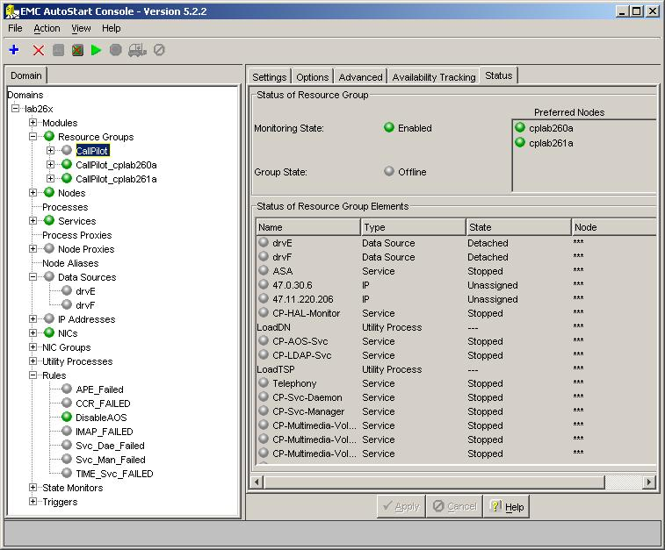

- Expand Resource Groups on the left panel of the AutoStart Console, and right click the resource group CallPilot and then click Delete Current Resource Group.

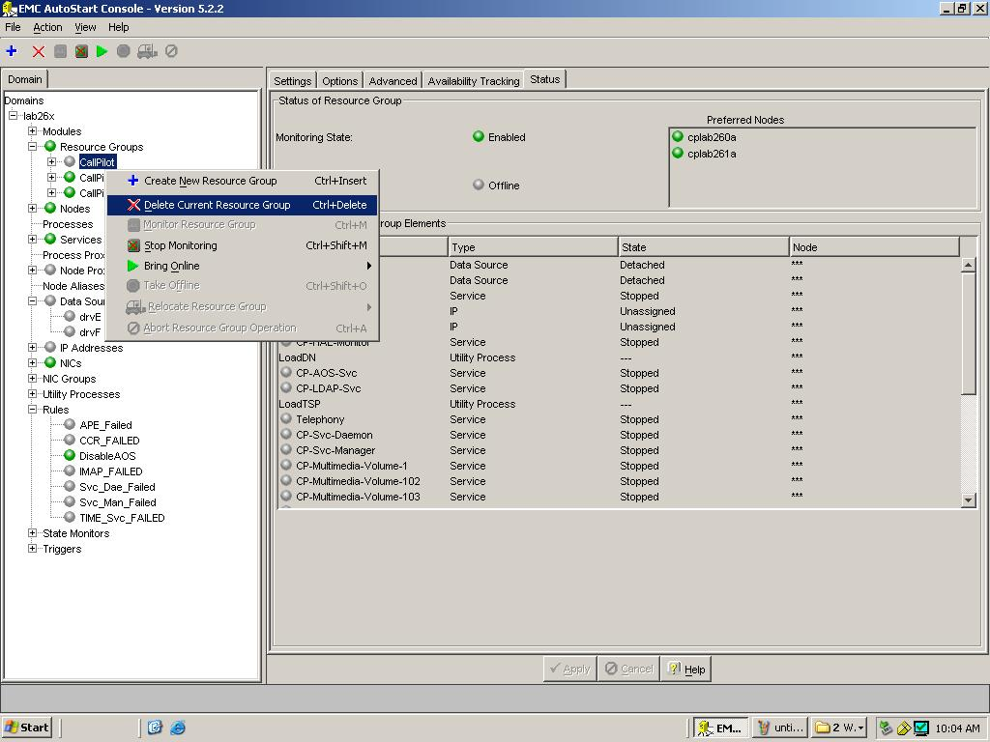

- Click the Yes button on the Confirm Delete of Resource Group window.

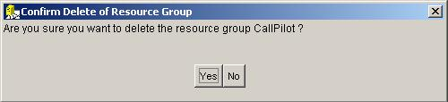

- Expand Data Sources on the left panel of the AutoStart Console, right click on drvE and then click Delete Current Data Source.

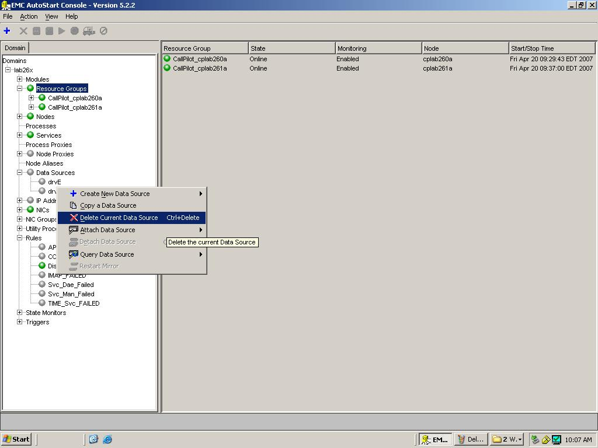

- Click the Yes button on the Confirm Delete of Datasource window.

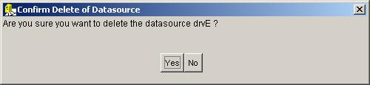

- Repeat the step 4 and 5 on the data source drvF to delete drvF as well.
- Expand Rules on the left panel of the AutoStart Console, right click DisableAOS and then click Disable Rule if the rule DisableAOS is enabled (in green).

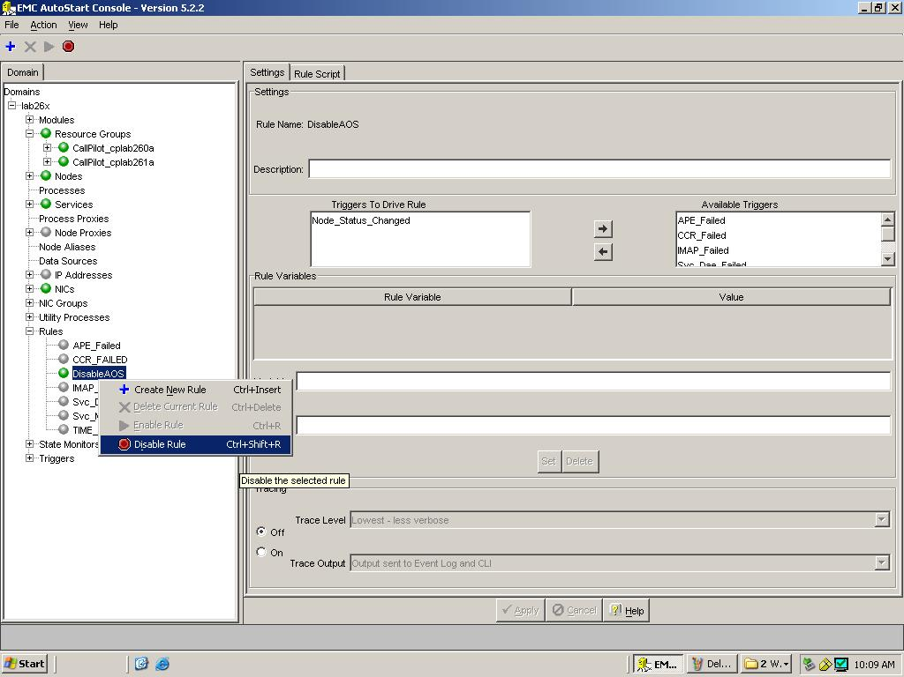

- Click the Yes button on the Confirm Disable of Rule window.

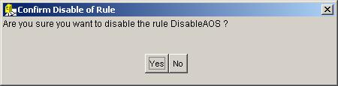

- Launch HighavailabilityConfigurationWizard.exe under D:\Nortel\HA.
- Click the Reset button on the GUI of the High Availability Configuration Wizard.
- Click the Step 1: Get Node Information button.
- Click the Step 2: Validate Node Information button. The Stage 1 Complete window will show up if there is no error.
- Click the Ok button on the Stage 1 Complete window.
- Click the Exit button on the GUI of the High Availability Configuration Wizard.
- Click the Yes button on the Confirm Exit Request window.
- Re-launch HighavailabilityConfigurationWizard.exe under D:\Nortel\HA.
- Click the Step 3: Generate Definition File button.
- Click the Ok button of the Phase 2 Complete window which will show you the definition file has been successfully generated.
- Click the Exit button, and then click Ok button on the Confirm Exit Request window to exit the High Availability Configuration Wizard.
- Open the AutoStart Console if it is open.
- Right click the AutoStart Domain name (For example, lab26x on the screenshot below) on the top of the left panel of the AutoStart Console, and then click Import Domain Information.

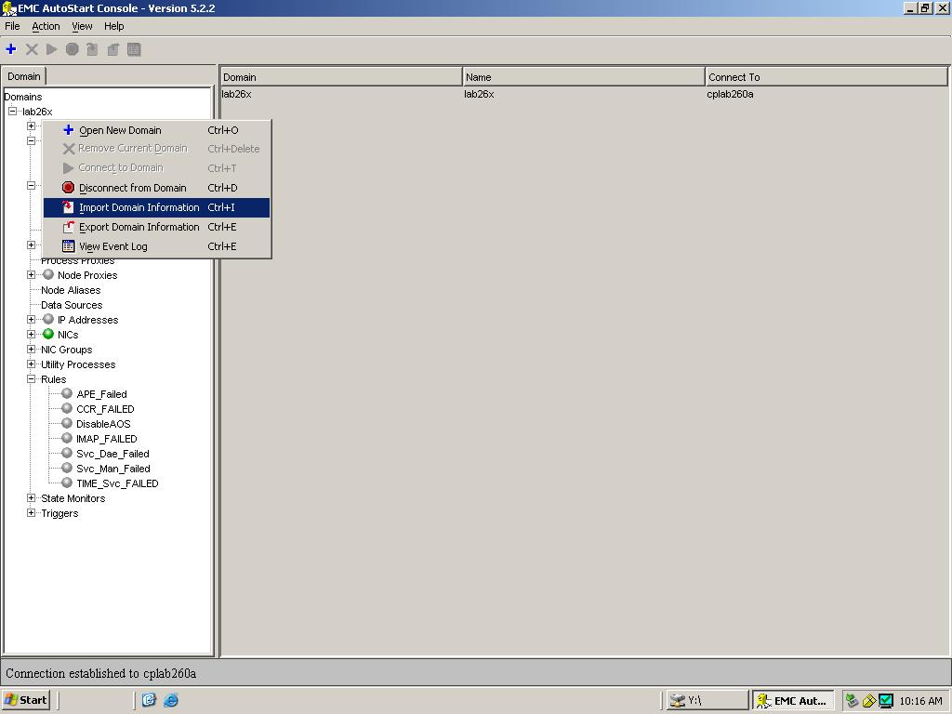
- Click the new definition file under D:\Nortel\HA\ToolkitInstaller2.0, and then click the Import button. In this example, CallPilot-Mirroring.def is the newly created definition file. The file can also be identified by the date Modified field having the most current date.

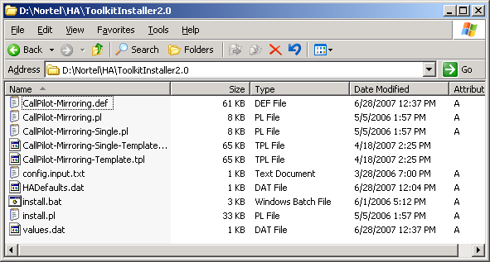

- After clicking the Import button and waiting for around one minute, the importing will have succeeded if the Data Sources drvE/ drvF and the resource group CallPilot are created, and there is no error or warning message on the information bar at the bottom of the AutoStart Console. Error messages you should check for that indicate that an error message has occurred are; Managed_ELAN_IP_Failure for the new trigger and Managed_ELAN_IP_Failure_Notif for the new rule.
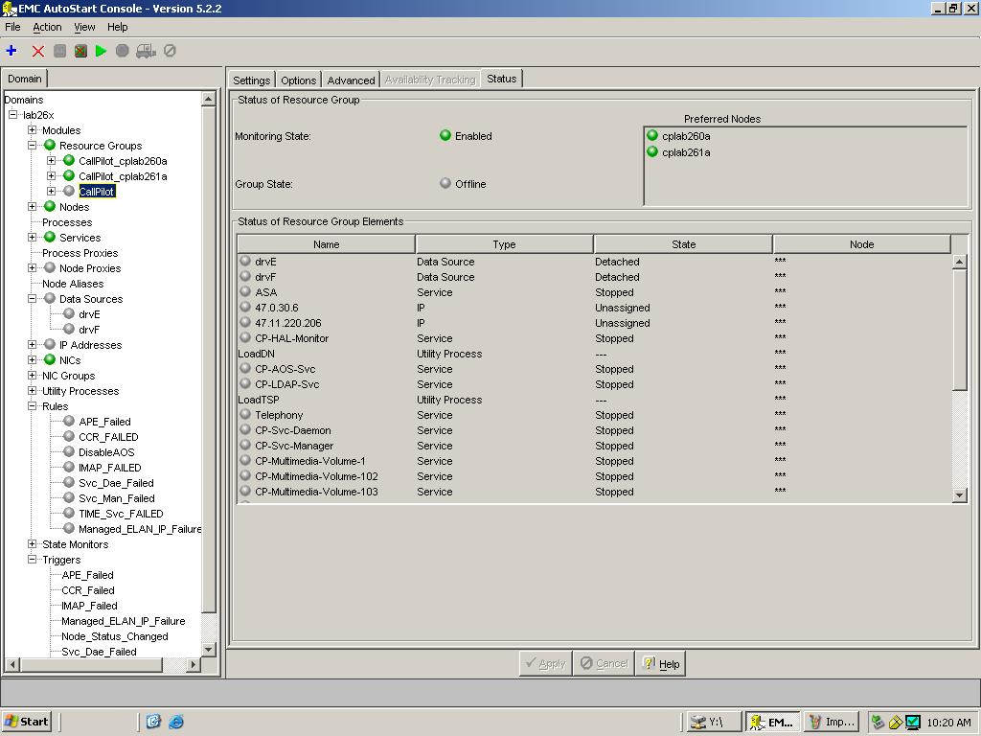

- Expand Utility Processes on the left panel of the AutoStart Console, and update the Login Info (Password, Domain name, and User name) on the Settings tab of each utility process under Utility Processes (DisableAOS, KillServices, LoadDN, LoadTSP, UnloadTSP, and UnloadTSPOnSandbyServer) by following the procedure Add the Windows administrator password for the AutoStart UtilityProcesses in Chapter 5 of CP5.0 HA NTP (NN44200-311).
- Bring the resource group CallPilot online by following the procedure Bring the Resource Groups online in Chapter 5 of CP5.0 HA NTP (NN44200-311).

CallPilot Switch Ping Email Address Configuration

This procedure describes the configuration of one of more email addresses to whom email messages will be sent when a ping test from CallPilot to the switch fails. If no email accounts are manually configured, the trigger will still fire but no messages sent.

The email addresses are added into a script for the rule Managed_ELAN_IP_Failure_Notif so that Autostart sends out email notification to administrator(s) when a path test failure occurs for the Managed ELAN IP.

Customers may make this configuration update right after the NTP NN44200-311 procedure ‘Add the Windows administrator password for the Autostart Utility Processes’ in the section ‘Configure the Autostart software’ on page 109. This procedure may be executed during a fresh installation after importing the definition file created by the HA wizard, or afterwards on a configured running system.

The email message that will be sent to the email address is; ‘Managed ELAN IP has failed a ping on the HA node CPServerX’ where CPServerX is the active server name of the high availability pair.

- Make sure that the PEP has been installed on your CallPilot server following the PEP installation procedure described in the CallPilot 5.0 High Availability NTP NN44200-311.
- Open AutoStart Console, and take the resource group CallPilot offline if it is currently online.

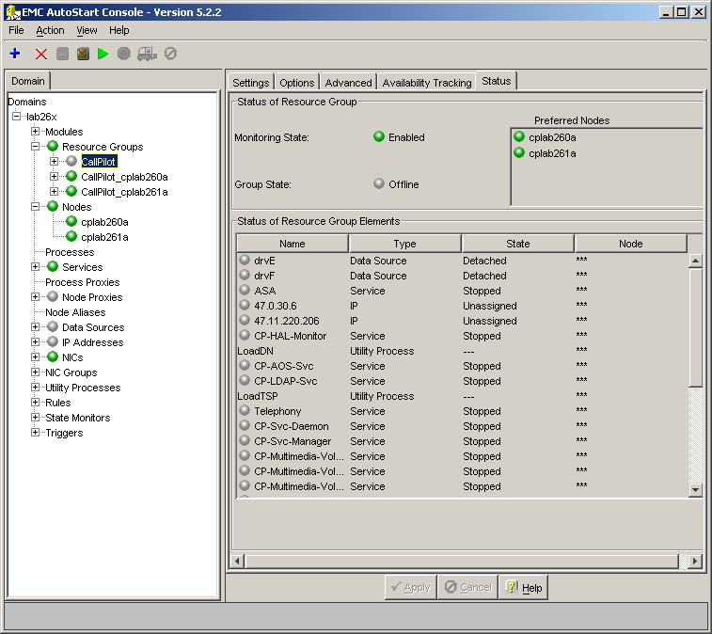
- Expand Rules on the Domain window (The left window of the AutoStart Console).

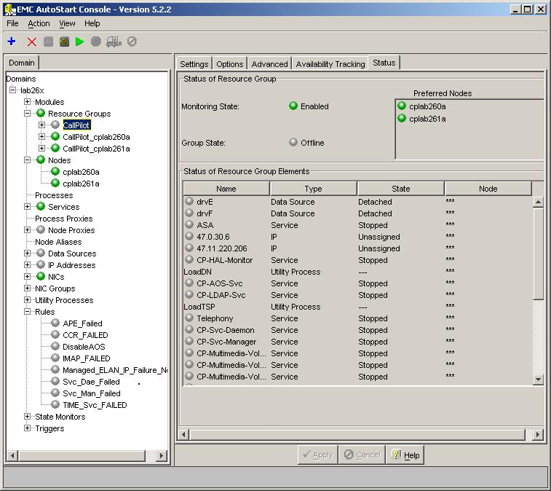

- Click the rule Managed_ELAN_IP_Failure_Notif and the window below will appear on the screen.

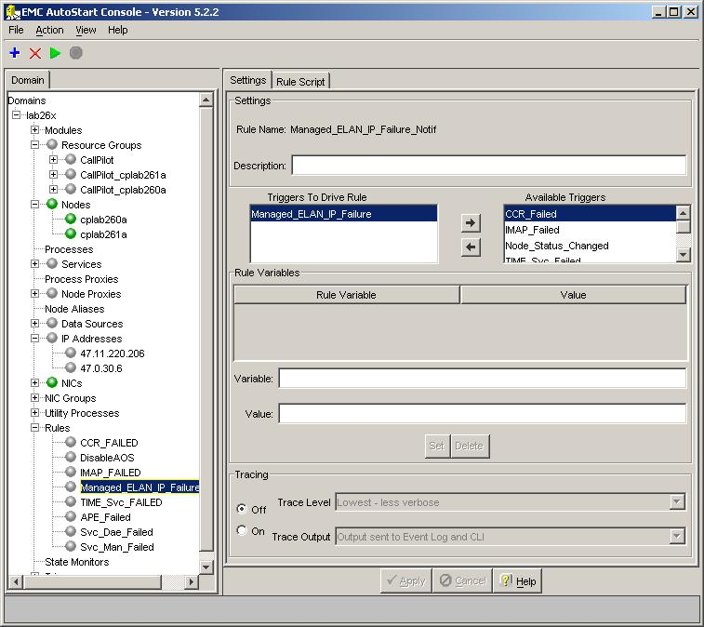
- Click the Rule Script tab, and the rule’s script will appear on the right window of the AutoStart Console.

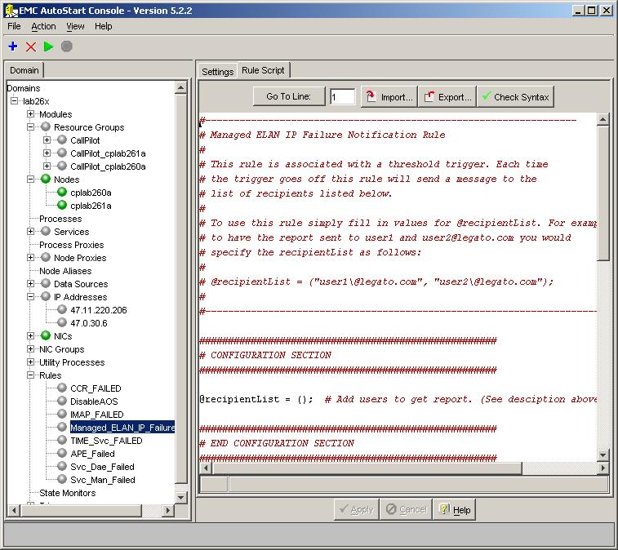
- Add the recipient’s email address into () of the recipientList in the script by following the required format of email address, and then click the Apply button. Note you have to add “\” before @ inside each email address. Multiple email addresses must be separated by commas.

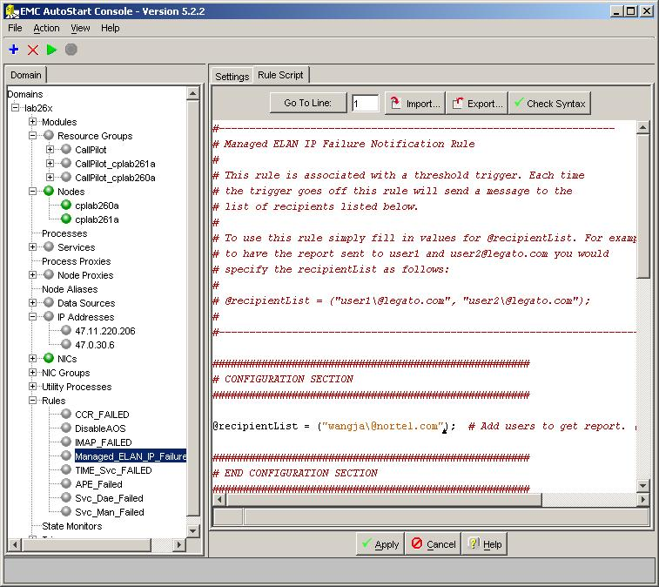
- Bring the resource group CallPilot online if you took it offline at the beginning of this procedure, or you can continue the installation and configuration procedure in the CP5.0 HA NTP if this is a fresh installation.
- You also have to configure the SMTP Server of Notification under the Settings tab of the AutoStart Domain on AutoStart Console, as shown in the following screenshot (Click your AutoStart Domain name on the left panel of the AutoStart Console, and then click the Settings tab on the right panel).

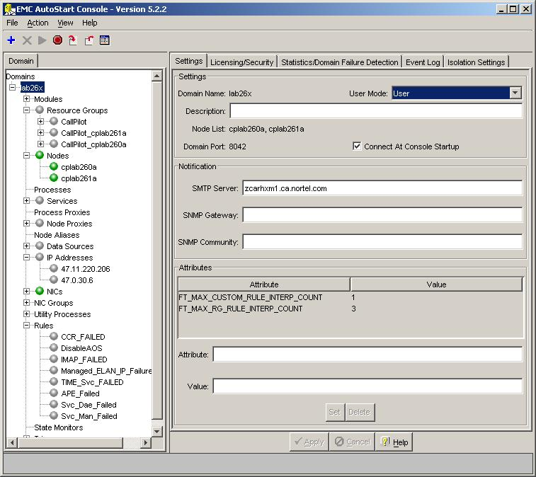

Enable HA Failover on Switch Ping Failure Procedure

By default the switch ping path test is disabled when the PEP is installed. This procedure describes the enabling of the rule. The process may also be used to disable the rule if enabled.

- Make sure that the PEP has been installed on your CallPilot server following the PEP installation procedure described in the CallPilot 5.0 High Availability NTP NN44200-311.
- Open AutoStart Console, expand Resource Groups and take the resource group CallPilot offline.

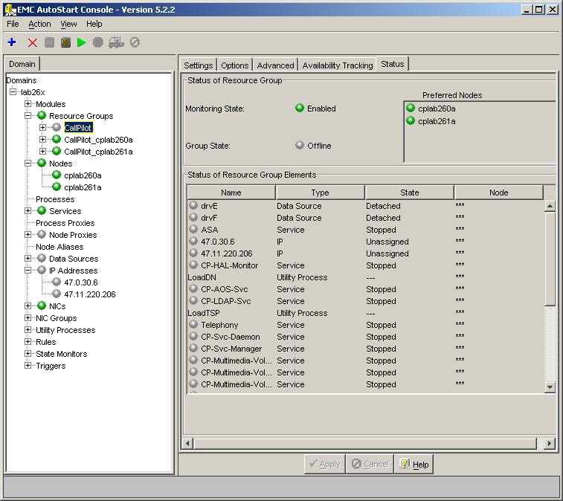

- Click the Settings tab of the resource group CallPilot on the right window of AutoStart Console.

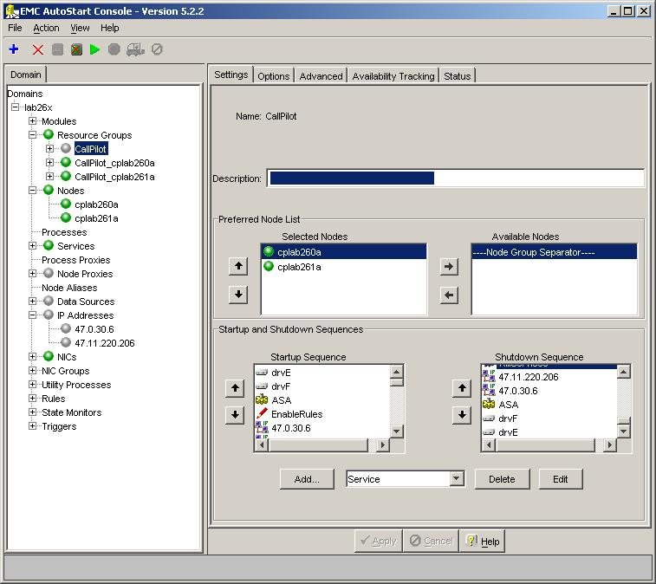

- Highlight the Managed ELAN IP (for example, 47.0.30.6), and click Edit.

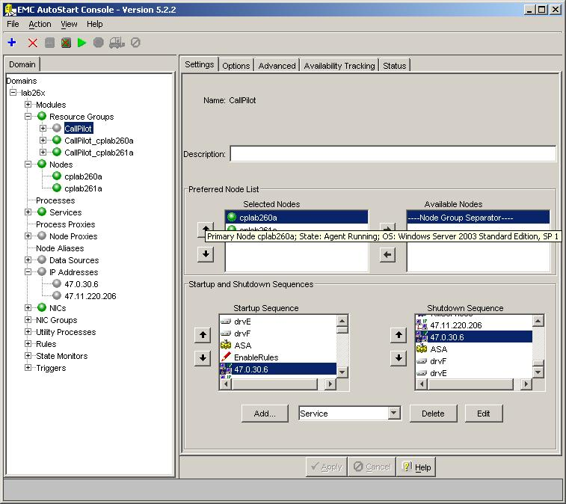

- The window below will show up on the screen.

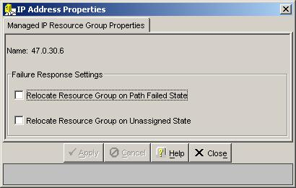

- Check both check boxes on the window and click Apply.

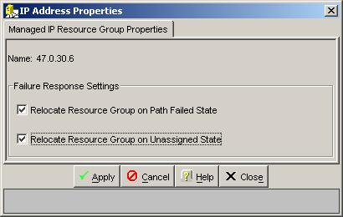

- Bring the resource group CallPilot online by following the procedure Bring the Resource Groups online in Chapter 5 of CP5.0 HA NTP (NN44200-311).

  - Changes in T1/SMDI and CallPilot Server Configuration
Interaction between a CallPilot Server and an SL100 switch can result in a “glare” condition. The “glare” condition appears when the SL100 places an incoming call to a T1 channel and the CallPilot places an outgoing call to the same T1 channel at the same time.
The switch and the CallPilot Server, independently of one another, select the idle channel to make a call. If the same channel is selected by both sides simultaneously, a glare condition takes place.
To minimize glare conditions, the following approach was implemented. All T1 channels will have to be divided onto groups to minimize using the same channels for incoming and outgoing calls. Using two different UCD groups on the SL100 switch for outgoing and incoming calls can eliminate the “glare” condition completely. One of two UCD groups should be used for incoming calls to CallPilot Server. The second UCD group can be safely used for outbound services.
To split the channels on the server side, one more parameter was added into the T1 channels configuration. That parameter defines the direction of calls that are allowable for the specified group. Channels can be used for incoming calls only, for outgoing calls only or for both types of calls (bidirectional channels).
Bidirectional channels are used only if there are no appropriate idle non-bidirectional channels. The glare condition is only possible if there are configured bidirectional channels. On one hand, using bidirectional channels increases the possibility of a glare condition, however, using only incoming and outgoing channels result in decreasing system capability, as the channels that are reserved for outbound services can not be used for incoming calls, and vice versa.
The way the channels are to be divided into the groups is defined individually depending on what kind of traffic is specific for the system. It’s necessary to minimize glare condition and provide enough channels for call processing. Traffic reports can be used to get statistical information related to number of incoming and outgoing calls. The maximum number of channels that are necessary for incoming and outgoing calls should be defined. If that sum is less than total number of channels in the system, then no bidirectional channel should be used. Otherwise, bidirectional channels should be used together with incoming and outgoing channels. The sum of incoming and bidirectional channels should comply with the maximum number of channels used at the same time for incoming calls. The same is concern outgoing channels.

SL100 Switch Configuration:
Each group of channels on the CallPilot Server has to be associated with a UCD group on the switch. So, the number of UCD groups has to be the same as the number of groups on CallPilot Server.

CallPilot Server configuration:
The ability to configure a “Direction” parameter for T1 channels was added into Configuration Wizard starting from CallPilot 5.0.
A drop-down list called “Direction” was added to the SDN Detail Information page in Configuration Wizard. It can have one of three values: “Incoming calls”, “Outgoing calls”, “Bidirectional”. T add a new group, it is necessary to define “Group DN”, “Application type” and “Direction” parameters.

  - PEPs

Important: Ensure that you download any PEPs for CallPilot 5.0 (release 05.00.41) and install them when prompted during the Setup Wizard.

Note: after installing 5.0 or booting up a new system for the first time, the Setup Wizard will walk you through setting up you CallPilot. It will prompt you when to install PEPs. At this point, the Windows 2003 network configuration has not been defined. If you plan on downloading PEPs from ESPL/MPL, you can either configure your network settings from the control panel -or- download the PEPs on another PC that has a network connection and burn them to a CD (recommended).

  - Reboot After Setup Wizard

When you have completed the Setup Wizard the system will automatically reboot the server before running the Config Wizard. Prior to the reboot, the following popup will appear. Click OK to reboot the server.

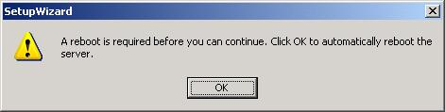

Important: If the server does not start shutting down after a few seconds – a manual reboot may be required.

  - Re-Installation of Software

At times you may be required to remove and install or re-install various CallPilot related components. The following is a list of these components. Uninstalling and installing the CallPilot server software is no longer supported, only a system re-image. Reinstall of the CallPilot software is still supported.

    - AppBuilder Install

The CallPilot Manager install / reinstall / upgrade executable (cpmgrsetup.exe) can be found in \CallPilotInstall

The Application Builder install / reinstall / upgrade executable (appbuilder.exe) can be found in the \CallPilotInstall folder on the root of the CallPilot Applications CD.

    - Directory Sync MMC Plugin

The Directory Sync MMC plug-in install executable (plug-in.exe) can be found in the \DirectorySync folder on the root of the CallPilot Applications CD.

    - pcAnywhere 11.0.1 uninstall / install / reinstall

Found in \PCAnywhere11. Need to install both the package 11.0 (CallPilot Support Host Only.exe) and the update 11.0.1 (pca1101.exe) in order for it to work correctly. Can run “change” from the control panel -> Add / Remove programs to repair an existing installation and run “remove” to uninstall. Run the executable CallPilot Support Host Only.exe, follow the on screen instruction, and then run pca1101.exe to reinstall. Default installation directory C:\Program Files\Symantec

    - CallPilot Server Reinstall

Re-installing CallPilot server via Application CD is supported. The CallPilot Server reinstall executable (setup.exe) can be found in \CallPilotInstall folder on the root of the CallPilot Application CD.

Note: While Reinstalling the CallPilot software, you may receive a Windows File Protection’ error. You should choose the option to continue using the questionable (from Windows point of view) file.

    - pcAnywhere uninstall
If pcAnywhere is uninstalled, it removes a DCOM registry value that is required for CallPilot Manager, My CallPilot, Application Builder, and Reporter to function correctly.
Workaround: Obtain the “EnableDCOM.reg” file from the ESPL PEP Library and apply to the CallPilot system. The affected applications will resume functioning normally.

    - Adobe Reader 7 uninstall / install / reinstall

Found in \AdobeReader7. Can run “change” from the control panel -> Add / Remove programs to repair an existing installation and run “remove” to uninstall. Run the executable AdbeRdr70_enu_full.exe, and follow the on screen instruction to reinstall. Default installation directory C:\Program Files\Adobe\Acrobat 7.0

    - LSI MegaRaid 1600/320-2 Power Console + (RAID admin software)

This software is only applicable to the 703t and 1002rp platforms.

Found in \RAID\MegaRaidPowerConsole. Can run “change” from the control panel -> Add / Remove programs to repair an existing installation and run “remove” to uninstall. Run the executable setup.exe, and follow the on screen instruction to reinstall. Default installation directory C:\Program Files\MegaRAID

    - Sun Java Run Time Environment

The Sun Java run time environment version 1.3.1_11 is included for customers that want to use Reporter and are using the Netscape browser, or Microsoft Internet Explorer without a built in Java virtual machine. Found in \Java2RunTimeEnv. Can run “change” from the Control panel -> Add / Remove programs to repair an existing installation and run “remove” to uninstall. Run the executable j2re-1_3_1_11-windows-i586.exe, and follow the on screen instruction to reinstall. Default installation directory C:\Program Files\JavaSoft\JRE\1.3.1_11

  - Change in location of various Windows OS-centric utilities

In Windows 2003, Microsoft has relocated many OS-centric utilities that may be used for installation, configuration, or maintenance of the CallPilot server. The following highlights those commonly used utilities and how to access then in Windows 2003

- Event Viewer: Start > Programs > Administrative Tools > Event Viewer
- Disk Management: Start > Programs > Administrative Tools > Computer Management
- Device Manager: Start > Programs > Administrative Tools > Computer Management
- Local Users and Groups: Start > Programs > Administrative Tools > Computer Management
- Services: Start > Programs > Administrative Tools > Services
- Computer Name: <Use Configuration Wizard>. Do not change the computer name via the Operating System otherwise database inconsistencies may result.

Known Problems / Issues

  - Server

    - Server OS Activation
If the server does not have the correct release of the BIOS / firmware, the O/S requires activation after the image is installed. If the system is not activated within 30 days it will be blocked from logging into the Windows 2003 system if logged out. Options at that point are (1) activate your system using the COA via the internet or phone, or (2) re-image your system for another 30 day trial period. If after installing an image you adjust the date past the 30 day activation period the system will lock and you will have to activate it or install it from an image again. Upgraded 703t Tower systems require product activation as part of the upgrade process.

Workaround: Ensure the system has the appropriate BIOS/Firmware versions

    - Incorrect Settings in ELAN DNS and WNS
The image for the 1002rp has incorrect ELAN configuration. The ELAN has IP address settings for the DNS and WNS. This may generate unnecessary traffic on the customer's network.

Workaround: Remove the unwanted values from the ELAN DNS and WINS. From the Control Panel, select Network Settings. Right click on the ELAN connection, and select ‘properties’. Select ‘TCP/IP’ and click on ‘properties’. Go to ‘Advanced’ and select the DNS tab. Remove the values for ‘DNS server addresses’. Remove the values for ‘DNS suffixes’. Select the ‘WINS’ tab. Remove the values for ‘WINS addresses’

    - Using Wrong Image CD
Using the wrong image CD on a server (i.e. 201i on a 1002rp) will cause unpredictable results i.e. the image will install but the system may not work correctly.

Workaround: Only use CallPilot Image CDs that correspond to the matching platform type. Running the Upgrade Wizard will prevent this problem since it will check that you have the correct CD.

    - Drive Letters are Incorrect
In rare occasions on the 1002rp and 703t, after installing the CallPilot software from the image CD, the drive letters are incorrect. The drive letters should be C, D, E & F. However, they may be C, D, E & G. If this is the case, some CallPilot applications may not run correctly, including restoring data during an upgrade. Refer to CR # Q01184243.

Workaround: You can manually adjust the drive letters using the following procedure (during upgrades this should be done prior to running the Setup Wizard):
- Launch the Computer Management applet (Start -> Programs -> Administrative Tools -> Computer Management).
- In the left hand pane select Computer Management (Local) -> Storage -> Disk Management.
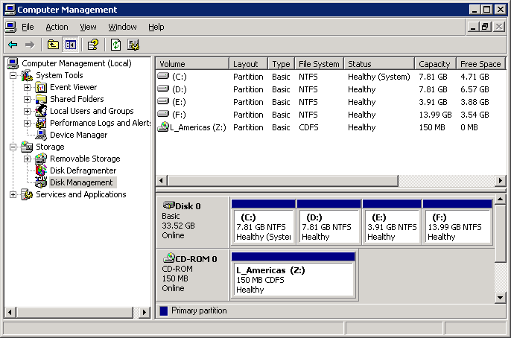

- In the right hand pane, right click on the drive that you want to change the drive letter of and select "Change Drive Letter and Paths…".
- In the "Change Drive Letter and Paths for ..." window click on the Change button.
- In the "Change Drive Letter or Path" window select the "Assign the following drive letter" option, assign the desired drive letter from the drop down menu, and click OK.
- In the "Confirm" window, click Yes to acknowledge that that changing the drive letter could cause programs to no longer run.
- Repeat the above steps for any further drives that need to have the drive letter changed.
- Exit from the Computer management window.

Note: If you need to change the drive letters for C: and D: you may need to reboot the system for the changes to take effect.

    - Unable to change password via Configuration Wizard
When the "Finish" button is clicked, at the last page in Configuration Wizard dialog, the server is updated with all new information provided by user. During this phase, the Configuration Wizard will try to update the password, but could fail, due to the Windows 2003 security policy ("Minimum Password Age") if the policy value is set to a value greater than zero (0).

Workaround: Adjust the Windows 2003 security policy for Minimum Password Age to zero (0). This will alter the security policy for this server, so recommend coordinating with the system administrator first.

    - “No Dongle Found” error after installation
Very intermittently, you may receive a “No Dongle Found” error after installing a 201i server.

Workaround: Reboot the server.

    - “RDP Protocol Component – Data Encryption” error
When trying to connect to a 201i from a desktop using Microsoft Remote Desktop, the following error “The RDP Protocol component “DATA ENCRYPTION” detected an error in the protocol stream and has disconnected the client.” may occur which may block connecting to the server.
Workaround: Refer to Microsoft Knowledge Base article KB323497 at the following URL
http://www.support.microsoft.com/?kbid=323497

    - Taskbar Menu pops up or MAS window appears in center of screen –PCAnywhere issue
Whenever the MAS window is minimized, the Taskbar Menu pops up as indicated (see below). Additionally, sometimes closing the Taskbar Menu results in the MAS window appearing in the center of the screen again. This behavior is primarily observed when using pcAnywhere. Refer to CR # Q00947757.

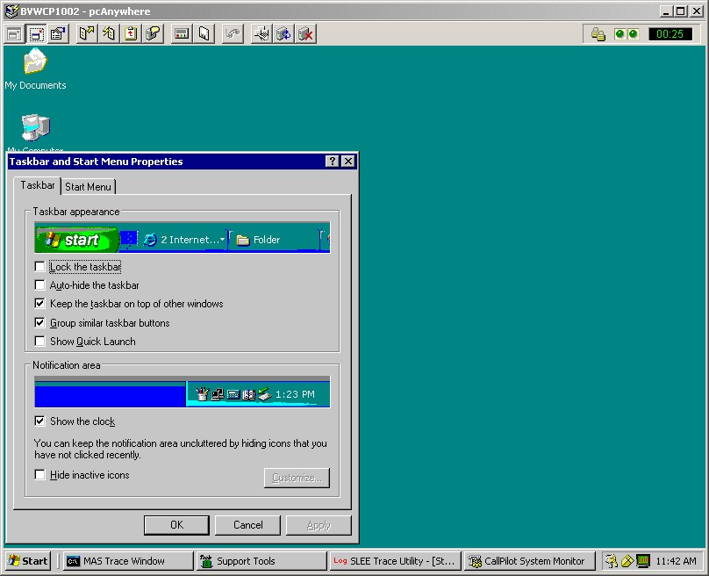

    - Windows Task Bar appears to be missing
When the system is first powered up following a new install, the mini-setup will run for a period of time and then reboot. Once the system reboot has completed, you will be able to log into the system using one of the CallPilot Windows usernames. Once logged in, the Windows taskbar may appear to be missing but is only hidden at the bottom of the console window. Refer to CR # Q01008560.

Workaround: To make the taskbar visible, use your mouse pointer and left mouse button to grab the task bar and pull it up to the desired height.

    - Remote Disk backup to network share takes excessively long time
When performing remote disk backups to a network share, if the LAN configuration is invalid, the backup may still complete successfully, but may take a longer period of time.

Workaround: To ensure the NIC is configured appropriately, use the following steps:
- Click Start > Settings > Network Connections
- Right-click on the NIC Card and click on Properties. The CLAN (or ELAN) Properties screen will appear.
- Click on the Configure... Button. The Network Connection screen will appear.
- Select the Advance Tab
- For 703t and 1002rp:
  - Highlight Link Speed and Duplex then select the required setting from the Value Drop-down Box on the right. Default value is Auto-Detect.
- For 201i:
  - Highlight Duplex then select the required setting from the Value Drop-down Box on the right. Default value is Auto-Detect.
  - Highlight Speed then select the required setting from the Value Drop-down Box on the right. Default value is Auto-Detect.

    - RAS connection to server unstable and drops
When the client makes a connection to a CallPilot server through a modem and RRAS, the connection appears unstable and finally drops. The connection is negotiated, modem to modem, then RRAS on the server side assigns temporary IP addresses to both the client and the server. From the client, when the server is ping’d using the assigned IP address (typically 192.168.0.1), mostly timeouts occur but some packets are successful. After a short period of time, the connection may drop. Impacted are any remote applications including Microsoft RDC, pcAnywhere, CallPilot Manager, Application Builder, etc. Refer to CR # Q01070343 – Documentation CR.

Workaround: The problem described above may occur if two (2) modem devices are configured for COM1, the one that was actually connected (US Robotics 33.6 FAX Ext. PnP) and one not connected to the system, in CallPilot’s case the Standard 33600 Modem. Because of this, it instability is caused by the incorrect driver being used for the US Robotics modem.

To verify if two devices are connected to COM1, look into the Routing and Remote Access application (Start > Programs > Administrative Tools > Routing and Remote Access). Under Server Status there should only be one (1) total port. In the case of this failure, there may be two (2) or more.

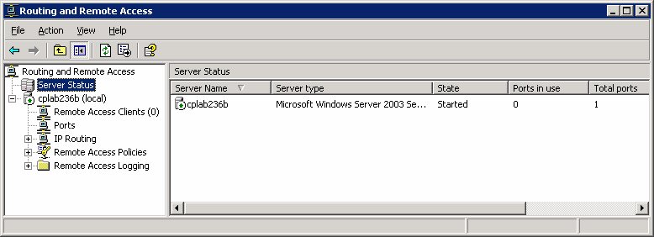

Under Ports, select the modem and then Status. There should be only one device listed in the drop down list box (U.S. Robotics 56K FAX EXT (COM1), but in this case there was also the Standard 33600 modem.

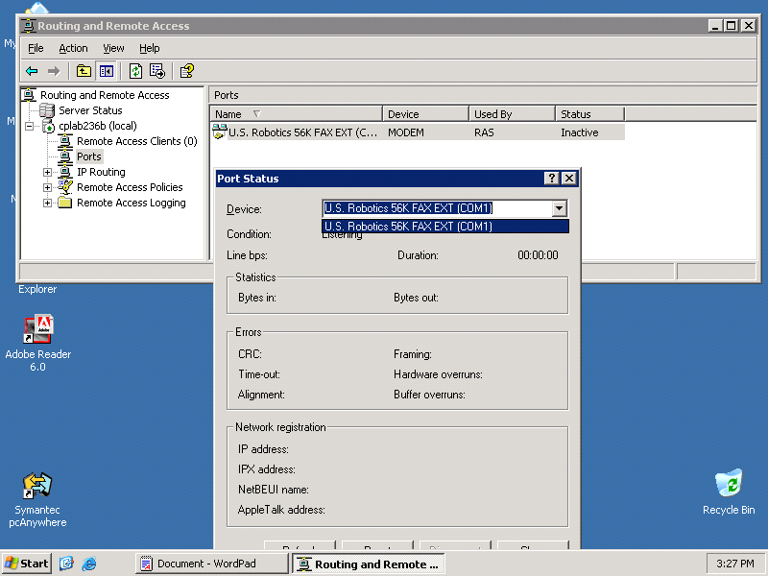

The only method of removing the incorrect modem (e.g. Standard 33600 modem) from RRAS is to remove it from the system.

The method used is to remove all modems from the system under Windows Device Manager, and then scan for new devices with only the correct modem connected to COM1. The Standard 33600 modem was now removed from the system, RRAS only contained the U.S. Robotics 56K FAX modem and automatically finds the correct driver.

    - ELAN Disables After RDC /console Connection Over RRAS IP Address

When connected to CallPilot system using RDC over a RAS connection, the AML may occasionally restart with the following events appearing in the system log:

6/7/2005 2:31:35 PM AML_TSP Information Information 42802 N/A CALLPILOT The AML Link is up
6/7/2005 2:31:34 PM AML_TSP Information Startup 42804 N/A CALLPILOT TSP has started, CDN call model is in effect
6/7/2005 2:31:02 PM AML_TSP Warning Warning 42800 N/A CALLPILOT The AML Link is down. CInit::DoStartStepSocket - Socket re-started to Host address 137.135.128.253
6/7/2005 2:30:56 PM AML_TSP Error Information 42800 N/A CALLPILOT The AML Link is down. %1

Additional symptoms may include:

- Callpilot manager slow to respond
- Ring - No - Answer
- Elan bounce
- System locks up due to High CPU

Note: It has been observed that once the RDC session is terminated the system recovers on its own. This issue is currently being investigated through CR# (Q01154914)

Workaround: The issue has been identified as a Microsoft Windows 2003 RDC issue. Microsoft is not planning to address the problem. Until further notice: only pcAnywhere should be used when remotely connecting to a CallPilot 703t or 1002rp Server.

Because the 201i relies on RDC for remote connectivity, the following recommendations apply:

Note: These recommendations decrease (but not eliminate) the likelihood of a service interruption with RDC.

- Local resources - The local resources tab controls if your disks and printers are available once you connect. In order to copy files you must have disk drives checked. You should NOT have printers checked. With printers checked - any printer installed on your machine, even network printers will be installed on the CallPilot Server. There is no benefit to having your printers available and the extra bandwidth/processing power consumed should be avoided. Please review your RDC connections and make sure printers are unchecked.

- The recommended way to connect - In the majority of cases you will want to connect by specifying the computer name or ip address and /console - e.g. 192.168.0.1 /console - Using /console gives you full control of the server and logs off the user at the console. If you do not specify /console - you are in a virtual session and do not have full control of the machine. In a virtual session there are numerous tools/programs that will not function properly.

- An alternate way is the use of WebEx.

    - List Tape Procedure with SLR32 and SLR50 Tape Drives

When performing a backup and restore in the same session (i.e. a system upgrade) on either an SLR32 or SLR50, a list tape performed before the restore will take an additional hour if the following two steps are not executed. This problem is due to an incompatibility with the Windows 2003 operating system and the use of aging tape drivers.

Workaround: Once the backup has been complete remove the tape cartridge. Do not reinsert the tape cartridge until the CallPilot server has been rebooted. If the tape is inserted before the reboot takes place, the problem will still occur.

    - Power Console 5.0 shows up only when logged in with installed username

When upgrading the RAID subsystem on a 2.02 system, upgrading of the Power Console from version 4 to version 5 is required. Once upgraded, Power Console is only accessible using the same account that the software was installed (i.e. Administrator). When the system is logged into using one of the other accounts (i.e. NGenSys), the Power Console software is not visible under Start/Programs. Refer to CR# Q01167671.

Workaround: There are two workarounds:
- To log into the system using the account that the Power Console software was installed under.
- To make Power Console utility available for a specific user profile(WinNT4- CallPilot2.x)
- Press Start Button, slecet Settings/TaskBar
- Select Start Menu Program from the top
- Select Add, then Browse
- Enter the following path: C:\Program Files\MegaRAID\Client\meganet.exe
- Press Open
- Press Next twice
- Type for the shortcut name : MegaRAID PowerConsole 5.00i
- Press Finish.

This will add a shortcut to the Program files to the MegaRAID power Console Utility.
To launch the Power Console press the Start Button/Programs/MegaRAID PowerConsole 5.00i

    - Program is not responding

Q01150368: While the Upgrade Wizard is performing the data validation, if you move the window by dragging with the mouse, a “program is not responding” message may appear in the title bar.

Workaround: Ignore this message. Once the data validation is complete, the message will go away.

    - Auto Delete feature only requires the Mailbox Number field in the input file

Q01163935: The Auto Delete feature only requires the Mailbox Number field in the input file. If you also use the MWI DN field, the Auto Delete feature will fail to delete any users.

Workaround: If your input file contains the MWI DN field, do not map this field. Best practice is to only map the Mailbox Number field.

    - Glare Condition with CallPilot T1 (SMDI) Connection causes RNA

Q01340574: Occasionally CallPilot servers with T1 connectivity can experience glare issue. Glare is caused by conflict on a T1 line when telephone switch places incoming call to a T1 channel and CallPilot server places outgoing call to the same T1 channel at the same time. Both SL100 switch and CallPilot use idle channel queue to select idle channel for a new call. Recently used channel goes to the tail of the queue. If both SL100 and CallPilot make new call at the same time, they both take the same channel from the head of the queue and causing glare condition.

Impact:
If glare appeared on a T1 channel, both incoming and outgoing calls fail. Glare does not affect channel’s serviceability. The channel gets back to service almost immediately. The condition only affects the present call and it happens randomly.

    - Power Console 5.0 shows up only when logged in with same username used to install the software

Q01167671: The user may not realize that need to re-login with a different account name.
After the RAID Subsystem Update on a CP 2.02 System, the Power Console 5.0 shows up only when logged in with the same username that was used when installing the software. LSI Logic states that this is how it supposed to work, for security reasons.

Workaround:
Below is another work around that does not require logging off and logging on as a different user thus it does not require stopping CallPilot:

If logged in as a different user than the Administrator(which is the default user the software would install on) proceed thru the following steps to make available Power Console utility for a specific user profile(WinNT4- CallPilot2.x):

1. Press Start Button, slecet Settings/TaskBar
2. Select Start Menu Program from the top
3. Select Add, then Browse
4. Enter the following path: C:\Program Files\MegaRAID\Client\meganet.exe
5. Press Open
6. Press Next twice
7. Type for the shortcut name : MegaRAID PowerConsole 5.00i
8. Press Finish.

This will add a shortcut to the Program files to the MegaRAID power Console Utility. To launch the Power Console press the Start Button/Programs/MegaRAID PowerConsole 5.00i.

    - Fax Driver Fails with Error Code 126 in Install log

Q01074279: Unable to install the fax driver. install.log file (created by the ImageMaker installer) contains the following error:

01/21 14:59:26 Printer installer WARNING (AddPrintDriver): error #126 for value 'ImageMaker Fax Print Driver'.
01/21 14:59:26 The specified module could not be found.”

The root cause of the problem is incorrect “PATH” environment variable.

Workaround:
Instructions to address the problem:
1) Run RegEdit
2) Open the key [HKEY_LOCAL_MACHINE\SYSTEM\CurrentControlSet\Control\Session Manager\Environment]
3) In the left pane of RegEdit, right-click on “Environment” and choose “Export”
4) Enter the file name path.reg and save to the desktop. THIS SAVES A COPY OF THE ORIGINAL PATH VALUE!
5) In the right pane of RegEdit, double-click on “Path”
6) Find and replace C:\Windows\System32 with %SystemRoot%\system32;%SystemRoot%;%SystemRoot%\System32\Wbem
7) If you cannot find C:\Windows\System32, then find and replace %SystemRoot%\system32 with %SystemRoot%\system32;%SystemRoot%;%SystemRoot%\System32\Wbem
8) Close RegEdit
9) Reboot the computer

    - Slee, Unified Trace Outstanding CR’s
The following problems have been identified, and work is in progress to provide fixes.

Q01568697 Unified Tracing - Freeze trigger doesn't work
Q01568882 User can not use the SLEE trace tool as desktop application
Q01569673 Save All" function in SLEE trace doesn't work
Q01569675 incorrect tracing if changing Circular buffer size
Q01572393 Incorrect row in "Row x: Brackets mismatch" error message
Q01583590 SLEE Trace - Save trigger does not work on network drive
Q01583865 SLEE Trace - Operator EQUAL is not completely correct
Q01584219 SLEE Trace - 'New' function does not work properly
Q01584231 SLEE Trace - Information in Trace level is truncated
Q01569675 - Incorrect tracing if changing Circular buffer size
Q01577748 - SLEE trace - New buffer size can not be set to all lines
Q01577868 - SLEE trace - Unable to set buffer size to 2000

  - CallPilot Manager

    - Upgrade with One-Number Voice/Fax Call Answering
Q01653667 Users upgrading from 4.0 to 5.0 with one number fax have two instances of one-number fax to select from in SDN creation page.
Within SDN creation page, drop down list shows:
- One-Number Voice Fax Call Answering (this is from 5.0)
- One-Number Voice/Fax Call Answering (this is from 4.0)
The second option is not deleted during upgrade process. Also, when the second one-number option is selected, the 'ring-back type' field is greyed out, as this was not a feature on 4.0, but is a feature on 5.0.

Workaround: Choose the first instance of one-number fax, ignore the leftover feature from 4.0.

    - Config Wizard stalls at about 45% complete
Q01577022 /Q01583362 The config wizard freezes for approximately 10 minutes at 45%. This issue is across all platforms and releases of CallPilot.

    - Unable to log into CallPilot Manager due to unknown password
Access to CallPilot Manager requires the user to have an Administration account/password.
If the default Administration Password (mailbox “000000”, password “124578”) has been changed and forgotten or misplaced, a utility exists with CallPilot 4.0 “Support Tools” for resetting it to the default.

Note: This utility requires access to CallPilot “Support Tools”. If you do not have the password, you’ll need to engage your next level of support to obtain it or for them to assist with the reset procedure outlined below.

Workaround: Use the following procedure to reset the default administrator password.
  - Log in to "Distributor" Support Tools on the CallPilot Server
Start → Programs → CallPilot → System Utilities → Support Tools
  - From the main menu, select (9) Database Utilities
  - From the Database Utilities menu, select (3) Database API Utility
  - At the CI> prompt, type “resetadminpwd” and press <Enter>
  - At the CI> prompt, type “quit”. This will close the API Utility
  - In the main menu, press <Enter>, then select (1) to exit.

The default Administration mailbox “000000” password will be reset to “124578”

    - Remote Disk backup fails if share name contains sub-folders
Remote Disk backup may fail if the network share name uses sub-folders. This is a known issue within 04.04.04.00 and will be addressed in a future SU, PEP, or release.
Workaround: Configure backup device using Universal Naming Convention (UNC) and with root-level access. Examples:
Good device: \\servername\sharename
Bad device: \\servername\sharename\backupfolder\

    - Q01421658: On the 1002rp T1 System
Was able to bring up system into full service. However the system ready indicator indefinitely displays the following message." Call Pilot is running and is able to accept calls, however Call Pilot has not received the 'acquired access voice ports' command from SCCS or Call Pilot is still in the process of initializing the 'access' voice ports. Please wait, as this could take some time"
Workaround; ignore messag

    - Messages forwarded to a third-party server
Messages forwarded to a third-party email server that are converted to WAV will be converted as WAV-PCM, not WAV-GSM 6.10. WAV-GSM 6.10 conversion will be added to the server in a later release.

    - Auto Delete Option
Known issues – This page does not get loaded, gives an error.
Work around – Delete users one by one

    - Auto Add Option
Known issue – If CP Server has more that 200 NMS locations configured, at end of add operation, the message “LDAP SIZE LIMIT EXCEEDED” will be displayed in a new window. (Sometimes along with details of failed add entries). This is because the LDAP looping of more than 200 locations were not handled correctly)
Workaround – ignore the message.

    - Change passwords via ConfigWiz when original password in unknown
Q01295997 OS account passwords unknown/lost and now unable to change via Configuration Wizard.

Workaround:

- Login to CallPilot server as Administrator (or under any account with admin rights).
- Go to Start->Settings->Control Panel-> Administrative Tools->Computer Management->Local Users and Groups -> Users.
- Click the NGenSys account and select SetPassword.
- Set any suitable password. (We could set here any passwords for any accounts).

    - Voice Form Archive Modify Error Message
When attempting to re-open a Voice form archive backup schedule, an error message is displayed when the next button is pressed. The error message displayed is ‘Éxpected;’. This message can be bypassed and ignored by pressing the OK button a couple of times.
Workaround – Pressing the OK button a couple of times and then continuing with the display or modification.

    - A Pop-up Message Occurs While Installing CPMgr on IE7 Standalone Server
While installing CallPilot Manager onto a standalone web server containing Internet Explorer 7, the following error message may pop up;

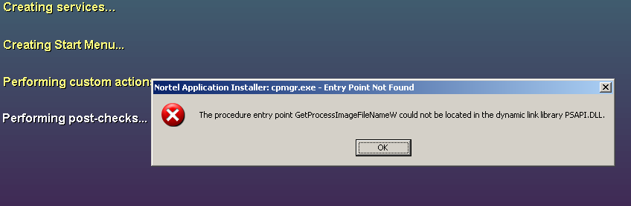
Workaround – Pressing the OK button and continue with the installation. The installation will complete successfully without ill effects. Q01487471-01 is associated with this issue.

  - Event Monitor/Viewer

    - Events 2, 3, 4, 8, and 9 appear in System Event logs
When accessing the CallPilot server via a Remote Desktop, Events 2, 3, 4, 8, and 9 may appear in the System Event log. These events reference LAN printers even though no print action was performed by the user. Refer to CR # Q00943668.

Workaround: Discontinue using Remote Desktop or simply disregard the events. They have no known impact to CallPilot.

  - My CallPilot

    - A no-extension file cannot be attached to a message
Q01670017: In My CallPilot after composing a message, some files having extension (*.doc, *.pdf.)..were attached to the message. Attached one more file having no extension.. The file having no extension could not be attached.

  - Desktop Messaging

    - CallPilot desktop upgrade to 5.0 may fail from CD-R
Q01637360 When upgradingfrom 4.04.04.12 to the latest desktop using a cd-r you may get an error window asking to insert disk 1

Workaround: copy the software to the hard drive under D:\temp and install from there

    - Address Book download and Fax DTT/DTF fails
Several functions that use TCP/IP within CallPilot require DNS to be properly configured to function. For example, from the Desktop client, download of the address book and/or delivery of fax may fail if the primary DNS suffix is incorrect. Refer to CR # Q00943541

Workaround: Adjust the CallPilot server DNS configuration using the steps below to correct this condition.

- Right Click on My Computer and click on properties. The System Properties screen will appear
- Select the "Computer Name" Tab
- Click on the "Change" Button
ATTENTION: Do not change the computer name through this window. Only change the computer name through CallPilot Config Wizard.
- Click on the "More" Button
- Enter the Primary DNS Suffix for the CallPilot server. Example: “ca.nortel.com”
- Reboot the server

    - Users unable to import wav files as greetings via MyCallPilot (version 4.04.04.02) if MyCallPilot installed on CallPilot Server

Q01287553: This appears to be some unexplainable DCOM/RPC problem that causes the AOS component to fail to connect because of a DCOM permissions restriction on Win2003. This is an issue when My CP is installed on a CP server. If My CP is installed on a fresh Win2003 server it does not occur.

Workaround:
The workaround is to record the mailbox greeting using the telset or to use an external web server rather than the CallPilot server itself.

Another workaround is to adjust the DCOM permissions during install process. This requires contacting your first support level.

  - Reporter

    - Uninstalling CallPilot Reporter causes TM application failed
Q01411001 When CallPilot reporter and TM 3.00.888 are installed on the same server, and then CallPilot Reporter is uninstalled and the system restarted, users cannot use the TM application (win and web).

    - List tape operation is too slow: If a system backup is completed and the tape is left in the tape drive, then the List Tape operation (from CallPilot Manager or the CallPilot Backup and Restore tool) may take a long time to respond.
The work-around is to eject the tape from the tape drive after the system backup is completed and then re-insert the tape back
.
Notice when run some reports or alerts, there will be an error message “Bad Date Format String” occurred. No work around yet.

    - When logged in through remote desktop you must be connected to the root console to use any CallPilot tools. This requires running the ‘shadow 0’ command when connecting when you connect using "Method-1/Private" or "Method-2/Shared’

    - Unable to view reports
Reports show up blank/grey within the CallPilot manager/ Reporter viewer
Workaround: Install comparable version of Java, J2SE version 1.3.1. J2SE versions can be downloaded from http://www.nortel.com, http://www.java.sun.com or the CallPilot 4.0 Applications CD.

  - Networking

    - VPIM Networking fails to deliver message
VPIM Networking requires all TCP/IP settings be configured correctly. It may fail to deliver messages successfully if the primary DNS suffix configuration is missing or invalid. Refer to CR # Q00943541

Workaround: Adjust the CallPilot server DNS configuration using the steps below to correct this condition.
- Right Click on My Computer and click on properties. The System Properties screen will appear
- Select the "Computer Name" Tab
- Click on the "Change" Button
ATTENTION: Do not change the computer name through this window. Only change the computer name through CallPilot Config Wizard.
- Click on the "More" Button
- Enter the Primary DNS Suffix for the CallPilot server. Example: “ca.nortel.com”
- Reboot the server

  - Shared Telephone/Dorm Room
Q01384064 – There is no a message to the Windows Events Log when a mbx has been initialized.

Q01364428 – Cannot login to a mailbox that requires the password to be changed when system dongle missing
Note: This is more prevalent during a failover on an HA system.
Work around: Insert a dongle to the CallPilot

  - High Availability
Q01360366 Isolation recovery failed on the HA systems
Description: Our HA prototype failed to come back to the normal state after all Ethernet links resumed during the isolation test, unless the AutoStart Backbone and Agent were restarted manually. We need to know how to automatically start the AutoStart Agent on the previously isolated server after all Ethernet links are recovered. EMC team is looking into the issue and will provide the solution.
Work around: Manually restart the AutoStart Backbone and Agent on the previously isolated server.

Q01360389 Both Heartbeat Down Issue
Description: The Standby server failed to come back to the normal state after both Heartbeat links were down for a short period of time.
Work around: Manually restart AutoStart Backbone service.

Q01360425 Failed to start AutoStart Agent
Description: Once Alan from EMC and I had to reboot the server three times to be able to start AutoStart Agent after an isolation test.
Work around: No

Q01597122 <<Runtime Error! Program: D:\Nortel\bin\nbccr.exe
This application has requested the Runtime to terminate it in an unusual way. Please contact the application’s support team for more information.>>

The problem is when the installation of a PEP causes another PEP to be uninstalled automatically, the PEP framework sets all of the services to disabled so that if the system reboots they will not restart. At the end of installing all of the PEPs they are reset back to the "correct" state. If the system is configured they are set to automatic start, if it is unconfigured they are set to a mixture of automatic and Manual start (based on an array in the code). This logic was not HA aware so it did not know that on a configured HA system the services should be manual, not automatic (since Autostart manages the software).

Workaround: If this issue occurs, run the Configuration Wizard again after installing the final PEP. This will set the status of the services to the correct state, and then reboot the system.

  - T1 Systems

Q01422796 T1: CallPilot HAL Monitor service will not start, intermittently, after system reboot, because T1 dialogic boards not starting
Workaround: Disconnect the T1 links during initial boot up, configure the CallPilot software, reconnect the T1 links , reboot the system. The LED should turn into green when the T1 links are connected again

Q01581298 T1: Remote Notification does not work.. T1 systems must have the latest PEPs installed on the server before running Config Wizard otherwise the remote notification feature will not work on the system. If the PEPs are not installed before running Config Wizard, the system must be re-imaged with the image CDs and the PEPs installed before running the Config Wizard.

The process that must be followed is as follows; image the system with the 5.0 GA image CDs, run the Setup Wizard and add the PEPs when queried, restore backup tape if required, run Config Wizard.

The most recent PEPs for CallPilot 5.0 can be found on the Nortel Enterprise Solutions PEP Library (ESPL) website at: http://www.nortel.com/espl (all regions)

  - 600r Platform

The CallPilot NTRH40AA MPB96 PCI DSP board is not physically compatible with the 600r due to insufficient mechanical clearances. For the 600r you must use the RoHS complaint NTRH40AAE5 variant. Surplus NTRH40AA PCI cards can safely be used with the 1005r, 703t or 1002rp.

  - Backup and Restore

Q01565596 The full system backup failed due to lack of space. When space was made available, and a second full system backup was performed, it completed with some items skipped.
Workaround: When having to perform a second full system backup due to the reason above,
1. Delete or rename D:\Nortel\Sysops\Backup\RegData file.
2. Perform full system backup again

  - Contact Center
Given the physical constraints on the number of DSPs that may be provisioned in a Media Gateway there are limitations on the use of “Give Controlled Broadcast” with CS 1000E'

Upgrades to CS 1000 Release 5.0

Existing System Type Upgraded to Release 5.0 Limitation
CS 1000M Single Group CS 1000 M Single Group No Limitation
CS 1000M Multi Group CS 1000 M Multi Group No Limitation
CS 1000S (Single Cabinet) CS 1000E Single Cabinet No Limitation
CS 1000M ( Single Chassis/ Cabinet) CS 1000E Single Chas/ Cab No Limitation
CS 1000S/ M (Multiple Chas/ Cab) CS 1000E Multi Chas/ Cab Engineering required/
Limitation*
CS 1000E CS 1000E HA Engineering required/
Limitation*

CS 1000 Release 5.0 New Systems

CS 1000 M Single Group/ Multi Group No Limitation
CS 1000E Single Cabinet/ Chassis No Limitation
CS 1000E Multi Cabinet/ Chassis Engineering required/
Limitation*

*Engineering required/ Limitation
For systems with a single Media Gateway configuration there is no limitation on the use of Give Controlled Broadcast.
For systems with multiple media gateways it is necessary to provision the incoming trunks in the same Media Gateway as CallPilot. With this configuration the broadcast media path remains within the Media Gateway and does not require DSP resources for each listener.
For larger configurations where it is not possible to provision trunks in the same MG as CallPilot the Controlled Broadcast is not supported.

  - Alternate User Interface

    - Menu User interface users unable to log in
Menu User Interface requires the mailbox length match that as configured in Messaging Management. If the mailbox length doesn’t match what is configured, the user will be unable to log in from their telset. Refer to CR # Q01041115.

Workaround: Ensure all mailboxes that will utilize AUI services are configured with a mailbox DN length that corresponds the length as configured in Messaging Management / General “Length of mailbox number”.

PEP/Service Update application overview

Performance Enhancement Packages (PEPs) and Service Updates (SUs) are software fixes or updates that enhance CallPilot features and operation. CallPilot PEPs generally deliver individual fixes while Service Updates contain more comprehensive updates. As PEPs/SUs are delivered periodically, it’s recommended the Meridian Enterprise Solutions PEP Library (ESPL) website be checked regularly to ensure the latest updates are applied.

The most recent PEPs for CallPilot 5.0 can be found on the Nortel Enterprise Solutions PEP Library (ESPL) website at: http://www.nortel.com/espl (all regions)

Note: If you are new to the ESPL website, you will need to register for a user ID/password. Please apply on-line at http://www.nortel.com or contact your local Nortel Channel Partner Account Manager.

  - PEP Numbering Format

The PEP numbering format for server PEPs includes supplemental information for which Service Update they apply to using format: CPRRRSSSXYYZ:

Where:
RRR: Software Release (eg. 5.00,4.00, 2.02, 2.50)
SSS: The required SU level required to apply the PEP
Example: (S01 = Service Update 01)
X: The type of PEP:
(G)eneral, (R)estricted, (L)imited, or (D)iagnostic.
YY: The PEP number (01-99).
Z: The component that is being PEPed / updated:
(S)erver, (C)allPilot Manager, (A)pplication Builder, (M)y CallPilot, or (D)esktop client.

The CallPilot server is the only component that will have small PEPs. Other components may have PEPs released, but the PEP will really contain an updated version of the software package. The following list summarizes the different components and how they are PEPed:

CallPilot Server: PEPS
CallPilot Manager: PEPs/Software update
Reporter: Packaged as part of CallPilot Manager software update
My CallPilot: Software update
Desktop: Software update

  - CallPilot 5.0 Service Updates and Individual PEPs

At the time of this printing the following CallPilot 5.0 PEPs are available for download.

    - CallPilot Obsolete PEPs

PEP number | Description
CP500S00G01S | PEP package containing several fixes for the CP5.0 GA software, release 05.00.41.20 for robustness and SLEE updates
CP500S00G02C | Software upgrade for CallPilot Manager, to be installed during the same maintenance window as the installation for CP500S00G03S
CP500S00G03S | PEP package containing several general fixes for the CP5.0 GA software, release 05.00.41.20
CP500S00G04S | Varios fixes and enhancements for SLEE/Unified trace
CP500S00G05C | Software upgrade for CallPilot Manager, to be installed during the same maintenance window as the installation for CP500S00G06S Replaces CP500S00G02C
CP500S00G06S | PEP package containing several general fixes for the CP5.0 GA software, release 05.00.41.20, Replaces CP500S00G03S
CP500S00G07C | Software upgrade for CallPilot Manager, to be installed during the same maintenance window as the installation for CP500S00G06S Replaces CP500S00G05C
CP500S00G09S | HA failover during PBX midnight routine
CP500S00G10S | T1 connectivity issues during boot up – incorporated into new T1 image
CP500S00G11S | Multiple DSP failure after reboots – incorporated into new T1 image
CP500S00G12S | Esn/dialing plan conflict

    - CallPilot Server PEP CP500S00G13S Content

This section provides a detailed list of the fixes in the CallPilot 5.0 PEP CP500S00G13S
CP500S00G13S obsoletes CP500S00G01S, CP500S00G03S, CP500S00G04S, CP500S00G06S, CP500S00G09S, CP500S00G12S

From CP500S00G01S/CP500S00G04S
CR | Title
Q01541528 | SLEE / Unified Trace Enhancements
Q01501318 | Unified Tracing : Appid, Dialed DN and CLID are always set back to unchecked
Q01567949 | Unified Trace is closed when clicking "[...]" button.
Q01569670 | SLEE Trace - Log buffer displays wrong time stamp
Q01569673 | "Save All" function in SLEE trace doesn't work
Q01572395 | Trigger doesn't happen if the buffer is set to 100%
Q01568697 | Unified Tracing - Freeze trigger doesn't work
Q01360444 | Voice Forms Clear Tool

From CP500S00G03S/CP500S00G06S
CR | Title
Q01489570 | T1 RNA happened during load
Q01533368 | World time zone changes
Q01543533 | No desktop notification occurs if the MFR has been disabled.
Q01536477 | MM CP migration - Duplicate entries created for each user migrated to CP system
Q01543244 | “RNA occurs under 192 channel load on 1002rp connected to opt81C”
Q01531076 | Major event 36209
Q01559858 | Rasman service failed to be stopped on the HA standby server even after reboots
Q01557390 | Sync Users task runs non-stop
Q01569317 | Some AutoStart utilities failed to get the domain name on CP5.0 HA system

From CP500S00G09S
CR | Title
Q01434608 | HA failover during PBX midnight routine

From CP500S00G12S
CR | Title
Q01619856-01 | Unable to add esn codes which start with number that conflicts with dialing plan
Q01647786 | DN Conflict-Dialing Info Prefix&DDT/DDF

    - CallPilot Manager PEP CP500S00G08C

The following fixes and enhancements are addressed with CP500S00G08C :
CP500S00G08C obsoletes CP500S00G02C, CP500S00G05C, CP500S00G07C

CR | Title
Q01522892 | Cannot export as well as print reports, alerts monthly on time.
Q01500798 | CP Reporter - Adding return codes 61000-61007
Q01548869 | Config wizrad missing a newly added field "Direction" in 5.00.41.20
Q01508845 | Telephone Remote Service Activation is disabled when modifying this SDN.
Q01486716 | System should check the space disk before re-installing or updating
Q01499930 | Connection status between CP Server and CP Reporter shows Offline

    - CallPilot 5.0 Content

The following fixes and enhancements are addressed in the GA Software for CP5.0 release 05.00.41.20

CR Id | Title
Q00373788-03 | Backup Status/Support Tools do not trackTape errors
Q00374812 | NDN for a message not printed to Fax Machine is incorrect
Q00374833 | NDN text is incorrect when Outcalling is not enabled.
Q00375057 | IMA not lookup MX records when connecting to rem site
Q00375181 | NMS Satellite to Satellite Users hear location prefix in CA
Q00375571 | Errors flagged in log file with successful CP installation.
Q00376035 | Incorrect address spoken when compose-send-delete CDP address
Q00376342 | Err Msg for Open AMIS addr conflict RPL is not detail enough
Q00376476 | IMA faultreport routine is insufficient
Q00376645-03 | Reporting of tape write protect errors could be improved
Q00376834-03 | Says "Please repeat..." just before aborting paced collection
Q00377606 | Incorrect system path setting after installed Reporter
Q00378541-03 | VPIM msg sender's text name presented incorrectly
Q00379046-03 | Multiple ACKs were sent for the same VPIM message
Q00379080-03 | Networking Activity Report - wrong number of msg sent or received
Q00379687-03 | Restoring Inc. Apps Over Comp. Apps Does Not Update DB
Q00380055-01 | If greeting corrupt, should still record message
Q00380995 | The command "continue recording" does not work in certain context
Q00381581 | DTF does not create Info Severity Event
Q00381630 | Save As Draft From File menu automatically closes message
Q00382677 | The User RN schedule time period may overflow to next day
Q00383910 | Can add duplicate server locations in preferences
Q00383945 | 1 sec interval still supported by CallPilot for Multimedia functions
Q00384056 | SDN:SAM can be configured with non SR languages
Q00428260 | 201i system controller device driver Event codes overlap NTBus
Q00460625 | Incorrect value in column ClientNetworkAddress of table NMomAdminJournal
Q00468255 | Maintenance Admin - DSP fails diagnostic test # 10 - DSP DMA Test.
Q00480626 | 24 hour time ranges are not consistent
Q00480876 | BACKUP/RESTORE - Cannot schedule backup - taking error
Q00486871 | The first letter of the trace message is messed when checking "Brief"
Q00489213 | VPIM compose prefix should override defined networking protocol
Q00492049 | Daylight Savings time switches at wrong time for Satellite users in different TZ
Q00492427 | Default dial plans could be more intelligent
Q00503622 | Wrong error special user try to change or reset the admin password
Q00524680-01 | Problem with saving the 501st application in Application Builder
Q00531861 | BACKUP/RESTORE - Backup continues to run when CP MMFS Text Volumes are full.
Q00609135-01 | CallPilot 2.0 address book cannot be disabled for desktop client users
Q00620119 | Can't login right away after user aborts TTS session with network is down
Q00635699-05 | B/R: Empty archive causes no warning
Q00652536 | NBnot and NBflt spreadsheet not match on some event code
Q00681013 | Intermittent failure of transfer to DN when using callpilot treatment with SCCS
Q00681182 | B/R: Status is incorrect in many situations
Q00686336 | Backup/Restore -FATAL bkup failure - Status should state backup failed.
Q00703297 | Tools - CallPilot System Monitor doesn't display installed PEP's
Q00721579 | Last digit is missing when system plays message destination info.
Q00721948 | Auto attendant sends to wrong extension
Q00730655 | Call Transfer failures identified by application log errors 58006,55741
Q00763049 | Email acct details should be inactive until email server info is entered
Q00765604 | The description for Event ID ( 33623 ) cannot be found
Q00771245 | View Eventlog from CPmanager system event browser causes Major ALARM 40594
Q00779427 | B/R - Archive to new tape fails if the append option is selected for the backup
Q00786287 | CP should allow only between 1 -99 for 'Maximum failed authentication' option
Q00794240 | View Backup History should show latest backup log first
Q00806372 | Name Dialing Prefix still required even if feature is off
Q00813231 | On multi language CallPilot systems cannot view some language custom prompts
Q00823601 | Remote notification using paging service inappropriately prompts for input
Q00839241 | B/R - System running low on virtual memory RC55501 during user restore operation
Q00839313 | Event code 41850 shows severity unknown in Event Monitor
Q00853499 | Call sender via desktop to a user that is HCFWD to CP gets dropped
Q00858851 | CallPilot doesn't drop/release DSP if not recording any command during training
Q00892184 | CPCA: Minor Code Analysis coding issues in IMAP component
Q00893080 | CPCA: MINOR: Code Analysis reveal issues in SCE APPS component
Q00893091 | CPCA: MINOR: Code Analysis reveal issues in SLEE component
Q00893102 | CPCA: MINOR: Code Analysis reveal issues in LDAP component
Q00893115 | CPCA: MINOR: Code Analysis reveal issues in HAL component
Q00893126 | CPCA: MINOR: Code Analysis reveal issues in LDAP CLIENT component
Q00893139 | CPCA: MINOR: Code Analysis reveal issues in NETWORK component
Q00893142 | CPCA: MINOR: Code Analysis reveal issues in NBRSC (Resources) component
Q00893161 | CPCA: MINOR: Code Analysis reveal issues in NBLLS (MDLWARE) component
Q00893190 | CPCA: MINOR: Code Analysis reveal issues in CCR (MDLWARE) component
Q00893245 | CPCA: MINOR: Code Analysis reveal issues in Notification Server component
Q00893250 | CPCA: MINOR: Code Analysis reveal issues in FAULT MANAGEMENT component
Q00893254 | CPCA: MINOR: Code Analysis reveal issues in NBOSA component
Q00893296 | CPCA: MINOR: Code Analysis reveal issues in NBSL (MDLWARE) component
Q00893347 | CPCA: MINOR: Code Analysis reveal issues in AOS (configAgent) component
Q00893354 | CPCA: MINOR: Code Analysis reveal issues in PROMPT ADMIN component
Q00893358 | CPCA: MINOR: Code Analysis reveal issues in TSP component
Q00893371 | CPCA: MINOR: Code Analysis reveal issues in I&C component
Q00893377 | CPCA: MINOR: Code Analysis reveal issues in System Manager component
Q00893387 | CPCA: MINOR: Code Analysis reveal issues in NBDSE component
Q00893395 | CPCA: MINOR: Code Analysis reveal issues in ADDR MODULE component
Q00893409 | CPCA: MINOR: Code Analysis revealed issues in AOS component
Q00893414 | CPCA: MAJOR: Code Analysis reveal issues in AOS CONFIGAGENT component
Q00893427 | CPCA: MAJOR: Code Analysis reveal issues in I&C component
Q00893431 | CPCA: MAJOR: Code Analysis reveal issues in FAULT MANAGEMENT component
Q00893439 | CPCA: MAJOR: Code Analysis reveal issues in SCE APPS component
Q00893452 | CPCA: MAJOR: Code Analysis reveal issues in AML TSP component
Q00893487 | CPCA: MAJOR: Code Analysis reveal issues in SLEE component
Q00893644 | Excessive Web Application Mappings in CallPilot Manager
Q00896112 | No Backups while NGenSys is logged off
Q00902108 | User can send messages via My CallPilot when mailbox is full
Q00902736 | Error message not clear for disconnect LAN during backup/restore
Q00902808 | Error message is not clear for removing tape out during archive users to tape
Q00903049 | Error message is not clear for removing tape out during system restore
Q00903177 | Difficult to select for restoring system backup from remote disk
Q00904699 | RN: Fax only systems fail using RN, continuous events 36885 and 36884
Q00905067 | A mailbox can be deleted while it is in use.
Q00905538 | MWI status isn't updated properly
Q00905585 | DTT DTMF confirmation required check box is always active.
Q00905597 | The number (Public) is automatically truncated without any warning
Q00905983 | B/R - progress Indicator bar of user archive hard to see.
Q00906381 | Attempt to reject CD while installing CP from CD causes wrong behaviour.
Q00907061 | Deleted e-mail message does not have advice about deletion in playback stop help
Q00908779 | B/R Event 41814 Description text is incomplete ( backup is already running).
Q00909160 | Can not attach a fax via telset
Q00919281 | Telset unable to handle the LDAP failure in updating RN profile
Q00925171 | Error : Pwd change in Config Wizard, when "minimum password age" is set to 1,
Q00925815 | Reporter database backup/restore improvement is required
Q00927084 | No client/server version checking for Application Builder.
Q00929931-05 | User can not record any greetings with CallPilot Manager Player
Q00933814 | CPmgr Cannot view detailed log file of user Archive using stat screen hyperlink
Q00935690 | User can not modify the Device Name of the Backup device
Q00941352 | 38727 event doesn't contain enough information for troubleshooting
Q00941657 | Mailbox Invalid login event 55214 does not include mailbox number
Q00942259 | Misdefined event log when MMFS volume is full
Q00945068 | Trace Viewer got hung when playing with Max lag before skipping
Q00947463 | User cannot stop Garbage daemon Audit operation.
Q00947478 | Wrong notice shows when doing backup with the invalid tape.
Q00950491 | PBX CDNs not deacquired when CallPilot server shut down
Q00970145 | R&R: Major SLEE error events during fax load test
Q00974310 | Incorrect values displayed in system monitor
Q00988576 | Auto Admin gives http 500 error when bulk-add with an inexistent sheet name
Q00990741 | Custom Commands drops session while training "Stop" command
Q01018661 | SCE designer development tool crashes when searching
Q01035702-03 | CP202S04G05C can not be installed on Windows 2000 standalone server using runme.
Q01039605 | Config Wizard fails while programming DSPs after an upgrade
Q01039684 | Config wizard should block if keycode platform type does not match the server
Q01040907 | Can't print fax and email messages
Q01042343 | Error messages display when deleting multiple voice items.
Q01047204 | The user having only Backup/Restore right can reset the password of mailboxes
Q01048897 | An error message displays when using Advanced search with Search within results.
Q01050062 | CR to test out the new NEU CP40 project
Q01051426 | Data cannot be updated.
Q01052609 | SRI Icon on system tray is not self-updating
Q01052831 | Error 35808#(null) when changing from Full Admin to No Admin right
Q01053763 | Fax item ID takes wrong value in the verification fax.
Q01066678 | The Used If filter expression does not have a maximum size limit
Q01067068 | Platform validity checks displays incorrect memory and HD sizes
Q01067162 | System kept loop info even user changed switch info from M1 to M1-Opt11
Q01075507 | Can't use special characters in a CP Manager user search request
Q01076995 | Discrepancy between the number of mailboxes on the server and Reporter
Q01082197 | The default value of Maximum prompt size is not correct.
Q01084983 | Hyperlinks to B/R summary & detail log file s/b greyed out until files created
Q01084990 | B/R - ERROR display checking device ready status has bad information #41809
Q01086635 | MTF: Fax appears as lines when accessed with image viewer other than CallPilot
Q01086975 | Hookflash time in configwizard switch config page should be displayed in "10ms"
Q01088117 | R&R BCR Robustness Enhancement to restart procedure
Q01089440 | Cannot send a message out when using shared SDN.
Q01090981 | Major error event 44540 - frame slip is detected on the DS30 link
Q01091485 | High Cap: Not all channels Start on start command in Channel Monitor
Q01091898 | Message Archiving will give up and delete messages that fail to be forwarded
Q01093739 | Generate major alarm if connection to Reporter is left down for extended period
Q01094185 | Scholastic: System prompts to print while mailbox has no fax capability
Q01096635 | Auto Add can not handle more than 40 failures
Q01098052 | CallPilot desktop client cannot open some faxes intermittently
Q01098351 | Need guardrail to prevent system backups from being scheduled during audits
Q01099528 | Error message displays when deleting multiple reports
Q01100351 | Filter value is reset when adding the 51st digit of a Numeric value
Q01101164 | Scholastic: System can not detect an unplayable email message
Q01103831 | The information of mailbox in User View is not correct.
Q01104798 | Print button on Holidays page only works for default values.
Q01105886 | SL100 - Channel Usage Report Shows 9 Digit Channels For 10 Digit Agents
Q01108383 | DV4: DirSync: New cpmgr error windows should not contain cpmgr menu
Q01108428 | Searching users with string "00...001" shows up unexpected result
Q01108840 | DV4: There is no exit button (field) in the 'Data Validation Complete Window'
Q01110672 | DV4: Keycode field should be highlighted or empty once the system in 4.0
Q01110716-01 | DV4: Hour glass was steady when config wizard did it final switch configuration
Q01111320 | DV4: TAB key doesn't function as customer expected in the password change page
Q01111500 | DV4:UW should warn the customer when they do the backup during the high traffic
Q01113504 | Spelling error in Mailbox class details- "forwarding"
Q01114048 | DV4:Printing large list of users giving screen times out
Q01115291 | AUI mailbox length can be more than the value set on CP Manager
Q01116404 | Install PEPs and SUs without stopping Windows and CallPilot services
Q01117844 | MM -> CP migration blocked Found inconsistencies in App voice segments
Q01118404 | T1: Time Elapsed does not change on Reboot Timer Screen
Q01118576 | Restore allows selection of invalid user archive
Q01119202 | Bkup/Res - Restore of user fails unless Regular User COS defined
Q01119304 | Number sign # not working in Fixed-length extension numbers
Q01120221 | Reporter does not collect data after a network disconnection
Q01120642 | System does not increase Invalid Login Attempts if user enters a blank password.
Q01121625 | User Detail->Link button page contains blank entries
Q01121759 | The number of entries found does not display in Test Filter page
Q01121810 | Can't add backup when CP Manager logins an other CP server
Q01123230 | DV4: DirSync: Insertion strings are not integrated with error message
Q01123252-03 | PI: No prompt to played ifTAG is recorded and message blocking is active
Q01123553 | Pressing Save button on Reset Mailbox Password page 2 times makes error
Q01123908 | NEU test CR for project cp_50
Q01124373 | All applications are listed when select File/Locks in Application Builder
Q01125024 | Incorrect data in Date Control block properties of Application Builder
Q01125045 | Help for Message Forwarding Rule Detail does not work.
Q01125054 | The valid range for Mailbox Storage Limit is not right.
Q01125942 | Remote Notification Disabling Itself
Q01127870 | Can create two Notification Device Classes with the same name and property.
Q01129047 | Archive log event 44087 needs to be more descriptive
Q01129886 | DirSync Events in Event log not in CallPilot range
Q01130258 | No warning message appears when setting the store day is 0 in system properties
Q01131092 | Print Schedule takes the wrong date and time
Q01131290 | Event 58554 should be of INFORMATION severity, when exceeding Email-by-phone
Q01131373 | Remove capability on CallPilot to disable/enable access links.
Q01134717 | Memory Leak In TAPI
Q01135737 | Event 35807 generated after running config wizard, applying config & clicking OK
Q01136761 | With full overlap, a CDP remote location can't be saved if its remote user exist
Q01136868 | Act on AMIS/Enterprise option is still available for unsupported services
Q01137008 | Can't launch to CPManager from web server standalone with ServicePack1 installed
Q01137294 | LDAP: 36220 event need to be added
Q01140807 | B/R: Event 41850/41800-41899 needs to be added.
Q01141122 | How to make a backup through Sybase of CallPilot Reporter Database (cprpt.db)
Q01141541 | Some Help buttons do not work properly
Q01141546 | Date/Time is not correctly saved in some scheduled tasks.
Q01143831 | DirSync: Enhance error codes/message when linking/unlinking from cpmgr
Q01143949 | Application Builder cannot import Wav file with sampling freq. rate at 44.1 Khz
Q01144655 | CallPilot - Backup/Restore -Error handler blocking new backup/Restore operations
Q01147318 | Remote text notify truncated
Q01148263 | Desktop 4.03.06 not installing CallPilot message store on fresh PC
Q01148709 | ConfigWizard fails if "Switch Customer Number" is blank
Q01149295 | MM to CP migration: the COS record could not be created, RC [60638].
Q01149376 | System displays an inappropriate error message when user clicks test button.
Q01150166 | Problem with closing an application after executing Export and Undo Export
Q01150402 | CP - Backup/Restore - allows backup to local CallPilot server disk drive
Q01151035 | Incorrect warning message when user edits a task.
Q01152901 | Imported WAV files sound bad/ degraded quality
Q01153542 | Events 38007, 58207, & 55213 cause RNA
Q01153644 | MTF: Event codes missing from Online and Offline help
Q01153814 | Backup description cannot exceed 14 characters
Q01154190 | Unable to remove corrupted Appbuilder Applications using App deletion tool
Q01154562 | GIVE CONTROLLED BROADCAST Fails Intermittently - RNA / Delayed Answering
Q01156351 | AUI prompts not presented on logon to mailbox
Q01156947 | MTA service stopped working.
Q01157107 | Schedule Sync tasks with overlapping times will make running task vanished
Q01157168 | CallPilot mailboxes were still supported by Message Archiving
Q01157192 | Country in Config Wizard DSP Encoding need to be set every time
Q01157224 | In Config Wizard Area Code must be defined even though it is not used
Q01157596 | Receive Error 60637 creating external email server w/ LDAP blank
Q01158061 | System event always indicates that Sync task is done with 0 errors.
Q01159162 | CallPilot backups allowed times changed - needs to renew documentation.
Q01159834 | Events 41015, 41016 need to be created
Q01159874 | Database skipped during restore of system backup - restore log needs enhancement
Q01160432 | Restore from Network, system does not automatically reboot
Q01161696 | Number of the entries to display field doesn't validate the entered characters
Q01161747 | Not possible to re-add previously used mailbox
Q01161781 | Warning message when RN time periods specified don't overlap
Q01161943 | ACCESS channels in PBX go MSB LOG OUT when CallPilot reboots
Q01162465 | CallPilot address book only downloads 167 records with same last name
Q01163001 | T1 CallPilot Setup Wizard cannot run Telephony Board Validation
Q01163106 | Improper error displays when auto add/ delete file with typed wrong sheet name.
Q01163488 | A *.dat file is attached to the forwarded voice message
Q01163717 | Channels 'TYPE' field is empty for Access channels at CM maintenance Page
Q01163760 | Upgrade to CallPilot 4.4.4.1 did not populate server time zone and search base
Q01163935 | Can not auto delete users which is auto added having MWI DN
Q01164007 | Event 41017 needs to be created
Q01164724 | Uninstalling SU04 fails to remove entry from registry.
Q01164902 | Setup Wizard information is misleading
Q01165638 | Must use logout and erase to connect server after Upgrade to CPMgr 04.04.04.01
Q01165963 | Need add the description for error code 60664
Q01167210 | Upgrade wizard gives wrong number of image cds
Q01167563 | In the Upgrade Wizard, there is no "Back" Button on the Select Media Screen.
Q01167583 | In the Upgrade Wizard, there is no "Back" Button on the Platform Validity Screen
Q01167595 | On Select Media Screen, the correct option should be "Backup to Remote Disk"
Q01167686 | Incorrect Disk size appears in the Upgrade Wizard log
Q01167692 | Registry check fails after the RAID subsystem was updated.
Q01168045 | Major event 54503 should not be sent when socket already closed on client side.
Q01168531-01 | Need add the description for event code 36220 - CP
Q01169568 | System is automatically disconnected after pressing about 6times an invalid key
Q01169956 | Some event codes need to be updated in CP 5.0 Online Help
Q01170028 | Upgrade/SetUp Wizards PEP/SU check sometimes incorrectly fails
Q01170113 | Upgrade Wizard guardrail for verifying successful backup
Q01170262 | CPTrace Utility still shows 04.02.06.01 After Upgrade to 04.04.04.01
Q01170285 | Setup Wizard should verify computername and database match every time
Q01171340 | An Open VPIM message can't be sent in mixed authentication mode.
Q01171365 | Error message displays when closing Message Module Tool window.
Q01172642 | Cannot enable Directory Synchronization - Test function working correctly.
Q01173262 | The printer prints over the number of fax page limitation via AppBuilder
Q01174591 | Admin Mailbox "000000" cannot dial out to DN from CallPilot Player
Q01174975 | "Please begin transmitting the fax now" prompted by Express Fax Messaging
Q01175346 | Some user records were empty at user view even users has greetings and DNs
Q01175363 | 'LDAP search error when opened Attribute under MMFS-Attribute view
Q01175376 | Get Single and Next Alarms always displays First Alarm in the nbflttst utility
Q01175452 | Email-By-Phone Message Cleanup tool disappeared after it check the messages
Q01176177 | Sync task status stays at "synchronization task is running"
Q01176185 | Directory sync user name shows as 000000
Q01177992 | Wrong IF checkings in CNMAOSClient_ConfigWizard::SetSwitchConfig() of CW
Q01178798 | Post SU04 application on CallPilot integration issuesSCCS Access Mas Link Handler
Q01180447 | Cannot login to My CallPilot using second VPIM prefix
Q01180554 | Session trace not working when selecting "all sessions"
Q01180907 | Beta Trial - CallPilot 4.0 - unable to enter "-" character in ldap search base
Q01180932 | Long restore names are truncated when restoring via B/R Tool
Q01181060 | CallPilot Upgrade Wizard fails to run on 1001RP platform
Q01181891 | Alarm Monitor does not get updated if AOS Service was restarted
Q01182198 | CallPilot 4.0 says "CallPilot is up and able to accept calls" in error
Q01182464 | SDLs are not sorted or printed properly
Q01183921 | CP is experiencing ring no answer when we make changes in DB values
Q01184243 | T1: Incorrect Drive configuration on the Image CD for GA load
Q01184250 | T1: ELAN and CLAN addresses swapped in SysMon
Q01184825 | Need add the description for error code 60864 - CP
Q01184859 | Help info about the "Security Modes for SMTP Sessions" page must be updated - CP
Q01185405 | Cannot login to My CallPilot using multiple VPIM prefixes
Q01185660 | Express Voice Messaging service is not available
Q01185674 | Events 54550 54551 should be created
Q01185725 | User can not log in to another mailbox by pressing 8-1
Q01185766 | Help for the Message Module Tool doesn't display all possible variants of input
Q01186392 | Setup Wizard should add user-id and password for restore from remote disk
Q01188212 | Can not view the usage of LDAP Delete Tool/Modify Tool by using option -W
Q01189913 | Strange Capability Bit Map IE in AML ITR Message
Q01190522 | Logging into CDN After Receiving RN to Telephone Not Playing AUI
Q01190688 | Notification Server error code 55008 needs be added
Q01191571 | Event codes missing from Online and Offline help
Q01191953 | MS outlook crashed, when a user compose the message with message forwarding rule
Q01192078 | Incoming call on second line while user is logged into voicemail disconnects
Q01192795 | Setup wizard crashed while it was listing the tape for data restore.
Q01193296 | Thru-dial block using left pad works wrong when DN has zero at the end
Q01193500 | Unable to use the Text Note Feature and modify individual blocks in Appbuilder
Q01195685 | Unable to add vpim if networking and nms disabled
Q01195924 | IMAP server shuts down and restarts after changing subject line from IMAP client
Q01196698 | Events 41015-41017 need to be added to Online and Offline help
Q01197417 | Error message in List Backups page is truncated.
Q01197878 | T1: CallPilot not answering calls for 20 mins
Q01198237 | Upgrade Wizard utility can not continue after selecting backup medium.
Q01198626 | CP - Unable to migrate 2.02 users onto CP 4.0 using user restore op event 41814
Q01200275 | Debug Mode does not work in (Setup wizard) Telephony Board Validation page
Q01200830 | System doesn't allow user to save Maximum for time delivery begin with number 0
Q01204812 | Unable to reset user passwords & temp. greetings.
Q01205037 | CP P/F consolidation - Mailbox number conflicts with CDP steering code
Q01205992 | CallPilot - Greetings restore for some user are skipped
Q01206484 | CallPilot Manager 4.0 SU01 (CP404S01G01C) is not registered in DMI on CP 2.02
Q01206692 | Cannot migrate Temporary Remote Users
Q01207769 | Unable to modify users "Error Retrieving Location list" LDAP SERVER DOWN, Err 81
Q01208098 | Operator cannot view backup history when login from the standalone CP Manager.
Q01209049 | MyCallPilot, can not attach file in reply message
Q01209394 | Cannot launch AppBuilder when upgrading from older AppBuilder to AB4.0 PEP+SU1
Q01209606 | User search fails due to trailing spaces in name fields
Q01211234 | Events 40107, 55057 and return codes 40140, 5508 have to be updated in CP help
Q01211286 | IMAP service crashes frequently with event 41505 rc=243
Q01211821 | CallPilot crashed, all services down after running re-install
Q01212214 | Several MTA Events 54103 seen in event logs
Q01213280 | AUI: Incorrect RPL is used for thru-dialing after login
Q01214250 | Outbound fax stops working with IMA crash
Q01214442 | All Ports Busy Condition - causing RNA
Q01217153 | System Monitor/Click Refresh button does not remove the deleted SDN.
Q01217208 | Fault Management Tool (nbflttst.exe) should not be installed to Nortel bin
Q01218326 | RNA - ALL DSPs active - All DSOs idle except for one
Q01220263 | Old OM data can become inaccessible after CP Reporter upgrade from 2.02 to 4.00
Q01221489 | CPU's not Correct in CPMGR
Q01221618 | T1: Upgrade Wizard Fails to Detect CallPilot 4.0 CDROM
Q01221950 | AOS/Maintenance not working.
Q01222317 | Synchronization Task ceaselessly runs, although Connection is lost
Q01222362 | Cannot configure CDP on Satellite location when Prime uses hybrid dialing plan
Q01223299 | DoD: Desktop password expiry warning and force change at every login
Q01223396 | Unable to start a backup via CP Manager from 8:00 am to 10:00 am
Q01223811 | Unable to compose and send message to more than 200 recipients using PDLs
Q01225715-01 | Call sender button grayed out while logged in through My CallPilot
Q01226593-02 | No Delivery Receipt when using Fax Batch
Q01226653 | Desktop error while using desktop call sender
Q01227401 | DoD: User Restore could not retrieve user list from a stand-alone CP Mgr
Q01228305 | CallPilot 4.0 says "CallPilot is Booting" in error
Q01232454 | IMA Terminations with AMIS Networking
Q01233161-01 | User cannot set Custom Operator Number via My callpilot
Q01234491 | DoD: Fail sending Enterprise message.
Q01234749 | Memory leaks can happen in functions DecodeKeycode() and DecodeKeycode40()
Q01239001 | Has question mark instead of check mark (CP Man. upper right corne
Q01240260 | Intermittently unable to login to CallPilot Manager.
Q01241448 | EVT41505 NMAOS
Q01241548 | All calls have digitized or Garbled Voice
Q01243810 | Can link two CP users on two CP servers to one AD user, but only one is updated.
Q01245761 | LDAP: 60672 & 60687 return codes need to be added
Q01246154 | Unable to create new template, Getting DB error 60610
Q01247846 | Wrong using of the nmaosbackuprestoreserver.dll and nbsvcnet.dll libraries.
Q01248194 | There is no possibility to restore particular messages of an archived user.
Q01250928 | Incorrect Version displayed
Q01251169 | Minimum channels for CallPilot SDN's not working properly
Q01252012 | Trace Viewer (NBTView) Hangs
Q01252658 | Upgrade Wizard 4.04.04.02 fails after filling up D drive with 301MB free space
Q01252816 | CallPilot does not play Access voice prompts until 2 mins after SRI is displayed
Q01260543 | M1 High Cap system stopped answering calls 11 hours into load test with SU1 PEP
Q01263060 | Cannot send Location specific broadcast message if overlap is defined
Q01263772 | Q01263772Q01263772
Q01266555 | LDAP client does not handle exceptions
Q01270186 | One Number faxing fails 50% of the time
Q01271142 | High Cap: Under heavy traffic/load - 18% of calls fails to be answered
Q01272228 | Individual channels get stuck causing RNA
Q01274618 | Remote text notification intermittently fails sending to blackberry
Q01274860 | Events 55097, 55098, 55099 should be added
Q01277798 | instruction to be automated
Q01281064 | System can display the right path of a volume regardless of wrong flags
Q01281217 | The value of "Retry Limits and intervals" can't be larger than 09:06.
Q01281240 | Setup Wizard fails with no clear explanation in the log.
Q01281365 | Events 58723-58726 to be added
Q01281519 | Unified tracing does not work properly
Q01281525 | Throttling implementation is not thread safe
Q01286975 | T1: CallPilot system went into ring no answer state
Q01288003 | Auto Admin Error Handling
Q01288619 | Can not play CallPilot MFR messages from OWA
Q01290499 | Call Sender fails when remote users login to their mailbox at the main site
Q01290513 | Update NTP 555-7101-325 CP 4.0 Application Builder Guide
Q01290881 | PF: User Archive restore terminates -error 41814 unanticipated exception error
Q01291040 | PF: User archive restore fails, no entry in the history log table
Q01291063 | PF: User archive summary/detailed logfiles are not displayed on restore failure
Q01291548 | PF: B/Restore - Grey out the user archive Restore tab after it is selected..
Q01292749 | Virtual Memory Error Popup Followed by System Degradation
Q01293905 | System freezes under load with more than 2 MPB96 in 1002rp and 1005R
Q01294865 | Users Unable to Login to CallPilot. Event ID 36219 Generated
Q01296727 | Backward compatibility broken in Config Wizard 4.0
Q01296805 | CallPilot 4.0 Auto Add feature issue
Q01297058 | European date format required on CP4.0
Q01297115 | Fault management: Two new events are required for JITC
Q01301911 | CallPilot 4.0 - Desktop Messaging & My CallPilot Administration Guide
Q01302137 | Platform consolidation - Need to speed up user archive restore.
Q01302166 | DoD: Record Failed/successful login to CallPilot in the event log for JITC
Q01302785 | Reporter R&R (Export function overwrites old report)
Q01303122 | Copying voice items in AppBuilder gives error
Q01303251 | Unable to use Session Trace tool due to no OM table data
Q01303303 | Reporter show all zero's OM not collecting on the Blue database
Q01304839 | Reporter R&R. Errors handling/reporting and tracing enhancement.
Q01305783 | Performance Monitor does not work
Q01305930 | Reporter Data Incorrect
Q01306183 | CallPilot didn't turn off MWI after receiving return receipt from exchange server
Q01307621 | Calls RNA/Event ID 1 SQlany Fatal Error Memory Exhausted
Q01307853 | Enterprise Networking-System plays envelope of message with wrong sent time
Q01308337 | Backup from Upgrade wizard V.04 completed with error.
Q01308944 | Reporter R&R.Relocate Reporter's database to a different location
Q01310489-01 | Modification and changes to all Help Files (Feb 06)
Q01311307 | Languages not present
Q01312262 | The number specified for 'CDPCode' conflicts with mailbox
Q01313439 | Implicit GAM behavior
Q01313485 | Several events and return codes need to be updated in CP documentation
Q01313763 | Lacking in some characters in exported report as text format
Q01313783 | Lack of two detailed reports when MailboxCountsReport is exported on schedule
Q01313939 | Unable to save user details due to error 60735
Q01314465-01 | Cannot Forward Text Message via Unified Messaging
Q01316253 | Reporter R&R. Events reporting enhancement.
Q01317004 | Return code 60871 needs to be added in LDAP-server
Q01317392 | CallPilot: Can't save application - Error:TSL File Identifier not found
Q01318958 | No warning when entering a non-numeric in Starting field of Report properties.
Q01320934 | Unable To Get Into Application Builder on Windows XP Pro
Q01321895 | Missing information on Upgrade Wizard for CP4.0 to support 1005r.
Q01322944 | Call revert back to CallPilot get dropped after TAT
Q01324083 | OM server synchronization failure causing Reporter connection issue
Q01325172 | Event 41572 is not documented in on-line help
Q01325175 | Event 41572 is not documented in CallPilot documentation
Q01330343 | Can not install CP404S01G26S PEP on 1005r platform.
Q01331284 | Incorrect data is in the alert report "RN Target Problem Alert (1)"
Q01331368 | Calls RNA/Event ID 1 SQlany Fatal Error Memory Exhausted (Reporter side)
Q01331547 | Fault Management : New events required for the 5.0 Voice Form Feature
Q01332062 | Failure to start scheduled archive to invalid target-No event is generated
Q01332316 | OM Server: Event 41052 needs to be added
Q01334463 | CW failed at the step Configuring Switch Information in 1001RP to 1005R upgrade
Q01334909 | Unable to add mailboxes after upgrade
Q01335068 | Remove Language Tool - Language removal failed, with error code = 1
Q01335784 | CallPilot desktop messaging install fails for custom setup.msi if no admin right
Q01335873 | PromptArchive-Restore operation was completed successfully, nothing was restored
Q01336190 | MMFS viewer shows incorrect VOICE total and free size
Q01336524 | 1005 server firmware out of date
Q01336724 | Cannot download CallPilot Address Book
Q01336754 | Status of SSL setting in MyCallPilot Server is not updated
Q01337338 | CallPilot Remote Text Notification Is Not RFC 821/RFC 822 Compliant
Q01339555 | CallPilot Manager contains improper grammar in E-mail Account Info screen
Q01340574 | Glare Condition with CallPilot T1 (SMDI) Connection causes RNA
Q01342036 | Name across network-sender’s text name is transmitted in wrong order
Q01342408 | CallPilot Reporter - Scheduled reports print only once
Q01342455 | SQL Internal error when using Microsoft LDAP API Q01342455
Q01342738 | Heavy memory leak during load test
Q01342774 | System blue screens when adding additional MPB96 boards
Q01342795 | Changing computer name during install causes problems
Q01342824 | Cannot run any utilities from the boot up menu of a 600R image DVD
Q01342832 | Cannot view system events - viewing bring up the message "Corrupt"
Q01342845 | Cannot login using PC anywhere into the 600R CallPilot system
Q01342852 | Clarification on Event 55760
Q01343529 | Hanging up a receiving FAX produces many MAJOR and Warning events
Q01344164 | Cannot detect Dongle Serial Number after installing CP4.0 SU2 on 1005r platform.
Q01344447 | VM: Return codes 60900-60916 need to be added
Q01345794 | Import application error when opening application
Q01346188 | Operations to tape are blocked after scheduling backup to tape.
Q01346197 | Can not erase tape successfully using Backup Restore Tool.
Q01346425 | Events and Return codes 34200-34299 need to be updated
Q01346838 | CP5.0 Config Wizard display of old keycode platform value following migration
Q01347058 | The on-line help for the Announcement block is not accurate
Q01347180 | VPIM(SMTP) connection time-out configuration parameter is required
Q01347326 | Cannot delete CP users in CP Manager
Q01347349 | CP5.0 Setup Wizard Restore fails to restore LDAP SUFFIX regkey
Q01347732 | CP5.0: Config Wiz Nic card page error on 1005r with HA set to normal
Q01347889 | BUS OBJ: Output file from Reporter Java Plugin viewer is unreadable
Q01348067 | Can not review or edit Remote Text Notification in My CallPilot
Q01348479 | User Privacy--print "allow user to hide mailbox" setting twice
Q01348774 | IMAP Server Does Not Pass New COS Settings To Desktop Client
Q01349123 | Can not install PEP CP40404SU02S on 1005r after removing all existing PEPs.
Q01349146 | Thru Dial restriction feature
Q01349246 | LDAP service on CP Server is terminated
Q01349262 | Wrong information displayed in Server Properties page when click "Save"
Q01351708 | Planning & Engineering NTP
Q01351863 | Third Party fax viewer not acceptable for viewing CallPilot faxes
Q01351976 | Backup Restore Tool - Typo in warning window message
Q01352863 | IMAP Server fails to notify attached clients when message is marked unread
Q01353296 | Voice Forms: LDAP rejects connections due to wrong contextID received from SLEE
Q01353313 | Voice Forms: VFTS peg data to OM server does not appear in Reporter
Q01353340 | Voice Forms: Implementing Om pegging from MyCallPilot through IMAP
Q01353354 | My CallPilot upgrade to 4.04 04.10 deleted the list of other servers
Q01353655 | MFR Prompts don't handle error cases correctly / Prompt Refresh
Q01353705 | Message forwarding rule fills up C:\windows\temp directory
Q01353818 | MTF: Invalid link (and spelling) in CallPilot Manager Help
Q01353922 | CP state indicator has to be created on the CP Reporter main page (Reporter R&R)
Q01354407 | Primary and secondary languages should not be the same in ConfigWizard
Q01354410 | Unsuccessful logging into CDN after receiving RN to telephone
Q01355478 | Only current timestamp must be present in the export file name.
Q01356188 | Can not view Backup history from standalone CP Manager on Windows 2000 Server
Q01356237 | Incorrect login status when user clicks Change Mailbox Password button
Q01356296 | New parameter to specify thru dialing permission is required
Q01357332 | MWI is not updated correctly for shared DNs
Q01357801 | CPMGR MFR creation page needs modification
Q01357804 | My CallPilot MFR creation page needs modification
Q01357848 | Names Across the Network does not propagate when using VPIM networking
Q01357861 | Voice Forms: restrict some modification to VF if caller's sessions are on
Q01358015 | Cannot run Reporter after upgrading it.
Q01358245 | Receive error trying to record greetings with telset
Q01358294 | CallPilot Desktop message timestamp is 1 hour ahead of the current time
Q01358342 | Major event code 41527 - Further information is needed
Q01359076 | The error prompt for short password is not played (Shared SDN)
Q01359078 | Default greeting is played even if Shared DN greeting is recorded
Q01359147 | Warning beep default values are not correct (Warning Beep)
Q01359286 | Voice Forms: failed to send Notification Message to New/special responses
Q01359293 | AppBuilder can crash while importing voice or fax item
Q01359537 | Not able to use 5.0 CallPilot player from CP manager
Q01360299 | RAS Manager service failed to be started or stopped due to TAPI crash
Q01360380 | Missing LDAP attribute for delete flag in msg forward rule
Q01360406 | Voice Forms: Implementing the logic for multi-user access to VF responses
Q01360522 | Voice Forms: Application Builder does not check for Voice Forms availability
Q01360620 | VF: GetVFProfile required to add additional returning code for LDAP Failure
Q01360699 | HA: Appbuilder can not open existing applications after failover
Q01360732 | Fax-on-demand fails intermittently with a 59900 event
Q01360743 | Fax-on-demand fails intermittently with a 40201 event
Q01360967 | Dual Language Feature. SLEE/SCE part.
Q01360972 | Dual Language Feature. LDAP part.
Q01360978 | Dual Language Feature. CPMgr part.
Q01361004 | CP Reporter install doesn't work correctly with msiexec v2.00
Q01361203 | VF: Failed to Select first message
Q01361264 | Mailbox length definition seems to have no effect
Q01361359 | Event definition for 36221 and 36222 events should not include MyCP
Q01361472 | CP5.0 Upgrade Wizard Keycode wrong for Symposium and HAGR
Q01361518 | CPMgr Auto Add - complains of LDap size limit error
Q01361542 | Voice Forms: Caller's application does not check boundary conditions
Q01362355 | VF: some responses not being announced after "mark special" and "save as new"
Q01362534 | CP5.0 Upgrade Wizard needs to allow migration from 1001rp T1 to 1002rp T1
Q01362905 | VF Caller Application: Response can be saved when should not
Q01363277 | VFProfile fields were not overwritten when restoring with "Overwrite" option
Q01363461 | There is no instructions for shutting down 1005r or taking it out of service
Q01363469 | HA servers failed to load DB tables during the HA upgrade tests
Q01363470 | Upgrade Wiz blocks CP upgrade process when invalid disk configuration detected
Q01363487 | CW didn't update the unloaded DB tables after some switch changes on HA servers
Q01364337 | RNA on individual ports - DS-0 channels show green lollipops
Q01364804 | Setup Wizard must keep the old version number on upgraded system
Q01365351 | HA: Need to modify autostart definition file setup script
Q01365360 | HA: Need a distinctive name for autostart definition file
Q01365365 | HA: A wrong directory in CallPilot server image CD
Q01366255 | RNA with 192 channel load, SLEE event 58005 reported during 4.0 + SU02 testing.
Q01367010 | Message icons are not converted to CP message icons when using personal folders
Q01367132 | Desktop client does not receive notification if a admin changes their MFR rule
Q01367189 | Excessive TCP Keep-Alive LAN traffic with Desktop Messaging
Q01367206 | 1002rp Documentation incorrectly reads it is OK to add 512 Mbyte DIMM
Q01367505 | No Read Receipt/Delivery Receipt message is received.
Q01367719 | Cannot save a mailbox class after clicking "Pager Configuration" button
Q01367729 | VF: Failed to add new responses to the list
Q01367827 | Adding extra MPB96 cards to the 1005R system didn't work at the first time
Q01367845 | Incorrect Name format for Temporary Remote User
Q01367951 | Help Submission CR: CallPilot Server build 5.04.xx V&V Build 2 (Alpha Load)
Q01368437 | Mailbox number is not correct on fax cover page.
Q01368925 | Direct VPIM Delivery does not stop after 3 delivery failures
Q01368936 | VF - TS: Goodbye prompt missing with command LogOff
Q01369041 | Voice Forms: Response ID starts from 2 instead of 1
Q01369285 | Cannot re-install CallPilot 5.00.31.10 on platform 201i
Q01369435 | CP5_Upgrade wizard fails to upgrade database
Q01369462 | CP 5 Upgrade wizard can not be removed from CallPilot system entirely
Q01370505 | Voice forms: updating the label of 55234 event and admin action for 55232 event
Q01370713 | Event Severity can no longer be overridden when using NBflt_ReportEvent
Q01371286 | System Information shows incorrect platform type
Q01371683 | Desktop search with blank field causes Outlook to restart
Q01372888-01 | Customized CallPilot Desktop install fails to add fax drivers
Q01373323 | Voice Forms: Enhancements to Admin interface-phase-1
Q01373326 | Voice Forms: Enhancements to Admin interface-phase-2
Q01373664 | Volume 103 locks up intermittently and has to be restarted
Q01373767 | Cannot enable/disable "Hide my name and number in all CallPilot address books"
Q01373768 | Invalid values of User Privacy Option in the input file are not noticed.
Q01374387 | Restore with overwrite option should not overwrite VF with availability 'ON'
Q01374554 | CallPilot is not able to receive a fax for longer than an hour
Q01375047 | Cannot display the results when user searches with space value in the content.
Q01375101 | My CallPilot Messages List displays incorrectly
Q01375199 | CP5_Upgrade wizard_Validate Platform Type does not detect invalid image DVD
Q01375206 | Setup wizard- Grey out tabs on List Backups page after failed list backup oper..
Q01375724 | MWI not updated properly for shared DN after NS restarts
Q01375822 | Cannot make a fax call properly via One Number Voice Fax Service
Q01375988 | Cannot run reports and alerts as well as export their content
Q01376011 | Cannot launch My CallPilot page from Desktop Messaging for a mail client
Q01376445 | Failed second class services should be marked as "Not in Full service"
Q01376985 | Cannot launch AppBuilder Consistency Check & Deletion Tool
Q01377014 | Quick User/SDL Search doesn't find SDLs
Q01377027 | The information about changing password on Online Help is not correct.
Q01377044 | Setup Wizard shows unclear error message when data tape is empty.
Q01377146 | Standalone CP manager fails to open user archives with error 35810.
Q01377206 | Backup Device could be deleted when there is a scheduled backup.
Q01377308 | B&R retrieve operation is very slow and memory consuming.
Q01378130 | An error message appears when user opens the Configure Profile.
Q01378548 | Cannot filter data of Reports
Q01378628 | Lotus Notes Users' Addresses are not listed
Q01378865 | CP starts booting after config Wiz, no reboot in between
Q01379232 | Config wizard failed at the installing languages step
Q01379498 | Can't add remote user and remote SDL to local system.
Q01379505 | Can't add new directory entry to SDL.
Q01379533 | The information about Authentication mode on Online Help is not correct
Q01379986 | The event description for the events 58208 and 58223 should be updated/added
Q01380499 | The events code 36222 and 36221 don't exist on Online Help
Q01380601 | Voice Form copy problem: prompts with record IDs 2, 3 and 4 are not copied
Q01380623 | RUN and RLL file paths of AppBuilder apps weren't changed during upgrade
Q01380776 | Upgrade Wizard 05.00.32.11 shows busy status.
Q01380786 | Upgrade wizard 5.00.31.10 displays reference to wrong release
Q01380823 | Service polling return code misinterpreted by system manger.
Q01381261 | Spelling check doesn't run automatically when saving a text message as a draft
Q01381312 | The number of NMS Locations on Resources of system is not correct.
Q01381314 | Can add new SDL with duplicated name which has some spaces.
Q01381684 | 1005R system encountered blue screen after add the 2nd and 3rd MPB 96 Card.
Q01381690 | Several events and return codes need to be added to CP help
Q01382322 | CW should work on HA system without dongle
Q01382406 | "Convert incoming voice message to WAV" is not disabled with enabled voice block
Q01382441 | Cannot add a user archive backup.
Q01382598 | There is no a disconnect sequence when a user doesn't answer
Q01382897 | Audio player still permits logon to CallPilot 2.02 servers.
Q01383147 | Description of event 57306 need to be added to get appropriate info about event
Q01383736 | Excessive Web Application Mappings in My CallPilot
Q01383759 | "Enable dual Language Prompting" blocks Shared Telephone Call Answering Service
Q01383896 | Can not change pswd for Fax or Voice Item Maintenance application
Q01384050 | The recorded CA Greeting for secondary language is not played
Q01384338 | The Nortel Fax Printer cannot be installed
Q01384773 | Voice Forms: NS must not send notification when a response is deleted
Q01384828 | MyCallPilot French modify greeting displays error in English
Q01384946 | The "Use local CallPilot server only" checkbox is not hidden
Q01385115 | Cannot view backup (restore) log by using CP Manager.
Q01385256 | CP manager fails with Jscript runtime error when a user archive is scheduled.
Q01385507 | Incorrect path in high availability batch file for Autostart 5.1.2
Q01385691 | Cannot play wav files when forwarded with MFR to email address
Q01385966 | Some issues found in CallPilot AML traces
Q01386005 | System cannot disable Message Forwarding Rule
Q01386186 | The logic for Insert method for Bag class is too slow
Q01386419 | MFR may not send all attachments
Q01386427 | LDAP server returns error trying to search for Broadcast Distribution List Entry
Q01386648 | Problem to migrate users from MM to CP5.0
Q01386682 | Data lost when Reporters were disconnected from CallPilot Servers
Q01386978 | Help Submission CR: CallPilot Server build 5.00.33 V&V Build 3 (Verif. 2nd Pass)
Q01387016 | Help Submission CR: CallPilot Application Builder build 5.00.34 V&V3 (Beta Load)
Q01387079 | New event for Windows App Events Log - Shared Rooms
Q01387143 | Cannot export a report when export file name includes 232 characters.
Q01387569 | Help Submission CR: CallPilot DM build 5.00.34 V&V Build 3 (Beta Load)
Q01387867 | Help Submission CR: My CallPilot build 5.00.34 V&V Build 3 (Beta Load)
Q01387987 | 4 reports have not been generated after Crystal Reports had been upgraded to XI.
Q01387993 | Voice Forms: failed to send Notification Message to New/special responses
Q01388256-01 | System wide outages with both fax and voice calls with all DS-0 channels idle
Q01388565 | IMAP Server fails to process telset notifications for VF messages
Q01388817 | Current Task shows completely with no error while log file contains some errors
Q01388819 | Wrong prompt after modifying Message Forwarding Rule in CallPilot Manager
Q01388906 | Cannot enter value beginning with zero
Q01389770 | Cannot sort data in Administrator Action Report
Q01389782 | Incorrect date after the first exporting of scheduled report
Q01389877 | User with Voice Form Administration privilege cannot modify a voice form
Q01389918 | Voice Forms: SLEE does not notify My CallPilot on the message status changes
Q01389940 | 1000NMS-Location and interaction with Pre CP 5.0
Q01390327 | NTPs need to be updated to reflect design recommendation in CR Q01267335
Q01390571 | Missing desktop content for Shared Telephone.
Q01390645 | 1000NMS-Cannot add more than 500 locations
Q01391222 | Restore more than 200 VFs cause the SDN Detail page error.
Q01391322 | Help page can not display for Voice Form.
Q01391357 | My CallPilot should disable Auto Logon if not offered by CallPilot Manger
Q01391364 | MFR Notification not working properly
Q01391378 | VF: Full Envelope is played with incorrect time.
Q01391399 | Can add 2 fields with the same field name for a Voice Form
Q01391407 | Shared Telephone Call Answering - call could not be transferred to an attendant
Q01391425 | User can not record Personal Verification from My CallPilot
Q01391466 | Does not transfer caller to attendant if press 0 while recording Voice Answer.
Q01392192 | Cannot mark a response as special through MyCallPilot.
Q01392200 | Incorrect status is showed if "Maximum day Permitted between changes" is 0.
Q01392273 | Cannot delete 2 responses at the same time through MyCallPilot
Q01392285 | No right treatment when number sign not entered
Q01393313 | Fax License Issue
Q01393643 | Language with ASR cannot be removed via Support Tools.
Q01393878-01 | Wrong CallPilot version 04.04.04.03-00 causing restore to stop
Q01393892 | Restore operation can not complete the RestorePostCheck step
Q01393920 | EMC: AutoStart Backbone service restarted unexpectedly on CP5.0 HAStandby server
Q01394097 | Voice Forms: mismatch between the field's Name and Type through MyCallPilot
Q01394655 | Setup Wizard does not display information on Drive Letter assignment
Q01394791 | Progress bar screen not visible during auto add
Q01396017 | CallPilot 5.0 server will be compatible with My CallPilot 4.0 and Desktop 4.0
Q01396333 | Checking for prefixes conflict has to be corrected
Q01396391 | Attached files are sent without pressing OK button at Add Attachments box.
Q01397317 | A warning message occurs after saving RemoteTextNotification setting in My CP
Q01397736 | Response is deleted after going to an nonexistent response
Q01397788 | Upgrade wizard does not validate SU version properly
Q01398408-01 | Language installation in configuration wizard fails over Dialup
Q01398485-01 | Minor error 54513 when logging into mailbox using MyCallPilot
Q01399093 | Voice Forms: merge and redesign MWI update functions
Q01399829 | Invalid prompt is played after recording answer for a disabled VF.
Q01399865-01 | Error messages display when users delete multiple fax items
Q01400554 | Error message displays at Select Voice Form backup page.
Q01401167 | Remove language utility in Release 5 reports error during removal of a language
Q01401311 | Help Submission CR: CallPilot Server build 5.00.34 V&V Build 3 (Beta Load)
Q01401936 | Excessive Thru-Dialer Access Alert (Alert Reports) is empty
Q01403860 | VoiceForms: the NMns_sCreateNotifyMsg is hanging up
Q01403936 | Redesign of VF notification - IMAP Server must add subject to VF notification msg
Q01404265-01 | Calls coming back into CallPilot with TAT disconnects caller
Q01404376 | Alarm Monitor doesn't work when using CP Manger 5.0 and CP Server earlier of CP5
Q01404391 | Cannot Re-install CallPilot server after selecting wrong platform.
Q01404508 | Cannot send a message when msg subject is filled up
Q01404523 | Cannot view Some of the Voice items in CallPilot applications
Q01404665 | Config wizard is interrupted at the language installation step
Q01404846 | If DTMF answer value is more than 247483647 system interpret it differently
Q01405337 | Cannot return mailbox class page after changing some attributes on Mailbox class
Q01406070 | 5.0: ConfigWizard to block language install for CD version lower than 5.0
Q01406284 | RPL of DTT and DTFdoesn't gray out with Out calling capability box is unchecked
Q01406449 | Default value for Search Base parameter in mailbox class should not be empty.
Q01407278 | BWComp: Config Wizard 5.0 cannot be used to configure CP server running 4.0.
Q01407422-02 | Deliver to Telephone messages being severely delayed
Q01407647 | users can't use MyCP, desktop without logging out/in (after failover)
Q01407855 | Can not install Trend Micro 7.3 on CallPilot server
Q01408079 | Compose Message &Call Answering Warning Beep Time Threshold value
Q01408686-02 | Dual Lang Prompting- PV plays twice continuously after system prompts
Q01409513-01 | Message Archive feature does not work for mailboxes located at NMS sites
Q01409575 | Return code 38550 missing from on-line help
Q01410563 | System sometimes disconnects when user dials to a Voice Form Application SDN
Q01410602 | Can save VF although "Transfer to Revert DN" without entering "Revert DN"
Q01410624-02 | Outcalling generating 58008 and 59500 events
Q01411290 | NTP 555-7101-202 needs to be updated
Q01411646 | Directory Synchronization documentation improvement for connect as info
Q01411667 | Default greeting is played to external callers instead of CA Greeting
Q01411731 | (Backward Testing) Incompatible server when access MWI of a mailbox
Q01411943 | Prompting for calling of sender is not suitable
Q01412424 | Add KillService and scripts to enable/disable Rules to HA def templates
Q01412697 | The upload data file page has ugly design.
Q01412995 | Shared DN usage needs to be reported by Reporter.
Q01412997 | No right treatment if Stop recording after silence is unchecked
Q01413454 | Fault Management Tool- Keying any char is considered as choosing value 0
Q01413915 | Invalid prompt is played if pressing 4, 6 while in an empty list
Q01414712 | Invalid prompt is played if pressing 1 at the end of response.
Q01415461 | An error message will pop up when user saves User Creation Templates page
Q01415551-02 | Cannot send fax from MyCallPilot using Swedish language
Q01416052 | Wrong treatment when pressing 1 or 3 at "Start of response"
Q01416581 | A note should be added to the NTP 555_7101_207
Q01416585 | Upgrade wizard returns an unknown precheck error code 10000
Q01417064 | Add a command into Start_Srv.bat to enable AOS service
Q01417576 | Event code/41505/41500-41599 needs to be updated
Q01418036 | Cannot get addresses of networked servers or NCND from My CallPilot
Q01418418 | Invalid login user in Desktop is able to affect messages of other users
Q01418620 | The Through Dial Tool is required
Q01418725-01 | DSPs disabling when voice and fax on same DSP
Q01418888 | "Save response if disconnect" does not work for the first field.
Q01419088 | T1: Can not image CP with option 2: install CP server image & exit to DOS
Q01419906 | DM Client Installation Issue
Q01420551-01 | 55076 Error
Q01421069 | The >| button does not work
Q01421716 | Wrong treatment if pressing 2 when playback is stopped at response's header.
Q01421860 | Wrong treatment if press 3 while playback is pausing at Field Separator
Q01422809-01 | NTPs Need to Discuss Relationship Between SMDI, UCD, Mailbox, Extension DNs
Q01422815 | After Upgrade to 5.0, can not do remote text notification
Q01422821 | Cannot login to Application builder using Dial-up connection
Q01423756 | Major events 34267 were logged during CP 5.0 load test.
Q01424452 | Better to handle SMTP authentication options automatically when upgrading to CP5
Q01424958 | Reporter does not work after terminating the upgrade process
Q01425364 | Recorded system CA is played for internals calls instead of the default greeting
Q01425421 | DV: CP - Change CDN dn in SDN table removes it from the ConfigWizard CDN table
Q01425665-01 | No verification fax sent out for failed update through FIM service
Q01426168-04 | Trace Viewer Utility can not be used to capture traces under the traffic
Q01426759 | DV: EMC software install too cumbersome, too much manual intervention required
Q01426896 | VF: Cannot disable a VF although all responses are deleted.
Q01426950 | DV CallPilot - Allow Different Password/Name in Backup Device
Q01427623-02 | CallPilot 4.0 SU02/ Stops answering calls Dead Air and then RNA
Q01427921 | Productivity report contains empty fields
Q01427998-02 | Scheduled backups do not run after SU02/04C install
Q01428294 | warning to stop monitoring when HA in keycode, but not configured
Q01428338 | update install procedure to include the removal of *.prm files
Q01428738 | LDAP: description for return codes has to be added (60673, 60674, 60675)
Q01428821-01 | There are a lot of 38003 events in the application event log
Q01435658-01 | No Documentation on Configuring SNMP Traps to NMS
Q01435939 | HA: Config Wizard should store switch IP address in the registry
Q01435958 | HA: Config Wizard should warn user when changing the administrator password
Q01436745 | Several events and return codes need to be updated in CP help
Q01437517 | Incorrect treatment when pressing * for help
Q01438160-01 | DCOM setting for Reporter on Windows Server 2003 Service Pack1 webserver
Q01438199 | Desktop clients do not provide consistent way to access Configuration Dialog
Q01439082-01 | Reporter installation: Able to capture passwords to DB during install
Q01440055 | 1005R server hung right before the Win2K3 Starting-Up screen after powering-up
Q01440784 | Setup and Upgrade Wizard should not run in remote session mode
Q01441507-04 | GIVE IVR to CallPilot Transfer to SCCS CDN Disconnects When Button is Held
Q01441675 | DV: CallPilot CND/GAB trace - Administrator password viewable in log File
Q01442255 | CallPilot MWI Properties: no change for server data can be made
Q01442666-01 | SLEE Trace Tool terminates unexpectedly
Q01443375 | DV: CallPilot - No dual language prompt documentation in the online help
Q01443438 | PI - MFR prompts for enabling and disabling have been swapped
Q01444209-01 | Documentation missing post GA backup and restore changes
Q01444602 | Shared DN: MWI isn't updated properly if users have a different MWI options
Q01444604 | Voice Forms: Update MWI behaviour according to FS v1.05
Q01445151-03 | Desktop configuration dialog menu changes - Outlook
Q01446724 | To Allow platform migration from a 702t to a 600r
Q01446868-01 | Message getting appended to end of message when rewinding
Q01447004 | Desktop attempts to download address book from all network servers.
Q01447363 | Voice Forms: MWI DNs aren't light OFF after disabling a VF
Q01448603 | EMC: Displays of local mirror address and remote mirror host are not updated
Q01448626 | EMC: Remote console on standalone PC not getting updated with node status'
Q01449607 | DV: Changing CP Manager settings in one location affects another
Q01449653 | MWI light on phone stays lit after deleting message
Q01450604 | Alpha trial: Desktop attempts to download address book from all network servers.
Q01450615 | EMC: Can not delete/add any resource from Startup sequence on AutoStart 5.2
Q01451382 | MFR Delete option not working
Q01452152-02 | The progress bar does not display when auto add is used
Q01452410 | Event code 55076 - Need to change description information.
Q01452639 | LDAP changes for Glare Condition fix
Q01452645 | ConfigWizard changes for Glare Condition fix
Q01454390 | Fails to restore backed up data on 1005r through the setup wizard
Q01455109 | CallPilot address book only downloads 167 records with same last name
Q01455298 | Invalid drives size do not block setup wizard
Q01455447 | Sync with PDA causes CallPilot About Splash screen to appear
Q01455770-02 | RNA when running Fax-on-demand over 3 hours
Q01456008-01 | Clarify Slots a 201i Can be Installed in a Option 11C Cabinet
Q01456180 | MWI Icon hangs when computer shutdown
Q01456393 | CP Reporter: Adding event codes 61300-61325
Q01458263 | AppBuilder Archive was completed with some items skipped.
Q01458626 | EMC: Mirrored data sources still in green after the resource group offline
Q01460333 | MTF: Msg marked as read when selected when Legato E-mail Xtender also installed
Q01462272 | Describe method to reboot after image completes
Q01463230 | Remove Step in Nt410.txt File --- Update NTP
Q01463418-02 | T1: Channels are busy after stopping the load
Q01464969 | CP5.0 Upgrade Wizard should validate new Language CD
Q01465168 | Setup wizard fails to upgrade the restored data
Q01465734 | There are some errors when adding applications on volume ID 102,103
Q01466261 | IMAP Authentication Options should be hidden in CPManager
Q01466638 | Help Submission CR: CallPilot Server 5.00.39 GA-1 Build
Q01467060 | M1: Can not image CP with option 2: install CP server image & exit to DOS
Q01467278 | EMC: Mirrored drives inaccessible after removing AAM Software and Re-Installing
Q01467621 | CP Manager "CallPilot Installation and Administration" page improvement
Q01467785 | Resource Manager doesn't monitor drive where the database actually stored
Q01468205 | Help Submission CR: My CallPilot 5.00.39 GA-1 Build
Q01468254 | Help Submission CR: Desktop (Player only) 5.00.39 GA-1 Build
Q01468465 | Event 58208 appears when running Fax Call Answering.
Q01469366 | No NDN message when sending a fax message to invalid DN
Q01469374 | Message Notification doesn't work correctly
Q01470045-03 | Dual Lang Prompting - Recording plays twice continuously after system prompts
Q01471251 | Group Titles are missed in Building Bock Summary Reports
Q01471648-01 | Some DSP channels quit recognizing DTMF tones
Q01474905-01 | Address module do not recognize DTT/DTF RFC2822 addresses.
Q01476086 | HAConfigWizard showed wrong IP after the IP changed by Windows Utility
Q01477036 | EMC: Java NULLPointer Exception issue when tried to open the AutoStart Console
Q01477423 | OM data can be pegged second time when Reporter re-establishes connection.
Q01478023 | CallPilot Message not marked as Read when Unread MFR message is deleted
Q01478097 | HAConfigWizard Could not handle the No CLAN situation
Q01478849 | Express fax messaging plays personal greeting
Q01481478 | Can not change temporary password in My CallPilot
Q01481988 | Can not print an Application Builder fax with Fax Delivery Options is Callback
Q01481993 | No Billing DN appears when running Fax On Demand Bill-back on CP reporter
Q01482198 | converting HA pair to standalone server fails
Q01482217 | CP Manager - Message Forwarding Rule config does not provide way to delete msg
Q01482291-01 | Messages marked as read when MS Business Contact Manager installed
Q01482534 | Re-running System restore during SetupWizard makes some items skipped
Q01482600 | Changing message from read to unread to read failure
Q01482601 | MFR acknowledgement receipt from exchange server crashes My CallPilot
Q01482907 | LEE: Some fields not displayed correctly for Dynamic SDLs
Q01483098 | LEE - MTA may restart due to ENAN sanity failure
Q01483295 | LEE - AMIS/EN remote users should not be added when remote user uses Network SDL
Q01483328 | MyCP doesn't display a Not Read notification (from MS Exchange server) correctly
Q01483536 | LEE: Can not send a message to Dynamic SDL in many cases
Q01483616 | LEE: Incorrect data displayed when pressing the Print button.
Q01483875 | LEE:All partial admins should be displayed after turning on Admin Access feature
Q01484286-01 | CallPilot Upgrade and Platform Migration Guide missing reference to 3.0
Q01484338 | Can not access LDAP address book from MyCallPilot
Q01484364 | Failed to change password from MyCallPilot
Q01484687 | Wrong vocabulary in Upgrade Wizard.
Q01485080 | 2.5 Inch HD and Conversion Kit not mentioned in 201i NTP
Q01485220 | Online help need to be added for 60673, 60674 and 60675.
Q01485281 | IMAP Authentication Options should be hidden in CPManager
Q01486254 | Sending Network broadcast msg -when failover involved- fails
Q01486398 | Load.inf file not updated when upgrading to CallPilot 5.0
Q01487544 | LEE: User sync is requested each time Server Properties web-page is saved
Q01487823-01 | MyCallPilot revealing IP of Lotus Notes server
Q01487942 | HA CW window doesn't fit on screen
Q01488063 | LEE: An typo in Static Shared Distribution List Details page.
Q01488260 | Cannot edit MFR with "Fax/Text Message" in "Message to forward" option by My CP
Q01488440 | Incorrect report filter verification
Q01488765 | Virtual Memory Minimum Low
Q01489579 | T1: Critical Events 38727 and 38728 happened frequently during the load
Q01489984 | Spoken Name causes Enterprise Networking to fail
Q01490159 | LEE: Error lines appear after pressing Search button
Q01490497 | Browser generated report have wrong limits of range.
Q01490628 | HA CallPilot DBA (database ) password displayed in CallPilot.log
Q01491316 | Help Submission CR: CallPilot Server 5.00.40 GA Build
Q01491441-01 | Memory usage of BCR gets increased during load testing
Q01491658 | LEE: Manual Sync with a large number of users does not work properly
Q01492300 | Help Submission CR: My CallPilot Build 40 for GA
Q01492308 | Help Submission CR: Desktop Messaging Build 40 for GA
Q01492435 | Fax item ID is wrong in cover page
Q01493860 | HA stuck during failover scenario (power loss on active when standby down)
Q01494138 | The HA server failed to accept calls after upgraded from the beta site backup
Q01494236 | Complex filter validation fails in SLEE Trace Tool
Q01494254 | Filter isn't cleaned up when filter type switched from wizard to manual one
Q01494590 | The description for Auto Delete feature need to be update.
Q01495533 | Need to add rack rail specifics to CDoc for 600r + 1005r
Q01495987 | Need to add text to My CP install guide regarding OS & IIS security/permissions
Q01496489 | Several events and return codes need to be updated in CP documentation
Q01496703 | HW expansion -1 to 3 MPB96- fails; update procedure
Q01498993 | CP address book does not initially appear in GroupWise 7.0.1
Q01499605 | Backward Compatibility for Dual Language feature is implemented incorrectly
Q01499691 | Backup Restore Tool doesn't work well.
Q01500223-01 | Upgrade Wizard Fails at UpdateClassOfService Process in Data Validity Check
Q01500331 | A problem occurred during running configuration.
Q01500481 | Cannot add an Archive backup (User/Prompt/AppBuilder).
Q01500776 | CP Reporter: Adding event code 61326 (range 61300-61399)
Q01501047 | Reporter Can not connect to CallPilot server after restore from backup
Q01501326 | Telset getting message "attached fax" when listening to a message w/ text
Q01501666 | An error pops up after finishing upgrade
Q01501733 | Wrong behavior when using Custom Commands
Q01502240 | Warning event 55087 (Failed to retrieve user data) issued after every logout.
Q01502318 | The prompt is incorrect when message forwarding rule is disabled by system
Q01502920 | T1: SRI indicator never goes to CallPilot is up and running state
Q01502933 | "Next and Previous response" commands do not lead user to the right response.
Q01505148 | Notification-Mark Special, Save as New response through MyCallPilot do not work.
Q01505773 | MyCallPilot doesn't save a time when a mailbox was initialized
Q01506366 | Import greeting in French language does not work
Q01507878 | Test CR - Testing NEU 4.6 upgrade
Q01507958 | UpgradeWizard: Missing info on the list of supported platform migration paths
Q01508492-01 | 1005r Maintenance Document is missing the BiOS setup section
Q01508809 | Event 55092 is not created or sent to event log
Q01509395 | MyCallPilot does not logged into mailbox
Q01510214 | Cannot import VBK greeting using Safari on Mac
Q01511611 | CP Features, Useful Information tab and some email links are not visible
Q01513792 | Text icon is inserted in message header of external mailbox
Q01514183 | Coversheet subjects not included in faxes
Q01522584 | Administrator’s Guide (NN44200-601) needs to be updated accordingly
Q01525186 | CP5.0 Upgrade Wizard does not handle incorrect input for Language validation
Q01526845 | System doesn't delete the duplicate message sent to email inbox
Q01528738 | CPMgr and Server online help submission
Q01528744 | Help Submission CR: My CallPilot 5.00.41 GA Build
Q01529277 | CP Reporter - Adding return codes 61000-61007 - Child CR for Help submission
Q01529366 | CPU affinity changes required to improve performance on 1002rp to avoid RNA
Q01529933 | Warning Event 55300 logged after every mailbox login/logout session
Q01529997 | Cannot filter the report when entering some specific values
Q01530044 | CP - Can not leave message when routing call over analog DID trunk error 55200

    - CallPilot Server Security PEPs

CallPilot 5.0 factory-images contain all applicable Windows security updates through Jan 16, 2007. For a list of additional individual Microsoft Security Updates (hotfixes) that apply to CallPilot 5.0 servers running the Windows 2003 Operating System, refer to Product Bulletin P-2006-0011-Global “CallPilot Server Security Update” or the published Product Security Advisory Alerts.

To apply Microsoft Security Updates, use Start > Windows Update.

At the time of writing, the following security PEP is available.

PEP number | Description

Documentation References

The following table provides a list of supplemental documentation, available at the time of this printing, which may be useful in support of CallPilot 5.0 servers.

These documents are available on the following web sites:

Nortel Support: http://www.nortel.com/support
Partner Information Center (PIC): http://my.nortel.com

Document Type | Document Number | Description
Product Bulletin | 99067 | CallPilot Unauthorized Hardware and Software
Product Bulletin | P-2003-0151-Global | CallPilot Support for Anti-Virus Applications for details
Product Bulletin | P-2005-0026-Global | CallPilot 3.0 and 201i IPE Platform –  Using Microsoft Remote Desktop Connection
Product Bulletin | P-2006-0011-Global | CallPilot Server Security Update

- CallPilot/SCCS Integration
The following items should be reviewed to ensure proper integration between Symposium Call Center Server 4.2, 5.0, or Contact Center 6.0 and CallPilot 5.0 for Voice Services.

Software pre-requisites:
- SCCS 4.2 with PEP NS040206SU07S or later
- CallPilot 5.0 (05.00.41.20)
- Communication Server 1000 (release 3.0) or later with the following software packages:

 |  | CallPilot |  | SCCS
Pkg | Description | X11 | X21 | X11 | X21
35 | IMS – Integrated Message Service | * |  | * | *
40 | Basic Automatic Call Distribution | * |  | * | *
41 | ACDB (ACD Package B) | * | * | * | *
42 | ACDC (ACD Package C) |  |  | * | *
43 | LMAN – ACD Load Mgt Reports |  |  | * | *
45 | ACDA (ACD Package A) | * |  | * | *
46 | MWC – Message Waiting Center | * | *
50 | ACDD (ACD Package D) |  |  | * | *
77 | CSL – Command Status Link | * | * | * | *
83 | CDRQ – ACD CDR Queue Record | *
98 | DNIS – Dialed Number Identification Service | opt
111 | TOF – ACD Timed Overflow Queuing | *
114 | AUXS – ACD Pkg D, Aux Security |  |  | * | *
153 | X25AP – Application Module Link – AML | * | * | * | *
155 | ACDNT – ACD Account Code |  |  | * | *
164 | LAPW – Limited Access to Overlays | * | *
175 | NMS – Network Message Service | opt | opt
209 | MLM – Meridian Link Modular Server |  |  | * | *
214 | EAR – Enhanced ACD Routing | * | * | * | *
215 | ECT – Enhanced Call Treatment | * | * | * | *
218 | IVR – Hold in Queue for IVR | * | * | * | *
242 | MULI – Multi-User Login | * | *
243 | Alarm Filtering | * | *
247 | Call-ID (for AML Applications) | * | * | * | *
254 | Phantom TN | * | *
296 | MAT – Meridian Administration Tool | * | *
311 | NGCC – Nortel Symposium Call Center |  |  | * | *
324 | NGen (MAS Connectivity) | * | * | * | *
364 | NMCE (CallPilot) | * | *

Note: The software packages listed above may be included as components in other X11/X21 packages. They are provided here individually for reference only. Refer to the ordering bulletins for each associated product for additional information.

Documentation available:
- NTP NN44200-302: Meridian 1 and CallPilot Server Configuration
- NTP NN44200-312: Communication Server 1000 System and CallPilot Server Configuration
- NTP NN44200-502: Meridian Mail to CallPilot Migration Utility Guide
- Symposium, M1/CS1000 Voice Processing Guide

Note: The Partner Information Center / Helmsman Express documentation website contains the above documents. Ensure the latest versions are utilized when integrating both solutions.
- For CallPilot documentation, from the main product screen, select “Meridian 1 and Communication Server 1000 Systems” and under Applications select “CallPilot Release 5.0 (CallPilot_50).
- For Symposium documentation, from the main product screen, select “Symposium” and under Applications select “Symposium Call Center Server Release 4.2 CPI”.

PBX configuration guidelines:
- VAS/SECU setting for both CallPilot and SCCS ELAN/VAS-ID should YES
- CallPilot agents segregated for SCCS support should be build w/ Class of Service:
CLS-MMA and AST

Additional general notes:
- Recording Voice Prompts using telephone set requires Desktop Messaging License
The recording of Voice Prompts using a telephone set on CallPilot currently requires the Desktop Messaging application to be installed with appropriate licensing. Customers requiring this capability and not having Desktop Messaging should contact their Nortel prime to resolve this issue.

- Calls receiving GIVE IVR ring indefinitely when CallPilot Server out of service
SCCS will attempt to perform the GIVE IVR operation if specified in the scripts even if the CallPilot Server with the voice ports for IVR processing is powered down. In this case, calls will hear ringing but will not be provided voice services and will not advance in the SCCS script. Refer to CR # Q00503343 and Q00465763.
Customers should ensure that the scripts are modified not to provide voice services if the CallPilot Server is out of service. An alternative solution is to manually log out the voice ports on the switch if the CallPilot server is shut down.
Workaround: During shutdown of the CallPilot server, to ensure the proper MLINK messages are sent from CallPilot to SCCS and that voice services channels are properly logged out; ensure Meridian 1/Communication Server 1000 Release 1.1 PEP MPLR16351 or latest has been applied.

- Stop/Start of voice channels on CallPilot requires action on SCCS
If voice channels are stopped and re-started using CallPilot Manager (through Channel Monitor or Maintenance Admin), they will not resume voice processing until they have been de-acquired and re-acquired through the SCCS Client.
Customers should avoid stopping and starting the voice channels. If this action is necessary, the voice ports should be de-acquired and re-acquired through the SCCS Client Voice Ports window.

- GIVE CONTROLLED BROADCAST fails, returning only silence
The Give Controlled Broadcast script command does not currently operate properly when the CallPilot 2.02 and SCCS 4.2 systems are installed on the Communication Server 1000 switch running Release 2.02 or some Meridian 1 systems using Superloops. Callers will hear silence rather than the specified voice segment if this script command is employed.
Workaround: To resolve this issue, install the appropriate PBX PEP. For Meridian 1 systems, install PEP MPLR17006 or the latest.
- ACCESS channels remain in an un-initialized state if CallPilot reboots before SCCS MLink service is started.

If the MLINK service is not up prior to the CallPilot system completing its initialization, the ACCESS channels will be put into an un-initialized state. Without manual intervention, the access channels will remain in an un-initialized state. From lab tests, SCCS takes approximately four (4) minutes to bring up the MLink service.
Workaround: Defer the boot start time on CallPilot for five (5) minutes after SCCS starts its boot sequence. This can be done through the WinNT Operating System setting:
On the CallPilot server, from Control Panel → System → Startup/Shutdown. In “System Startup” set “Show list for” to 300 seconds. This will delay the CallPilot boot-up for five (5) minutes, giving SCCS time to boot first.
What works with the workaround (5 minute delay to boot start of CallPilot):
With both systems powered down (SCCS and CallPilot):
  - Both CallPilot and SCCS can be powered up at the same time
  - Both CallPilot and SCCS can survive an unattended power outage, assuming that both systems are attached to the same power source.

What does not work with the workaround:
- During the first power-up of CallPilot, the workaround will not be applied. Therefore, cannot power up SCCS and CallPilot at the same time, for the first time.
- With a functional network (SCCS, CallPilot, and Meridian 1 / CS 1000)
- CallPilot rebooting in a 3-5 minute window prior to the SCCS rebooting.

- Migrating voice prompts from Meridian Mail requires additional steps
When migrating SCCS voice prompts, ensure the additional steps as outlined in NTP 44200-502 Meridian Mail to CallPilot Migration Utility Guide are completed prior to attempting to use those prompts within SCCS scripts.

- SCCS requires VOICE channels for integration
While CallPilot offers three channel types (Voice, Fax, and Speech Recognition), SCCS and CallPilot require dedicated voice channels for integration. As Voice channels utilize only a single MPU per channel, use of Voice channels is the most cost-effective resource, similar to that of the Meridian Mail “BASIC” and “FULL” service channels.
To avoid conditions where no voice is presented, and to ensure the integration utilizes the most cost-effective resources, ensure that all channels that are to be used for SCCS voice services are dedicated voice channels.

- SCCS unable to acquire resources after improper shutdown/crash.
Symposium Call Center Service (SCCS) acquires devices such as TNs and ACD agent phone-sets on the Meridian 1/Communication Server 1000. If the server crashes or is shutdown without running the shutdown utility, these devices will remain acquired. This can cause a number of problems including:
- If the SCCS has a problem such that it cannot de-acquire one or more devices, then these devices cannot be used by other applications until a switch SYSLOAD is performed.
- After the switch INIT, CDN count might be corrupted for an application link.
In these (and possibly other) occasions, it is required to forcibly de-acquire resources from the Meridian 1/Communication Server 1000. Some commands have been developed as tools to perform these tasks, such as:
- De-acquire all acquired devices of application over a specified ELAN link
- De-acquire an acquired Agent TN
- De-acquire an acquired Route of a Customer
- De-acquire an acquired CDN
- De-acquire an acquired ACDDN.

The commands to de-acquire each of the resources are:
From Overlay 48 (LD 48):
- De-acquire an acquired "AGENT":
DACR AGT <Loop> <Shelf> <Card> <Unit><CR>
- De-acquire an acquired "ROUTE":
DACR RTE <Route#> <Customer#><CR>
- De-acquire "ALL" acquired devices on a specified link:
DACR ALL <Link#><CR>
From Overlay 23 (LD 23):
- De-acquire an acquired "CDN”:
REQ <DACR>
TYPE <CDN>
CUST <Customer#>
CDN <XXXX>
- De-acquire an acquired "ACDDN":
REQ <DACR>
TYPE <ACD>
CUST <Customer#>
ACDN <XXXX>

You can use overlays such as 10, 11, 20, 21, or 23 to confirm the action is carried out successfully on your device.

- CallPilot performance and recommended measurements
To avoid running into memory problem, the following measure are recommended to help with system performance:

- It is recommended that no unneeded application programs are left running on the CallPilot server.
- Quit out of Internet Explorer when you are done.
- Quit out of Windows Explorer if you do not need it.
- Log off the local console and properly log off (do not simply disconnect) from any Remote Desktop sessions when they are no longer required.

- If Anti-virus software has been installed, double-check that the guidelines in product bulletin P-2003-0151-Global-Rev4 (or later) CallPilot Support for Anti-virus Applications have been followed completely. If AV configurations are being managed remotely (e.g. via McAfee ePolicy Orchestrator), please ensure that the configuration settings being applied to the CallPilot server properly conform with the bulletin.

- Do not leave the Anti-Virus console running unnecessarily.

- If Anti-virus software has not been installed, please take steps to ensure the CallPilot server has not become and will not be infected by a virus or other malicious software.

- Ensure that any backups, AV scans or AV updates are performed at off-hours to minimize impact to system performance.

Do not:
- Attempt any engineering-related configuration changes on the CallPilot server.
- Add memory
- Reconfigure the paging file.
- Adjust partition sizes.
- CallPilot High Availability Troubshooting Reference

Problem Types | Symptoms | What might be wrong | Where to check | How to fix
Bring CallPilot online | Failed at EnableAOS | Administrator's pwd was not changed. | Click EnableAOS on the Utility Processes list on Autostart Console and then click the tab Settings. | Enter the right pwd on the Login Info section.
Bring CallPilot online | Failed at LoadDN | Administrator's pwd was not changed, or the Directory path was changed wrongly. | Click LoadDN on the Utility Processes list on Autostart Console and then click the tab Settings. | Check the Directory path first, and if nothing wrong there, enter the right pwd on the Login Info section.
Bring CallPilot online | Failed at Managed ELAN IP | ELAN connection might be down. | Check the ELAN cable connection and ping the switch.
Bring CallPilot online | The resource group CallPilot became online after the manual failover and the system showed being able to accept calls, but calls failed to go through after dialed the CDN number. | Didn't put the right Managed ELAN IP into AutoStart_Configuration.ini. | E:\Nortel\HA | Add Managed ELAN IP into AutoStart_Configuration.ini.
Failovers | After failover, make calls but no voice prompt. | The DS30 cable connection to the CP server and the switch may fall off.. | First make sure the DS30 cable connection to the CP server and the switch is Ok. | Reconnect the DS30 cable firmly.
Failovers | After failover, make calls but no voice prompt. | The TNs/Key0/Key1 (DNs) on the active server do not match the switch resources. | Run CW Switch Configuration Express mode to make sure the TNs/Key0/Key1 (DNs) on the active server match the switch resources | Finish CW with the right TNs/Key0/Key1, and reboot by following the procedure how to change the switch settings on CP5.0 HA NTP.
Failovers | The HA system failovers every night (around midnight). | The M1 switch has the old Controller card which would cause the temporary ÉLAN connection loss when the midnight audit was running, and the ELAN Ping failure would trigger the failover on the HA system. |  | Upgrade the Controller card on the switch.
 | After the failover, the Data Sources drvE and drvF were in yellow on the AutoStart Console, and restarting AutoStart services and rebooting wouldn't help, and also manually re-synchronizing failed either. | Missing Registry keys: Please contact your Nortel support organization at this time to help troubleshoot this issue. |  | Please contact your Nortel support organization at this time to help troubleshoot this issue.
Importing AutoStart Definition File | Importing failed and didn't create drvE and drvF. | Forgot to add the Remote Mirror Host | The Configure Mirror Settings section on the tab Failure Detection and Mirroring of each node on AutoStart Console. | Select the right Local Mirror Address and the available Remote Mirror Host, and then click Apply, if not configured yet.
Installation | The second node failed to find the first node during the AutoStart Agent installation. | The name of the first node didn't match the real computer name of the first node. | Right click My Computer, and then click property to check the current computer name of the first node. | Make sure to enter it as the name of the first node without mistyping during the Agent installation on the second node.
Installation | The second node failed to join the domain after installed AutoStart Agent and Console. | Didn't add the administrator account of the second node into the Valid User List of AutoStart Domain. | The Valid User List section on the License/Security tab of <Domain name> on AutoStart Console. | Add the administrator account of the second node into the Valid User List of AutoStart Domain
Installation | Install.bat failed to find the AutoStart directory. | Entered the wrong Domain name or forgot to change the drive letter of the path or entered the wrong path of the AutoStart directory. | The AutoStart directory should be located at D:\Program Files\EMC AutoStart, and check the Domain name on the AutoStart Console. | Key in the right domain name if the previous name was wrong, or reinstall AutoStart if the previous AutoStart directory was wrong.
Installation | Install.bat failed to find the AutoStart directory. | Forgot to install the AutoStart patch(es). | Search the patch's ID in D:\Program Files\EMC AutoStart\<Domain Name>\bin, D:\Program Files\EMC AutoStart\Common\bin, or D:\Program Files\EMC AutoStart\Console52\bin | Install AutoStart patches and then reboot on both nodes.
Web Applications | Reporter or other CP Web applications fail to connect to the HA system by using the Managed Host name, but able to connect to the HA system by using the Manage CLAN IP. | The Managed Host name is not registered on the DNS server(s). | Ping the Managed Host name to see whether or not the Managed CLAN IP will be returned, if not, the Managed Host name is not registered on the DNS server(s). | Register the Managed Host name on your DNS server(s).
Web Applications |  | The wrong Managed Host name was entered when running the HA wizard | Open the AutoStart_Configuration.ini under E:\Nortel\HA to check the Managed Host name | If the wrong Managed Host name is used, you can rerun the HA wizard to correct it or simply open AutoStart_Configuration.ini under E:\Nortel\HA to change it on the active server.

Note: HA_Troubleshooting.xls source document under Webdoc CP5.0 HA project folder at the following link;
http://zbvws031.ca.nortel.com/livelink/livelink.sh?func=ll&objId=1247091&objAction=browse&sort=name

