

Distributor of Record Change Process

Partners may fill out a form to change the Distributor of Record information for Nortel Heritage CS 1000/Meridian 1, CallPilot, Symposium and Enterprise VoIP (e.g. BCM) products on KRS. This will allow Partners to be proactive and will alleviate the problem of Emergency cases for Keycode information due to the wrong distributor of record in our systems.

Background

- Keycodes are created on KRS by associating a System ID (or MAC Address) with one or more Licenses (either paper or electronic [eAuthcode]) to create a unique keycode that can be loaded onto that specific system to enable the SW features
- For new BCM systems, any partner (Direct or Indirect / Tier 1 or Tier 2 / Distributor or Reseller) can do provided they have user access to the KRS (Keycode Retrieval System)
- When a keycode is created the partner account details associated with the user profile that created the keycode are stored by KRS – This is called the ‘Distributor of Record’
- KRS will only permit users who are registered to the same partner account to generate future keycodes e.g. expansion & upgrades – This is a commercial restriction aimed to limit grey market trade
- If a different partner needs to provide keycodes for an installed system, then they will need to request that they become the ‘Distributor of Record’ by completing the “Keycode Access Request” form before creating the new keycode on KRS.

NOTE: If this is a Keycode Emergency, please contact eBusiness regional support via telephone:
North America: 1-800-4NORTEL (1-800-466-7835), Option 1, enter ERC 4560
CALA: 919-905-4210, Option 1, enter ERC 4560
Europe / Middle East / Africa (EMEA): 00800-8008-9009
Asia: 61 2 8870 8800

To access the Keycode Access Request Form, please use the following link:

www.nortel.com/servsup/distributorchange/index.html

Note: Allow up to 5 business days to process the form

A reference form is presented on the following page.

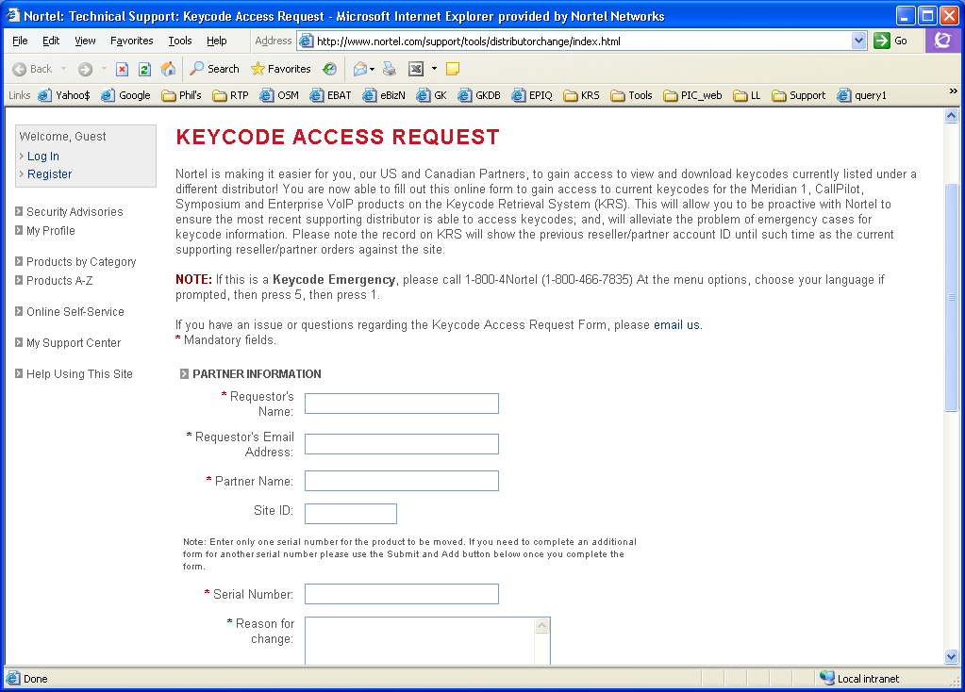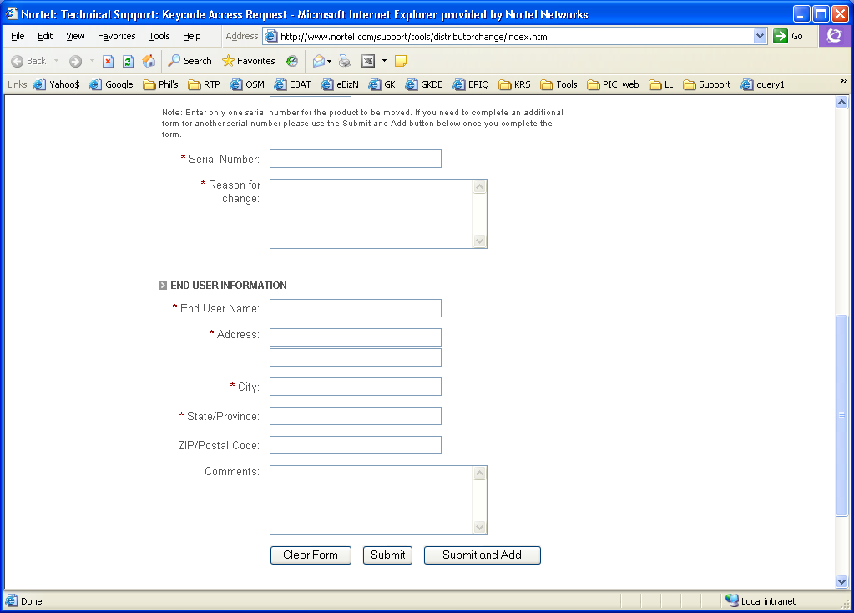
MAC address fior BCM products
Enter “n/a” if you choose not to disclose End User Information
Click <Submit> if there is only one system to change.

Click <Submit and Add> if there are other systems to change. Partner Information will remain pre-populated.

Confirm and enter “This is a transfer request to enable registration of a purchased BCM. The end customer has given permission for my company to action this upgrade”.

