Select “Software Distribution”

Accessing Keycode Application – KRS
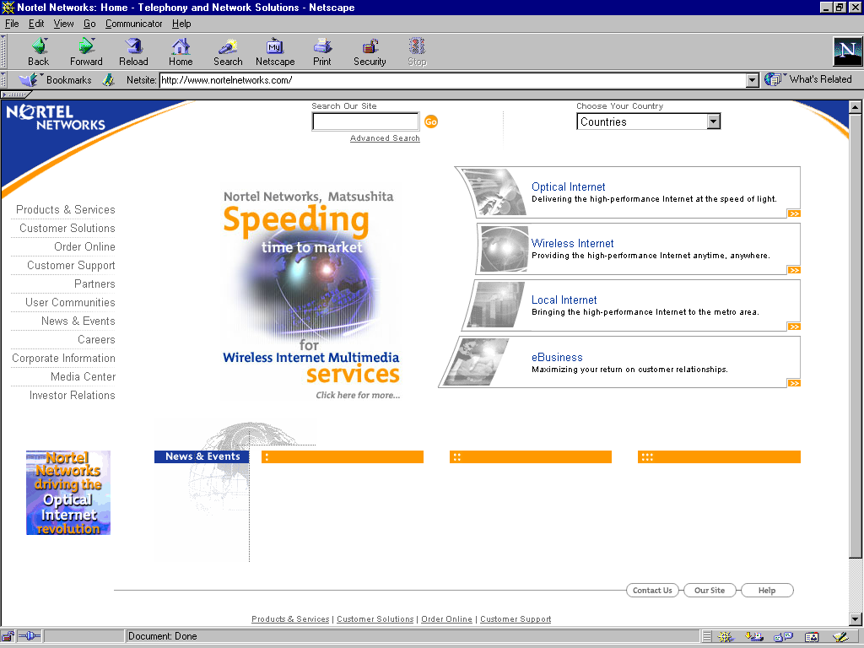
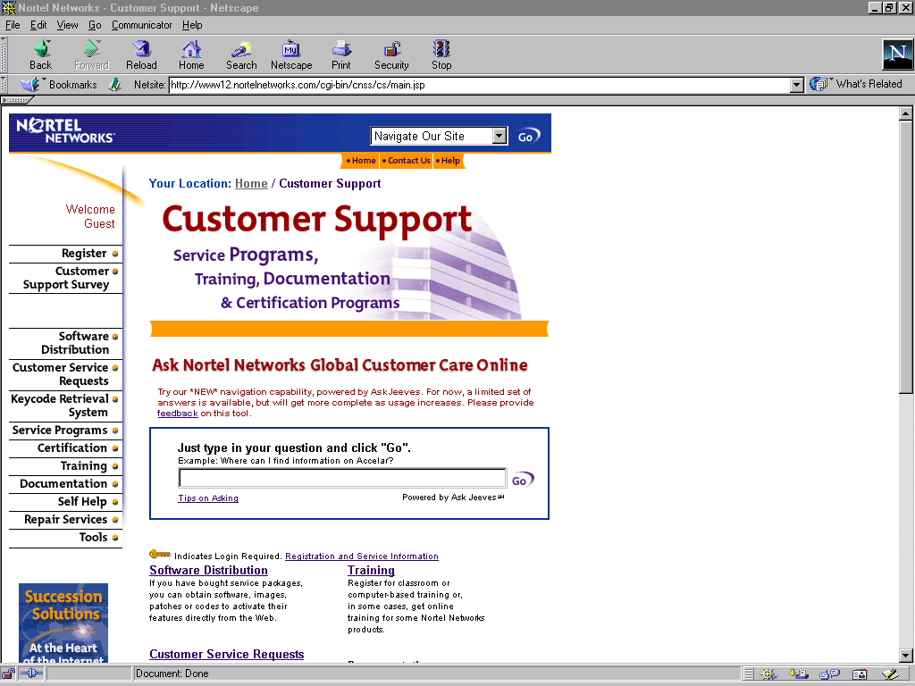
http://www.nortelnetworks.com

Select “Customer Support” Icon on the left
side of the Nortel Networks homepage.

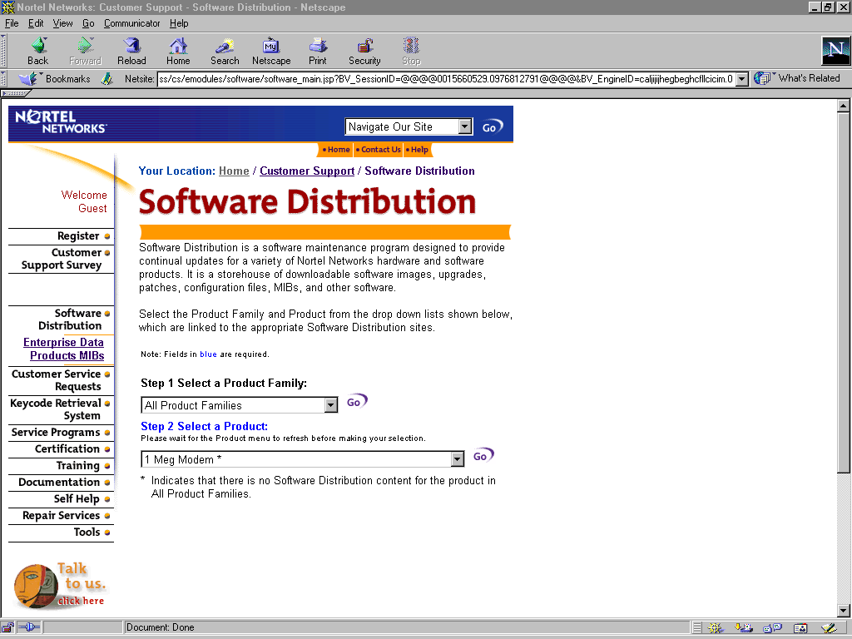

Select “Keycode Retrieval System”
Select Keycode Retrieval

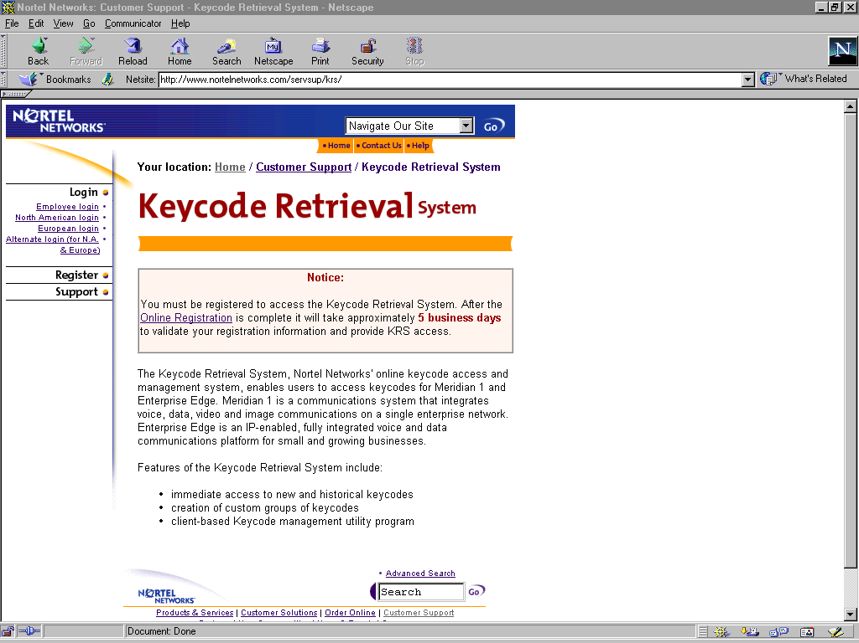
Keycode Banner Page

If you are a registered user select
the Login icon.

KRS Application

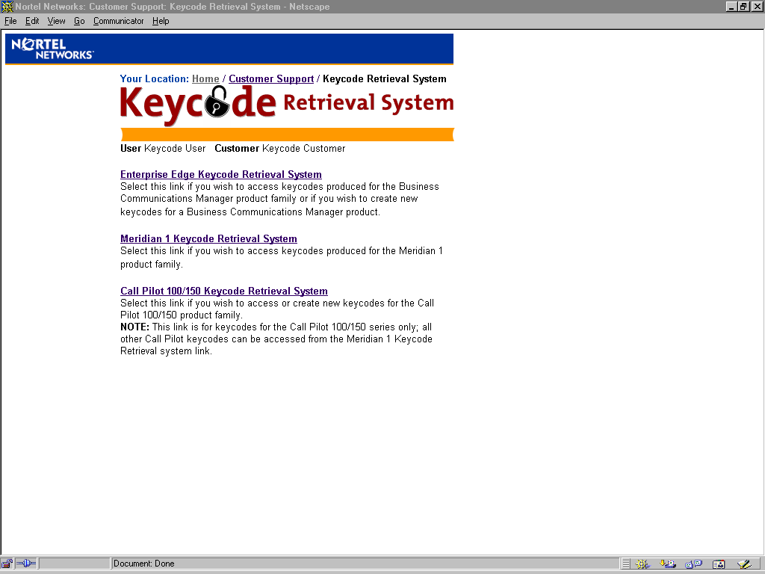

Enterprise Edge Keycode Retrieval System

This link will take the user to the keycode application for the Business Communications Manager product line.

Note: After logging into the KRS, verify that your username and company you work for is displayed correctly.

Meridian 1 Keycode Retrieval System

This link will take the user to the keycode application for the Meridian product line.

Note: A registered user will have access to all keycode applications for the various product lines displayed.

Call Pilot 100/150 Keycode Retrieval System

This link will take the user to the keycode application for the Call Pilot 100/150 product line.

Note: After logging into the KRS, verify that your username and company you work for is displayed correctly.

Enterprise Edge Keycode Retrieval System

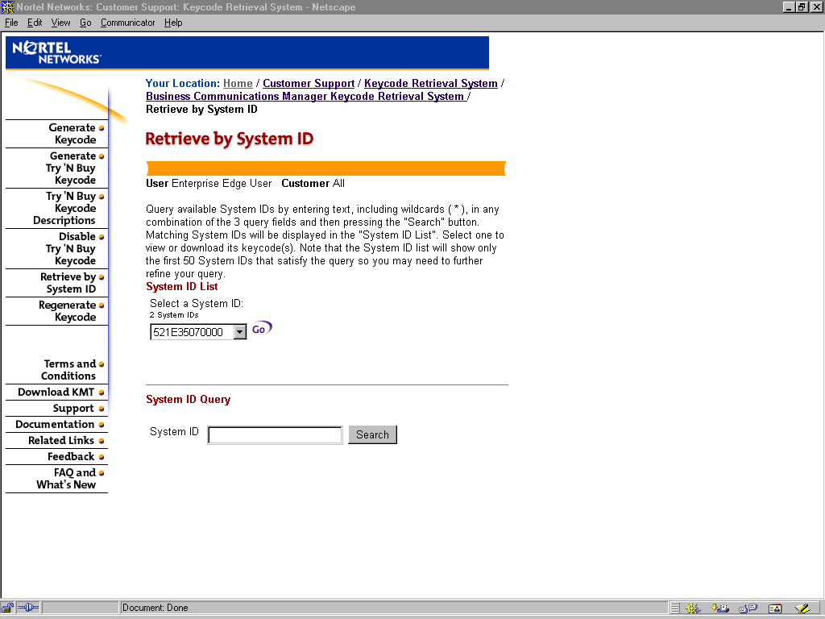

Quick Links: (on left of screen)

- Generate Keycode Takes the user to a page where keycodes can be generated after entering the required data (valid system ID and authorization code).
- Generate Try ‘N Buy Keycode Takes the user to a page that allows customers with existing Enterprise Edge systems to enable systems on a thirty-day trial basis.
- Try ‘N Buy Keycode Descriptions Takes the user to a page that displays brief information about what each option does.
- Disable Try ‘N Buy Keycode Takes the user to a page that will generate a keycode that disables the previous Try ‘N Buy codes.
- Retrieve by System ID Takes the user to a page where current and legacy keycodes can be retrieved for a specified System ID.
- Regenerate Keycode Takes the user to a page where a failed unit’s keycodes are invalidated and a new set generated.
- Terms and Conditions Takes the user to the Nortel Networks terms and conditions of the KRS web application.
- Download KMT Takes the user to a site where the latest version of the KMT can be downloaded to the users desktop to manage keycodes. This client side application is only necessary for viewing downloaded keycodes when not connected to the website.
- Support Provides the phone number (1-800-755-4995 or (905) 863-6896) for Level 1 support and an email link to the support group for North America.

- Documentation This link provides the user with the option to download the latest Keycode Quick Reference Guide.
- Related Links Takes the user to additional Nortel Networks keycode related sites.
- Feedback Pops up an email reply that will allow the user to provide comments and suggestions back to the business owners of the KRS web site.
- FAQ and What’s New Frequently asked questions and latest site information (Should be checked every time the user accesses the site).

Generate Keycode

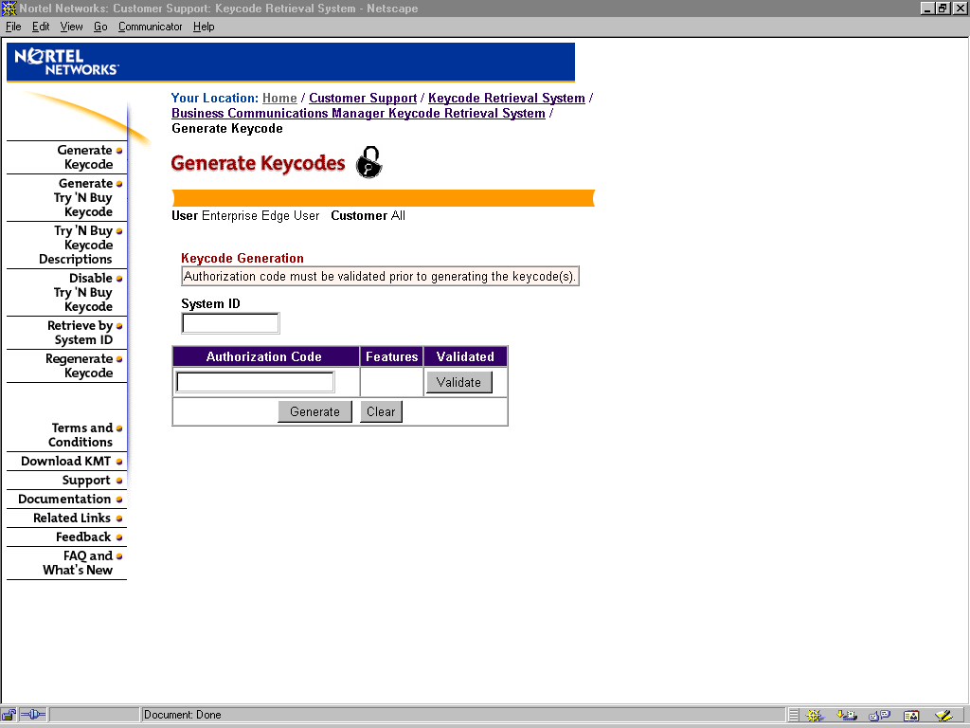

Process Overview

- System ID: 12 digit alphanumeric code found on the Enterprise Edge system the user is generating the keycodes for.
- Authorization Code: 8 digit numeric code found inside the product Feature Pak.

- Validate: Pressing this action button will validate the authorization code entered by the user with authorization codes that are contained within the KRS database.
- Successful validation will return the product description of the S/W purchased.

- Generate: Pressing this action button; after an authorization code has been validated will validate the system ID entered by the user with system ID’s that are contained in the KRS database.
- Successful validation of the system ID will generate a keycode(s) that when entered into the Enterprise Edge web manager will enable the appropriate functionality.

Retrieve by System ID

Process Overview

- By entering a valid system ID in the appropriate box or selecting the appropriate one from the system ID list, you will be able to retrieve all keycodes for that system.

Toll Free Customer Support can be reached at 1-800-755-4995
8 am EST – 8 pm EST Monday - Friday

Meridian Products Keycode Retrieval System

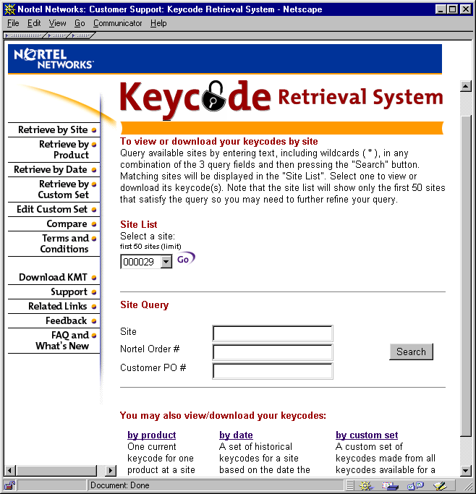
Quick Links: (on left of screen)

- Retrieve by Site Allows the user to specify a site ID and retrieve ALL keycodes for products associated with the entered site ID.
- Retrieve by Product Allows the user to view site id's sorted by product type.
- Retrieve by Date Allows the user to retrieve all historic (previously produced) keycodes for a particular site ID.
- Retrieve by Custom Set Allows the user to retrieve previously "grouped" keycodes by a custome label created by the user.
- Edit Custom Set Allows the user to edit (add or delete) the contents of a custom set of keycodes.
- Compare Allows the user to compare two keycodes of the same product type.
- Terms and Conditions Legal disclaimers

- Download KMT Takes the user to a site where the latest version of the KMT can be downloaded to the users desktop to manage keycodes. This client side application is only necessary for viewing downloaded keycodes when not connected to the website.
- Support Provides the phone number (1-800-755-4995 or (905) 863-6896) for Level 1 support and an email link to the support group for North America.
- Related Links Takes the user to additional Nortel Networks keycode related sites.
- Feedback Pops up an email reply that will allow the user to provide comments and suggestions back to the business owners of the KRS web site.
- FAQ and What’s New Frequently asked questions and latest site information (Should be checked every time the user accesses the site.

Call Pilot 100/150 Keycode Retrieval System

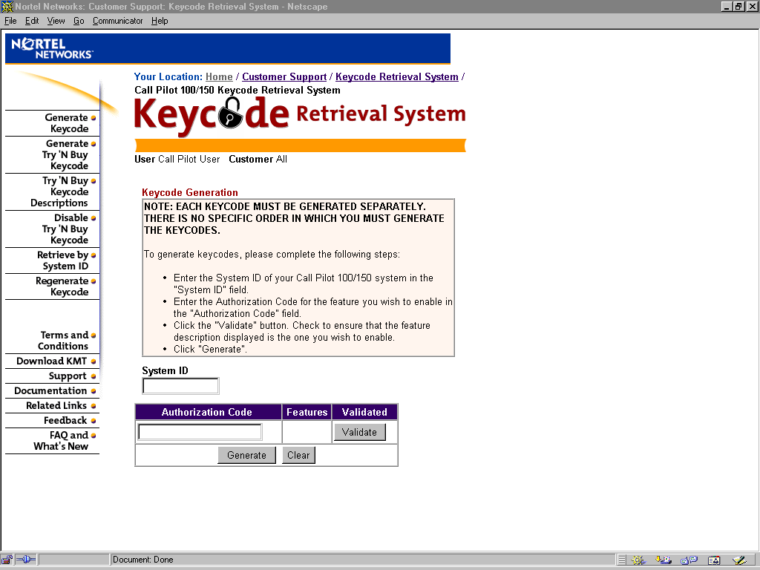

Quick Links: (on left of screen)

- Generate Keycode Takes the user to a page where keycodes can be generated after entering the required data (valid system ID and authorization code).
- Generate Try ‘N Buy Keycode Takes the user to a page that allows customers with existing Call Pilot 100/150 systems to enable systems on a sixty-day trial basis.
- Try ‘N Buy Keycode Descriptions Takes the user to a page that displays brief information about what each option does.
- Disable Try ‘N Buy Keycode Takes the user to a page that will generate a keycode that disables the previous Try ‘N Buy codes.
- Retrieve by System ID Takes the user to a page where current and legacy keycodes can be retrieved for a specified System ID.
- Regenerate Keycode Takes the user to a page where a failed unit’s keycodes are invalidated and a new set generated.
- Terms and Conditions Takes the user to the Nortel Networks terms and conditions of the KRS web application.
- Download KMT Takes the user to a site where the latest version of the KMT can be downloaded to the users desktop to manage keycodes. This client side application is only necessary for viewing downloaded keycodes when not connected to the website.
- Support Provides the phone number (1-800-755-4995 or (905) 863-6896) for Level 1 support and an email link to the support group for North America.

- Documentation This link provides the user with the option to download the latest Keycode Quick Reference Guide.
- Related Links Takes the user to additional Nortel Networks keycode related sites.
- Feedback Pops up an email reply that will allow the user to provide comments and suggestions back to the business owners of the KRS web site.
- FAQ and What’s New Frequently asked questions and latest site information (Should be checked every time the user accesses the site).

Generate Keycode

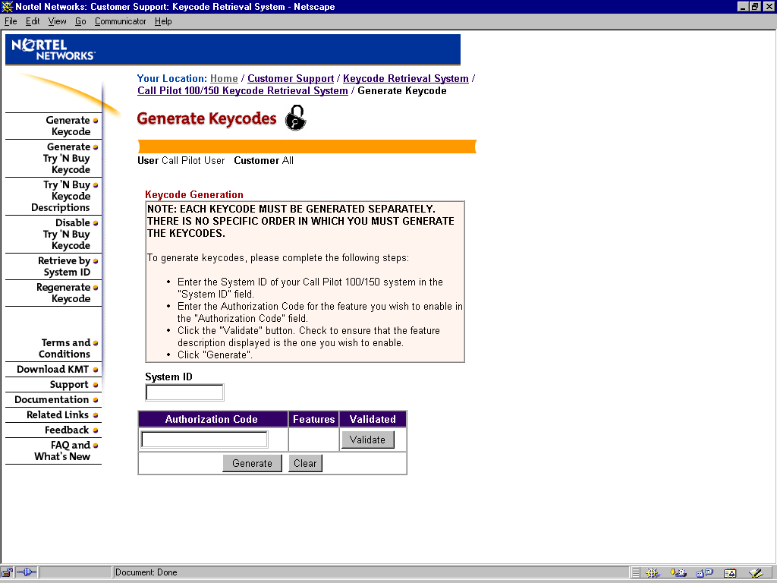
Process Overview

- System ID: 12 digit alphanumeric code found on the Call Pilot 100/150 system the user is generating the keycodes for.

- Authorization Code: 8 digit numeric code found inside the product Feature Pak.

- Validate: Pressing this action button will validate the authorization code entered by the user with authorization codes that are contained within the KRS database.
- Successful validation will return the product description of the S/W purchased.

- Generate: Pressing this action button; after an authorization code has been validated will validate the system ID entered by the user with system ID’s that are contained in the KRS database.
- Successful validation of the system ID will generate a keycode(s) that when entered into Call Pilot 100/150 web manager will enable the appropriate functionality.

Retrieve by System ID

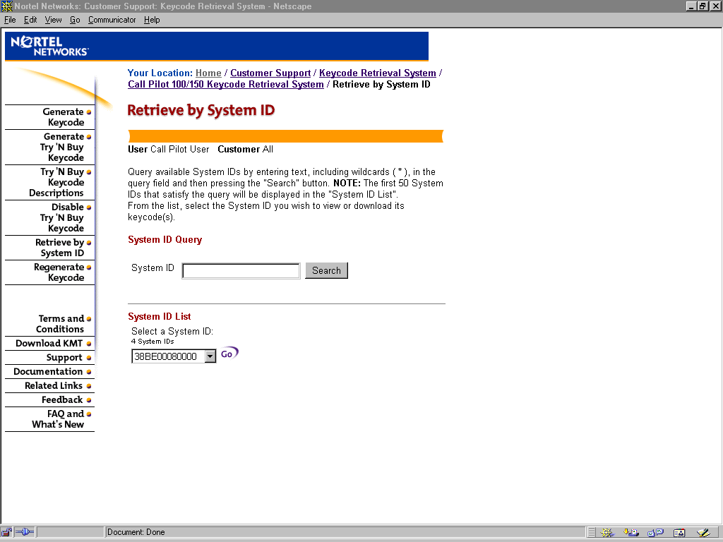

Process Overview

- By entering a valid system ID in the appropriate box or selecting the appropriate one from the system ID list, you will be able to retrieve all keycodes for that system.

Toll Free Customer Support can be reached at 1-800-755-4995
8 am EST – 8 pm EST Monday - Friday

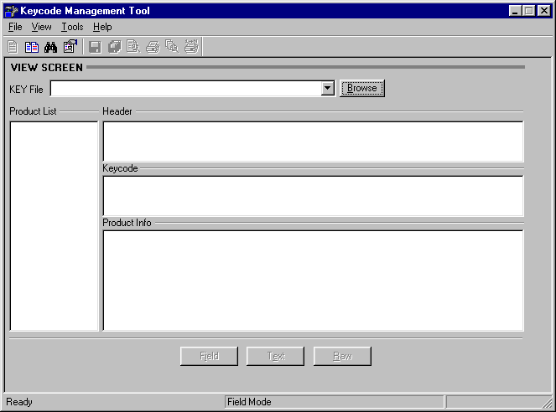
Contains the list of product Keycodes contained within the Keycode file selected.
Contains the name and date of the user who downloaded this file.
This window contains the actual Keycode (regardless of size).
Contains data about the distributor, PO, order #, end user, site ID, software release, features and packages and limit levels enabled by this particular keycode.
file name being displayed is shown here.
Keycode Management Tool (KMT) Client side application

The Keycode Management Tool (KMT) is used to view and compare keycode files that have been downloaded from the KRS web site.
The icons on the toolbar allow you to:
- View a single keycode selected from the product list displayed on the left of the screen above.
- Compare two Keycodes brings up a second screen where you select the two files to compare and then specify which keycodes within the two files to compare. Allows the difference between 2 keycodes to be easily seen. Note: Identical keycodes can not be compared.
Contains data about the distributor, PO, order #, end user, site ID, software release, features and packages and limit levels enabled by this particular keycode.
- Search for a keycode. This option allows you to search through the logical devices contained on your computer to find a specific keycode (a variety of search criteria is allowed).
- Management allows for the manipulation of keycodes on the local system to me managed (moved, deleted etc.)
- Save Current Keycode allows the Keycode seen in the "Keycode" window to be saved to disk (i.e. large systems will be saved with all necessary formatting in proper file convention keycode.kcd .
- Save All Keycodes allows all keycodes (only that portion that would be seen in the Keycode window) to be saved to disk (separate file or to diskette).
- Print Preview allows the viewing of the keycode file as it would be printed.
- Print initiates the printing of the keycode.
- Print Preview All allows the preview of ALL keycodes withing the selected keycode file.
- Print ALL Prints all keycodes contained within the keycode file.

