Using the KRS to produce Keycodes (license files, license keys) for the
Business Communication Manager, (BCM), and Call Pilot Mini/150, (CP), Product families.

Version 1.0
April 29, 2004

Contents:

Step 1 Access the KRS

Step 2 Generating Keycodes

Step 3 Regenerating Keycodes

Step 4 Retrieve Keycode

Step 5 Error Messages

Step 1 Access the KRS

- Open your browser and go to Nortel Networks.com
- From Nortel’s main page, under Support click on Keycode Retrieval System. This will take you to the secure login page.
- In step 1 (Location) select a login server which matches the region you’re located in, i.e. European Login, North America Login etc.
- In step 2 (Product Family) select the product you wish to generate keycodes for, in this case select Business Communications Manager or Call Pilot 150/Mini.
- Next enter your User ID and Password, then the screen below will appear.

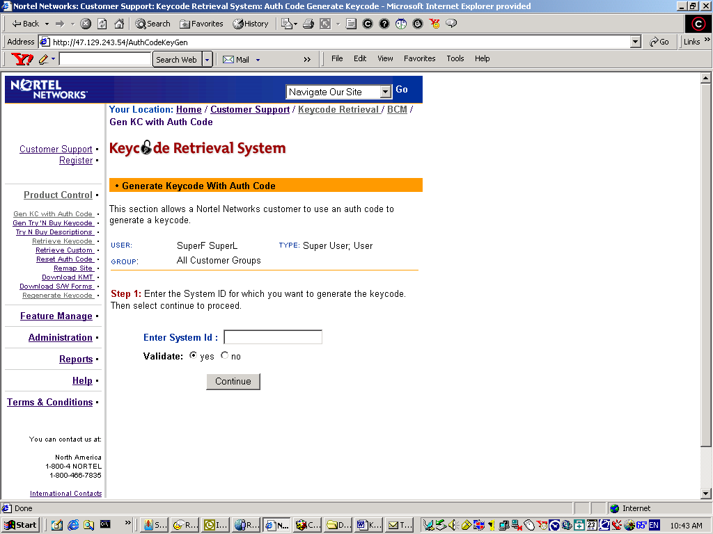
Step 1b Select Create to Register a New system.

Step 2 Generating Keycodes

- Follow the screens and enter the requested information

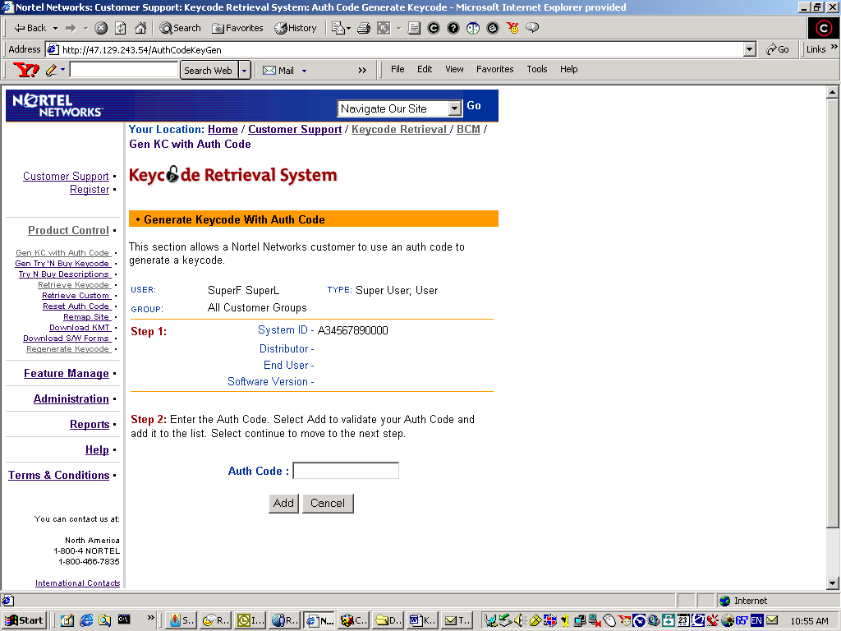

- After entering the first Authorization Code, click Add. Continue adding authorization codes until all are added.

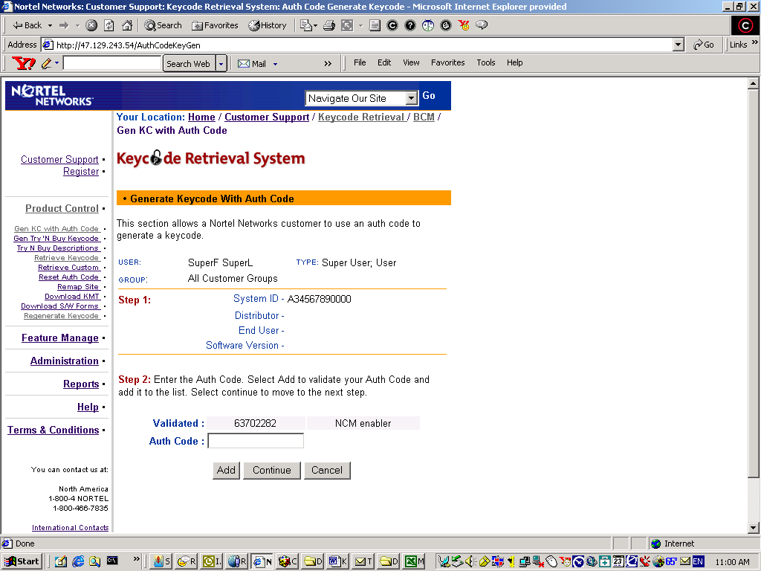

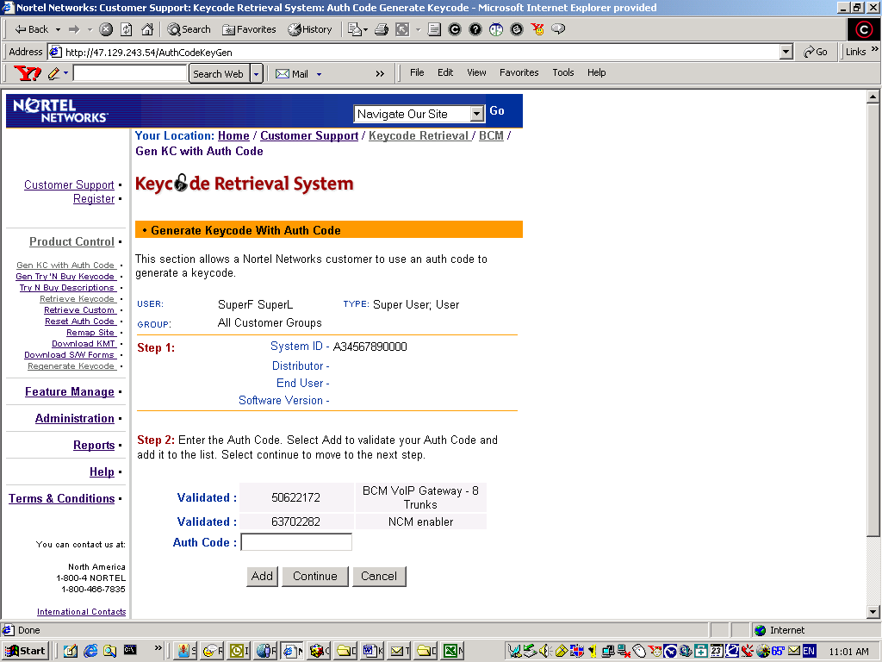

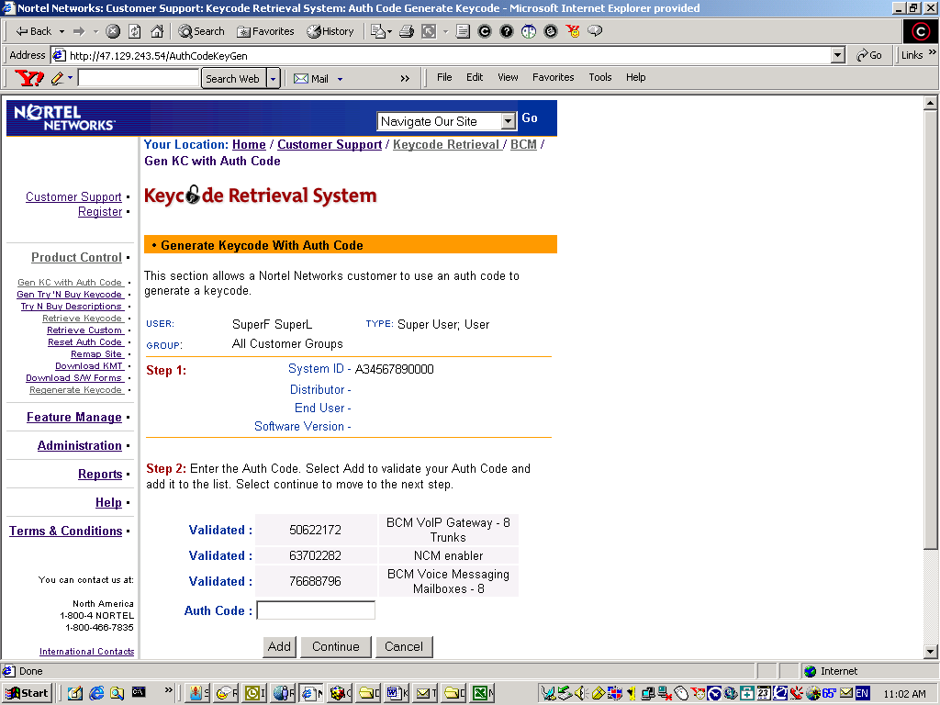

- Once all Authorization Codes are entered, click Continue.

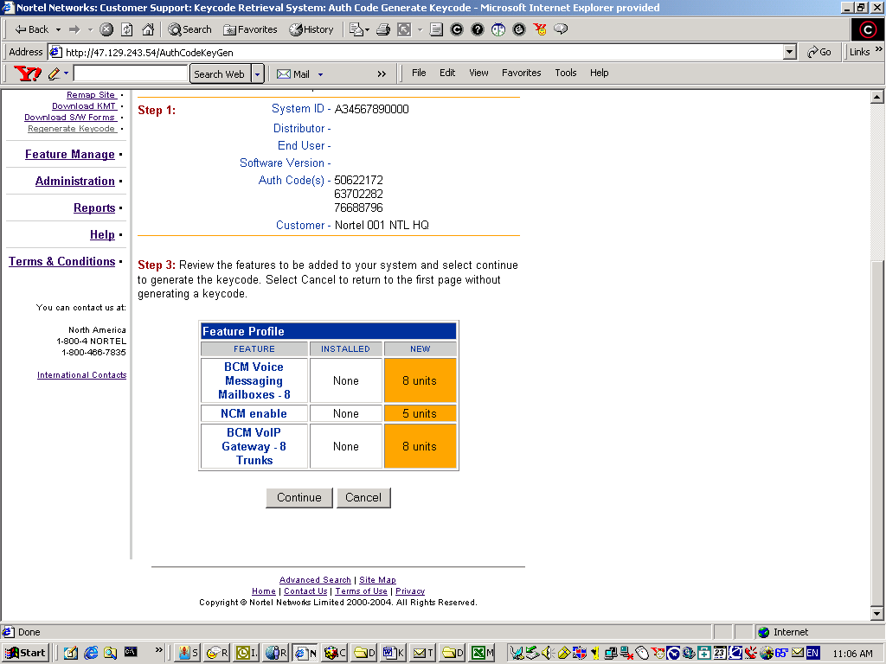

- A summary of the authorization codes will be displayed. If the information is correct, click Continue. If the information is not correct, click Cancel and start the process over.

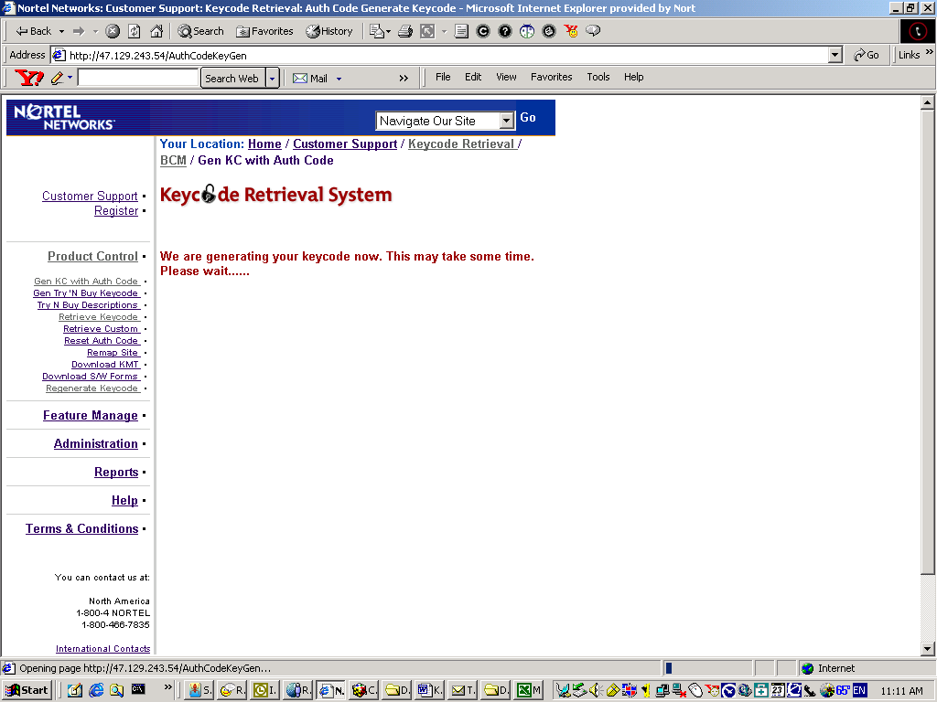

- The keycodes will be presented in a format that can be printed or click the Download Envelope button to save them to the desktop.

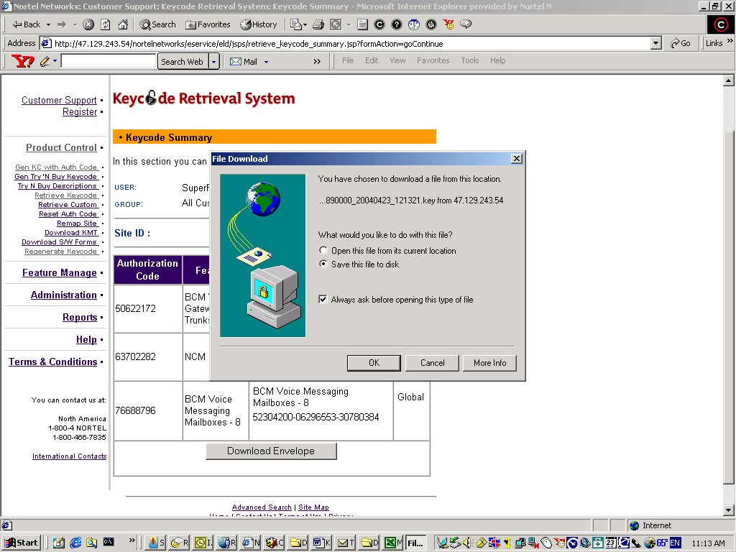

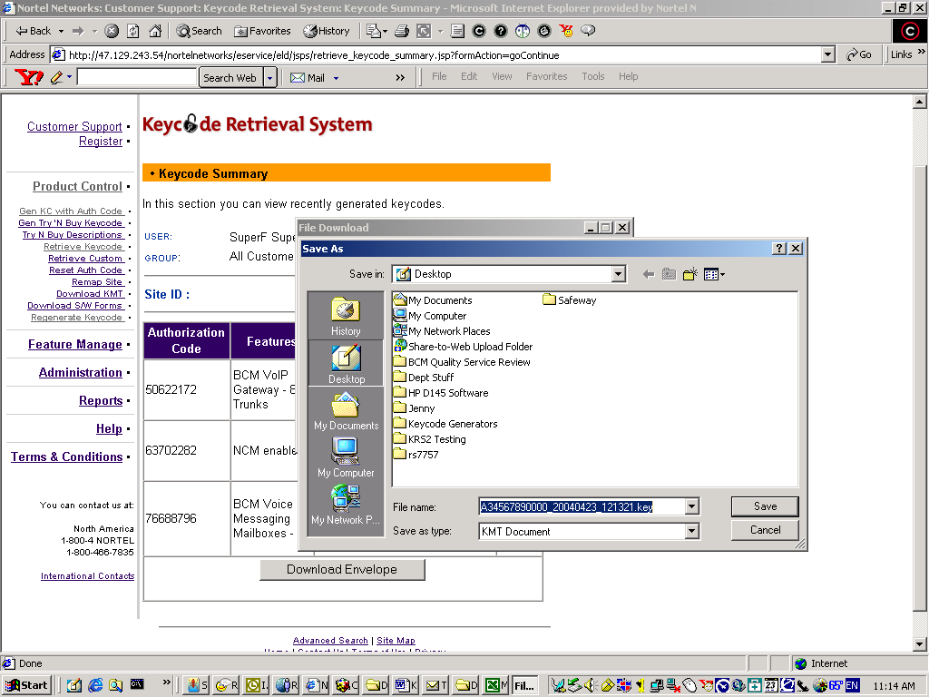

- Follow the same steps for Call Pilot 150/Mini.

Step 3 Regenerating Keycodes

- When a system fails and is replaced, the keycodes can be transferred to the new system by using the Regenerate Keycode option on KRS.
- Follow the screens and enter the requested information

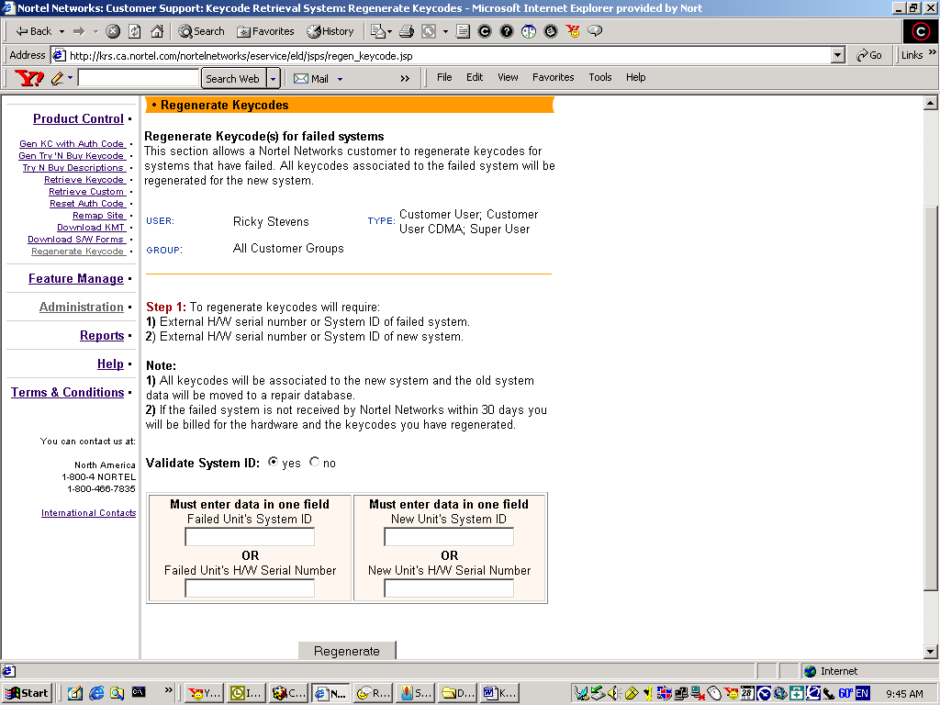

- Enter the failed system’s ID or hardware serial number then enter the replacement system’s ID or hardware serial number then click Regenerate.
- Follow the previous steps to print or download the keycodes.
- Follow the same steps for Call Pilot 150/Mini.

Step 4 Retrieve Keycode

- To view previously generated keycodes, use the Retrieve keycode option.
- This feature is also used when a browser time out occurs during generation. If the message “The Auth Code has already been used” appears, use the Retrieve Keycode option to see if the keycode generated.
- Follow the screens and enter the requested information

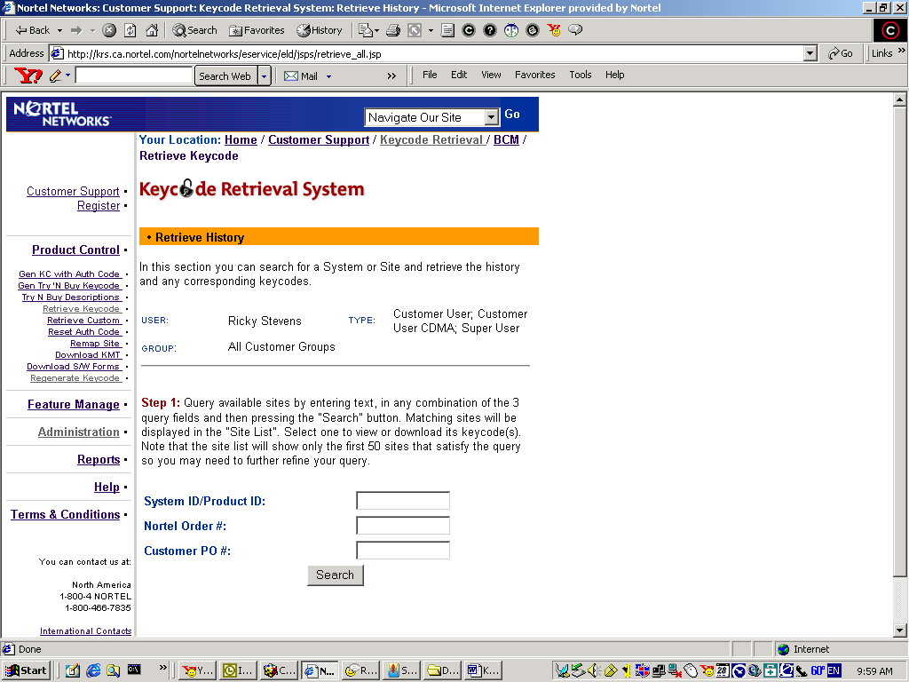

- Follow the previous steps to print or download the keycodes.
- Follow the same steps for Call Pilot 150/Mini.

Step 5 Error Messages

- Keycode Generator Failed: This error message indicates the System ID is incorrect. The system ID must be a 12 character hexadecimal number.
- These error messages apply to both BCM and Call Pilot 150/Mini.

