

Maintenance Guide

Meridian 1 Corruption Guide

Authors: Naresh Mistry, Graham Barton

Approved: David Henley

Date: October 1 2005

Issue: 3.0

System: Merdian 1, Succession

Keywords: CORRUPTION

Abstract: This document provides info about known corruption’s..

PROPRIETARY INFORMATION
The information contained in this document is the property of Northern Telecom.
Except as specifically authorized in writing by Northern Telecom, the holder of this document shall: (1) keep all information contained herein confidential and shall protect same in whole or in part from disclosure and dissemination to all third parties, and (2) use same for operating and maintenance purposes only. No
commitment is implied by this document unless expressly given in a covering
memorandum.
Table of Contents

1.0 Introduction ................................................................ 5

2.0 TN type corruption........................................................... 6
2.1 Symptoms of Problem
2.2 How to Resolve Problem
2.3 Software Structure

3.0 DN type corruption........................................................... 8
3.1 Symptoms of Problem
3.2 How to Resolve Problem
3.3 Software Structure

4.0 Group Hunt Corruption (GPHT) ............................................... 12
4.1 Symptoms of Problem
4.2 How to Resolve Problem
4.3 Software Structure

5.0 Dass/Dpnss Corruption ...................................................... 16
5.1 Symptoms of Problem
5.2 How to Resolve Problem
5.3 Software Structure

6.0 Loop/Superloop Corruption .................................................. 21
6.1 Symptoms of Problem
6.2 How to Resolve Problem
6.3 Software Structure

7.0 BRI Corruption.............................................................. 23
7.1 Symptoms of Problem
7.2 How to Resolve Problem
7.3 Software Structure

8.0 Set Relocation Corruption .................................................. 26
8.1 Symptoms of Problem
8.2 How to Resolve Problem
8.3 Software Structure

9.0 ACD Corruption.............................................................. 30
9.1 Symptoms of Problem
9.2 How to Resolve Problem
9.3 Software Structure

10.0 TTY corruption............................................................. 35
10.1 Symptoms of Problem
10.2 How to Resolve Problem
10.3 Software Structure

11.0 BFS Corruption ............................................................ 38
11.1 Symptoms of Problem
11.2 How to Resolve Problem
11.3 Software Structure

12.0 Authcode Corruption ....................................................... 41
12.1 Symptoms of Problem
12.2 How to Resolve Problem
12.3 Software Structure

13.0 ESN Corruption............................................................. 43
13.1 Symptoms of Problem
13.2 How to Resolve Problem
13.3 Software Structure

14.0 ITG CHID Channel ID Corruption............................................. 45
14.1 Symptoms of Problem
14.2 How to Resolve Problem
14.3 Software Structure

15.0 ACD SCHED Block Corruption ................................................ 48
15.1 Symptoms of Problem
15.2 How to Resolve Problem
15.3 Software Structure

16.0 MSDL Port Corruption ...................................................... 50
16.1 Symptoms of Problem
16.2 How to Resolve Problem
16.3 Software Structure

17.0 DCH Channel Corruption .................................................... 54
17.1 Symptoms of Problem
17.2 How to Resolve Problem
17.3 Software Structure

18.0 TTY Corruption on 11c ..................................................... 58
18.1 Symptoms of Problem
18.2 How to Resolve Problem
18.3 Software Structure

19.0 XPEC Corruption on Superloop............................................... 60
19.1 Symptoms of Problem
19.2 How to Resolve Problem
19.3 Software Structure

20.0 CDN Corruption............................................................. 63
20.1 Symptoms of Problem
20.2 How to Resolve Problem
20.3 Software Structure

21.0 FFC Corruption............................................................. 67
21.1 Symptoms of Problem
21.2 How to Resolve Problem
21.3 Software Structure

22.0 ADAN Corruption............................................................ 70
22.1 Symptoms of Problem
22.2 How to Resolve Problem
22.3 Software Structure

23.0 TRK Corruption............................................................. 73
23.1 Symptoms of Problem
23.2 How to Resolve Problem
23.3 Software Structure

24.0 LAPD (BRI) Corruption...................................................... 75
24.1 Symptoms of Problem
24.2 How to Resolve Problem
24.3 Software Structure

25.0 Appendix .................................................................. 78
25.1 CDNXPTR
25.2 SCLMHTPTR
25.3 LOG_IO_PTR
25.4 DTSLHT_PTR
25.5 CRMHPTR
25.6 QUEUE_ADDR
25.7 SET_RELOC_TABLE
25.8 P_MSDLMISP_MHPTR
25.9 BCS TEMPL_HDR
25.10 PBX_TEMPL_HDR
25.11 CONFIGLOOP
25.12 SYS_XPEC
25.13 CON_DDCS_FLAG
25.14 IO_TABLE_PTR
25.15 P_VAS_TBL_HDR
25.16 CRSTART
25.17 CREND
25.18 P_BRI_PROTMHTPTR

1 Introduction

This document has been written to provide information about known CORRUPTION on Meridian 1.

For each corruption type, there are 3 sections:
(a) Symptoms of problem.
(b) Software Structure: description of problem.
(c) How to resolve problem with debug/pdt.

See Appendix for a list of pointer values for pre 25 software releases to resolve corruption. For release 25 and onwards the TUA command used in PDT will provide the same pointer information.

This document is written for the benefit of:

(1) Nortel software engineers in a Support Role (CTS).

(2) Distributor Engineers who have knowledge of Meridian 1 software structures.
(Have attended the "Meridian 1 Software Tools Course").

The document can be used as an aid to resolving corruption problems without having to refer to the Meridian 1 software code.

It is recommended that after removing any corruption the system should be data dumped and sysloaded before reconfiguring any information.

It is intended that this document should form the basis for an investigation by Nortel Technology to find the root causes of all the corruption types listed in this document, and/or produce defensive code/workaround code to prevent the problems occurring.

2 TN Corruption

2.1 SYMPTOMS OF PROBLEM

TN corruption is caused when the protected and the unprotected unit pointers
are invalid or missing from the protected/unprotected card pointers.
The corrupted TN can be printed as normal in LD 20, but cannot be changed or outed because an SCH0128 will be produced.

REQ:
TYPE: 2616
TN 4 0 0 0
SCH0128 = Terminal does not exist.

REQ: OUT
TYPE: 2616
TN 4 0 0 0
SCH0128 = Terminal does not exist.

2.2 HOW TO RESOLVE PROBLEM

If there are any DN's associated with the corrupted TN these must be removed first from the DNTREE (see DN Corruption).

Do a TNT on the corrupted TN.

pdt> TNT 4 0 0 0
UNEQPD SLOOP TN 000400
GP 120739 SLP 12075F 1F8DDA CD 1207AD 1F8DC0 LN 12083B 000000

In this case the unprotected unit pointer is missing.

The next step is to remove the TN by printing the protected and unprotected card pointer and then deleting the protected and unprotected unit pointer.

In this only the protected unit pointer needs to be removed as the unprotected unit pointer is already zero.

pdt> P 1207AD 5
1207AD : 002060 12083B 12085C 120888 1208A7

pdt> W 1207AD
1207AD : 002060 /
1207AE : 12083B /0

Confirm if TN has been removed by doing a TNT on the corrupted TN.

pdt> TNT 4 0 0 0
UNEQPD SLOOP TN 000400
GP 120739 SLP 12075F 1F8DDA CD 1207AD 1F8DC0 LN 000000 000000

The corruption has now been confirmed cleared and ready to be rebuilt.

2.3 SOFTWARE STRUCTURE
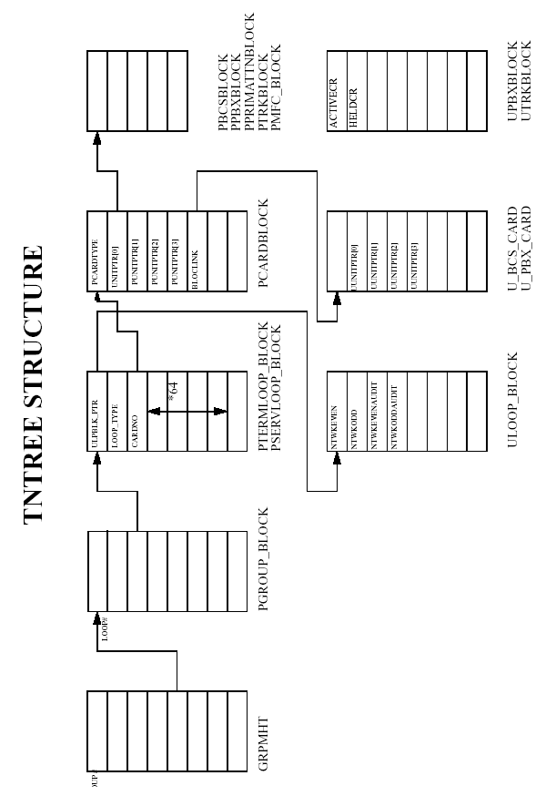
3 DN Corruption

3.1 SYMPTOMS OF PROBLEM

When a DN is printed in LD20 the TN and SCH0881 information is not
printed. It is also not possible to configure a NEW set with the DN.

REQ: PRT
TYPE: DNB
CUST 0
DN 2000
DATE
PAGE
DES
NO ACT SINCE NO DATE

NACT

This shows that a DNTREE entry exists for DN 2000, but the
TN referred to it does not exist.

pdt> DNT 0 2000
DIG 4 BCS
15D3F4 : 008208 000000 000000 000000 000000 0003FF 000000 000401

pdt> TNT 401
UNEQPD SLOOP TN 4 0 0 1
GP 158677 SLP 15869D 1F9234 CD 1586EB 1F921A LN 000000 000000

The corruption is in the DNTREE.

3.2 HOW TO RESOLVE PROBLEM

Print the CDNXPTR pointer for the customer with the corrupted DN.

CDNXPTR = 8922 (see Appendix)

pdt> P 8922 5
008922 : 15D0D0 15D232 15D2CD 000000 000000
Cust 0 Cust 1 Cust 2 etc

Print the beginning of the DNTREE for the required customer.

pdt> P 15D0D0 10
15D0D0 :0000DE 15D142 15D0DD 15D184 15D186 00000015D1F415D182
15D0D8 : 000000 000000 000000 000000 000000 000564 000000 15D167

Print the memory address for the first digit.

pdt> P 15D0DD 10
15D0DD : 000564 000000 15D167 000000 000000 15D3BC 1564EF 000000
15D0E5 : 15D0E9 000000 15D35C 000000 000400 000000 000000 000000

Print the memory address for the second digit.

pdt> P 15D35C 10
15D35C : 000400 000000 000000 000000 000000 000000 000000 000000
15D364 : 000000 000000 15D368 000000 000404 000000 15D3EC 000000

Print the memory address for the third digit.

pdt> P 15D368 10
15D368 : 000404 000000 15D3EC 000000 000000 000000 000000 000000
15D370 : 000000 000000 15D3F4 000000 000400 000000 000000 000000

Print the memory address for the final digit.

pdt> P 15D3F4 10
15D3F4 : 008208 000000 000000 000000 000000 0003FF 000000 000401
15D3FC : 008208 000000 000000 000000 000000 0003FF 000000 000402

The correct memory address can be checked by doing a DNT on the corrupted DN.

pdt> DNT 0 2000
DIG 4 BCS
15D3F4 : 008208 000000 000000 000000 000000 0003FF 000000 000401.

The DNBLOCK needs to be removed for the corrupted DN and the bit map needs to be adjusted.
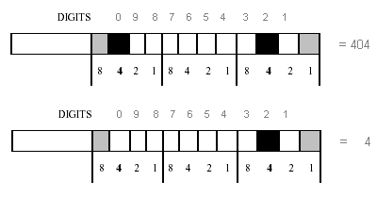

pdt> W 15D368
15D368 : 000404 /4
15D369 : 000000 /
15D36A : 15D3EC /
15D36B : 000000 /
15D36C : 000000 /
15D36D : 000000 /
15D36E : 000000 /
15D36F : 000000 /
15D370 : 000000 /
15D371 : 000000 /
15D372 : 15D3F4 /0

To confirm corruption has been cleared ok.

pdt> DNT 0 2000
DIG 4 INV

Corruption is now confirmed cleared.

Note that what has been done above is to adjust 2 words of memory.
(1) Adjust bit map in 1st word of DNXLBLOCK.
(2) Set word relating to digit 0 to zero.

3.3 SOFTWARE STRUCTURE
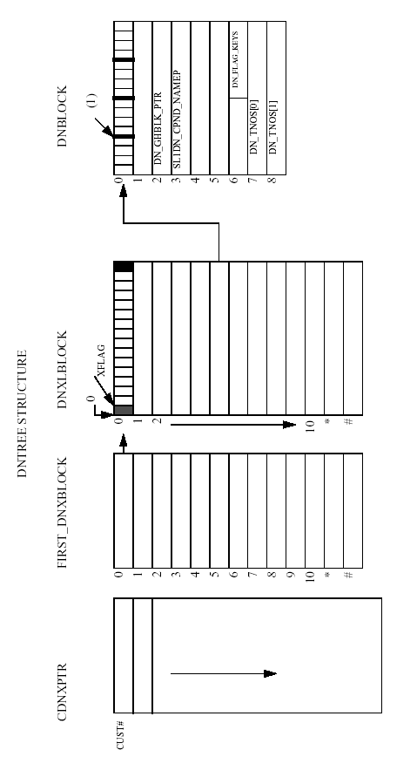
4 Group Hunt Corruption (GPHT)

4.1 SYMPTOMS OF PROBLEM

If a Group Hunt corruption has occurred then SCH8825 will be displayed. Key 00 has DN 2001 associated with it, if any change is made to this DN, SCH8825 is produced saying that this DN must be removed from the group hunt list. But when printing all of the group hunt lists, this DN does not appear.

LD 11
REQ: CHG
TYPE: 2616
TN 4 0 0 0
ECHG YES
SCH0618
ITEM KEY 00 SCH8825 = That DN must first be removed from the GHT list.

Print all Group Hunt Lists, if DN 2001 does NOT appear as a member in any
of the Group Hunt list, then we have Group Hunt corruption.

4.2 HOW TO RESOLVE PROBLEM

The best way to deal with this type of corruption is to zero out the group hunt
pointer DN_GHBLK_PTR in the DN block.

Print the DN block with the DNT<CUST><DN> command.

#DNT 0 2001
DIG 4 BCS
15D3EC : 008208 000000 158779 000000 000000 0003FF 000000 000400

The corruption is in the DN block. Word offset 2 holds the pointer DN_GHBLK_PTR to the group hunt data structure. This pointer should not exist as there is no entry for DN 2001 in any Group Hunt List.

NOTE : For a PBX type set the DNGHBLK_PTR needs to be cleared (word 8 in P_LINE_BLOCK).

Remove the DN_GHBLK_PTR.

#DNT 0 2001
DIG 4 BCS
15D3EC : 008208 000000 158779 000000 000000 0003FF 000000 000400

#W 15D3EC
15D3EC : 008208 /
15D3ED : 000000 /
15D3EE : 158779 /0

Confirm the corrupted pointer has been removed.

#DNT 0 2001
DIG 4 BCS
15D3EC : 008208 000000 000000 000000 000000 0003FF 000000 000400

The corruption has now been confirmed cleared.

DN 2001 can now be modified.

REQ: CHG
TYPE: 2616
TN 4 0 0 0
ECHG YES
SCH0618
ITEM KEY 00 NUL
KEY
ITEM

4.3 SOFTWARE STRUCTURE
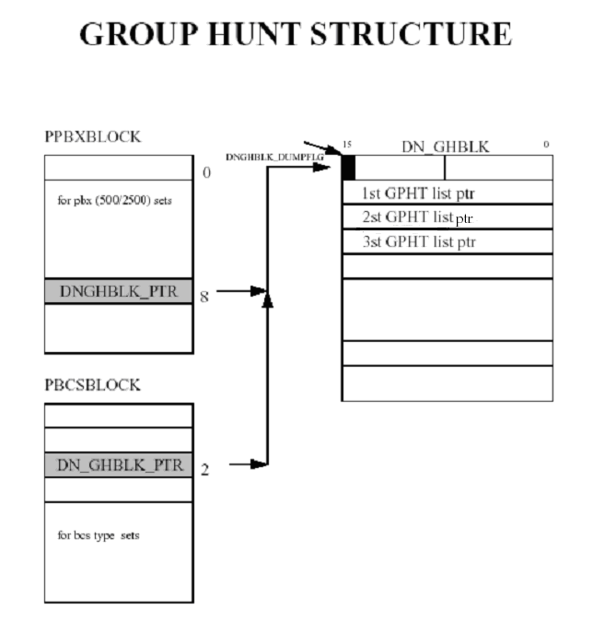

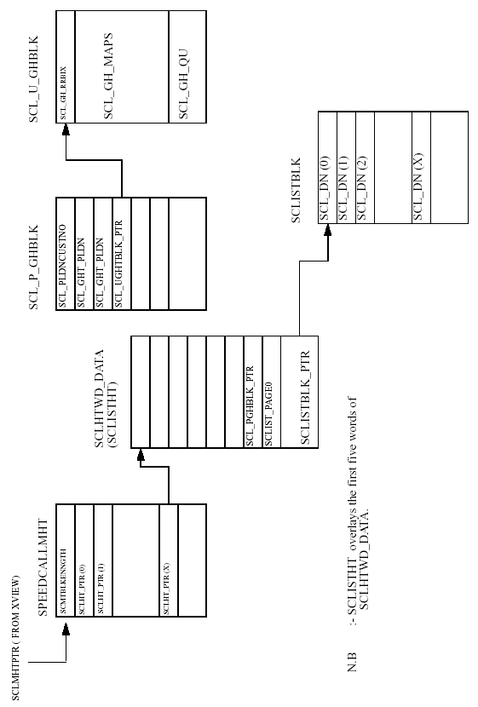
5 DASS/DPNSS Corruption

5.1 SYMPTOMS OF PROBLEM

1) If there is DASS / DPNSS corruption then an SCH0805 error will be produced when trying to print the loop and channel.

REQ: PRT
TYPE: TNB
TN 25 1
DATE
PAGE

SCH0805 = Specified TN is invalid

2) Using the TNT command in debug/pdt shows that no unit pointer exists.

#TNT 25 1
UNEQPD TN 25 1 * 001901
GP 158677 LP 15A863 1F48E5 CD 15A8B1 1F48B0 LN 000000 000000

3) Stat the loop in LD 75, STAT DDCS <LOOP> and the channel concerned is unequipped.

4) LTM the route number in LD 21, LTM <CUST><ROUTE No>

REQ: LTM
CUST 0
ROUT 99
TYPE TLS
TKTP IDA
ROUT 99
TN 025 01 MBER 1
TN 025 02 MBER 2
TN 025 03 MBER 3
TN 025 04 MBER 4

All members appear to exist.

NOTE : usually all members on the loop have been corrupted.

5.2 HOW TO RESOLVE PROBLEM

Null the TRKLIST_PTR pointer to the trunk member in the route data block using the P_ROUTE_DATA block found by the DRP<CUST NUM><ROUTE NUM> command.

#DRP 0 99
CUST 0 ROUT 99 P 157CC4 U 1F977B T 15D50A R 000000 VU000000 VT000000

#P 157CC4 5
157CC4 : 008384 00605C 000000 000000 15D50A

Word offset 4 is the TRKLIST_PTR.

Check for TN'S involved by using the TNT command, TNT <TN>.

#P 15D50A 10
15D50A : 000005 001901 001902 001903 001904 000003 001905 001906
15D512 : 1F931F 00000E 1F9279 000002 1F54FE 008000 000000 00000

#TNT 1901
UNEQPD TN 25 1 * 001901
GP 158677 LP 15A863 1F4904 CD 15A8B1 1F48CF LN 000000 000000

#TNT 1902
UNEQPD TN 25 2 * 001902
GP 158677 LP 15A863 1F4904 CD 15A8B1 1F48CF LN 000000 000000

#TNT 1903
UNEQPD TN 25 3 * 001903
GP 158677 LP 15A863 1F4904 CD 15A8B1 1F48CF LN 000000 000000

#TNT 1904
UNEQPD TN 25 4 * 001904
GP 158677 LP 15A863 1F4904 CD 15A925 1F48C6 LN 000000 000000

Take out the TRKLIST_PTR pointer in the P_ROUTE_DATA block.

#W 157CC4
157CC4 : 008384 /
157CC5 : 00605C /
157CC6 : 000000 /
157CC7 : 000000 /
157CC8 : 15D50A /0

NOTE : When Clearing DPNSS type corruption, we need to also take out the VIRT_TRKLIST_PTR pointer, word offset (57), from the P_ROUTE_DATA block.

Take out the route in LD16.

LD 16
REQ OUT
TYPE RDB
CUST 0
ROUT 99

Take out the DDSL/DDCS in LD74.

REQ OUT
TYPE DDSL
DDSL 9
SCH8849 1306
SCH8849 1329

There is still corruption so the data needs to be removed in memory.

DTSLHT_PTR = 8B34 (see Appendix)

#P 8B34 3
008B34 : 15CDC4 000000 000000
Cust 0 Cust 1 etc

#P 15CDC4 10
15CDC4 : 000021 000000 000000 000000 000000 000000 15CE21 000000
DDSL 5
15CDCC : 000000 000000 15CE03 000000 000000 000000 000000 000000
DDSL 9

The PDTSLPTR points to the P_DTSL_CARD_BLK block.

#P 15CE03 5
15CE03 : 000001 000000 1FB887 15CE0E 000000

The P_DASS_LINK_BLK block is pointed to by the P_DTSL_LINK_PTR pointer.

#P 15CE0E 20
15CE0E : 000913 00001D 000019 000125 001101 0040A4 000050 000101
15CE16 : 000100 000100 003278 004014 00007E 000000 000000 000000
15CE1E : 000000 000000 000000 000001 000000 1FC59E 15CE2C 000000
15CE26 : 000000 000000 1FB891 000000 000000 000000 000513 000019

The content of CHAN_CONFIGURED, word offset 12, 13, 14 and 15, needs to be removed.

#W 15CE0E
15CE0E : 000913 /
15CE0F : 00001D /
15CE10 : 000019 /
15CE11 : 000125 /
15CE12 : 001101 /
15CE13 : 0040A4 /
15CE14 : 000050 /
15CE15 : 000101 /
15CE16 : 000100 /
15CE17 : 000100 /
15CE18 : 003278 /
15CE19 : 004014 /
15CE1A : 00007E /0
15CE1B : 000000 /0
15CE1C : 000000 /0
15CE1D : 000000 /0

The remaining DDSL information can now be disabled in LD75 and then removed in LD74.

The corruption should now be cleared.

5.3 SOFTWARE STRUCTURE
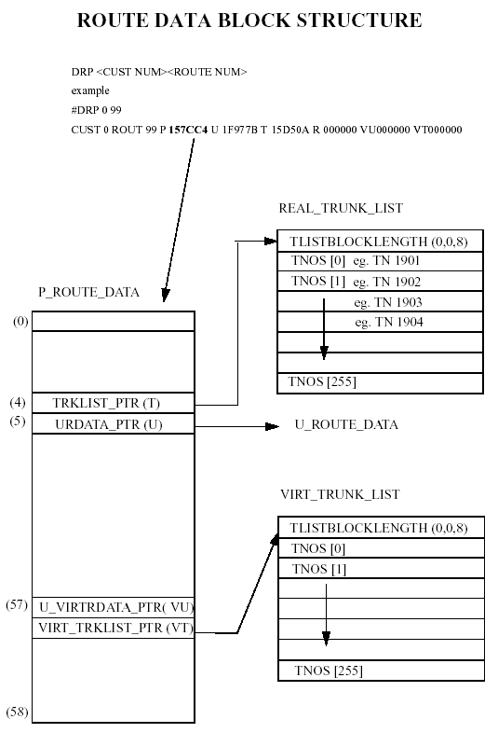

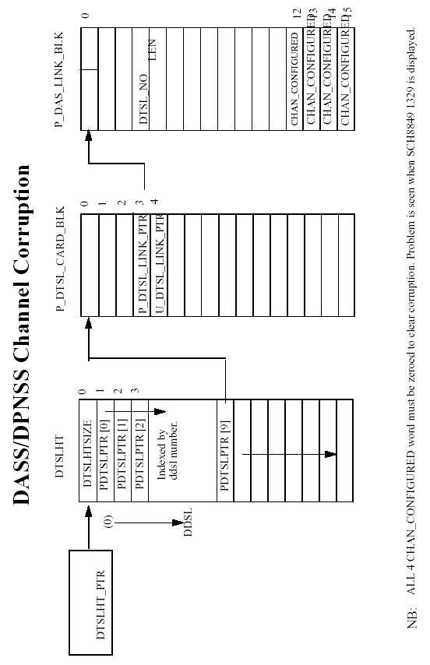
6 Loop/Superloop Corruption

6.1 SYMPTOMS OF PROBLEM

If loop corruption has occurred then the loop number and type will not appear in the configuration record. Also it is not possible to reconfigure or make any changes to this loop and an SCH0535 error will be produced.

Loop 11 configured as DDCS 11, but when printed does not exist.

LD 22
REQ PRT
TYPE CEQU
..
..
MPED 8D
TERM
REMO
TERD
REMD
TERQ 014 016
REMQ
SUPL 004
DDCS 000 008 010 025
DTCS
XCT 002
TDS * 002
CONF * 003
MFSD * 002

It is not possible to remove or add this loop in LD 17, an error SCH0535

REQ CHG
TYPE CEQU
MPED
TERM
REMO
TERD
REMD
TERQ
REMQ
DDCS X11

SCH0535 = Attempted to remove non-existing loop or add existing loop.

6.2 HOW TO RESOLVE PROBLEM

CONFIGLOOP = 90E1 (see Appendix)

NOTE : CONFIGLOOP is an array of .MAX_LOOPS where .MAX_LOOPS = 160

#P 90E1 10
1 0 3 2 5 4 7 6 9 8 ...etc
0090E1 : 000511 00020E 000D0D 000D0D 000A11 001411 000505 000508
0090E9 : 000508 000505 000505 000505 00110A 000505 000505 000513

As you can see from the above data structure loop 11 has a value of 14 hex, which
is incorrect and should be changed to a none existing loop with a value of 05 hex. This will completely remove this loop in the configuration record and enable you to reconfigure again.

#W 0090E1
0090E1 : 000511 /
0090E2 : 00020E /
0090E3 : 000D0D /
0090E4 : 000D0D /
0090E5 : 000A11 /
0090E6 : 001411 /0511

NOTE : In this we had NO trunks or other configuration associated with this loop so there no other corruption involved. If you were to remove an existing
corrupted loop/superloop with trunks, route, TN's or other configuration associated with that loop it will cause major corruption which will also need to be cleared.

6.3 Software Structure

Not available.

7 BRI Corruption

7.1 SYMPTOMS OF PROBLEM

This corruption is caused when multiple DN's are configured on a TSP. The
1st DN is OK, but subsequent DN's do not appear in the DN tree and cannot be removed. SCH0670 is displayed in LD27 when an attempt is made to OUT the TSP.

LD 27
REQ PRT
TYPE TSP
DSL 8 1
OPT
USID 0
MPHC NO
SUPL_SVC
DN 291
CT VCE DTA
MCAL 4
CLIP YES
PRES YES
FEAT HTD FND SFD CFTD MWD FBD HBTD CFXD
SSRV_ETSI

DN 292
CT VCE DTA
MCAL 4
CLIP YES
PRES YES
FEAT HTD FND SFD CFTD MWD FBD HBTD CFXD
SSRV_ETSI

DN 291
CT VCE DTA
MCAL 4
CLIP YES
PRES YES
FEAT HTD FND SFD CFTD MWD FBD HBTD CFXD
SSRV_ETSI

DN 292 <-----------------Corruption
CT VCE DTA
MCAL 4

Note : Up to release 21 patch number 05603 can be added to prevent this corruption.

7.2 HOW TO RESOLVE PROBLEM

First print all the DSL's in LD27, then all the TSP's associated with each DSL.
This will provide a list of all the DN's on each TSP which then have to be removed from the DN tree.

Having removed the DN's we now have to remove the DSL's themselves. Perform the TNT command on the DSL TN.
TN 4 0 and TN 4 1 both have the same protected and unprotected card pointers.

Now print the protected card block.

#P 056840 8
05 6840: 008060 058840 058840 058640 058640 048860 0000A8 000000

The 2nd and 3rd words are the protected unit pointers for TN 4 0.
The 4th and 5th words are the protected unit pointers for TN 4 1.
The 6th word is the unprotected card pointer.
The 7th word holds the MISP TN for this DSL.

Words 2,3,4,5 and 7 need to be removed, but the unprotected card pointer (word 6) must not be removed.

Now print the unprotected card block.

#P 048860 8
04 8860: 000000 049961 0499A8 0499C8 0499E6 000000 000000 000000

The 2nd and 3rd words are the unprotected unit pointers for TN 4 0.
The 4th and 5th words are the unprotected unit pointers for TN 4 1.

Words 2,3,4 and 5 need to be removed.

At this point the DSL's 4 0 and 4 1 have been removed and all of the DN's associated with the TSP's on these DSL's.

The DSL's now need to be removed from the MISP block.

In LD27 print the MISP Loop on which the DSL's were configured.

REQ PRT
TYPE MISP
LOOP XX

LOOP XX
APPL BRIL
DPSD NO
CARD1 4 0 0
CARD2
CARD3
CARD4

Perform the TNT command on the MISP TN and print the protected loop block.

#P 5915B 10
05 915B: XXXXXX XXXXXX XXXXXX XXXXXX XXXXXX XXXXXX XXXXXX XXXXXX
05 9163 XXXXXX 000101 000000 000010 000001 000001 000001 000000

The 9th word tells us we have 1 BRI card defined.
The 11th word gives us the TN of that card.
The 12th, 13th and 14th are set to 1 ie. no TN configured.

Word 9 and 11 should be set to 000001.

The DSL TN has now been removed from the MISP Loop Block.
7.3 SOFTWARE STRUCTURE
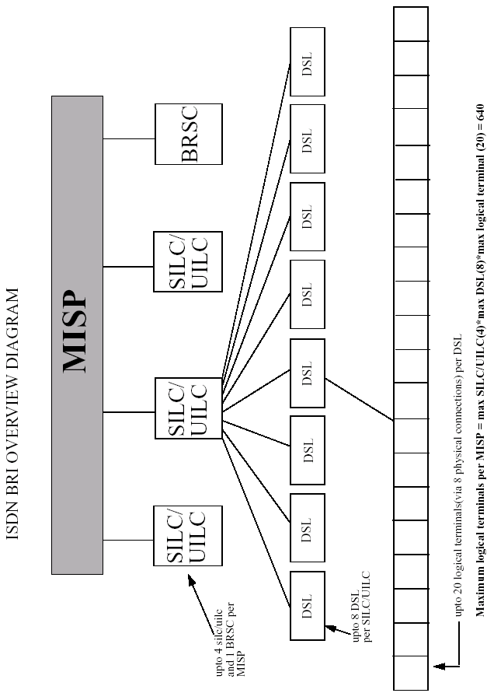
8 Set Relocation Corruption

8.1 SYMPTOMS OF PROBLEM

One or both of the following symptoms may occur with set relocation corruption.

1) When set relocation information is printed in LD21 a TN which is not in set relocation status it produced.

REQ PRT
TYPE SRDT

OLD TN TYPE ID SERNUM NT CODE COL RLS
93 XX0 00 2616 ID: 018D5D NT2K16C

2) A set cannot be changed due to an SCH2501 error being produced.

SCH2501 = An attempt was made to change a telephone that is in the process
of relocating.

8.2 HOW TO RESOLVE PROBLEM

One or both of the following solutions may be needed to remove the set relocation corruption.

1) Remove the SR_ELEMENTS in the relocation table structure. This table contains 14 words from pre software release 20 or 15 words for release 20 onwards.

SET_RELOC_TABLE = 924D (see Appendix)

#P 924D
00924D : 15D4F1

#P 15D4F1 1E6
15D4F1 : 00000D 1EE2E9 FFFFFF 000000 000000 000000 000000 000000
15D4F9 : 000000 000000 000000 000000 000000 000000 000000 000000
15D501 : 000000 000000 000000 000000 000000 000000 000000 000000
15D509 : 000000 000000 000000 000000 000000 000000 000000 000000
15D511 : 000000 000000 000000 000000 000000 000000 000000 000000
15D519 : 000000 000000 000000 000000 000000 000000 000000 000000
15D521 : 000000 000000 000000 000000 000000 000000 000000 000000
15D529 : 000000 000000 000000 000000 000000 000000 000000 000000
15D531 : 000000 000000 000000 000000 000000 000000 000000 000000
15D539 : 000000 000000 000000 000000 000000 000000 000000 000000
15D541 : 000000 000000 000000 000000 000000 000000 000000 000000
15D549 : 000000 000000 000000 000000 000000 000000 000000 000000
15D551 : 000000 000000 000000 000000 000000 000000 000000 000000
15D559 : 000000 000000 000000 000000 000000 000000 000000 000000
15D561 : 000000 000000 000000 000000 000000 000000 000000 000000
15D569 : 000000 000000 000000 000000 000000 000000 000000 000000
15D571 : 000000 000000 000000 000000 000000 000000 000000 000000
15D579 : 000000 000000 000000 000000 000000 000000 000000 000000
15D581 : 000000 000000 000000 000000 000000 000000 000000 000000
15D589 : 000000 000000 000000 000000 000000 000000 000000 000000
15D591 : 000000 000000 000000 000000 000000 000000 000000 000000
15D599 : 000000 000000 000000 000000 000000 000000 000000 000000
15D5A1 : 000000 000000 000000 000000 000000 000000 000000 000000
15D5A9 : 000000 000000 000000 000000 000000 000000 000000 000000
15D5B1 : 000000 000000 000000 000000 000000 000000 000000 000000
15D5B9 : 000000 000000 000000 000000 000000 000000 000000 000000
15D5C1 : 000000 000000 000000 000000 000000 000000 000000 000000
15D5C9 : 000000 000000 000000 000000 000000 000000 000000 000000
15D5D1 : 000000 000000 000000 000000 000000 000000 000000 000000
15D5D9 : 000000 000000 000000 000000 000000 000000 000000 000000
15D5E1 : 000000 000000 000000 000000 000000 000000 000000 000000
15D5E9 : 000000 000000 000000 000000 000000 000000 000000 000000
15D5F1 : 000000 000000 000000 000000 000000 000000 000000 000000
15D5F9 : 000000 000000 000000 000000 000000 000000 000000 000000
15D601 : 000000 000000 000000 000000 000000 000000 000000 000000
15D609 : 000000 000000 000000 000000 000000 000000 000000 000000
15D611 : 000000 000000 000000 000000 000000 000000 000000 000000
15D619 : 000000 000000 000000 000000 000000 000000 000000 000000
15D621 : 000000 000000 000000 000000 000000 000000 000000 000000
15D629 : 000000 000000 000000 000000 000000 000000 000000 000000
15D631 : 000000 000000 000000 000000 000000 000000 000000 000000
15D639 : 000000 000000 000000 000000 000000 000000 000000 000000
15D641 : 000000 000000 000000 000000 000000 000000 000000 000000
15D649 : 000000 000000 000000 000000 000000 000000 000000 000000
15D651 : 000000 000000 000000 000000 000000 000000 000000 000000
15D659 : 000000 000000 000000 000000 000000 000000 000000 000000
15D661 : 000000 000000 000000 000000 000000 000000 000000 000000
15D669 : 000000 000000 000000 000000 000000 000000 000000 000000
15D671 : 000000 000000 000000 000000 000000 000000 000000 000000
15D679 : 000000 000000 000000 000000 000000 000000 000000 000000
15D681 : 000000 000000 000000 000000 000000 000000 000000 000000
15D689 : 000000 000000 000000 000000 000000 000000 000000 000000
15D691 : 000000 000000 000000 000000 000000 000000 000000 000000
15D699 : 000000 000000 000000 000000 000000 000000 000000 000000
15D6A1 : 000000 000000 000000 000000 000000 000000 000000 000000
15D6A9 : 000000 000000 000000 000000 000000 000000 000000 000000
15D6B1 : 000000 000000 000000 000000 000000 000000 000000 000000
15D6B9 : 000000 000000 000000 000000 000000 000000 000000 000000
15D6C1 : 000000 000000 000000 000000 000000 000400 000400 005D0A
15D6C9 : 00018D 00D4CE 00CBB2 00B6B1 00CAC3 00B3B9 00D8D8 1A305D
15D6D1 : 000000 1A30A5 1A3139 15D086 000020 000000

#W 15D6C9
15D6C9 : 00018D /0
15D6CA : 00D4CE /0
15D6CB : 00CBB2 /0
15D6CC : 00B6B1 /0
15D6CD : 00CAC3 /0
15D6CE : 00B3B9 /0
15D6CF : 00D8D8 /0
15D6D0 : 1A305D /0
15D6D1 : 000000 /0
15D6D2 : 1A30A5 /0
15D6D3 : 1A3139 /0
15D6D4 : 15D086 /0
15D6D5 : 000020 /

2) To prevent the SCH2501 error the FAKE_TN_FLAG needs to be set to 0. Use the TNT<TN> command to find the protected unit pointer.

#TNT 4 0 0 0
EQPD SLOOP TN 000400
GP 1586B4 SLP 1586DA 1F9280 CD 158728 1F9266 LN 1A31E7 1EE1E4

#P 1A31E7 5
1A31E7 : 008024 000002 006000 000000 000005 000000 000000 000000

NOTE : FAKE_TN_FLAG (0,15,1),

#W 1A31E7
1A31E7 : 008024 /24

Changes should now be able to be made to this set.

8.3 SOFTWARE STRUCTURE

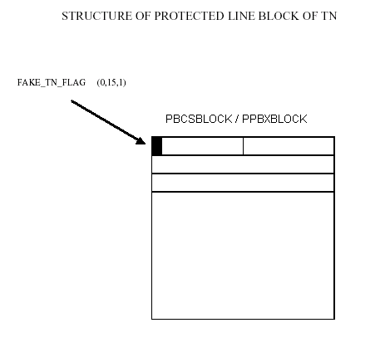
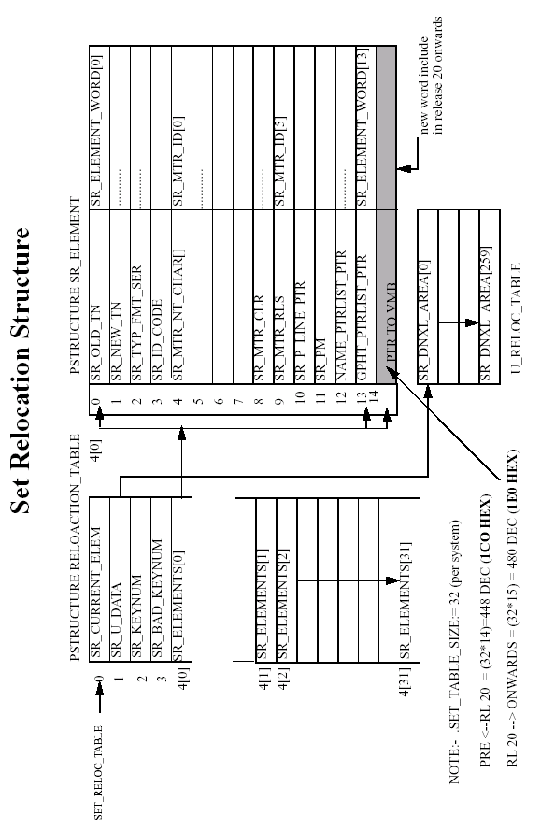
9 ACD Corruption

9.1 SYMPTOMS OF PROBLEM

One or more of the following symptoms may occur with ACD corruption.

1) When printed in LD20 the ACID information is corrupted.

DN 6000
TYPE ACDN
ACID 7001 TN 004 0 00 00
ACID <----------corruption

ACDN 6000 has corruption, it should look like:

DN 6000
TYPE ACDN
SUPY ACID 7000 TN 004 0 00 01 KEY 04
ACID 7001 TN 004 0 00 00 <-----------------acd agent
ACID 7000 TN 004 0 00 01 <-----------------acd supervisor

2) An SCH0767 error is produced when you try to out the set in LD 11.

REQ: OUT
TYPE: 2616
TN 4 0 0 0

SCH0767 = Supervisor's AGT key must be removed before removing agent.

3) No unit pointers exist when the TNT<TN> command is used.

#TNT 4 0 0 1
UNEQPD SLOOP TN 000401
GP 1586B4 SLP 1586DA 1F9280 CD 158728 1F9266 LN 000000 000000

9.2 HOW TO RESOLVE PROBLEM

The best way to deal with this type corruption is to remove the ACD AGENT,
the associated supervisor ACDN and the ACDN queue in LD 23.

First print all agents and supervisors in the ACD Queue. Then remove all related SCR, MCR DN'S to avoid any DN corruption.

REQ PRT
TYPE TNB
TN 004 0 00 00

..
..
KEY 00 ACD 6000 7001
SUPY ACID KEY 05
01 NRD
02 MSB
03 SCR 2001 MARP

REQ: CHG
TYPE: 2616
TN 4 0 0 0
ECHG YES
ITEM KEY 03 NUL

Remove the ACD AGT_ID for both the agent and the supervisor in the
DNTREE (see DN Corruption).

CDNXPTR = 8922 (see Appendix)

#DNT 0 7000
DIG 4 ACD_ID
1564F7 : 008B02 000401

#DNT 0 7001
DIG 4 ACD_ID
1564F9 : 008B02 000400

#P 8922 3
008922 : 15CF0E 000000 000000

#P 15CF0E 10
15CF0E : 0001C6 15CF80 15CF1B 000000 000000 000000 15D062 15CFC2
15CF16 : 15CFC0 000000 000000 000000 000000 000524 000000 15CFA5

#P 15CFC2 10
15CFC2 : 000400 000000 000000 000000 000000 000000 000000 000000
15CFCA : 000000 000000 15CFCE 000000 000480 000000 000000 000000

#P 15CFCE 10
15CFCE : 000480 000000 000000 000000 000000 000000 000000 15CFDA
15CFD6 : 000000 000000 15655C 000000 00000C 000000 15CFE6 15CFF4

#P 15655C 10
15655C : 000402 1564F9 000000 000000 000000 000000 000000 000000
156564 : 000000 000000 1564F7 000000 008208 000000 000000 000000

#W 15655C
15655C : 000402 /0
15655D : 1564F9 /0
15655E : 000000 /
15655F : 000000 /
156560 : 000000 /
156561 : 000000 /
156562 : 000000 /
156563 : 000000 /
156564 : 000000 /
156565 : 000000 /
156566 : 1564F7 /0

#DNT 0 7000
DIG 4 INV

#DNT 0 7001
DIG 4 INV

Remove the ACD agent and supervisor TN's (see TN Corruption).

#TNT 4 0 0 0
EQPD SLOOP TN 000400
GP 1586B4 SLP 1586DA 1F9280 CD 158728 1F9266 LN 1A30E5 1EE0E0

#W 158728
158728 : 002060 /
158729 : 1A30E5 /0
#W 1F9266
1F9266 : 000000 /
1F9267 : 1EE0E0 /0

#TNT 4 0 0 0
UNEQPD SLOOP TN 000400
GP 1586B4 SLP 1586DA 1F9280 CD 158728 1F9266 LN 000000 000000

At this point we have practically removed all of the TN'S and removed all of the
DN'S that belongs to its ACDN. Now we have to remove all of the TN'S out of the ACD_POS_LIST structure. We also need to modify the ACD_NUMB_POS word offset(1) which contains the number of stations.

a) In LD23 print all the ACDN's. The ACDN'S configured in a given customer
number are in the order they will appear in ACD_LIST data structure.

Note : Look for the corrupted ACDN and make a note of it’s position of order.

b) Use the DCP<CUST> command to find the address of CDATAPTR which points to the P_CUST_DATA_BLK.

#DCP 0
CUST 0 P 15658D U 1F9D06 AUX 156ABF ICI 156C52 PREXL 000000 BGD 156ECD

#P 15658D 87
15658D : 004104 000000 000001 000000 000000 000000 000000 000000
156595 : 000000 0061E5 009951 000000 000000 1F9D06 000001 001EE0
15659D : 000003 000000 000000 000002 000000 156C52 15CB86 000100
1565A5 : 000000 000000 000000 00FEA0 000000 000000 000000 000000
1565AD : 000000 000000 000000 000000 000000 000000 000000 000000
1565B5 : 000000 000000 000000 000000 000000 000000 000000 000000
1565BD : 000000 000000 000000 000000 000000 000000 000000 000000
1565C5 : 000000 000000 000000 000000 000000 000000 00001E 000000
1565CD : 000000 000000 000000 000000 000000 000000 000000 000000
1565D5 : 000000 000000 000000 000000 000000 000000 000000 000000
1565DD : 000000 000000 000000 000000 000000 000000 000000 000000
1565E5 : 000000 000000 000000 000000 000000 000000 000000 000000
1565ED : 000000 000000 000000 000000 000000 000000 000000 000000
1565F5 : 000000 000000 000000 006870 002871 000041 000000 000F00
1565FD : 00080F 002014 000000 000000 000000 000000 000000 000000
156605 : 000000 000441 000441 000000 000000 00085A 000111 000000
15660D : 00AAAA 00FF20 00FFFF 000000 000001 00201E 1564EF

By printing the ACDN’s in LD23 we know that the DN we are looking for is in the second position.

#P 1564EF 10
1564EF : 000003 15BF3E 1A3075 008A03 000000 000001 008B02 000400
1st 2nd
1564F7 : 008B02 000401 008B02 000400 000000 00000C 000000 1A30C9

Print the P_ACD_BLOCK for this DN

#P 1A3075 8
1A3075 : 00003A 00AAA6 000000 1EE16E 1A30AF 00000A 0003FF

Note : AAA6 000000 (2 words) = ACDN 6000

Print the ACD_POS_LIST at word offset (4).

#P 1A30AF 20
1A30AF : 00001A 000002 000401 000000 000000 000000 000000 000000
1A30B7 : 000000 000000 000004 000000 000000 000000 000000 000000
1A30BF : 000401 000400 000000 000000 000000 000000 000000 000000
1A30C7 : 000000 000000 00011C 00BF63 000001 001AF6 001F04 002E20

Use the TNT<TN> command to check which TN’s are in this list.

#TNT 4 0 0 0
EQPD SLOOP TN 000400
GP 1586B4 SLP 1586DA 1F9280 CD 158728 1F9266 LN 000000 000000

#TNT 4 0 0 1
UNEQPD SLOOP TN 000401
GP 1586B4 SLP 1586DA 1F9280 CD 158728 1F9266 LN 000000 000000

These TN’s do not have any unit pointers and do not exist so should be removed. The ACD_NUMB_POS should also be updated to match this.

#W 1A30AF
1A30AF : 00001A /
1A30B0 : 000002 /0
1A30B1 : 000401 /0
1A30B2 : 000000 /
1A30B3 : 000000 /
1A30B4 : 000000 /
1A30B5 : 000000 /
1A30B6 : 000000 /
1A30B7 : 000000 /
1A30B8 : 000000 /
1A30B9 : 000004 /
1A30BA : 000000 /
1A30BB : 000000 /
1A30BC : 000000 /
1A30BD : 000000 /
1A30BE : 000000 /
1A30BF : 000401 /0
1A30C0 : 000400 /0

We have now taken out the ACD agent, the supervisor and the ACDN queue can be removed in LD23.

9.3 SOFTWARE STRUCTURE
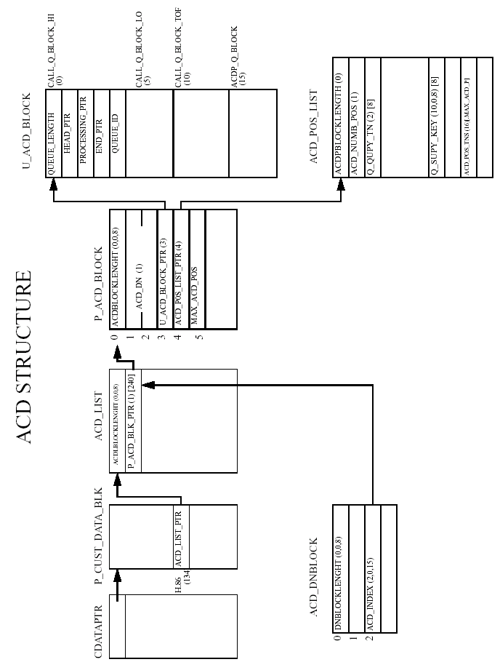
10 TTY Corruption

10.1 SYMPTOMS OF PROBLEM

CTYP **** is produced when the TTY’s are printed in LD22. DNUM may also not make sense if that TTY is corrupted.

LD 22
REQ PRT
TYPE ADAN TTY
ADAN TTY 0
CTYP SDI2
DNUM 0
DES
USER MTC TRF SCH CTY BUG BGD
CUST 00
XSM NO
TTYLOG 0
ADAN TTY 1
CTYP ****
DNUM 8
DES
USER
XSM NO
STA 0

The TTY cannot be taken out in LD17 and an SCH6083 error is produced.

LD 17
REQ CHG
TYPE ADAN
ADAN OUT TTY 1

SCH6083 = Since this TTY is configured with an STA application, it cannot be removed until the STA is removed.

10.2 HOW TO RESOLVE PROBLEM

The TTY information needs to be removed from 3 locations in memory.

1) LOG_IO_PTR = 9DD0 (see Appendix)

#P 9DD0
009DD0 : 12478A

#P 12478A 10
12478A : 000005 124BE9 1247DC 12478F 000000 000011 1247A0 1247BE
124792 : 000000 000000 000000 000000 000000 000000 000000 000000

Print the P_SDI_BLK_PTR(1)[.max_num_of_ttys] pointer.

#P 12478F 10
12478F : 000011 1247A0 1247BE 000000 000000 000000 000000 000000
TTY0 TTY1 TTY2 ----------etc
124797 : 000000 000000 000000 000000 000000 000000 000000 000000

Remove the pointer of the corrupted TTY 1.

#W 12478F
12478F : 000011 /
124790 : 1247A0 /
124791 : 1247BE /0

2) CONFIGTTYOP = 8FE1 (see Appendix)

NOTE : Each word is overlaid by the structure LOGUWORD

#P 8FE1 5
008FE1 : 00805E 000000 000000 000000 000000 000000 000000 000000
TTY0 TTY1 TTY2 TTY3 TTY4 TTY5 --------etc

In this TTY 1 is already 0.

3) TTYLOGU = 881A (see Appendix)

#P 881A 4
00881A : 000004 000000 000000 00000
TTY No 3210 7654 ------etc

In this TTY 1 is already 0.

To confirm the corruption has been cleared print TTY 1 in LD22.

REQ PRT
TYPE ADAN TTY 1

TTY 1 IS UNDEFINED

ADAN NEW TTY 1
CTYP SDI2
DNUM 01
DES
USER MTC BUG
TTYLOG
ADAN DATA SAVED

10.2 SOFTWARE STRUCTURE
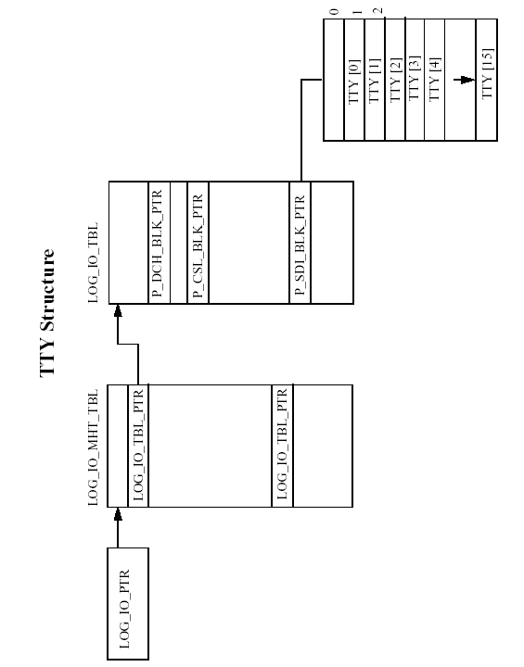
11 BFS Corruption

11.1 SYMPTOMS OF PROBLEM

When printed in LD20 the BFTN information is corrupt.

LD 20
REQ PRT
TN 4 0 0 0
DATE
PAGE
DES

DES TEST
TN 004 0 00 00
TYPE 2616
CDEN 8D
CUST 0
..
..
CPND_LANG ENG
BFTN 000 0 00 00
000 0 00 00
000 0 00 00
000 0 00 00
000 0 00 00
008 0 00 01
000 0 00 00
000 0 00 00
000 0 00 00
000 0 00 00
..
..

By printing the BFS_POINTER, word offset (9), from the protected unit pointer it can be seen that there is no BFS information available.

#TNT 4 0 0 0
EQPD SLOOP TN 000400
GP 1586B4 SLP 1586DA 1F9280 CD 158728 1F9266 LN 1A305D 1EE1E4

#P 1A305D 10
1A305D : 000024 000002 007000 000000 000005 000000 000000 000000
1A3065 : 000000 005862 000000 00000E 0000C0 000004 000000 001FFF

#P 005862 10
005862 : 000000 000000 000000 000000 000000 000000 000000 000000
00586A : 000000 000000 000000 000000 000000 000000 000000 000000

11.2 HOW TO RESOLVE PROBLEM

The BFS_POINTER needs to be removed from the PBCSBLOCK or the PPBXBLOCK for 500/2500 sets.

#TNT 4 0 0 0
EQPD SLOOP TN 000400
GP 1586B4 SLP 1586DA 1F9280 CD 158728 1F9266 LN 1A305D 1EE1E4

#P 1A305D 10
1A305D : 000024 000002 007000 000000 000005 000000 000000 000000
1A3065 : 000000 005862 000000 00000E 0000C0 000004 000000 001FFF

#W 1A305D
1A305D : 000024 /
1A305E : 000002 /
1A305F : 007000 /
1A3060 : 000000 /
1A3061 : 000005 /
1A3062 : 000000 /
1A3063 : 000000 /
1A3064 : 000000 /
1A3065 : 000000 /
1A3066 : 005862/ 0

11.3 SOFTWARE STRUCTURE
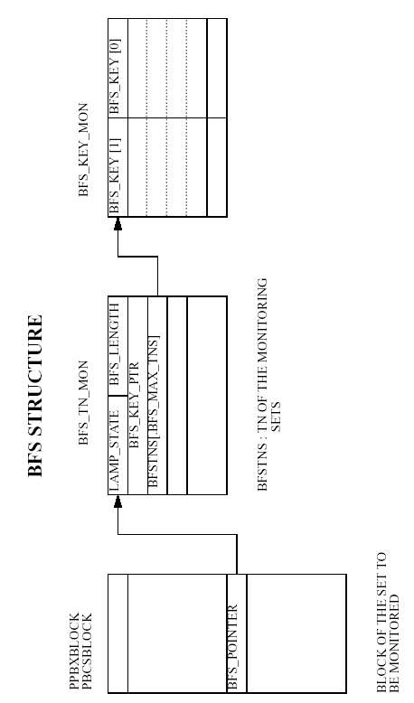
12 Authorisation Code Corruption

12.1 SYMPTOMS OF PROBLEM

One or more of the following symptoms may occur if authorisation code corruption is present.

1) If an authorisation code is printed in LD 88, the system prints from say
021175 to 317490, it then skips back to 131490 and prints to 317490 and then
remains in a loop, infinitely.

2) Corruption in the authorization code table, auth codes are lost when re-
inputted and cause an initialization.

12.2 HOW TO RESOLVE PROBLEM

To deal with this type of corruption take out the P_AUTH_TBL_PTR word offset (157) in the protected customer data block P_CUST_DATA_BLK. This will remove the authorisation code table for the given customer. The codes would then need to be re-entered again.

#DCP 0
CUST 0 P 11DC59 U 1F9A8E AUX 11E4A7 ICI 11E701 PREXL 1242BB
BGD 11E9F5

#P 11DC59 9E
11DC59 : 007304 000000 000001 000004 000000 000000 000000 000000
11DC61 : 000000 0061E5 000021 000000 000000 1F9A8E 000001 001EE0
11DC69 : 000003 000000 000000 000002 000000 11E701 125401 000100
11DC71 : 000000 000000 000000 00FEE0 000000 000000 000000 000000
11DC79 : 000000 000000 000000 000000 000000 000000 000000 000000
11DC81 : 000000 000000 000000 000000 000000 000000 000000 000000
11DC89 : 000000 000000 000000 000000 000000 000000 000000 000000
11DC91 : 000000 000000 000000 000000 000000 000000 00001E 000000
11DC99 : 000000 000000 000000 000000 000000 000000 000000 000000
11DCA1 : 000000 000000 000000 000000 000000 000000 000000 000000
11DCA9 : 000000 000000 000000 000000 000000 000000 000000 000000
11DCB1 : 000000 000000 000000 000000 000000 000000 000000 000000
11DCB9 : 000000 000000 000000 000000 000000 000000 000000 000000
11DCC1 : 000000 000000 000000 006870 006871 000041 00003F 000A00
11DCC9 : 001C0A 00E018 000000 000000 000000 000000 000000 000000
11DCD1 : 000000 000444 000444 000000 000200 00085A 000111 000000
11DCD9 : 00AAAA 00FF20 00FFFF 000000 000003 00211E 1243BB 000000
11DCE1 : 12292A 000000 00AA82 000000 000000 000000 000000 000000
11DCE9 : 000000 00C300 000000 000000 000000 000000 000000 000000
11DCF1 : 000000 000000 000000 000000 123CCD 111413

#W 11DCF1
11DCF1 : 000000 /
11DCF2 : 000000 /
11DCF3 : 000000 /
11DCF4 : 000000 /
11DCF5 : 123CCD /
11DCF6 : 111413/ 0

12.3 SOFTWARE STRUCTURE
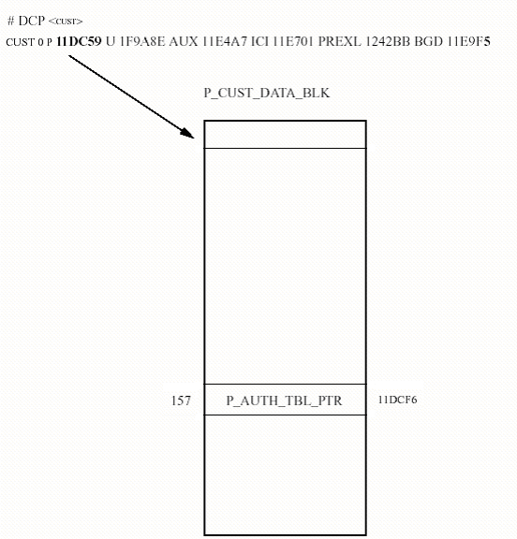

13 ESN Corruption

13.1 SYMPTOMS OF PROBLEM

One or more of the following symptoms may occur if ESN corruption is present.

1) Unable to dial 9-999, in LD20 when printing the DN 9 it shows it is NARS, AC1.
But in LD 90 when printing NET, AC1, SPN 9 is not configured. When trying to
configure a new NET, AC1, SPN 9 fails with ESN072.

2) Also in LD90 when printing SPN 0, FLEN = 0 is produced. But when changing FLEN to 1 and printing again FLEN = 0 is still shown.

13.2 HOW TO RESOLVE PROBLEM

The best way to deal with this type and many other type's of ESN corruption
is to take out ENS_DATA_BLK_PTR word offset (136) in the protected customer
data block P_CUST_DATA_BLK. By setting this pointer to zero you have removed the whole of ESN_DATA_BLOCK.

Find the P_CUST_DATA_BLK pointer by using the DCP<CUST> command.

#DCP 0
CUST 0 P 11DC59 U 1F9A8E AUX 11E4A7 ICI 11E701 PREXL 1242BB BGD 11E9F5

Print the word offset 88+1 hex (136+1 dec).

#P 11DC59 89
11DC59 : 007304 000000 000001 000004 000000 000000 000000 000000
11DC61 : 000000 0061E5 000021 000000 000000 1F9A8E 000001 001EE0
11DC69 : 000003 000000 000000 000002 000000 11E701 125401 000100
11DC71 : 000000 000000 000000 00FEE0 000000 000000 000000 000000
11DC79 : 000000 000000 000000 000000 000000 000000 000000 000000
11DC81 : 000000 000000 000000 000000 000000 000000 000000 000000
11DC89 : 000000 000000 000000 000000 000000 000000 000000 000000
11DC91 : 000000 000000 000000 000000 000000 000000 00001E 000000
11DC99 : 000000 000000 000000 000000 000000 000000 000000 000000
11DCA1 : 000000 000000 000000 000000 000000 000000 000000 000000
11DCA9 : 000000 000000 000000 000000 000000 000000 000000 000000
11DCB1 : 000000 000000 000000 000000 000000 000000 000000 000000
11DCB9 : 000000 000000 000000 000000 000000 000000 000000 000000
11DCC1 : 000000 000000 000000 006870 006871 000041 00003F 000A00
11DCC9 : 001C0A 00E018 000000 000000 000000 000000 000000 000000
11DCD1 : 000000 000444 000444 000000 000200 00085A 000111 000000
11DCD9 : 00AAAA 00FF20 00FFFF 000000 000003 00211E 1243BB 000000
11DCE1 : 12292A

#W 11DCE1
11DCE1 : 12292A /0

13.3 SOFTWARE STRUCTURE

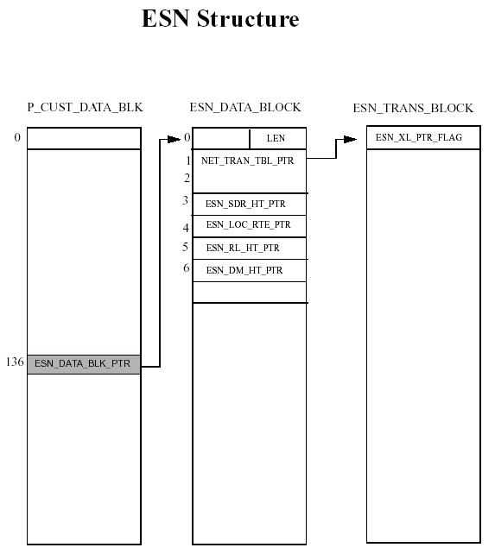

14 ITG CHID Channel ID Corruption

14.1 SYMPTOMS OF PROBLEM

When trying to enter a new ITG trunk in LD14 an SCH3162 error is produced.

REQ: NEW
TYPE: TIE
TN 92 0 8 0
DES ITG
XTRK ITG2
MAXU 24
IPTN
CUST 0
NCOS 7
RTMB 17 1
CHID 1

SCH3162 = In LD14 a duplicate CHID has been entered. This CHID already exists.

14.2 HOW TO RESOLVE PROBLEM

LOG_IO_PTR = 0xA70F (see Appendix)

pdt> p 000A70F
0000A70F : 000B51A0

This is the address of LOG_IO_TBL_PTR (0). Use it to find LOG_IO_TBL.

pdt> p 000B51A0 2
000B51A0 : 00000005 000B5441

This is the address of P_DCH_BLK_PTR (1). Use it to find the DCH 11 pointer.

pdt> p 000B5441 20
000B5441 : 00000100 000B5541 00000000 00000000 00000000 00000000 00000000 00000000
DCH 0
000B5449 : 000B55B8 00000000 00000000 00000000 000DEB97 00000000 00000000 00000000
DCH 7 DCH 11
000B5451 : 00000000 00000000 00000000 00000000 00000000 00000000 00000000 00000000
000B5459 : 00000000 00000000 00000000 00000000 00000000 00000000 00000000 00000000

This is the address of the DCH 11 data block. Use it to find P_DCH_BLOCK.

pdt> p 000DEB97 11
000DEB97 : 00000077 0076F832 0076F80A 00000000 004E43E1 004E4521 000C67B4 0070A4EE
000DEB9F : 004E6ACB 00000029 00000003 00000414 00000180 00003874 00001043 00000180
000DEBA7 : 000BFA36

This is the address of P_ESLTN_TBL_PTR (16). Use it to find P_ESLTN_TBL.

pdt> p 000BFA36 8
000BFA36 : 00000001 00005C20 00000000 00000000 00000000 00000000 00000000 00000000

This is the value of P_ESLTN_TBLNGTH (0) and should be changed to zero.

pdt> w 000BFA36
000BFA36 : 00000001 /0

The DCH should now be removed, ensuring there is no further corruption.

LD 17
REQ chg
TYPE adan
ADAN out dch 11

A new DCH can now be programmed.

LD 17
REQ chg
TYPE adan
ADAN new dch 11
...

To confirm the corruption has now been cleared configure a new tie trunk with a channel ID of 1.

LD 14
REQ new
TYPE tie
TN 92 0 8 0
DES itg
XTRK itg2
MAXU 24
IPTN
CUST 0
NCOS 7
RTMB 17 1
CHID 1
MNDN
...

14.3 SOFTWARE STRUCTURE
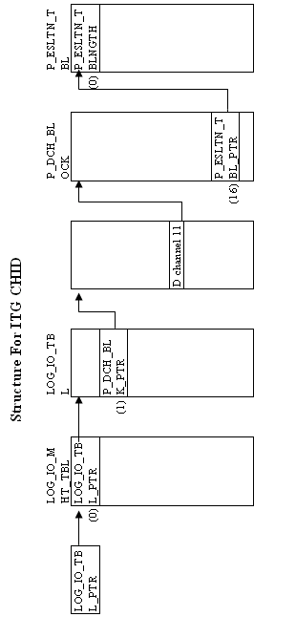
15 ACD SCHED Block Corruption

15.1 SYMPTOMS OF PROBLEM

An SCH0925 error is produced when trying to create a new schedule data block.

LD 23
REQ NEW
TYPE SCB
CUST 0

SCH0925 = New request is invalid for ADS prompt if the customer has been assigned as an ACD package D customer.

NOTE : The ACD D package does not exist.

15.2 HOW TO RESOLVE PROBLEM

To clear this type of corruption we need to reset ACD_D_ON and AGENT_ID_MODE values in memory.

Print 142 words in memory from the protected customer data block P_CUST_DATA_BLK.

#DCP 0
CUST 0 P 11DC59 U 1F9A8E AUX 11E4A7 ICI 11E701 PREXL 1242BB BGD 11E9F5

142 = 8E hex
11DC59 + 8E = 11DCE7

#P 11DCE7
11DCE7 : 000003

#W 11DCE7 : 000003 /0

NOTE : If the software release is applicable then the next step is to install patch
MPLR07561 or MPLR07562 depending on what you want to set AID to YES or NO.

15.30 SOFTWARE STRUCTURE

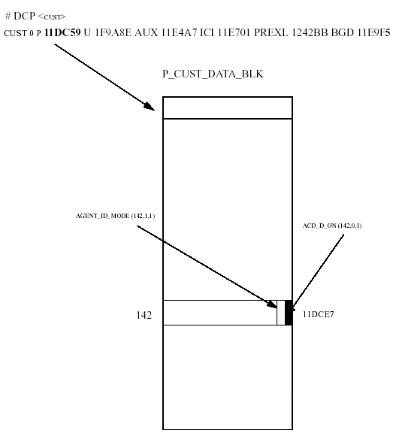

16 MSDL PORT CORRUPTION

16.1 SYMPTOMS OF PROBLEM

A port on the MSDL cannot be used when it is available and an SCH5573 error is produced. (Specified port not available, other ports are available.)

Print out the i/o device (ADAN) data in LD22 and make a note of all the MSDL ports being used. Double check to make sure that the port is corrupted and not being used as an AML instead of a DCH.

ld 48
.stat msdl 14

MSDL 14: ENBL

DCH 10 OPER PORT 1
DCH 11 OPER PORT 2

ADAN DCH 10
CTYP MSDL
DNUM 14
PORT 1
DES MCDN
USR PRI
DCHL 10
..
..

ADAN DCH 11
CTYP MSDL
DNUM 14
PORT 2
DES MCDN
USR PRI
DCHL 11
OTBF 32
..
..

LD 17
REQ CHG
TYPE ADAN
ADAN NEW DCH 9
CTYP MSDL
DNUM 14
PORT 3

SCH5573 = Specified port not available, other ports are available.
DNUM

16.2 HOW TO RESOLVE THIS PROBLEM

Print out the P_MSDLMISP_MHPTR pointer and the P_MSDLMISP_TABLE

P_MSDLMISP_MHPTR = 9fcf (see Appendix)

pdt> p 9fcf

00009FCF : 00022C22

This is the pointer to the P_MSDLMISP_TABLE.

pdt> p 00022C22 20

00022C22 : 00022BC1 00022CA2 00022CD4 00000000 00000000 00000000 00000000 00000000
00022C2A : 00000000 00000000 00000000 00000000 00000000 00000000 00000000 00000000
00022C32 : 00000000 00000000 00000000 00000000 00000000 00000000 00000000 00000000
00022C3A : 00000000 00000000 00000000 00000000 00000000 00000000 00000000 00000000

To find which P_MSDLMISP_BLOCK block is the one we're looking for, the best way to be sure of this (unless there's only one) is to first print out all of the blocks. Then using the PHY_IO_BLK pointer (word 0) of each block, print out the PHY_SERIAL_IOBLK for each MSDL.

pdt> p 00022BC1 10

00022BC1 : 0001EDD8 00728D17 00022D06 00728C67 00728B5D 0072894D 00000000 00000000
00022BC9 : 00000000 00000000 00000404 00000004 00000000 00000000 00000000 00000029

This is the pointer to the PHY_SERIAL_IOBLK block.

pdt> p 0001EDD8 30

0001EDD8 : 00008311 000030E0 000000A7 0000380E 00000000 00000000 00000000 00000000
0001EDE0 : 00000A02 FFFFFFFF 00000000 00000B02 FFFFFFFF 00000000 00000802 FFFFFFFF
0001EDE8 : 00000000 00008C04 00E00F01 00000000 00008000 00008108 00003090 000000A6
0001EDF0 : 00003009 00000000 00000502 FFFFFFFF 00000000 00008C04 00E00F01 00000000
0001EDF8 : 00008000 0001EDD5 0000000F 0001C81B 00000124 00000002 00006000 00000000
0001EE00 : 00000002 00000000 00000000 00000000 00000000 00000000 00000000 0000000E

In this the first pointer in the P_MSDLMISP_TABLE is the one we are looking
for because word 3 shows that it is an MSDL CARD and it's configured on device num 14.

Word 3 = 380E

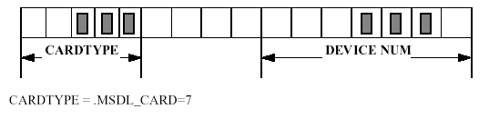
Once the appropriate P_MSDLMISP_BLOCK and associated PHY_SERIAL_IOBLK have been found the corrupted port needs to be removed. This is done by removing the appropriate entries in the IO_PORT_DATA array (word 5), which contain four structure instances of IO_PORT_INFO, one for each port.

pdt> w 0001EDE6

0001EDE6 : 00000802 /0
0001EDE7 : FFFFFFFF /0
0001EDE8 : 00000000 /

To confirm that the corruption has cleared.

LD 17
REQ chg
TYPE adan
ADAN new dch 9
CTYP msdl
DNUM 14
PORT 3
DES
DPNS
USR
..

16.3 SOFTWARE STRUCTURE

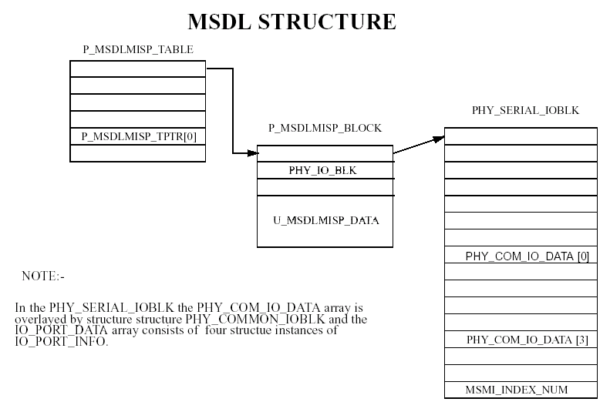

17 DCH channel Corruption

17.1 Symptoms of problem

DCH corruption can have symptoms where the associated loop is incorrect or missing. It can also produce an SCH4732 error when trying to remove the DCH in LD17.

LD 96
.stat dch
DCH 11 : DSBL RST DES : LOOP06XBERG2XL52
DCH 13 : DSBL RST DES : LOOP04XSIEG2XL04
DCH 14 : OPER EST ACTV AUTO DES : LOOP13_FT

LD 22
REQ prt
TYPE adan dch 11
ADAN DCH 11
CTYP DCHI
DNUM 11
DES LOOP06XBERG2XL52
USR PRI
DCHL 6 <-------
OTBF 16
DRAT 64KC
..
..

REQ prt
TYPE adan dch 13
ADAN DCH 13
CTYP DCHI
DNUM 13
DES LOOP04XSIEG2XL04
USR PRI
DCHL 4 <-------
OTBF 16
DRAT 64KC
..
..

REQ prt
TYPE cequ
CEQU
MPED 8D
TERM
REMO
TERD
REMD
TERQ 001 017
REMQ
SUPL 004 020
XCT 002 018
TDS * 002 * 018
CONF * 003 * 019
MFSD * 002 * 018
PRI2 000 012 013 016
DTI2
MISP 024
EXT0 3PE
CNI 012 000 000
EXT1 3PE
CNI 012 000 000
MCFN 004 004 004 004 016 016

ld 97
REQ prt
TYPE supl
SUPL 4
SUPL SUPT SLOT XPEC0 XPEC1
004 STD LEFT 04 0 3 05 0 3

LD 17
REQ chg
TYPE adan
ADAN out dch 11
SCH4732
ADAN out dch 13
SCH4732 = Cannot remove the D-channel when B-channel is still defined for loops
associated with this D-channel.

This loop 4, which is a superloop, is associated to DCH 13, and loop 6 is associated to DCH 11 which has disappeared. It is also not possible to remove either DCH 11 or 13.

17.2 To solve the problem

The DCH information for 11 and 13 need to be removed from the LOG_IO_TBL.

LOG_IO_PTR = 96AD (see Appendix)

pdt> p 9fd0
00009FD0 : 00026ADA

This is the LOG_IO_MHT_TBL address.

pdt> p 00026ADA 5
00026ADA : 00000005 00026CF6 00000000 00026ADF 00000000

This is the P_DCH_BLK_PTR pointer, print this to find the DCH_BLK_PTRS.

pdt> p 00026CF6 10
00026CF6 : 00000041 00000000 00000000 00000000 00000000 00000000 00000000 00000000
00026CFE : 00000000 00000000 00000000 00000000 00026D37 00000000 00026D91 00026DEB
DCH 11 DCH 13

To remove DCH 11 and 13 these pointers need to be removed.

pdt> w 00026D02
00026D02 : 00026D37 /0

pdt> w 00026D04
00026D04 : 00026D91 /0
Confirm DCH 11 and 13 have been cleared.

LD 22
REQ prt
TYPE adan dch 11
DCH 11 IS UNDEFINED
REQ prt
TYPE adan dch 13
DCH 13 IS UNDEFINED

LD96
DCH000
.stat dch
DCH 14 : OPER EST ACTV AUTO DES : LOOP13_FT

17.3 SOFTWARE STRUCTURE
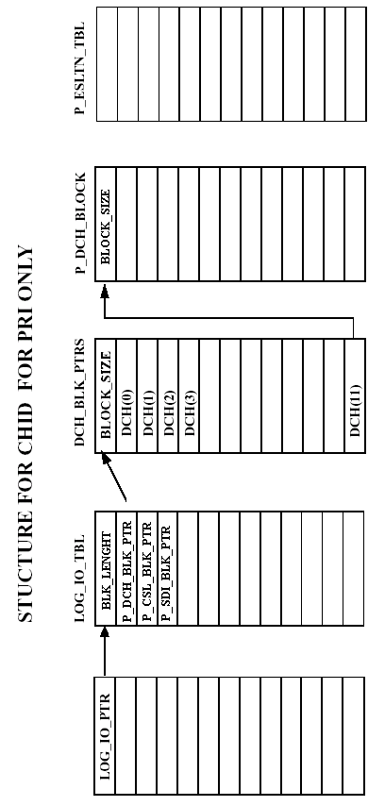
18 TTY Corruption On OPT 11c

18.1 SYMPTOMS OF PROBLEM

SCH6701 is produced when trying to add a new TTY on an option 11C. From release 22 onwards with option 11C it is possible to configure TTY's on expansion cabinets, but only ONE TTY is allowed per cabinet.

When entering a new TTY a SCH6701 error is generated showing a TTY is already assigned to that cabinet. If in LD22 there are no TTY's marked against the cabinet then there is corruption.

18.2 HOW TO RESOLVE THIS PROBLEM

The corruption occurs when an unconfigured TTY has a cabinet number other than 0.
Clear this information to enable the TTY to be configured.

As you do not know which TTY is corrupted it is advisable to go through all the unconfigured TTY's in the array PHYS_IO_PTR and check their values.

By looking in Procedure FIND_EXP_TTY we can see that a TTY has a cabinet
number defined by :-
CAB_NUM:PHYS_IO_PTR[INDEX]:IO_TABLE_PTR

IO_TABLE_PTR = 8089 (see Appendix)

pdt> p 00008002 5
00008002 : 000A6974 00115351 0014C926 00000000 00000001

There are 15 pointers in this PHYS_IO_PTR array, one for each TTY.

pdt> p 0014C926 20
0014C926 : 00000000 0013B80A 00003000 00008089 00000000 00124E42 00000000 00000000
0014C92E : 00000000 00000000 00000000 00000000 00000000 00000000 00000000 00000000
0014C936 : 00000000 00000000 00000000 00000000 00000000 00000000 00000000 00000000
0014C93E : 00000000 00000000 00000000 00000000 00000000 00000000 00000000 00000000

CAB_NUM (3,7,4) is the 3rd word, 7th bit for 4 bits.

This would imply the TTY was in Cabinet 1.

pdt> w 0014C929
0014C929 : 00008089 / 8009

18.3 SOFTWARE STRUCTURE

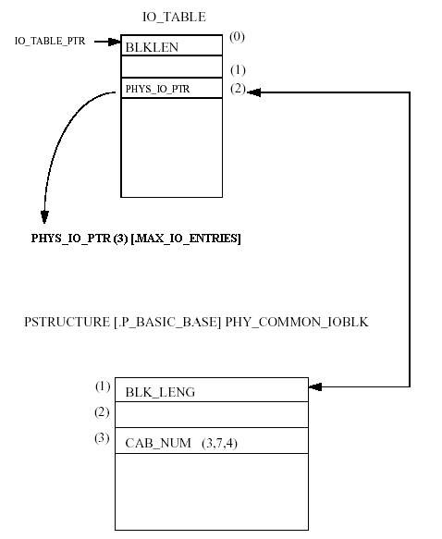

19 XPEC Corruption on Superloop

19.1 SYMPTOMS OF PROBLEM

This type of corruption is indicated when EDD039 is produced whilst performing a data dump in LD43.

LD 43
.edd clr

EDD039 = Audit indicates that peripheral controller and superloop data does not agree and the dump is aborted.

The corruption may be shown when printing the XPEC’s and superloops in LD97.

LD 97
REQ prt
TYPE xpe
XPEC
S0 S1 S2 S3 LOC DIS RGTP
01 000 000 NO 08
02 004 004 NO 08
..
..
20 104 104 NO 08
21 104 104 NO 08
22 138 084 000 000 Je NO 00 <------ Corruption on XPEC 22
23 108 108 NO 08
24 112 112 NO 08
..
..

REQ prt
TYPE supl
SUPL
SUPL SUPT SLOT XPEC0 XPEC1
000 STD LEFT 01 0 1 -- - -
004 STD LEFT 02 0 1 -- - -
..
..
064 ---- ---- PHANTOM -- - -
104 STD LEFT 20 0 1 21 2 3
108 STD LEFT 22 4 4 23 2 3
112 STD LEFT 24 0 1 25 2 3
116 STD LEFT 26 0 1 27 2 3
..
..

19.2 HOW TO RESOLVE PROBLEM

Remove the XPEC 0 on superloop 108.

REQ chg
TYPE supl
SUPL 108
XPE0 x
XPE1
WRAP UP SUPL 108 ..OK

REQ prt
TYPE supl
SUPL
SUPL SUPT SLOT XPEC0 XPEC1
000 STD LEFT 01 0 1 -- - -
004 STD LEFT 02 0 1 -- - -
..
..
064 ---- ---- PHANTOM -- - -
104 STD LEFT 20 0 1 21 2 3
108 STD LEFT -- - - 23 2 3 <------ XPEC 0 has been removed.
112 STD LEFT 24 0 1 25 2 3
116 STD LEFT 26 0 1 27 2 3
..
..

Remove the XPEC 22.

REQ chg
TYPE xpe
XPEC x22
S0 S1 S2 S3 LOC DIS RGTP
22 138 084 000 000 Je NO 00
XPEC NOT EMPTY
SCH5728 = Cannot delete a controller that is not empty

SYS_XPEC = 9687 (see Appendix)

Print the SYS_XPEC to show the pointers for all the XPEC’s.

pdt> p 9687 20
00009687 : 00000000 00037DEE 00037DF8 00037E02 00037E0C 00037E1 00037E20 00037E2A
XPEC 0 1 2 3 4
0000968F : 00037E34 00037E3E 00000000 00000000 00000000 00000000 00000000 00000000
00009697 : 00000000 00037E52 00037E5C 00000000 00037E70 00037E7A 00037E84 00037E8E
22
0000969F : 00037E98 00037EA2 00037EAC 00037EB6 00037EC0 00037ECA 00037ED4 00037EDE

Remove the pointer for the corrupted XPEC.

pdt> w 969d
0000969D : 00037E84 /0

To confirm the corruption is cleared print the XPEC.

REQ prt
TYPE xpe
XPEC
S0 S1 S2 S3 LOC DIS RGTP
01 000 000 NO 08
02 004 004 NO 08
..
..
20 104 104 NO 08
21 104 104 NO 08
23 108 108 NO 08
..
..

19.3 SOFTWARE STRUCTRUE
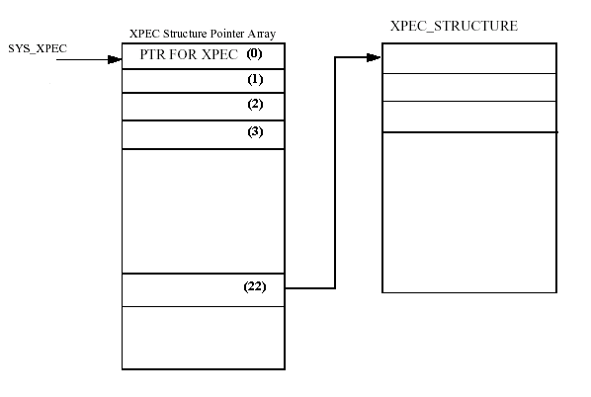

20 CDN Corruption

20.1 SYMPTOMS OF PROBLEM

When trying to remove a CDN in LD23 an SCH5351 error is produced which indicates it has calls in its default ACDDN.

LD 23
REQ out
TYPE cdn
CUST 0
CDN 40208
SCH5351 = Cannot remove a CDN when it has default calls in its default ACD-DN.

20.3 HOW TO RESOLVE THIS PROBLEM

All of the information relating to the existing call in the U_ACD_BLOCK must be removed.

By using the DCP<CUST> command fine the CDATAPTR pointer.

#DCP 0
CUST 0 P 11DC59 U 1F9A8E AUX 11E4A7 ICI 11E701 PREXL 1242BB
BGD 11E9F5

pdt> p 11DC59
00011DC59 : 0001C7AD

Print this address for 87 hex to find the ACD_LIST_PTR

pdt> p 0001C7AD 87
0001C7AD : 00004B04 00000000 0000FFFF 00000000 00000000 00000000 00000000 00000000
0001C7B5 : 00000000 000051E5 000089A5 00000000 00000000 0072454C 00000000 000006E0
0001C7BD : 00000002 00000000 00000000 00000000 00000000 00000000 0002647C 00000100
0001C7C5 : 0000001A 00005244 00000000 000000C0 00000000 00000000 00000000 00000000
0001C7CD : 00000000 00000000 00000000 00000000 00000000 00000000 00000000 00000000
0001C7D5 : 00000000 00000000 00000000 00000000 00000000 00000000 00000000 00000000
0001C7DD : 00000000 00000000 00000000 00000000 00000000 00000000 00000000 00000000
0001C7E5 : 00000000 00000000 00000000 00000000 00000000 00000000 0000001E 00000000
0001C7ED : 00000000 00000000 00000000 00000000 00000000 00000000 00000000 00000000
0001C7F5 : 00000000 00000000 00000000 00000000 00000000 00000000 00000000 00000000
0001C7FD : 00000000 00000000 00000000 00000000 00000000 00000000 00000000 00008000
0001C805 : 00000000 00000000 00000000 00000000 00000000 00000000 00000000 00000000
0001C80D : 00000000 00000000 00000000 00000000 00000000 00000000 00000000 00000000
0001C815 : 00000000 00000000 00000000 0000821F 0000596D 0000007F 0000003F 00001400
0001C81D : 00001C14 0000201E 00000000 00000000 00000000 00000000 00000000 00000000
0001C825 : 00000000 00000444 00000444 00000000 00000200 0000192C 00000000 00000000
0001C82D : 00000000 0000FF20 0000FFFF 00000000 00008000 0000201E 0002BC65

Print this address to find the correct location for the P_ACD_BLOCK for the CDN and ACD-DN.

pdt> p 0002BC65 2b
0002BC65 : 00000035 00025854 0002E744 006DC6D4 0002575E 00000000 0002569A 0002564F
0002BC6D : 00025604 000255B9 0002556E 000254F6 0002547E 0002541F 000253C0 00025361
0002BC75 : 00025302 000252A3 00025244 000251E5 00025186 00025127 000250C8 00025069
0002BC7D : 0002500A 00024FAB 00024F4C 00024EED 00024EA2 00024E57 00024E0C 00024DC1
0002BC85 : 00024D62 00024CF9 00024CAE 00024C63 00024C18 00024BCD 00024B82 00024B37
0002BC8D : 00024AEC 00024AA1 00025F7A

Print the P_ACD_BLOCK for this CDN.

pdt> p 00025F7A 5
00025F7A : 0000013A 0000A2A4 00000008 0071A7B9 00024A90

Word 1 & 2 = CDN 40208
WORD 3 = Unprotected ACD Block U_ACD_BLOCK

Print the U_ACD_BLOCK

pdt> p 0071A7B9 2b
0071ED2F : 00000013 00000001 0071ED2F 00000001 00000000 00000013 00000001 0071ED34
0071ED37 : 00000001 00000000 00000013 00000001 0071ED39 00000001 00000000 00000013
0071ED3F : 00000001 0071ED3E 00000001 00000000 00000001 00000000 00000000 00000000
0071ED47 : 00000000 00000013 00000001 0071ED48 00000001 00000000 00000001 00000013
0071ED4F : 00000001 0071ED4E 00000001 00000000 00000001 00000001 00000001 00000001
0071ED57 : 00000001 00000000 00000001

CCR_#DFLT = 00000001

We need to now check if there are any active calls in the ACD Queue by printing the protected ACD Block for that ACD-DN.

pdt> p 0002E744 5
0002E744 : 0000003A 000078A4 00000008 006DC6D4 000416BD

Word 1 & 2 = ACD-DN 40878
Word 3 = U_ACD_BLOCK

pdt> p 006DC6D4 2b
006DC6D4 : 00000013 00000001 006DC6D4 00000001 00000000 00000013 00000001 006DC6D9
006DC6DC : 00000001 00000000 00000013 00000001 006DC6DE 00000001 00000000 00000013
006DC6E4 : 006FA7F7 006EDF47 00000001 00000003 00000001 00000000 00000000 006DC6A3
006DC6EC : 00000000 00000013 00000001 006DC6ED 00000001 00000000 00000001 00000013
006DC6F4 : 00000001 006DC6F3 00000001 00000000 00000001 00000001 00000001 00000001
006DC6FC : 00000001 00000000 00000000

There are currently 3 calls in ACD queue, wait until there are no calls in the Queue.

When this number has dropped to 0 in the queue, check again to see how many default calls there are.

pdt> p 0071ED2F 2b
0071ED2F : 00000013 00000001 0071ED2F 00000001 00000000 00000013 00000001 0071ED34
0071ED37 : 00000001 00000000 00000013 00000001 0071ED39 00000001 00000000 00000013
0071ED3F : 00000001 0071ED3E 00000001 00000000 00000001 00000000 00000000 00000000
0071ED47 : 00000000 00000013 00000001 0071ED48 00000001 00000000 00000001 00000013
0071ED4F : 00000001 0071ED4E 00000001 00000000 00000001 00000001 00000001 00000001
0071ED57 : 00000001 00000000 00000001

CCR_#DFLT = 00000001

The CCR_#DFLT is still 1, which means that there is 1 default call in the CDN
but there no calls in the default ACD-DN. This is the reason why we cannot remove the CDN in LD 23. Since there no call in the default ACDQ we can reset this value to 0.

pdt> w 71ED59
0071ED59 : 00000001 /0

The CDN can now be removed in LD 23.

LD 23
REQ out
TYPE cdn
CUST 0
CDN 40208
..
..

20.3 SOFTWARE STRUCTURE

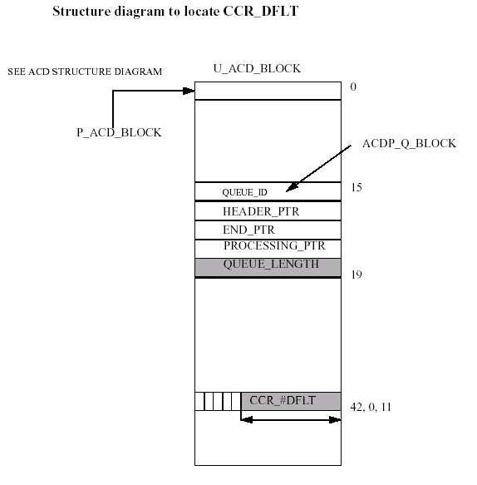

21 FFC Corruption

21.1 symptoms of problem

This corruption is caused when existing FFC DN has been created in LD57 and a 500 set configured as a ACD agent is using the same ACID as the FFC DN. This should not be allowed as there is a DN conflict and an SCH0730 error should be produced, but
The system seems to allow it causing corruption.

LD 57
REQ CHG
TYPE FFC
CUST 0
FFCT
CODE SSPU
SSPU 71
SSPU
..
..

LD 10
REQ CHG
TYPE 500
TN 9 0 6 9
ECHG YES
ITEM FTR ACD 310 710
FTR
ITEM
..
..

LD 10
REQ CHG 0R NEW
TYPE 500
TN 9 0 6 9
ECHG YES
ITEM FTR ACD 310 710
SCH0730 = DN conflicts with existing number.

Print out the DNBLOCK for 7 in LD20 and an SCH0886 error is produced.

LD 20
REQ PRT
TYPE DNB
CUST 0
DN 7
DATE
PAGE
DES
DN 710
TYPE ACID
TN 009 0 06 09
SCH0886 = Shorter DN number exists.

Try to remove the FFC SSPU code and an SCH8895 error is produced. But when it is printed in LD57 it exists.

LD 57
REQ OUT
TYPE FFC
CUST 0
ALL NO
CODE SSPU
SSPU 71
SCH8895 = FFC code does not exist.
SSPU

21.2 HOW TO RESOLVE PROBLEM

Print the DN 71 information using the DNT<CUST><DN> command.

pdt> dnt 0 71
000714E0 : 00000080 00000037 00000000 00000000 00000000 00000000 00000000 000714ED
000714E8 : 00000000 00000000 00000000 00000000 00000000

Remove the FFC SPRE code of 73 from DN 71.

pdt> w 000714E0
000714E0 : 00000080 /
000714E1 : 00000037 /0 "Remove the ffc spre code of 73 from digit 71"

Check the corruption has been removed.

pdt> dnt 0 71
DIG 2 INV

REQ prt
TYPE ffc
CUST 0
CODE sspu
CUST 00
FFCT NO
SCH8896 = FFC data does not exist.

NOTE : 37 is the .SPRE_SSPU (73 hex).

Patch MPLR11667 should now be added to prevent this type of corruption. This patch is not required for software release 24 onwards.

21.3 SOFTWARE STRUCTURE
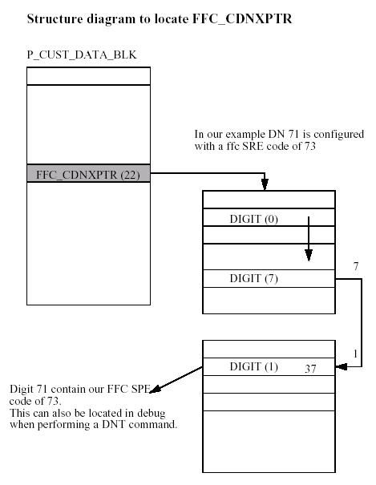
22 ADAN Corruption

22.1 SYMPTOMS OF PROBLEM

There may be several symptoms of ADAN corruption.

1) When trying to out or change any ADAN block in LD17 a BUG5513 is produced, it may also indicate an ADAN DATA ERROR.

BUG5513 = Serious problem in rebuilding the I/O table will cause data corruption and requires a system reload.

LD 17
REQ CHG
TYPE ADAN
ADAN CHG HST
SIZE
USER
BUG5513
BUG5513 :2 4
BUG5513 + 105EDC2C 115B29EE 115ACECA 1159AB0C 1159A514
BUG5513 + 1087C02C 1087AF10 1087A7C2 10878D64 1087626A
BUG5513 + 10CA24C6 10CA1988 10AC183C 10CA17D4
ADAN DATA ERROR

2) An SCH5579 error is produced when making a change to an ADAN block.

It look’s as if something has corrupted the ADAN block, first thing to do is to
print out all of the configured ADAN block and then just try making a change
on any of them.

LD 17
REQ CHG
TYPE ADAN
ADAN CHG AML 9
SCH5579 = Physical I/O block pointer corruption.

3) Stat the related AML link in LD48 and a BUG5504 is produced.

.STAT AML 9

BUG5504
BUG5504 : 00000002 00000009 0000256C 00000000 000D2934 00000000 00000000 000000
00 00000000
BUG5504 + 105EDC2C 105EB390 105EADCC 105EA8A0 11445AF8
BUG5504 + 11444486E 11443BA2 1144197C 1087C02C 1087AF10
BUG5504 + 1087A7C2 10878D64 1087626A 10CA24C6 10CA1A62
BUG5504 + 10CA183C 10CA17D4

22.2 HOW TO RESOLVE PROBLEM

The AML 9 needs to be removed.

LOG_IO_PTR = A243 (see Appendix)

pdt> p A243
0000A243 : 00050D62

pdt p 00050D62 5
00050D62 : 00000005 00050F6D 00050E0E 00050D67 00000000

The P_CSL_BLK_PTR pointer is at word offset (2).

pdt> p 00050E0E 10
00050E0E : 00000021 00000000 00000000 00000000 00000000 00000000 00000000 00000000
00050E16 : 00000000 00000000 00050E2F 00000000 00000000 00000000 00000000 00000000

Remove the AML 9 information from memory.

pdt> w 00050E16
00050E16 : 00000000 /
00050E17 : 00000000 /
00050E18 : 00050E2F / 0

The AML 9 has now been removed from the physical I/O block.

The associated VAS now needs to be removed from the protected VAS block.

P_VAS_TBL_HDR = 98E8 (see Appendix)

pdt> p 98e8
000098E8 : 00050E4B

Print the protected VAS block pointer.

pdt> p 00050E4B 10
00050E4B : 00000000 00000000 00000000 00000000 00000000 00000000 00000000 00000000
00050E53 : 00000000 00050E6B 00000000 00000000 00000000 00000000 00000000 00000000

pdt> w 00050E53
00050E53 : 00000000 /
00050E54 : 00050E6B / 0

The VAS 9 information has now been removed.

Check that a change can be made to the ADAN.

LD 17
REQ chg
TYPE adan
ADAN chg hst
SIZE
USER
..
..

22.3 SOFTWARE STRUCTURE
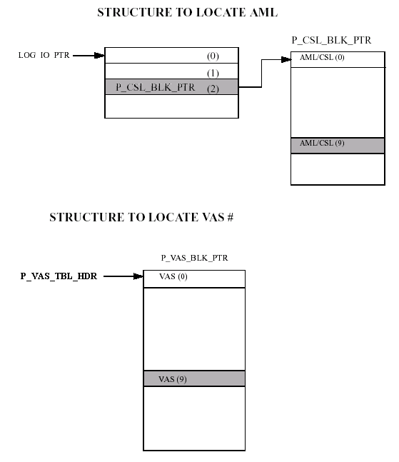

23 TRK Corruption

23.1 SYMPTOMS OF PROBLEM

The AWR trunks cannot be removed in LD14.

LD 36
.stat 10
UNIT 00 = IDLE (TRK)(AWR AUD)
UNIT 01 = IDLE (TRK)(AWR AUD)
UNIT 02 = UNEQ
UNIT 03 = UNEQ

LD 14
REQ out
TYPE awr
TN 10 0 0 0
SCH0126 = Station type conflicts with existing card.

REQ out
TYPE awr
TN 10 1
SCH0126

By printing the TNB in LD20 you can see XTRK shows up as NON-XTRK.

LD 20
TN 010 0 00 00
TYPE AWR
CUST 0
XTRK NON-XTRK
TIMP 1200
RTMB 20 1
DATE 4 NOV 1997
TN 010 0 00 04
TYPE AWR
CUST 0
XTRK NON-XTRK
TIMP 1200
RTMB 21 1
DATE 4 NOV 1997

23.2 HOW TO RESOLVE PROBLEM

Print the TN information using the TNT<L S C U> command.

pdt> tnt 10 0 0 0
EQPD SLOOP TN 000808
GP 00031046 SLP 00032116 000D5B16 CD 0003224A 000D5AA5 LN 00032252 000D5A53

pdt> tnt 10 0 0 1
EQPD SLOOP TN 000848
GP 00031046 SLP 00032116 000D5B16 CD 00032285 000D5A3D LN 0003228D 000D59EB

Print the protected Card pointer for the TN’s.

pdt> p 0003224A 10 0003224A : 00005040 00032252 00000000 00000000 00000000 000D5AA5 00000000 00000000
00032252 : 00000033 00000003 00000000 00000000 00000000 00000000 00000000 000D5A4C

pdt> p 00032285
00032285 : 00005040 0003228D 00000000 00000000 00000000 000D5A3D 00000000 00000000
0003228D : 00000033 00000003 00000000 00000000 00000000 00000000 00000000 000D59E4

Word 6 holds the value of type of XTRUNK that is configured in LD14, in our case word 6 has the value 0 which means it is configured as a NON XTRK CARD. This is incorrect and should be changed to a value of 6.

0 = .NON_XTRK_CARD
1 = .XUT_CARD
2 = .XEM_CARD
3 = XFEM_CARD
4 = XCOT_CARD
5 = XDID_CARD
6 = EXUT_CARD

pdt> w 00032250
00032250 : 00000000 /6
pdt> w 00032285
0003228B : 00000000 /6

The TN’s can now be removed in LD 14

LD 14
REQ out
TYPE awr
TN 10 0
OUT TRK TN 010 0 00 00 RT 20 MB 1

REQ out
TYPE awr
TN 10 1
OUT TRK TN 010 0 00 04 RT 21 MB 1

LD 32
.stat 10
CARD UNEQ

The corruption has been removed successfully.

23.3 SOFTWARE STRUCTURE

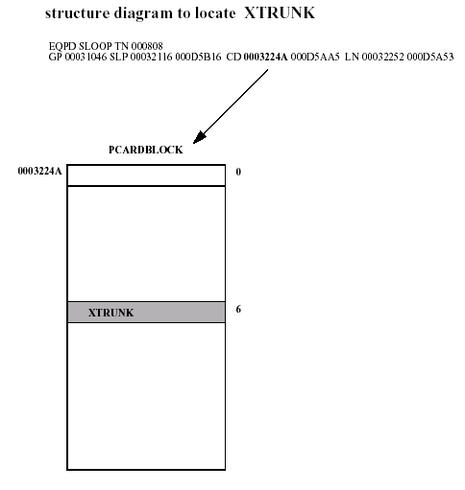

24 LAPD (BRI) Corruption

24.1 symptoms of problem

The LAPD cannot be removed in LD 27 with an unconfigured DSL showing when printed, and when trying to remove it an SCH5368 error is produced.

LD 27
REQ prt
TYPE lapd
PGPN
USER
PGPN 1
LAPD
T200 2
T203 20
N200 3
N201 260
K 1
N2X4 10
DSL 8 <------ Corruption

There is no DSL 8 configured.

REQ out
TYPE lapd
PGPN 1
SCH5368 = Protocol group is not removed because at least 1 DSL refers to it.

24.3 HOW TO RESOLVE THIS PROBLEM

P_BRI_PROTMHTPTR = a10f (see Appendix)

pdt> p a10f
0000A10F : 00044736

pdt> p 44736 10
00044736 : 00000000 000453C9 00000000 00000000 00000000 00000000 00000000 00000000
0004473E : 00000000 00000000 00000000 00000000 00000000 00000000 00000000 00000000

Remove PGPN 1.

pdt> w 44736
00044736 : 00000000 /
00044737 : 000453C9 /0

To confirm the corruption has been cleared print the LAPD in LD27.

LD27
REQ prt
TYPE lapd
PGPN
USER
REQ prt
TYPE lapd
PGPN 1
SCH5367 = Protocol group does not exist.
PGPN
USER

The corruption has now been cleared.

24.3 SOFTWARE STRUCTURE

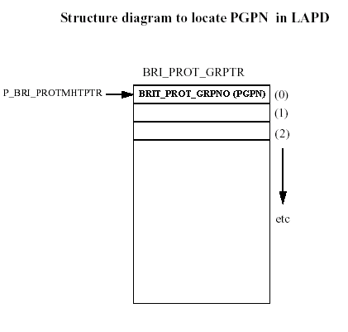

Appendix

25 List of Variables and pointers

From 25.40 onwards all variables are available using the PUA command in pdt.

pdt> pua

TRUNK_MONITOR @ 00000778 = 0000
TRUNK_TN @ 00000779 = 0000 0000 0000 0000 0000 0000 0000
DTSL_MONITOR @ 00000F66 = 0000
DTSL_MON_WORDS @ 00000F67 = 0000 0000 0000 0000 0000 0000 0000 0000 0000 0000
SNAP_BUG_RAS_OFS @ 0000A415 = 00000000
UIPE_BUG_PRT_CTL @ 00004DA1 = 0060

USPARE_WORDS[0] @ 00000A2C , SIZE 0126 PSPARE_WORDS[0] @ 00008EC4 , SIZE 0020
U_JUNK_WORDS[0] @ 00005C9D , SIZE 00C8 P_JUNK_WORDS[0] @ 0000AC58 , SIZE 00C8

MEM_PHYS_MEM_LIM @ 00009B09 LAST_INIT_HOUR @ 00009209
CONFIGLOOP[0] @ 0000972A , SIZE 0100 SYS_XPEC[0] @ 0000984D , SIZE 0064
CRSTART @ 00008003 CREND @ 00008004
QUEUE_ADDR[0] @ 00008F53 , SIZE 0025
CDNXPTR[0] @ 00009040 , SIZE 0064 SCLMHTPTR @ 0000916C
BCS_TEMPL_HDR @ 000093DB PBX_TEMPL_HDR @ 000093DC
LOG_IO_PTR @ 0000A63D CONFIGTTYOP[0] @ 0000962A , SIZE 0010
P_MSDLMISP_MHPTR @ 0000A639 IO_TABLE_PTR @ 00008002
P_VAS_TBL_HDR @ 00009B10 P_BRI_PROTMHTPTR @ 0000A460
DTSLHT_PTR @ 0000920F CON_DDCS_FLAG[0] @ 00009684 , SIZE 0100
TRO_ERR_MONITOR @ 00000F71 = 0000

25.1 CDNXPTR

Software | Small System – 311 | Large System – 511
22.16 | 8fae | 9036
22.46 | 8fae | 9036
23.47 | 8fae | 9036
24.25 | 8fb0 | 9038
25.15 | 8fc8 | 9050

25.2 SCLMHTPTR

Software | Small System – 311 | Large System – 511
22.16 | 900e | 9162
22.46 | 900e | 9162
23.47 | 900e | 9162
24.25 | 9010 | 9164
25.15 | 9028 | 917c

25.3 LOG_IO_PTR
Software | Small System – 311 | Large System – 511
22.16 | a23f | a51c
22.46 | a243 | a520
23.47 | a2a2 | a5c3
24.25 | a321 | a642
25.15 | a3ce | a70f

25.4 DTSLHT_PTR

Software | Small System – 311 | Large System – 511
22.16 | 90f4 | 9248
22.46 | 90f4 | 9248
23.47 | 90f5 | 9249
24.25 | 90f7 | 924b
25.15 | 9110 | 9264

25.5 CRMHPTR

Software | Small System – 311 | Large System – 511
22.16 | 8fce | 909a
22.46 | 8fce | 909a
23.47 | 8fce | 909a
24.25 | 8fd0 | 909c
25.15 | 8fe8 | 90b4

25.6 QUEUE_ADDR

Software | Small System – 311 | Large System – 511
22.16 | 8f57 | 8f57
22.46 | 8f57 | 8f57
23.47 | 8f57 | 8f57
24.25 | 8f56 | 8f56
25.15 | 8f6e | 8f6e

25.7 SET_RELOC_TABLE

Software | Small System – 311 | Large System – 511
22.16 | 974b | 996b
22.46 | 974b | 996b
23.47 | 9759 | 9979
24.25 | 976b | 998b
25.15 | 97da | 99fa

25.8 P_MSDLMISP_MHPTR

Software | Small System – 311 | Large System – 511
22.16 | a23e | a51b
22.46 | a242 | a51f
23.47 | a2a1 | a5c2
24.25 | a320 | a641
25.15 | a3cc | a70d

25.9 BCS_TEMPL_HDR

Software | Small System – 311 | Large System – 511
22.16 | 9248 | 9468
22.46 | 9248 | 9468
23.47 | 9249 | 9469
24.25 | 924b | 946b
25.15 | 9264 | 9484

25.10 PBX_TEMPL_HDR

Software | Small System – 311 | Large System – 511
22.16 | 9249 | 9469
22.46 | 9249 | 9469
23.47 | 924a | 946a
24.25 | 924c | 946c
25.15 | 9265 | 9485

25.11 CONFIGLOOP

Software | Small System – 311 | Large System – 511
22.16 | 95d5 | 97f5
22.46 | 95d5 | 97f5
23.47 | 95d6 | 97f6
24.25 | 95d8 | 97f8
25.15 | 95f1 | 9811

25.12 SYS_XPEC

Software | Small System – 311 | Large System – 511
22.16 | 9687 | 98a7
22.46 | 9687 | 98a7
23.47 | 9695 | 98b5
24.25 | 96a7 | 98c7
25.15 | 9712 | 9932

25.13 CON_DDCS_FLAG

Software | Small System – 311 | Large System – 511
22.16 | 952f | 974f
22.46 | 952f | 974f
23.47 | 9530 | 9750
24.25 | 9532 | 9752
25.15 | 954b | 976b

25.14 IO_TABLE_PTR

Software | Small System – 311 | Large System – 511
22.16 | 8013 | 8013
22.46 | 8013 | 8013
23.47 | 8013 | 8013
24.25 | 8013 | 8013
25.15 | 8013 | 8013

25.15 P_VAS_TBL_HDR

Software | Small System – 311 | Large System – 511
22.16 | 98e4 | 9b39
22.46 | 98e8 | 9b3d
23.47 | 98fe | 9b53
24.25 | 9918 | 9b6d
25.15 | 9997 | 9bec

25.16 CRSTART

Software | Small System – 311 | Large System – 511
22.16 | 8014 | 8014
22.46 | 8014 | 8014
23.47 | 8014 | 8014
24.25 | 8014 | 8014
25.15 | 8014 | 8014

25.17 CREND

Software | Small System – 311 | Large System – 511
22.16 | 8015 | 8015
22.46 | 8015 | 8015
23.47 | 8015 | 8015
24.25 | 8015 | 8015
25.15 | 8015 | 8015

25.18 P_BRI_PROTMHTPTR

Software | Small System – 311 | Large System – 511
22.16 | a10b | a3e8
22.46 | a10f | a3ec
23.47 | a145 | a466
24.25 | a160 | a481
25.15 | a1f8 | a539

