Guide on how to reset a BCM Accounts back to default

This process can be used on sites where you can’t access all of the configuration or administration data such as other accounts etc. You will need to be able to access the Backup and Restore section!.

This is also useful on sites where the systems accounts are corrupted or you are unable to list them.

Log into the BCM using a known account and password. It’s best to go to the Accounts section to see (if possible) what the current Administration rights are as shown below.

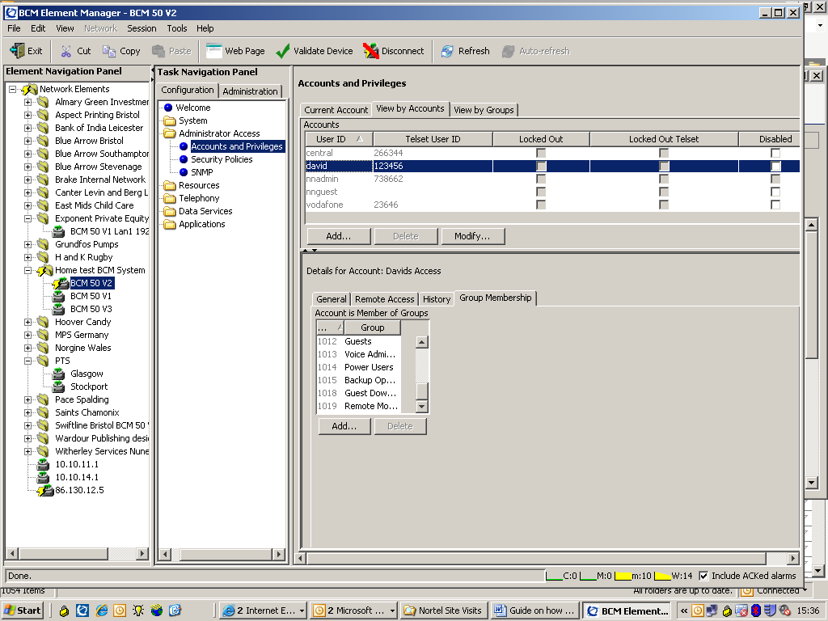

The site that I used didn’t have 1009 Administrator added on!, but you need to have one or more of the groups added as shown above from 1012 to 1019.

Click on the top Administration tab at the top and then select “Backup and Restore”, followed by the “Restore” green dot. You will be given a drop down box to restore from and select the “Factory Default” option. Click on the Restore box below it and another screen will appear as shown below.

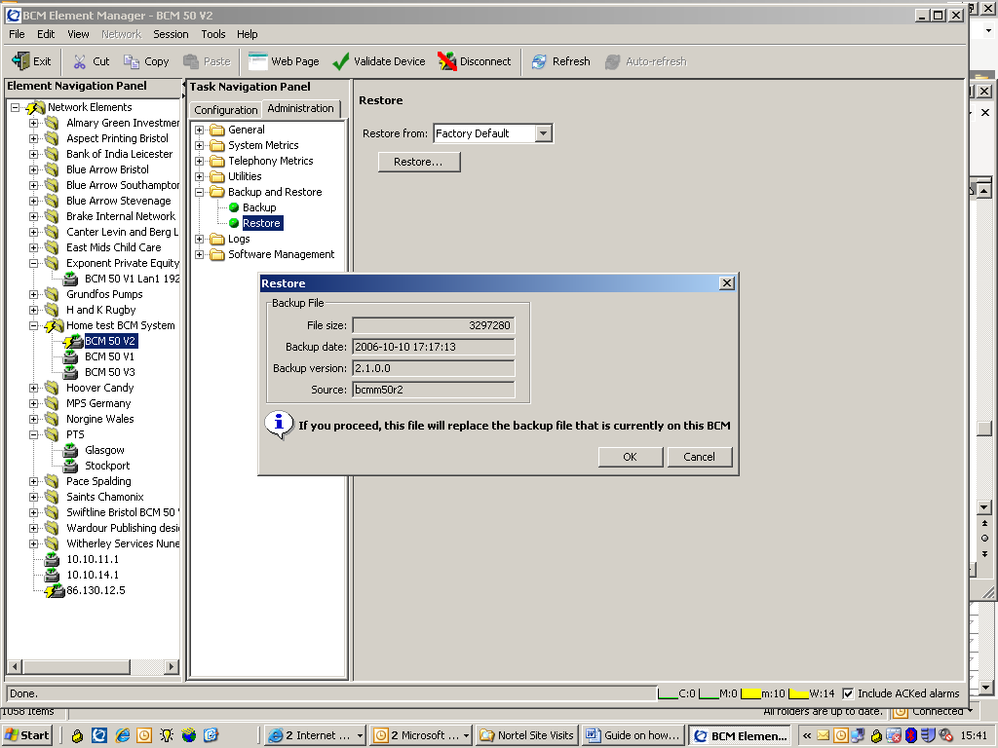

This is the first warning screen. Press OK for a different screen to appear that allows you to change what you require to be restored.

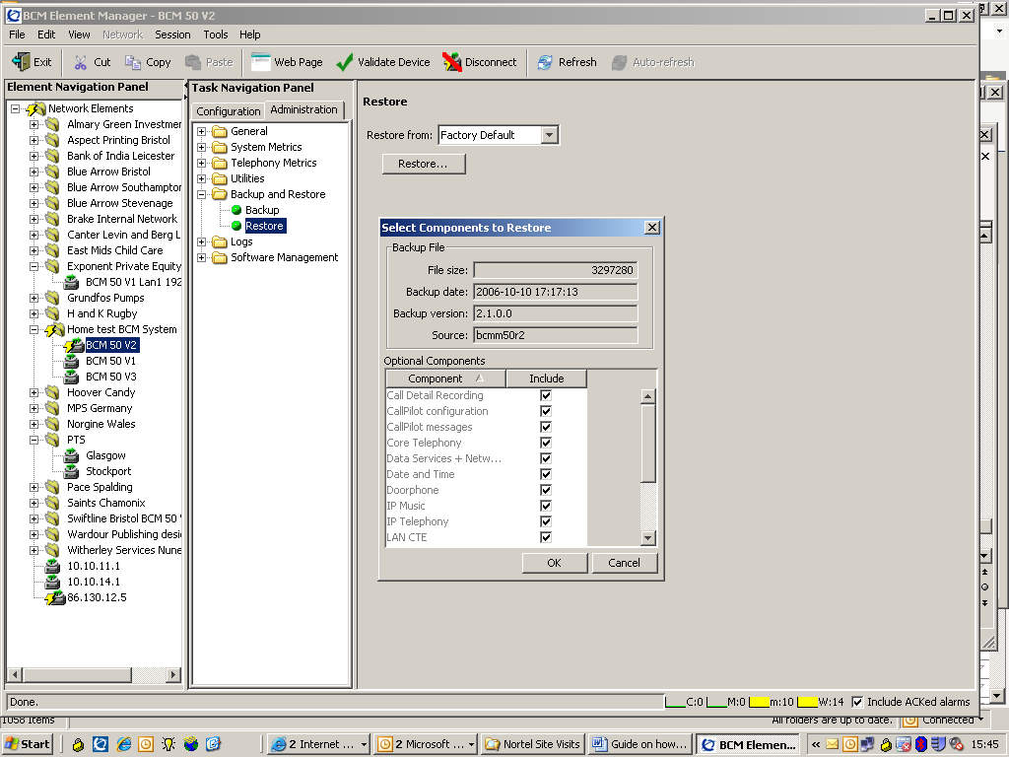

The important thing to remember is to DOUBLE CLICK to UNTICK everything first!. Then select the items afterwards, such as the one we need which is “Security. i.e.

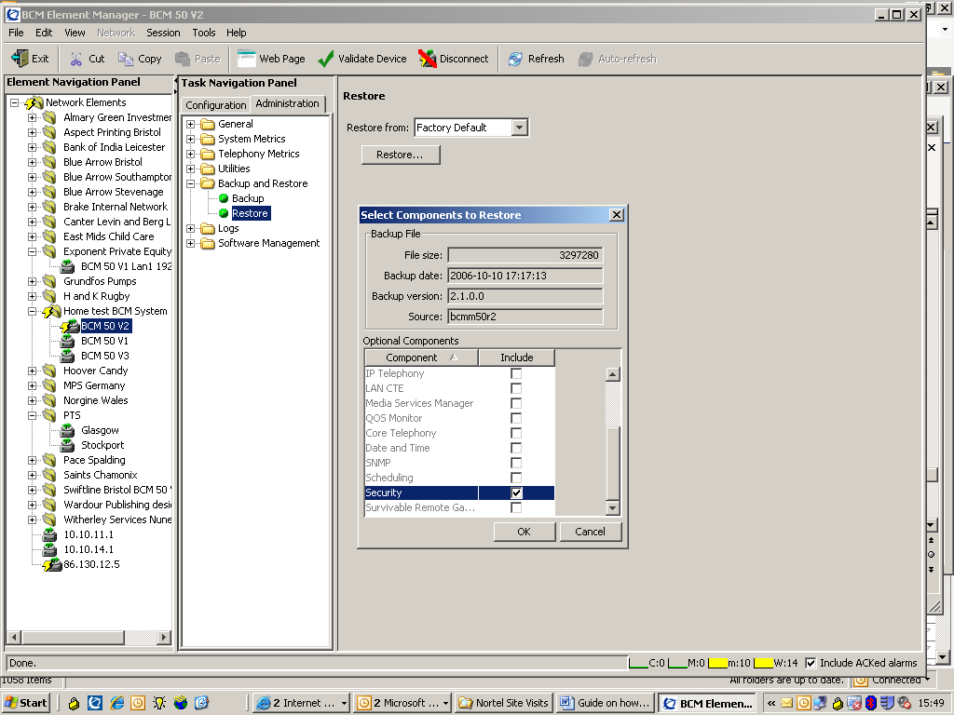

Click OK followed by YES to get the screen below.

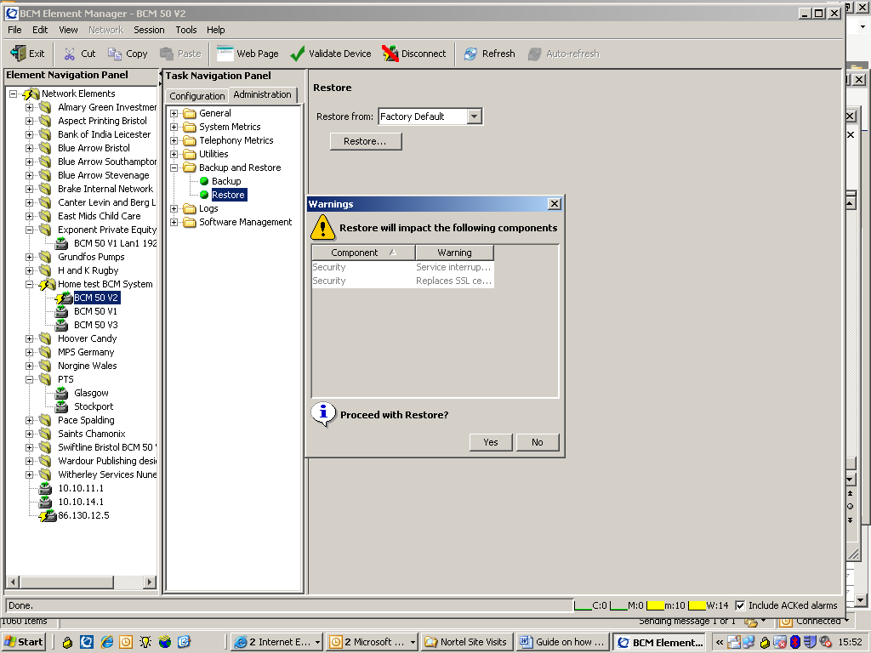

Once this has been done, you will be disconnected from the BCM such as

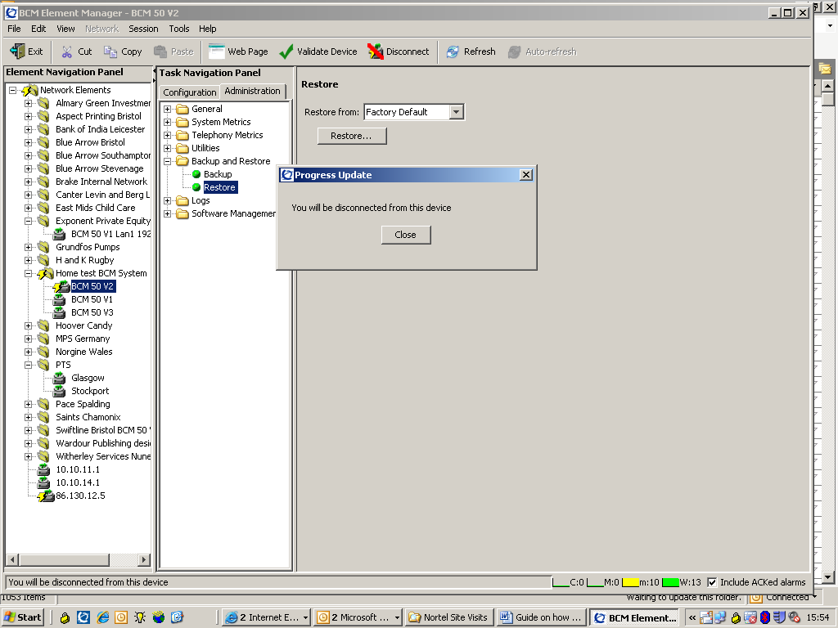

This time, log back into the BCM system using the default name of nnadmin and a password of PlsChgMe!. The login screen is slightly different now as shown below.

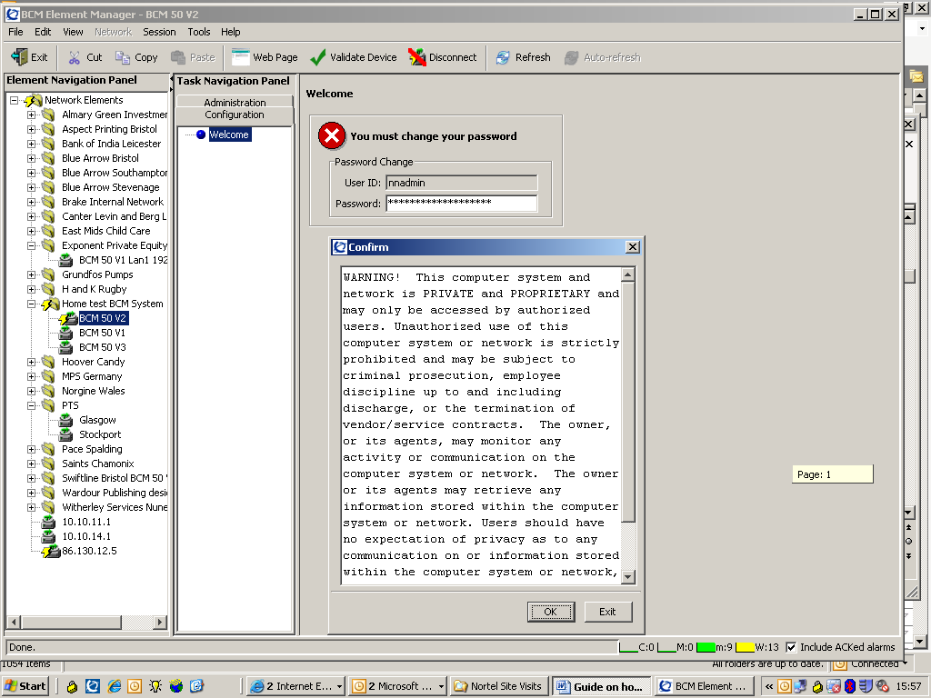

Click OK to the banner and then you can either enter in a new password, or re enter back in the original password of PlsChgMe!. Once you have pressed enter, you can’t see any change?. This is because you have to minimised the BCM Element Manager screen to see the “Confirm Password” screen which is shown below.

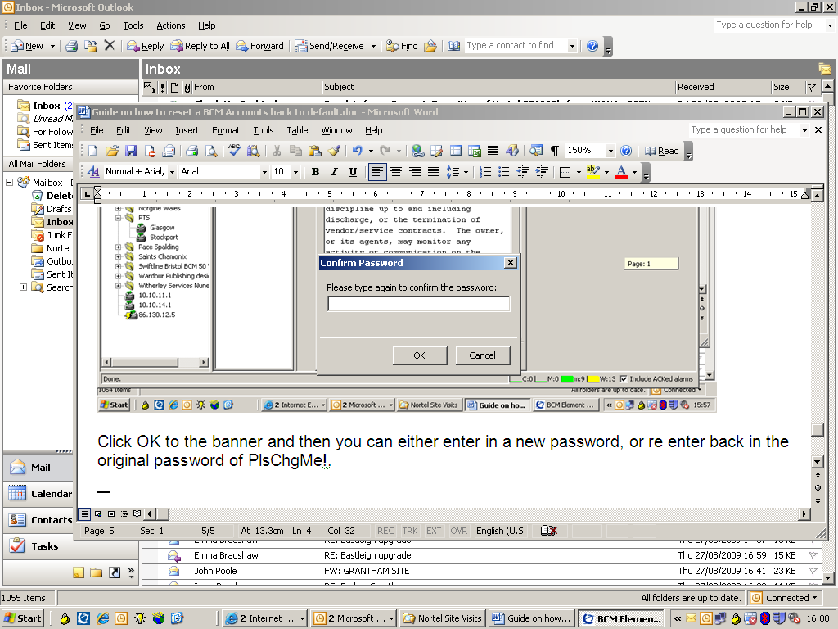

Re enter the password again and press OK for a warning message to appear telling you that the connection will be lost. Press OK to confirm this.

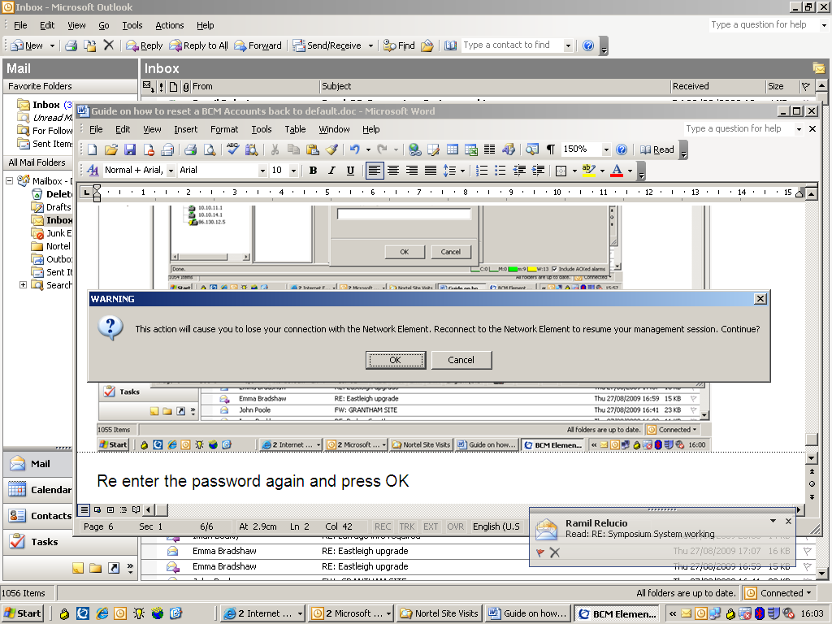

Log back into the BCM again and navigate to the accounts page. This time you will see the standard Nortel defaults in there such as shown below. It’s best to add in some new accounts to make it easier to log in for future occasions.

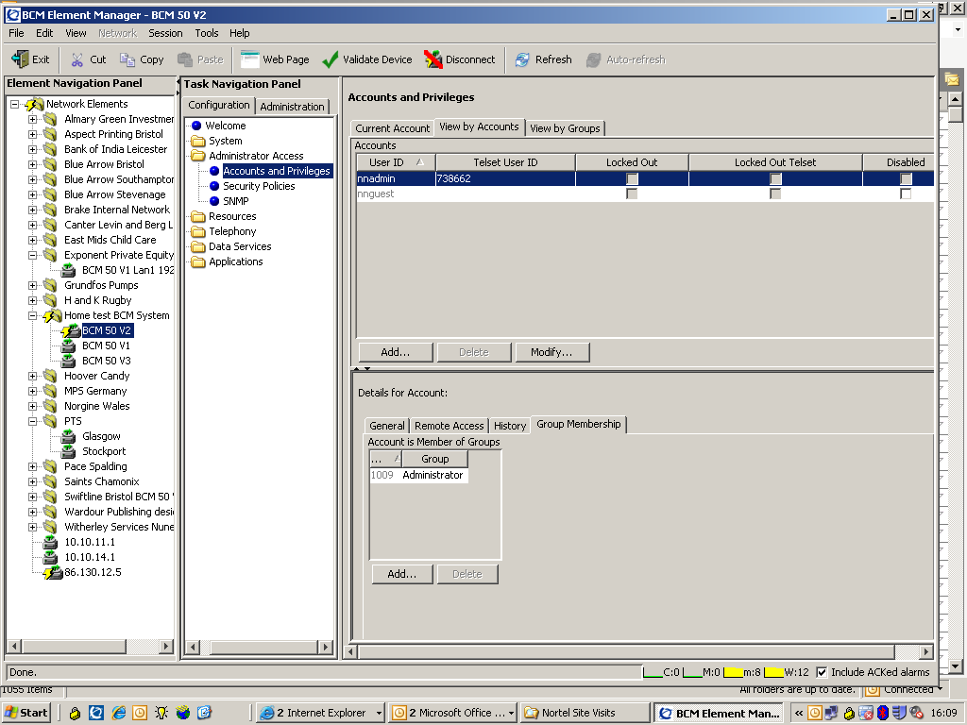

I hope that this guide helps you?.

