Guide to accessing a Nortel system via the Rlogin protocol
This guide is only intended to show you the different ways in which we can logon via a remote data call or by using an onsite IP connection. There are a number of good Rlogin programs available such as Putty, SMTelnet and also Avaya’s OrderPro tool. I’ll explain the OrderPro method first.

Avaya OrderPro collection tool

The first thing is to install the Avaya OrderPro configuration tool. This program is free and is easily available via the Avaya website. The tool uses a variety of access protocols such as Modem, Telnet, Rlogin etc.
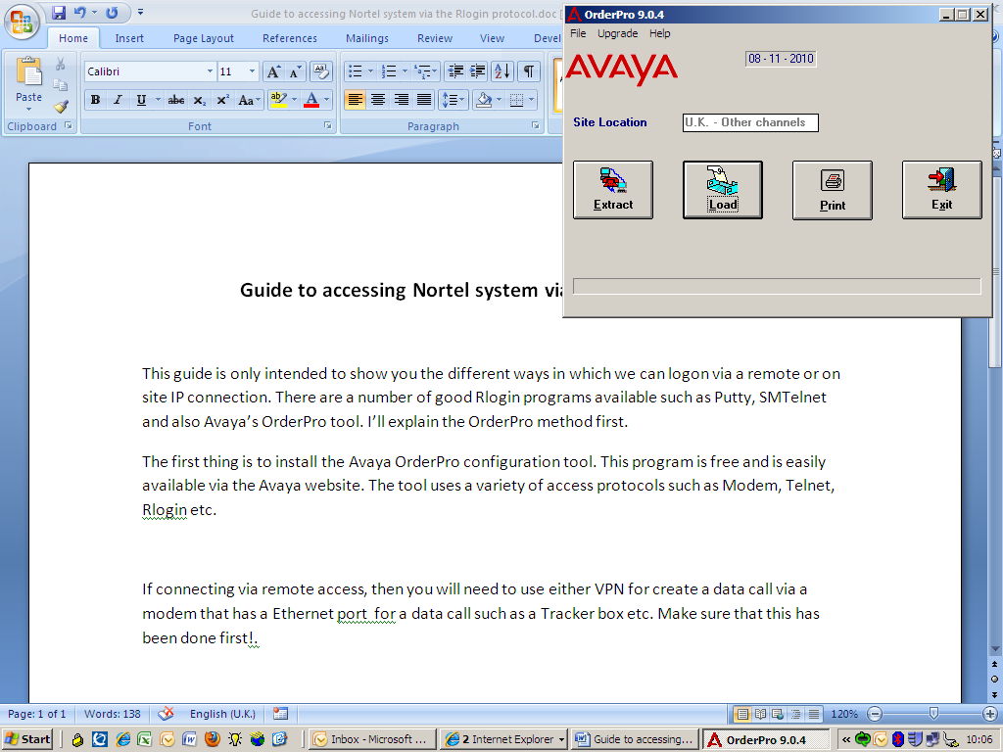
If connecting via remote access, then you will need to use either VPN for create a data call via a modem that has an Ethernet port for a data call such as a Tracker box etc. Make sure that this has been done first!.
Click on the Extract button to bring up the Connection Details entries. Select Rlogin and fill out the relevant fields such as the site details etc

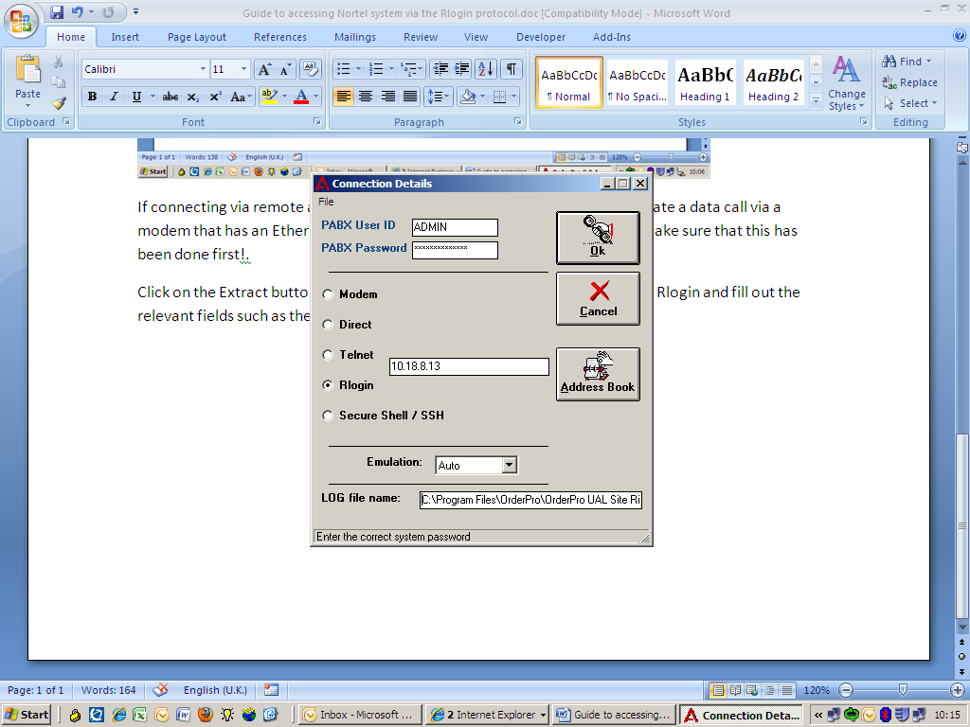
A better method is to add the site into the address book such as the way I’ve shown below.
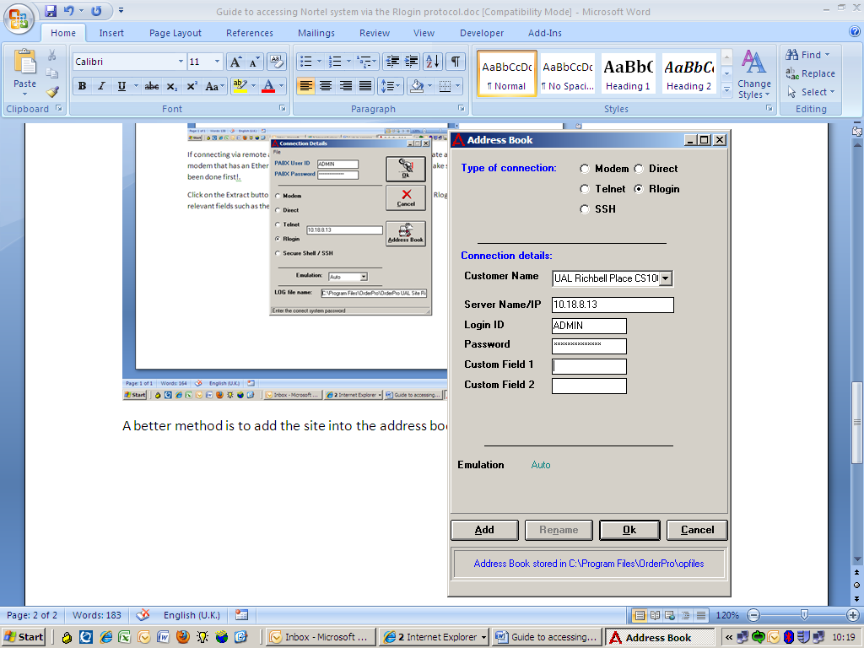
Just click on the “Add” button to enter it in. Press “OK” to go back to the Connection Details area.
You might need to enter in a new log file if you intend to run the OrderPro capture file, but it will also be useful to use as a general log file!. To get to the main “PBX Terminal” screen where you would log in is done via the Address Book button. Just press it and click on the drop down box against the “Customer Name” to find the site that you need to access. i.e.
On the older Option 11c to 81c / CS1000M systems to version 04.50 etc, access prior to the TTY system had to go via the “pdt” portal and this would require a manual input of the “pdt” password first, before entering in the “sl1input” command to take you to the TTY login area as shown below.
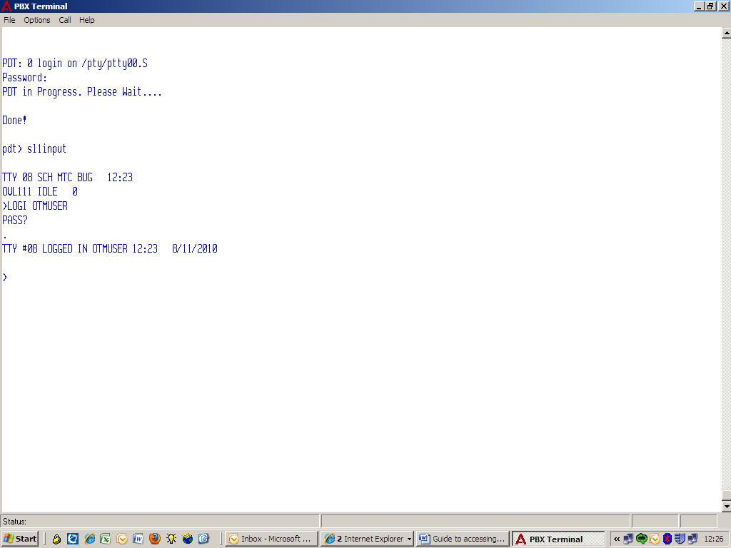
For the later versions 05.xx onwards, the “pdt” access requires a name to be entered and the process is slightly different as shown below.
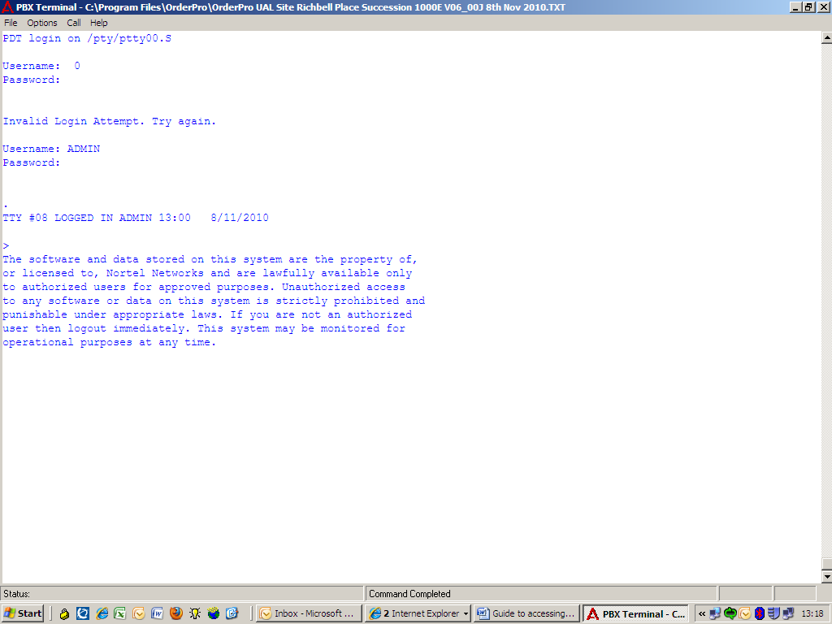
The screen shot above shows the initial access and a “0” is listed in the “Username:” field. All you need to do is to select from the top line, the “Call” tab followed by the “System Login” option. This will allow you access onto the system via the “pdt” shell. At this stage, you can run the OrderPro data extraction program, or just use it to view or make changes to the customer’s database in almost the same way that you would via a TTY serial port access.

The OrderPro tool screen can be maximised and you can also create more than one log or text file i.e.
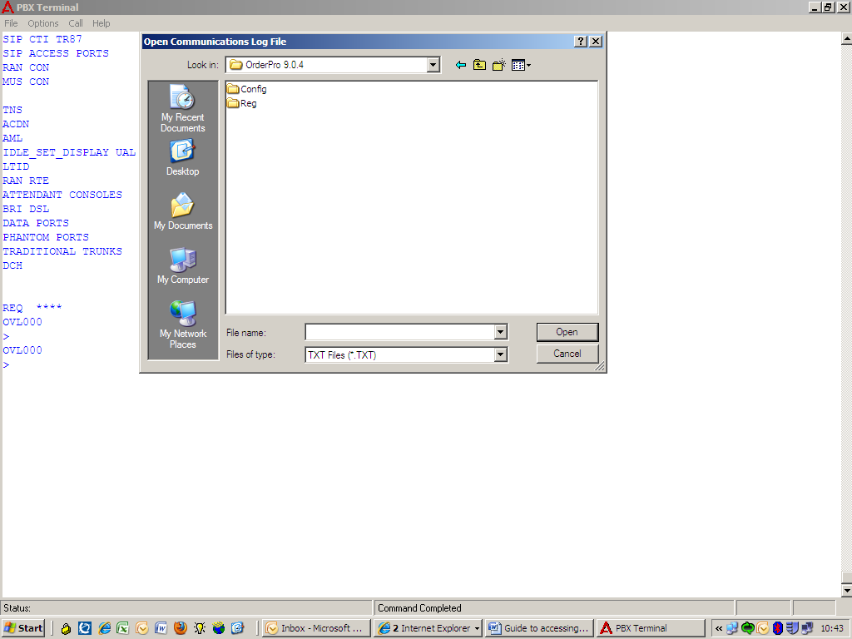
This is useful if you want to capture different parts of the configuration. Exit the system when finished and click on “File” followed by Disconnect to close down the site. Exit the program when finished.

SMTelnet Rlogin Program
The SMTelnet program has some useful advantages over other programs as it takes you straight to the login screen and this bypass’s the “pdt” portal.
First you need a client that supports RLOGIN.
You cannot TELNET to connect to the Ethernet port on the Nortel systems!.
Some clients that I know will work are Reflections, Exceed, ProComm Plus,
As well as some free RLOGIN clients you can download from the internet.

One program that works is called SMTelnet
The program fits onto a floppy disk. It’s first installed as an unregistered copy which allows you up to 15 minutes online each time until you have it registered. It costs $25 to do it online, but I have the full version copy here within this document for you to use.

You need to connect via RLOGIN directly to the Meridian / Succession PBX IP address. For this you need to build a pseudo TTY (PTY in ADAN on a empty DNUM) e.g.

ADAN TTY 14
TTY_TYPE PTY
PORT 1 (0 to 3 for Opt11c / CS1000)
DES remote
FLOW NO
USER MTC SCH BUG
TTYLOG 0
BANR NO

The RLOGIN command in UNIX to get in is as follows:

rlogin -l CPSID0000 IP address of pabx

You can change the CPSIDxxxx as follows:

CPSID1000 is with MTC on the port
CPSID0100 is with SCH on the port
CPSID0010 is with BUG on the port
CPSID0001 is with TRF on the port

See the significance of the '1'??

You can combine these,
CPSID1110 is with MTC,SCH & BUG, but no traffic
CPSID0011 is BUG and TRF but no MTC or SCH.

A copy of the unregistered 15 minute access “SMTelnet Version 1.1.4” is available from
http://www.brothersoft.com/d.php?soft_id=5657&url=http%3A%2F%2Ffiles.brothersoft.com%2Finternet%2Ftelnet%2Fsmtel.zip .

Install this first by using the standard paths such as e.g.
“C:\Program Files\SMTelnet” etc. Once the program has been installed, then you can run it and add sites via the connection directory using the details listed below. Access will only be for 15 minutes at a time, but you just re access it again without any problems as the Rlogin link is dropped each time. The full version can be obtained by purchasing it on line and all that happens is that the “smtelnet.exe” file replaces unlocked copy file of the same name. This file will need to overwrite the unregistered file to give you full access, without any time limits.
The example in the picture below shows how to enter in a site on the programs directory.

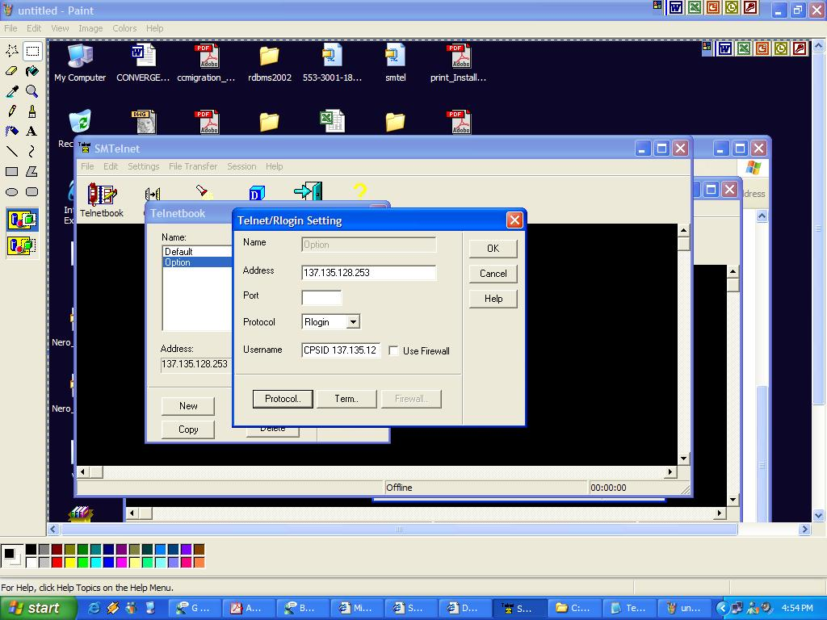

The beauty of this program, unlike “Putty” is that you don’t need to enter in any “pdt” login / password etc. As soon as you run it, you will be at the Nortel TTY login screen. This is a brilliant way of being able to access multiple data applications such as Call Pilot, Symposium & also the Call Server via a data call to e.g. a Tracker Box. All of this can be done at the same time, without you having to disconnect each time to swap between them.

This is the details of the programs developer below.

Thank you for registering SMTelnet. I am attaching the file smtelnet.zip which should be unzipped and the file smtelnet.exe copied to the directory where you installed the unregistered smtelnet program.

Regards,

Satyavrat Mehrotra

email = satmehrotra@yahoo.com

