Guide to carrying out a remote backup of a Call Server CS1000e Co – Res Linux system via SFTP

I’ve done this guide to explain how it’s possible to extract the customer’s database for safe keeping onto your computer as another backup copy in case of system failure or the contents of the compact flash / USB card have been lost / deleted etc.
On the typical CPPM VxWorks versions, it’s a simple case of using FTP and using the PDT access to navigate to the cf2 drive. However, with Linux you need to change the format to SFTP (Secure File Transfer Protocol). You can use a variety of FTP programs such as FileZilla which is free to download and install at http://filezilla-project.org/download.php?type=server
I also use WS_FTP Pro, which can be downloaded at http://www.ipswitchft.com/download This program is only available as a trial, although full version copies are available. I use 9.01 on my Windows XP.
Access the Call Server via remote access using a dial up data call or VPN access. Also open up your FTP program. I’ll be using WS_FTP Pro as an example via screen shots below.
Both programs have a site directory and it’s best to use them. Create a new entry such as shown in the example below.
Against the Host name: enter in the Call Server’s ELAN IP address. Also enter in the Linux login account. I normally use the nortel one, followed by the password. Also enter in the FTP type, which should be SFTP/SSH and port 22 for Linux systems.
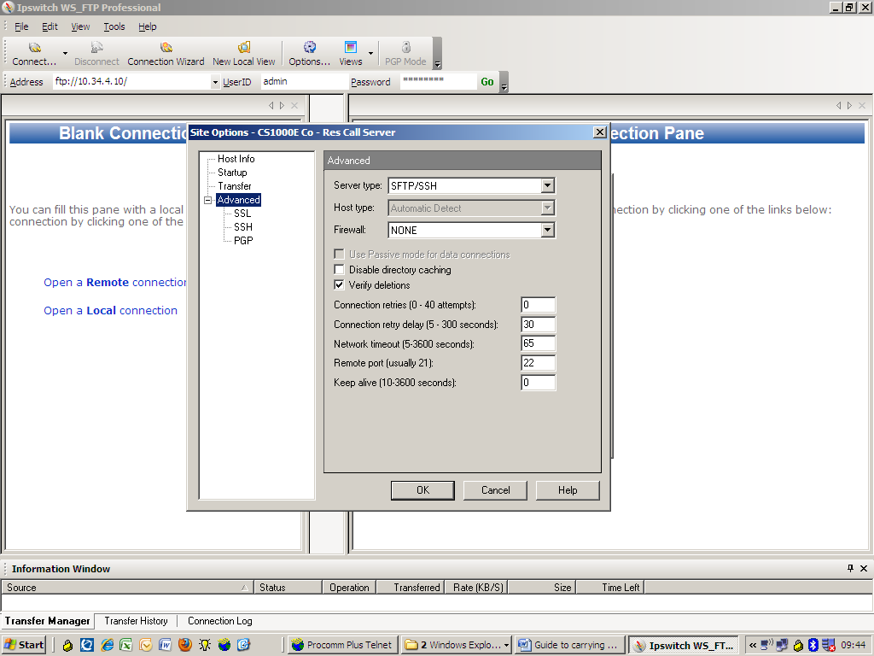

Once that’s been done, connect to the site. You might get a warning message such as Untrusted Public Key etc. Just select the “Trust this Key” option as shown below.
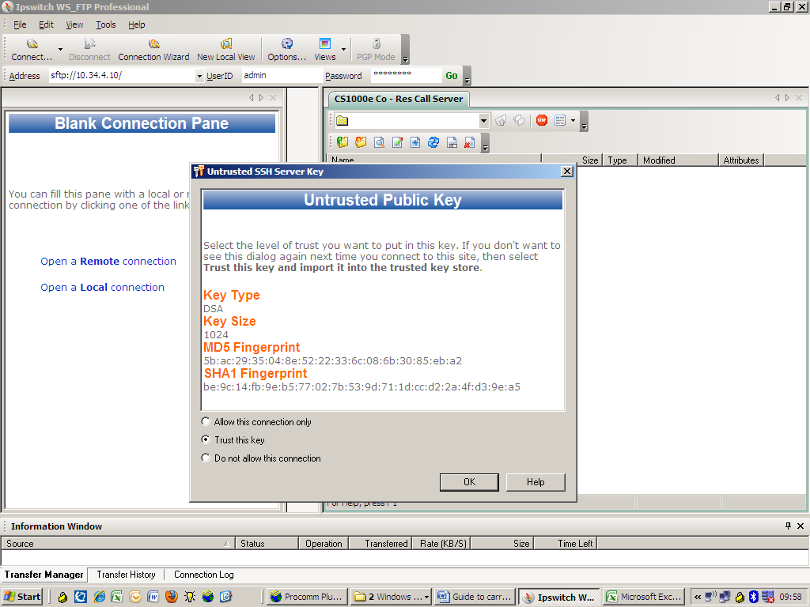
Hopefully, you will connect OK and should see some folders on the screen. You need to navigate to e.g. /var/opt/nortel/cs/fs. Once there, you will see the different devices and folders etc such as cf2 and usb. Also it should be possible to view the typical “u” and “p” folders found on the majority of Nortel systems.
If you select either “cf2” or “usb” and get a blank screen, then it’s either that your login access doesn’t allow you to view the contents, or that the external drive is unplugged.
The first thing to do is to log into the Call Server system via a rlogin program such as Putty and go to LD 43 and do a DAT.
>LD 43
.DAT

DATABASE ISSUE DATE(d/m/y)/TIME SIZE(bytes) SEQNO
Main 600R 09/08/2011 at 00:00:01 190464 109
Secondary 600R 06/08/2011 at 00:00:01 190464 108
Backup 600R 09/08/2011 at 00:00:01 1209 109
Current backup on RMD: /var/opt/nortel/cs/fs/cf2/backup/single
Current backup on USB: Not Available
.

This will confirm how or if the customers database is being backed up OK. In the example below, the (RMD) Compact Flash card is being used.

The trick here is to go into “pdt” and mount the external drive to make it viewable on SFTP. Use the example below
>
PDT login on /pty/ptty00.S
Username: ADMIN
Password: ????????

The software and data stored on this system are the property of, or licensed to, Nortel Networks and are lawfully available only to authorized users for approved purposes. Unauthorized access to any software or data on this system is strictly prohibited and punishable under appropriate laws. If you are not an authorized user then logout immediately. This system may be monitored for operational purposes at any time.
pdt> cd /cf2
cf2 mounted Successfully.
Please call unmount /cf2 before removing device
pdt> (Once the backup has been completed via SFTP, use unmount /cf2 for the CF device)
pdt> unmount /cf2

If you go back to the SFTP program and refresh the screen, you should see the contents of the backup drive that has a folder called “backup” with a sub folder called “single”. The single folder has all the main files and the dates will confirm then it was last backup up.
The final thing to do is to create a local directory on your computer and drag the “backup” into it. I’ve done an example below, using C:\Temp\Temp\Backups\24th August 2011.
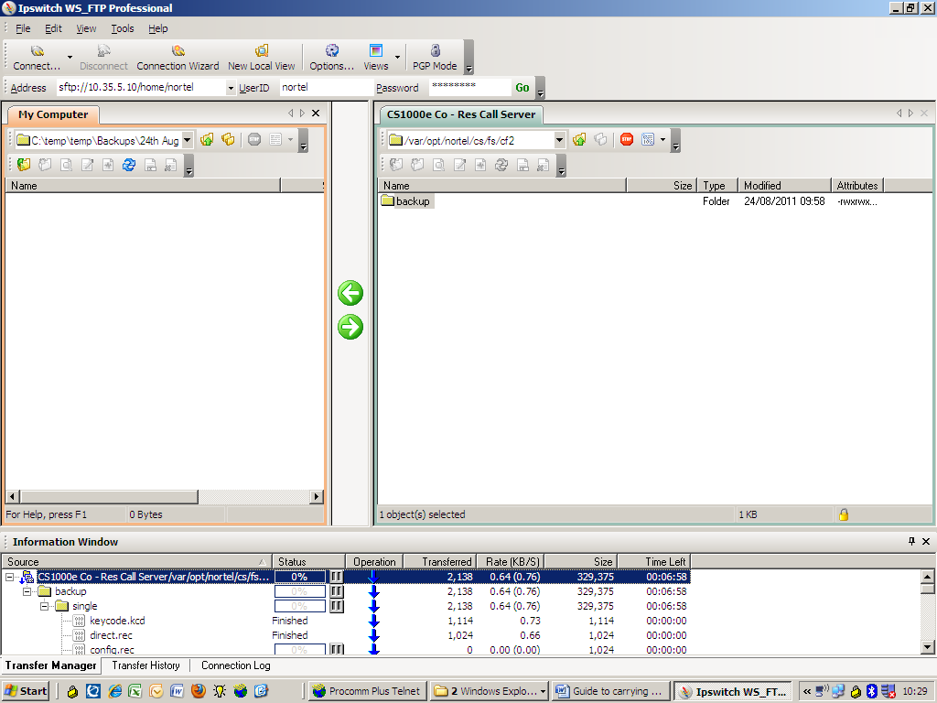
The backup also contains the sites keycode, which is handy to have!. Please remember to go back to “pdt” and unmount the drive afterwards. Just disconnect the SFTP site as required when finished.

