Guide to checking and resetting a Nortel Meridian 1/ CS1000 ISDN 30 Link

This guide is to assist remote and on site engineers with restoring the customers ISDN 30 lines. The Nortel system supports a number of digital links and the method used will depend upon the type of lines installed.
All the systems will probably be using a 2 Mb PRI card. There are two different versions available and I’ll explain each type.
The original PRI card used was a NTAK79xx (xx = generic version) An example is shown below in slo1 one above the MGC card.
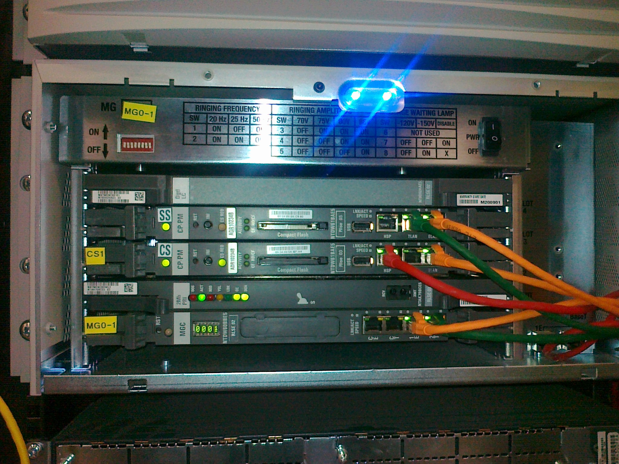
For most systems that have one ISDN 30 link, you would normally except to see 3 green LED’s as shown. They are Active (ACT) Clocking (CC) and D Channel (DCH) status indicators.
The NTAT79xx card was designed for DASS and DPNSS and also the early Q931 protocal.
The Programming, once logged into the switch is done in LD 74 and LD 75 with Clocking in LD 60.

Basic programming instructions on checking and resetting a DASS / DPNSS link.
If a customer has reported no incoming or outgoing lines, then check if possible the card’s LED status first. If doing remote work, then dial the DDI or main number if possible. If you hear the message that “The number you have called is temporary out of order”, then it’s most likely that the DASS is out of service on the Nortel system, but the Telco circuit is OK to the NTE box.
It’s possible to try and get the customer to do a warm start on the Nortel system to restore the link or if you have access to the system to do the following.
>LD 75
.STAT DDCS (This command lists out the number of DASS/DPNSS cards)
DDCS 01 ENBL (The result here shows that one exists in slot 1 in the main cabinet)

.STAT DDSL (This command lists out the number of D Channels configured)
DDSL 015 ENBL ACTIVE (The result here shows that D Channel 15 is present)
DSBL = DISABLED
ENBL = ENABLED
The results shown above are for a typical working DASS link.
If you see anything other than the above, then you will need to disable the link and re enable it again.

From LD 75, use e.g.
DIS DDSL 015 to disable the D Channel, Then DIS DDCS 01 to disable the card.
You can’t disable the DDCS before you do the DDSL first and you can enable the DDSL before the DDCS is done!.

Use the STAT DDSL and DDCS command to check the status at any time.

To enable the ISDN link, do e.g. ENL DDCS 01, then e.g. ENL DDSL 015 to bring up the D Channel.
Once that is completed, you MUST start the DASS or DPNSS link by doing e.g.

STRT 015
Stat the link for confirmation and card’s LED status.
If the clocking LED is flashing, then exit LD 75 by doing 4 stars e.g. **** to get to the “>” again.
Key in LD 60 and type in SSCK 0.
i.e.

>LD 60
.SSCK 0
ENBL
CLOCK ACTIVE
CLOCK CONTROLLER - LOCKED TO SLOT 1
PREF - 1
SREF - FREE RUN
AUTO SWREF CLK - ENBL
NO ERROR

If you see the “Locked to slot x” message, then it’s all working fine. You can disable the clocking by doing DIS CC 0 and use ENL CC 0 to enable it.

Basic programming instructions on checking and resetting a Euro ISDN, I421, QSIG circuit etc.

These circuit’s uses the later 2 Mb PRI card which is a NTBK50AA as shown below in slot 1 above the MGC card.

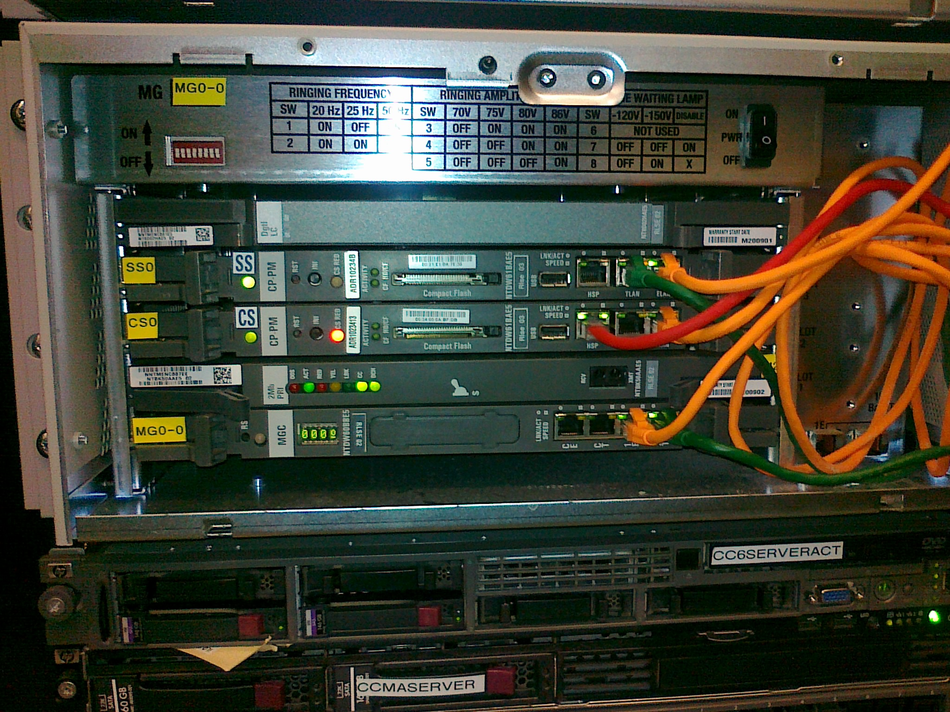

The two cards differ as the latter requires a separate D Channel and also a separate Clocking daughter board card that is attached. Programming for the clocking is the same as the DASS / DPNSS, but LD 96 is used instead of LD 75.

In LD 96 the status of the link is done by using
e.g.

>LD 96
.STAT DCH
DCH 015 : OPER EST ACTV AUTO DES : EURO_ISDN
.STAT MSDL
MSDL 15: ENBL

The two commands show the status of the link. Another area to look for channel status is in LD 60 such as..

>LD 60
.STAT

PRI2 LOOP 1 - ENBL
REF CLK: ENBL
TRACKING
SERVICE RESTORE: YES
ALARM STATUS: ACCEPTABLE
CH 01 - BUSY DID VOD * CH 02 - IDLE DID VOD *
CH 03 - IDLE DID VOD * CH 04 - IDLE DID VOD *
CH 05 - IDLE DID VOD * CH 06 - IDLE DID VOD *
CH 07 - IDLE DID VOD * CH 08 - IDLE DID VOD *
CH 09 - IDLE DID VOD * CH 10 - IDLE DID VOD *
CH 11 - IDLE DID VOD * CH 12 - IDLE DID VOD *
CH 13 - IDLE DID VOD * CH 14 - IDLE DID VOD *
CH 15 - IDLE DID VOD * CH 16 - IDLE DID VOD *
CH 17 - IDLE DID VOD * CH 18 - IDLE DID VOD *
CH 19 - IDLE DID VOD * CH 20 - IDLE DID VOD *
CH 21 - UNEQ CH 22 - UNEQ
CH 23 - UNEQ CH 24 - UNEQ
CH 25 - UNEQ CH 26 - UNEQ
CH 27 - UNEQ CH 28 - UNEQ
CH 29 - UNEQ CH 30 - UNEQ
CH 31 - DCH 15

This shows you the loop (card slot 1) and DCH (015) information.
IDLE = channel free
UNEQ = Not configured
BUSY = Channel in use
MSBY = circuit out of action

To take a circuit and card out of service, do the following as an example.

>LD 96
.STAT DCH
DCH 015 : OPER EST ACTV AUTO DES : EURO_ISDN
.DIS DCH 015 (to take the D Channel out of service)
(stat it again to see that it’s done if you don’t see a message on the screen!)
.DIS MSDL 015 (to disable the Mass Storage Device Loadware)
.STAT MSDL (to check it’s disabled OK.

>LD 60
.DISL 1 (to disable the card in card slot 1)
.STAT (you shouldn’t see any channels appear now!)

DISL = Disable Loop
ENLL = Enable Loop

You should see the top and bottom LED’s on the PRI card go red.
Key in DIS CC 0 to disable the clocking if required, not always needed!.
The PRI card can be re seated if you want to check it out, but don’t pull it out if it’s not showing RED!.
Once re seated or to enable the PRI card, do **** and go back to LD 96.
i.e.
LD 96
.ENL MSDL 015 FDL (This will enable the MSDL and download the loadware at the same time. Wait a minute until it completes!.
Do e.g. STAT MSDL to check it’s enabled OK.

.STAT MSDL
MSDL 15: ENBL

Do **** and go back to LD 60 to enable the card slot. i.e.

>LD 60
.ENLL 1 (This will enable the card in slot one)
For This type of PRI circuit, we usually find that the D Channel will established itself automatically after a few seconds!.

Check this by doing STAT again to view all the channels for that card and then go to LD 96 to stat the D channel by using e.g.

>LD 96
.STAT DCH

To check that the clocking is working, use the same commands in LD 60 such as e.g. SSCK 0 etc.
If you see the “Locked to slot x” message, then it’s all working fine. You can disable the clocking by doing DIS CC 0 and use ENL CC 0 to enable it.

Also check out the card’s LED’s for Green indicators.

