How to set up a new Client in Symposium

Below is a step by step guide on how to set up a client on the phone system.
You will need to do this on the Symposium computer at the back of the office by the phone system.

- Open the Nortel Networks SMI Workbench (the first icon in the taskbar at the bottom of the screen.
- Go to ‘Reports and Displays → Statistics Configuration’ and double click on ‘Skillset Threshold Classes’
- Click ‘File → New’ you will then get this screen 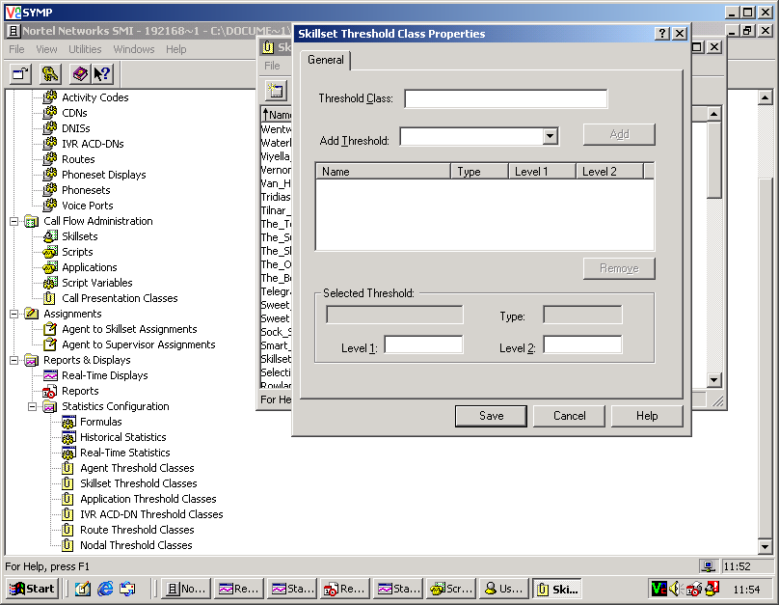
- Where it says Threshold Class type in the name of the client you are setting up. If you need to put a space in the name use an _ (underscore) i.e. Test_Client
- You will need to allocate a Threshold, click on the dropdown box next to Add_Threshold %Service_Level_for_Ans_Calls and click ADD. Save this and close out of the Skillset Threshold Classes
- Next open Switch Administration and double click on CDNs
- Locate the CDN (DDI) you have allocated the client and double click to open it. You will then get this screen 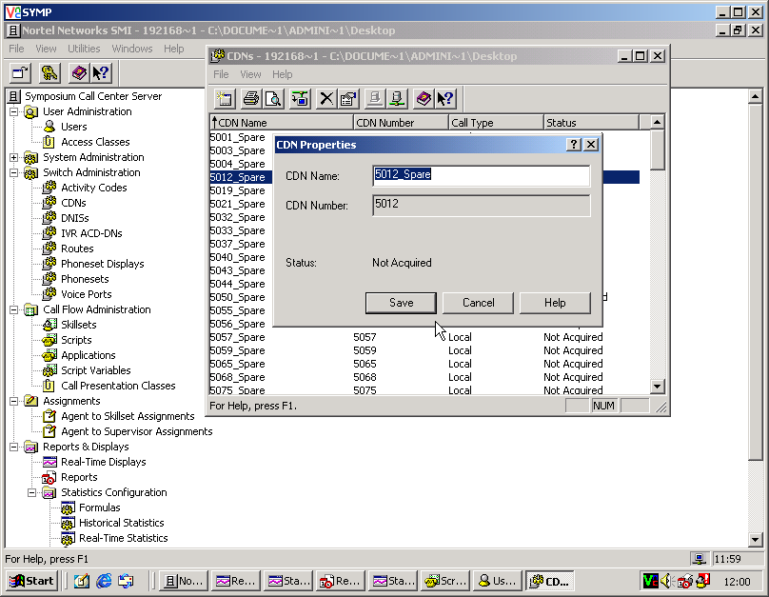
- Change the CDN name to the client name i.e. Test_Client and click Save
- Locate the CDN you have just changed right click on it and click Acquire. Close the out of CDNs box.
- Now you need to set up a Skillset, go to Call Flow Administration and double click on Skillsets.
- Click on File → New. You will get this appear 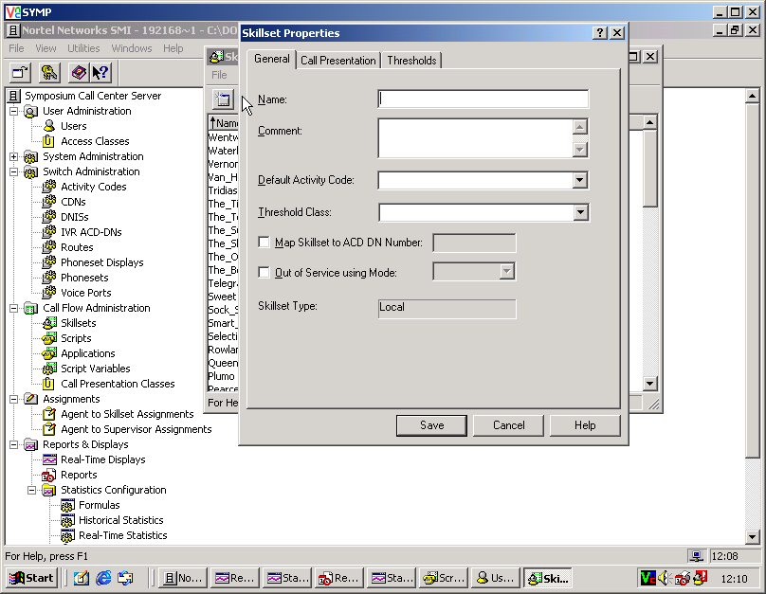
- Where it says Name you will need to type in the name of the client you are setting up i.e. Test_Client.
- Add a Default_Activity_Code this is always 00,Skillset_Default_Activity_Code
- Then add the Threshold_Class (this will be the client name you set up in step 3 and 4.
- Click on Save and close out of the Skillsets screen
- You need to set up a script so that the calls know where to go. To do this you need to stay in Call Flow Administration and double click on Scripts.
- This will open up a list of Scripts already in place. Double click on the script for Baker_Ross as this has everything you need in it.
- You will get this screen appear 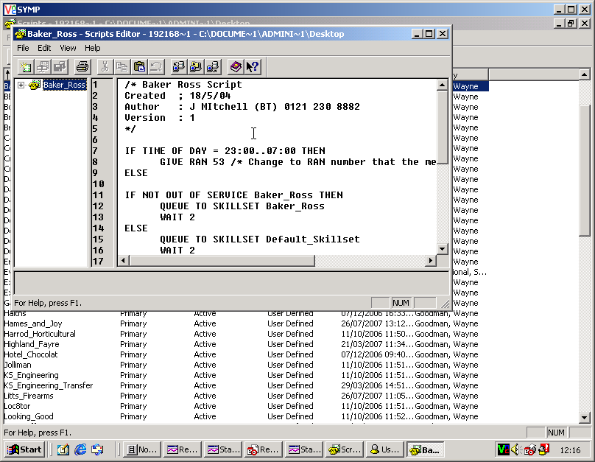
- Highlight all of the text inside the script, right click and click Copy.
- Now close the script, click File → New from the main scripts screen, this will bring you up a blank script, right click and paste all the text you have just copied into the new script.
- Look through the script and find any references to Baker_Ross and change them to the client you are setting up i.e. Test_Client
- Click on Edit → Validate, you will then be asked to enter a name for the Script, call it the clients name i.e. Test_Client and click OK.
- It will then tell you the task has completed successfully. Close the script and locate it from the list.
- Highlight the new script and right click on it and click Activate, this has now activated the script ready to be used.
- The final step is to locate the ‘Master_Script’ from the list. Double click to open this.
- You will have a script in front of you that looks like this 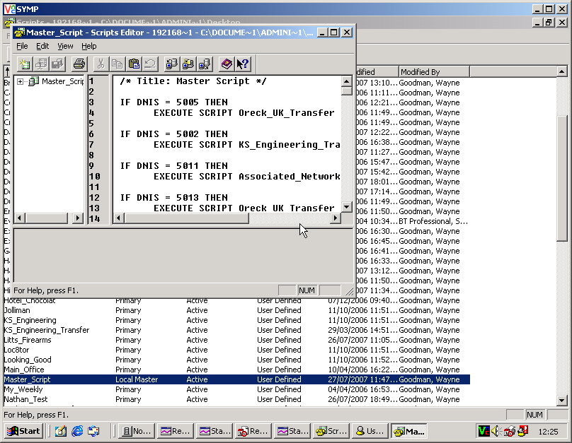
- Scroll down the script until you find the CDN Number you have allocated the client for example ‘VALUE 5034 : EXECUTE SCRIPT Spare_CDNs’
- Next you need to change the Spare_CDNs to the clients name i.e. Test_Client.
- When this is done close the Master_Script ensuring you save the changes when asked to, it will tell you the operation has performed successfully, close the Scripts page. The client has now successfully been set up, test it by dialing the CDN (DDI) number i.e 01392 455000 to ensure it has taken effect correctly.

