How to upgrade a Miran 2 card to release 17 & also instructions on connecting via Ethernet access

From the main screen after accessing the card via the serial port or AX x (on a option 11c system).

[10170404] - Log On -
[VLAN ID 00 - MiranII]
#### #### ## @@@@@@ @@@ @@@ @@ ]]]] [[[[
## ## ## ## ## @@ @@ @@ @@ @@@@ @@ ]] [[
## ### ## ## @@ @@ @@ @@ @@ @@ @@ ]] [[
## # ## ## @@@@@@@ @@@@@@@ @@ @@@@ ]] [[
## ## ## @@ @@ @@ @@ @@ @@@ ]] [[
## ## ## @@ @@ @@ @@ @@ @@ ]]]] [[[[

Meridian Integrated RAN Application
Version 2.0.16 (Rls 3)
Copyright (c) Nortel Ltd. 1998

Username : admin
Password : ->admin000 <-
- Log On -
- Status -
- << VLAN - - VLAN >> -
Keycode Validated

Once logged in, you will get the following screen

[10170404] - Main Menu - [Admin]

1 MIRAN Administration...
2 Pack Administration...
3 Maintenance & Diagnostics...
4 User Administration...
9 Log Off...

Choose a Menu Option or 9 to Exit :
MiranII[00]>

Press “2” followed by “3” to get to the upgrade section.

Tab down & select the browse button & navigate to the “A” drive when you would have installed the latest upgrade software. i.e. (2_0_17c.mms)

[10170404] - File Explorer - [Admin]
[FRI 20/03/2009 11:48:24]

* Filename Type Size Date Time
outofhrs wav 75122 03/10/2008 17:29
sys - 512 10/07/2008 11:45
music sbc 567898 11/02/2004 16:30
music10 sbc 689638 15/07/2002 14:59
music75 sbc 567898 09/12/2002 16:36
music50 sbc 567898 09/12/2002 16:36
music30 sbc 689638 15/07/2002 14:58
music25 sbc 567898 09/12/2002 16:37
mus1min sbc 142068 21/03/2001 11:09
--> 2_0_17c mms 544552 11/02/2004 16:26 <--

[Page 01 of 01 (12)]
[ A: ] 0 [ B: ] 0 [ C: ] 0
Bytes Free 12288 0 1501184

Press Space for more or Enter to Exit

[10170404] - Software Upgrade - [Admin]

Filename : A:2_0_17C.MMS

-> - Browse - <-
- Upgrade -
- Exit –

Tab down to the Upgrade button after the software file has been selected to load it onto the Miran 2 card. You will get the following message appear at the bottom left hand side of the screen.

Software Upgrade in Progress.
OK : Upgrade Successful.

Then click on the Exit button & reboot the card.

Ethernet access onto the Miran 2 card
First of all, make sure that the correct ip address’s have been entered in the example shown below. Navigate to this area from the main screen by pressing “2” (Pack Administration) & then “6” (Ethernet Configuration). E.g.

[10170404] - Ethernet Configuration - [Admin]

Current Configuration
MAC Address : 00.60.38.01.35.03
IP Address : 86.130.12.68
Subnet Mask : 255.255.255.0
Gateway : 86.130.12.1
IP Method : static

New Configuration
IP Address : ->86.130.12.68 <-
Subnet Mask : 255.255.255.0
Gateway : 86.130.12.1
IP Method : static

- Set -
- Exit –

Once the details have been entered in, reboot the card for the IP settings to apply

The most important thing to be aware of is where to wire up the Ethernet port. Here is the following information that I’ve learned last week.

You must have a TJF (Terminating Junction Frame) Viking type 48 wire standard Nortel cable attached to the same card slot that your Miran 2 card is using!.

The ports used here is 23 & 24. The individual colour codes are..

Nortel multi cable Standard Ethernet RJ45 Cable

Port 23a Violet / Green Pin 3 White / Green
Port 23 b Green / Violet Pin 6 Green / White
Port 24 a Violet / Brown Pin 1 White / Orange
Port 24b Brown / Violet Pin 2 Orange / White

If you have a spare “ITG” adapter, then just use the “T” LAN port.

Example of access onto a Miran 2 card via Internet explorer, shown below.

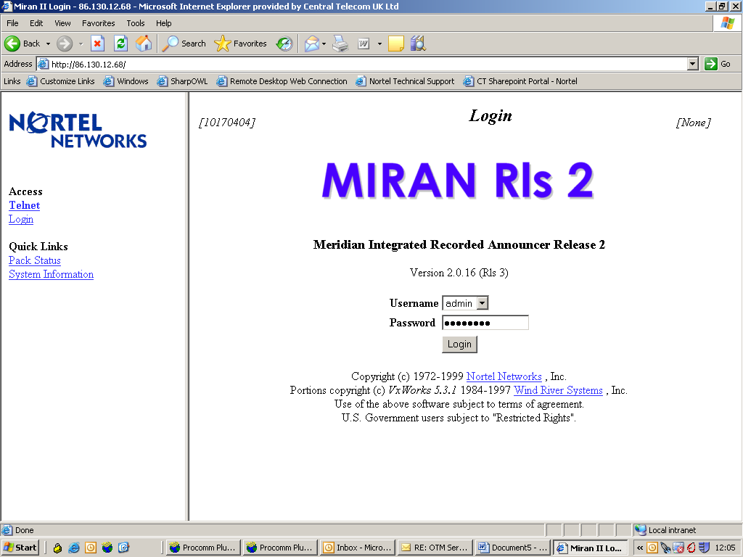

Once logged in, the layout is pretty well the same as via the Serial or Telnet access. i.e. It doesn’t look as if you can do a Miran 2 software upgrade via Ethernet!.

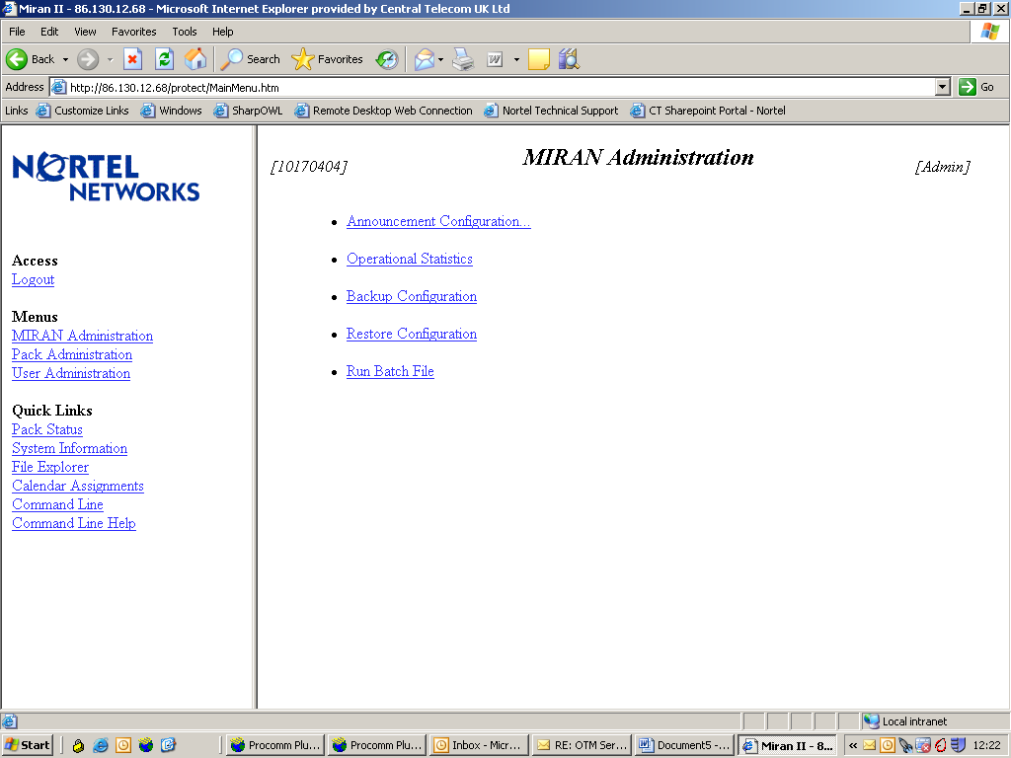

Hopefully the information contained within this guide will be of some assistance

Regards

David Bromley

