How to install & program a Meridian 2050 Soft Phone onto a computer

Install the software in the usual way under “C:\Program Files\Nortel Networks\IP Softphone 2050” etc, using the defaults given where required after clicking on the Setup.bat file. If you already have the older I2050 softphone installed, then you must uninstall it first!. A DOS screen will appear to make sure that you have understood this part. Key in “YES” to enable the program installation to continue.

Once completed, You will then be able to configure the IP settings. A 2050 icon will appear on the desktop.
If the 2050 softphone program has not started, then double click on the link to activate it. You will be presented with the “Quick start” help screen. I personally select the option to “Never show Quick Start at startup”. You will probably get a error message because the IP settings have not been entered in yet.

Select from the top left hand side of the screen, “File” & then click on the “Settings” option.

Under "Settings”, select “Server" & Untick the “Automatic DHCP” box . Below that line, select “Primary” against “server” In the IP box, use the following servers address information & enter in the IP address of your configured Signalling Server or ITG Line card. E.g. 10.224.208.44

The port should be 4100 (CS 1000M or Meridian 1). The BCM system uses Port 7000.
You may need to check the “Sound Devices” section. Make sure that they are correctly configured. Against “Advanced Audio”, you may want to change the Jitter to 4 frames.
You can select the “Sounds” box to select a compatible sound file to be played when the 2050 softphone is enabled during startup. The “Lamp Sounds” section can be set-up to play a sound, when a message has been left in your mailbox.
Finally, if you have a USB Headset, then you can use the “USB Headset” options to enable it.

On the initial 2050 power up sequence, you will have to enter in the Node ID & TN number. i.e.

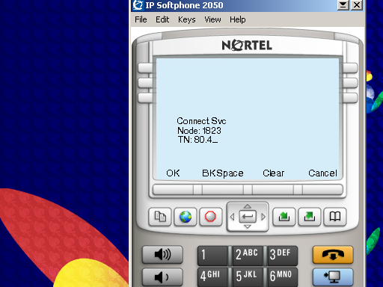
Use the 2050 Phones keypad & digits to enter in the required details. Press OK when completed.
If you are normally connected to a LAN, then you can get the 2050 softphone to work when the P.C. powers up.
The other settings within the tool should be ok as they are.

How to install & program a Meridian I2050 Soft Phone onto a computer

Install the software in the usual way under “C:\Program Files” etc, using the defaults given within the Setup.exe program. Once completed, You will be asked to reboot the P.C.

Before you start up the I2050 from the desktop, "Click on the Start button". Go to Programs & onto Nortel Networks.

Select from I2050 software phone, the Configuration Tool.

Under "Communications server" select use the following servers address information & enter in the IP address of your configured ITG Line card. E.g. 10.224.208.44

The port should be 4100 (Meridian 1). The other settings within the tool should be ok as they are.
You may need to check the sound devices.

After you have done that, Start up the I2050 phone & you will be prompted to enter in the node & TN.
e.g. Node = "1823" & TN = 73 18. Use the Up, Down, Left & Right arrow keys below the display or the “Tab” key to navigate to the correct lines.

It’s a good idea to click on the Nortel symbol (System), Which is located on the top left-hand side of the I2050 Phone box.

It will produce a drop down box. Click on the “Trays” (Top line) & then tick the “Combo” box.
This will open up the keypad & 1st Six Meridian keys for you, below the screen to use.

You can create a shortcut in your programs start up group task bar settings. So that the phone will always fire up when you switch on the Laptop!

