Instructions on how to reset most of BT’s P.A.B.X. modems
The information below is to enable you to reuse a “BT” password protected modem without the need to order up a new modem at a customer’s site. For many years, BT have used these models on most sites, but rarely visit to recover them again!. Please follow my instructions if you wish to reuse them.
BT 2 Box
This modem has been around for at least 15 years or more. It uses a single serial port and has a built in battery backup which lasts quite a while. The baud rate is only 1200 or 2400, but you can change it to 9600 for connection from the modem onto the telephone system access port. However the buffering is very poor, so it’s best to keep it at 2400 max!.
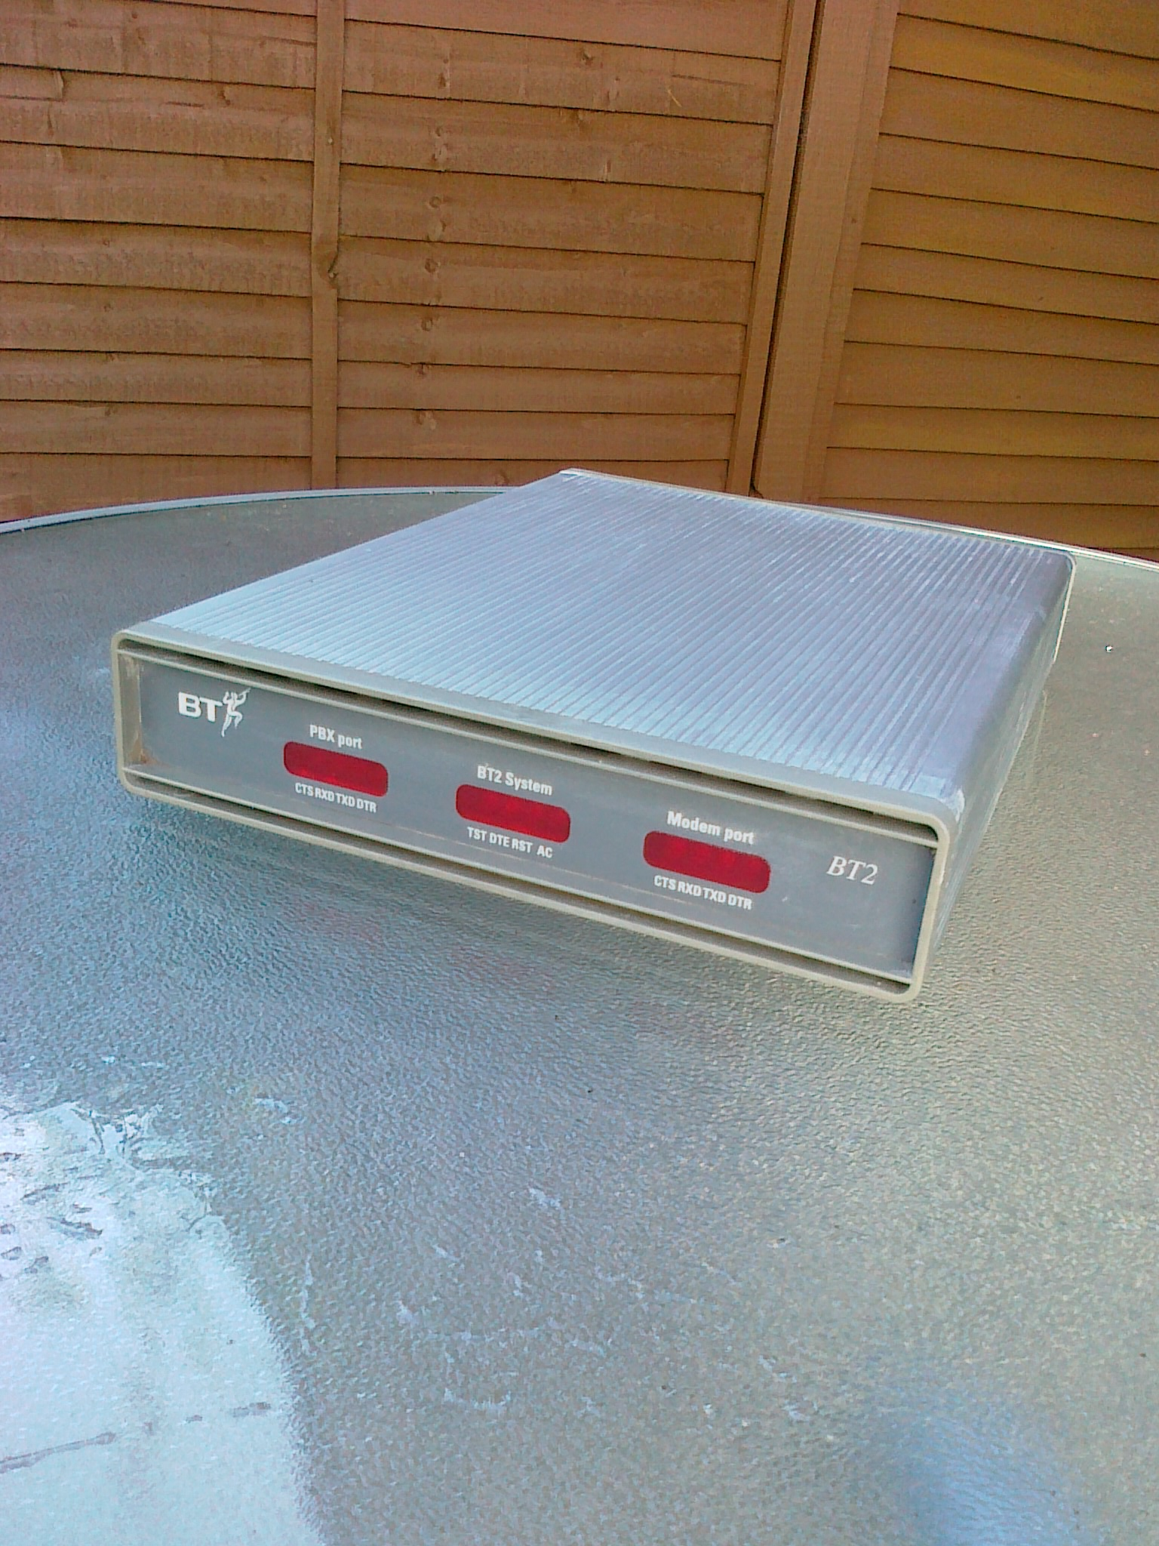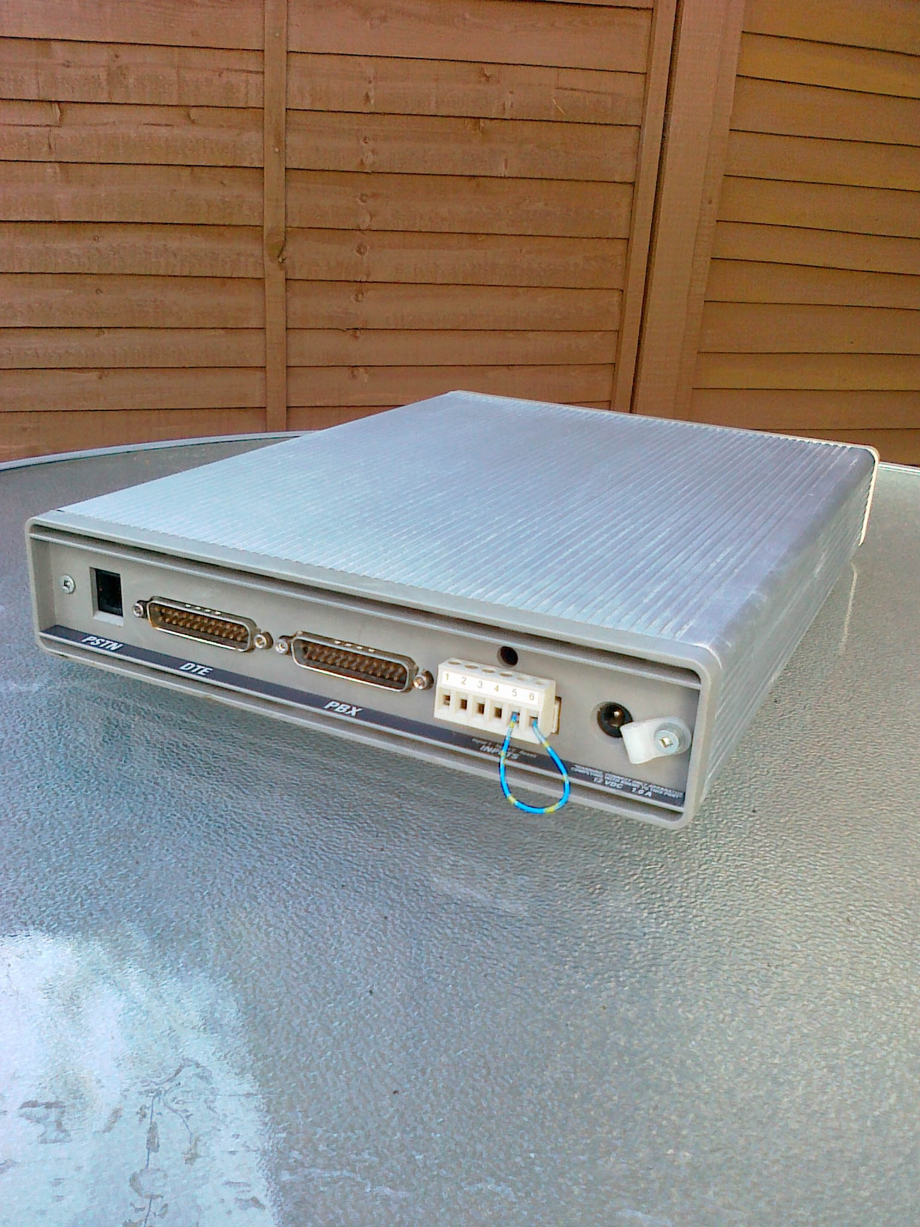
Resetting the box is carried out by doing the following instructions as shown above in the photo and below.
Full Reset
WARNING This will reset the BT box to factory default settings
Remove the power lead from the rear of the BT2 Box. Then using a piece of wire, not your 81s (pliers for non ex BT engineers!), apply a short circuit to terminals 5 and 6 of the connection strip, (located on the rear of the BT2 Box). With the short circuit still on replace the power lead. The "TST" LED should come on constantly and start to flash after about 20 seconds. When the "TST" LED is flashing remove the short circuit from terminals 5 and 6. This will reset the BT2 Box to factory default settings and it will need to be re-configured to allow access onto the system.
Programming the box can be done via the 25 way RS232 port on the back, or via dialling into the modem via a phone line. Either way, you will get a blank screen upon connection. This is what you do below.
Press and hold your “ctrl” key. Then press and release the “t” key followed by press and release of the “enter” key. Repeat this but use the “p” instead of the “t”.
i.e. in Procomm Plus, it’s ^T^M^P^M.
If it’s correct, you will get the default name of BT2> appear on the left hand side. This name can be changed, along with the baud rate settings.
At any stage of “BT2>”, press “h” for the help commands. Press “s” to list out the current baud rate settings. i.e.
BT2>s-System Port Status
BT2 V4.3.1 UK
Date: Mon 28/02/87 Time: 02:31
Port DSR Baud P D S Eol Record Reject SwName
1 X 1200 N 8 1 00 00000 00000
Contacts 00000 00000
Modem 1200 00000
Total: 00000 00000

Pbxid: 00000000
Memory Threshold: 00%
Transparency Escape Character: 00
Modem: CCITT V.22 Compatible

The details listed below are from a typical “BT” enabled BT2 RACE accessible modem. Usually 2400 Baud is selected as will be explained later in this guide.

BIRMHHL>s-System Port Status
BT2 V4.3.2 UK

Date: Wed 03/11/2010 Time: 12:12
Port DSR Baud P D S Eol Record Reject SwName
1 X 2400 N 8 1 8D 00000 00000 [03.04] SL1 ALARM-UK
Contacts 00000 00000
Modem 2400 00000
Total: 00000 00000

Pbxid: 14100999
Memory Threshold: 00%
Transparency Escape Character: 00
Modem: CCITT V.22 Compatible
Alarm Reporting Mode: Single
Dial#1(Ext):
Dial#1(Int): T08009174978
Revertive Dialing Enabled

The default settings usually have 1200 baud rate. Useful tip is if you see a “X” below DSR. It means that the port is connected to the telephone system.

The baud rate can be changed by entering in “X” at the BT2> prompt. i.e.

BT2>x-Set Extended Options

Pbxid: Modem Baud: 1200/2400
Prompt: BIRMHTL
Memory Threshold:
Transparency Escape Character: 00/
Internal Modem Setting (Y = Bell / N = CCITT):
Confidence Call Time (hh:mm):
Port Eol Baud Parity Data Stop
1 00/ 1200/2400 N/ 8/ 1/

Reboot?: Y (Use ^T^M^P^M)
BIRMHHL >

Note!. Use the spacebar to advance to the next prompt. If successful, then you will get something like this below.

BIRMHHL >s-System Port Status
BT2 V4.3.1 UK

Date: Mon 28/02/87 Time: 02:40
Port DSR Baud P D S Eol Record Reject SwName
1 X 2400 N 8 1 00 00000 00000
Contacts 00000 00000
Modem 2400 00000
Total: 00000 00000

Pbxid: 00000000
Memory Threshold: 00%
Transparency Escape Character: 00
Modem: CCITT V.22 Compatible
BIRMHHL >

To dial into the telephone system from the BT2 modem, just press “T” followed by “1” then “N” and sometimes “Y” is required. i.e.

BT2>T-Transparency
Port: 1
Flow Control(Y/N):N
Transparency active...

LOGI BIRMHHL
PASS?
.
TTY #02 LOGGED IN BIRMHHL 16:03 12/8/2010

Logging off and back to the BT2 box is done by pressing your “ctrl” key. Then press and release the “a” key 3 times in quick succession, or slowly 3 times. Finally use +++ as is normal for most modems to clear the call.
BT Plus RACE Box
Some of the larger phone systems used a modem with up to 5 serial ports. It was slightly bigger than the BT2 box, but could also support up to 9600 baud rate. The method to access and configure this box is the same way as shown above. However, a different method is used to default the passwords.
Full Reset
Remove the power lead from the rear of the BT Plus Box. Press and hold in the "TEST" button on the front of the BT Plus Box and replace the power lead. The "TST" LED should be on constantly and start to flash after about 20 seconds. When the "TST" LED is flashing release the "TEST" button.
An example of the different ports that can be used is shown below
BIRMHHL >s-System Port Status
BT PLUS V5.3.4 EUROUK

Date: Thu 12/08/2010 Time: 16:33
Port DSR Baud P D S Eol Record Reject SwName
1 X 9600 N 8 1 00 000000 000000
2 O 9600 N 8 1 00 000000 000000 Transparency only
3 O 9600 N 8 1 00 000000 000000 Transparency only
4 O 9600 N 8 1 00 000000 000000 Transparency only
5 O 9600 N 8 1 00 000000 000000 Transparency only
Contacts 000000 000000
Modem 9600 000000
Total: 000000 000000

Pbxid: 00000000
Memory Threshold: 00%
Transparency Escape Character: 00
Internal Modem Setting: CCITT
Inactivity Timer: 00
Modem Port: Internal Modem
Solo Junior box
This box has been used for the past 6 years or more and is the replacement for the BT2 / Plus versions. The Solo range does incorporate one IP connection. As stated above, It’s rare for BT to visit site to recover these modems, yet the cost must make them expensive to buy?. There are 2 versions of this type and the 1st one uses a type of PCMCIA card device to connect the Ethernet cable.
Access to these box’s is via a modem or data call. I have now figured how to make data call, but the instructions below will enable you to use the serial port. It’s OK to connect at 19200 baud as the connection is very stable.
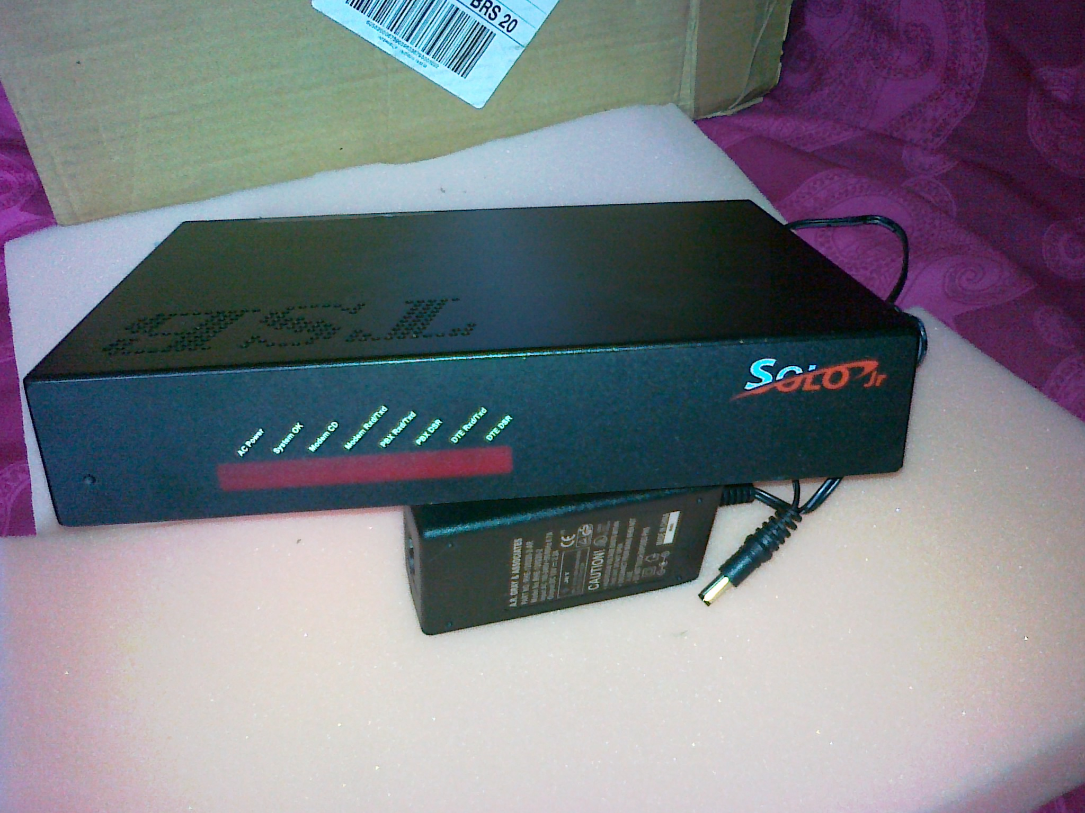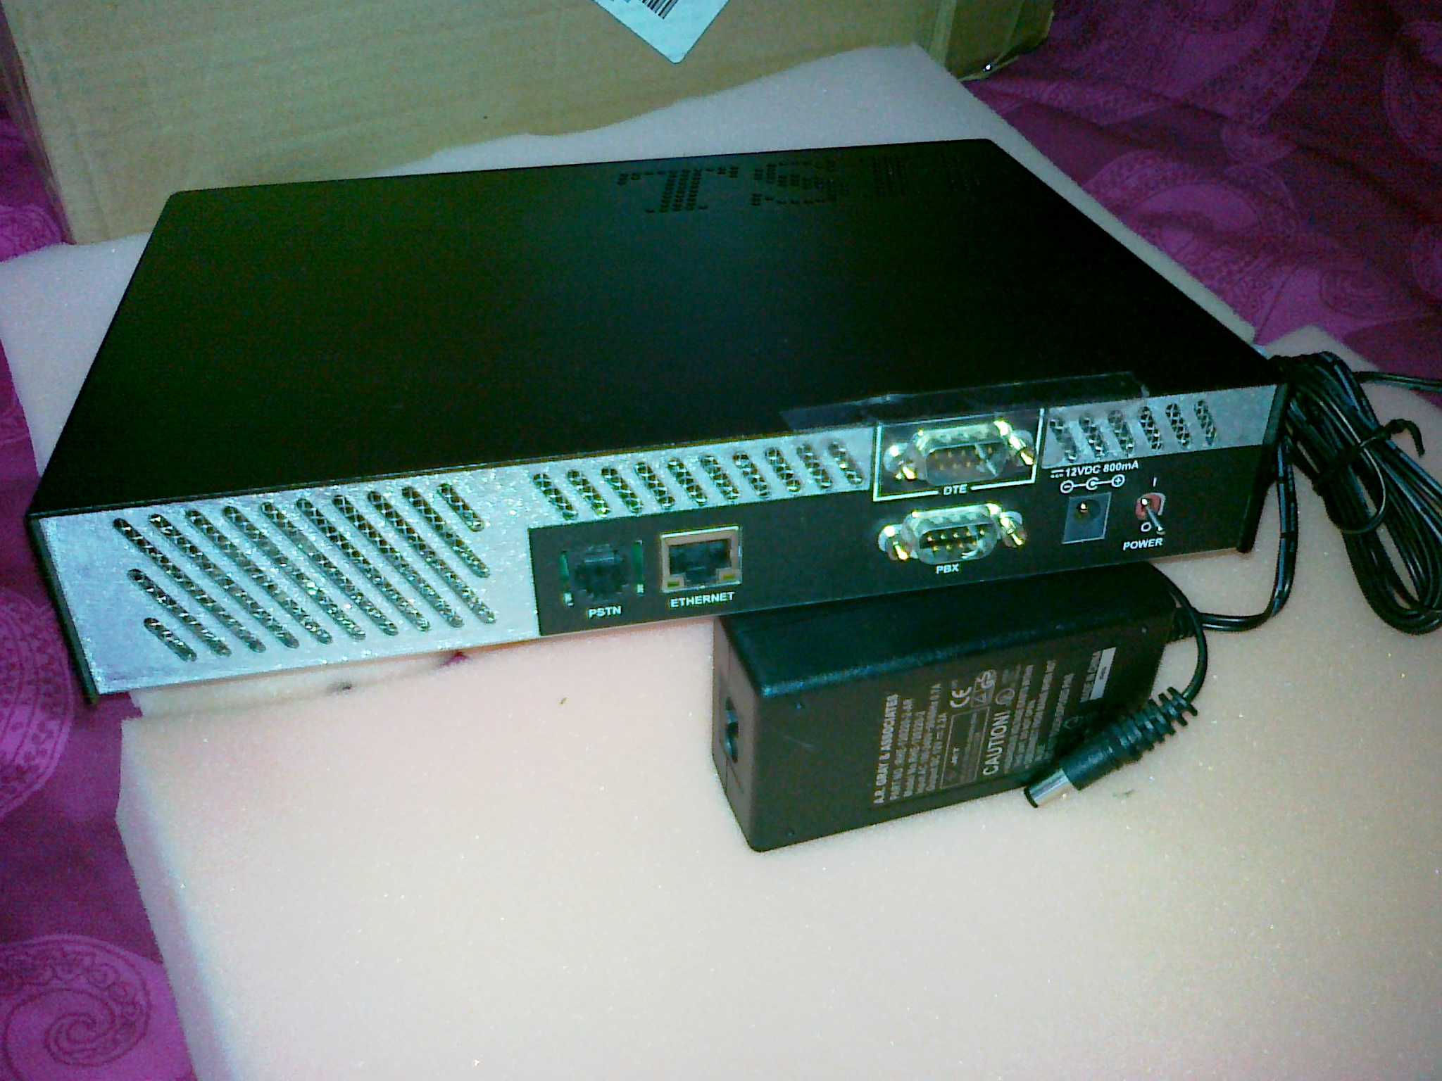
Solo Box Full Reset procedure
Solo will automatically reboot whenever it detects any task utilising all the CPU time or if a task has crashed.

A ‘special’ reboot is used to restore the factory default settings of the Solo unit. If you need to perform a ’special’ reboot, proceed as follows:

1. Press and hold the Reset button until the Solo buzzes.
2. When Solo buzzes, release the Reset button.

If the above method fails, then another way is to turn off the modem via the on/off switch at the back right hand side. Wait 20 seconds. Press and hold the reset button on the front left hand side, then turn on the power switch. Keep the reset button pressed for another 20 to 30 seconds. This should default the Solo box .

Accessing the modem via a dial call will show the following screen message.

Enter "c" for Solo shell or "ppp" for PPP:c

Enter in “c” and the solo login message will appear. Follow the instructions below to enable you to access the system correctly. Some of the prompts below appear only for the larger 5 port Solo Box’s!. These are coloured Grey and larger / heavier.

An extra security feature has been set in Version 3.0.7 and later issue solo boxes.
solo login:solo
password:solo
SoloShell>t
Enter a port number:1
Access to port 1 denied!
SoloShell>

Solo's delivered from the factory do not allow transparancy to the switch without that feature
being set. To fix, log in and do the following sequence using setuser. The only entries required are those shown in bold

SoloShell>
SoloShell>setuser
Enter user name: solo
User solo found!
user name:solo:
Password:solo:
Password Expires in(0-999):0:
Change Password at Next Login(y/[n]):N:
Change Password Retries(1-10):1:
Mininmum Password Length(0-20):0:
Strong Password Required(y/[n]):N:
Prompt:SoloShell>:solo> (Put in a ">" at the end as it makes viewing easier! i.e. BIRMHTL>)
AccessGroup(R,T,AT,R+T,F):F:
Assigned Ports(0-9)::1 (This is the important setting!)
Revertive(y/[n]):N:
Host Name:: birmhtl1
Audit Level(1-3):2:

(The information that you have entered is automatically repeated by solo below for viewing!)

user name: solo
Password Expires in: 0
Last Login: 10/03/2005 07:20:14
Password Changed on: 01/01/01 00:00:01
Change Password at Next Login: N
Change Password Retries: 1
Minimum Password Length: 0
Strong Password Required: N
Prompt: solo>
Access Group: F
Assigned Ports: 1
Revertive: N
Host Name:birmhtl1
Phone Number:
Audit Level: 2
Status Valid: Y

Do you want to save the changes(y/[n]):Y (Don’t forget to press “Y”!)

SoloShell>e

Then drop the line by pressing “e” and re-dial again using the same or new setuser login name!.

Access to the telephone is the same as the BT2 box’s by pressing “t” then the port number (usually “1”) etc. Exiting the solo box also uses the same procedure.

General Solo box help and display settings

SoloShell >h

e exit Exit shell
h help Show a list of commands
v version Show SOLO version number
t transparency Transparent access to the PBX Port
sp setport Display and change the Port settings table

dia displayincomingalarmDisplay incoming alarming in real time
dal displayauditlog Display the content of unit log file
dm displaymemory Display memory usage on data file system
m monitor Display incoming/outgoing data streams at a port
dpt displaypatterntable Display the patterns used on a specified PBX
dp displayport Display the port settings table or port status
fr findrecord Display requested range of stored PBX data records
ds displaysolo Display solo unit status
dnat displaynattable Display NAT table
dipf displayipftable Display IP Filtering table

sm setmodem Display and change the modem settings table
sp setport Display and change the Port settings table
st settime Display and change time
sd setdate Display and change date
i initialize Initialize (soft reboot) the system
cn configurenet Configure network parameters

These commands listed below aren’t available in the above print out!.

configureppp Configure ppp parameters
configurenat Configure Network Address Translation
setsolo Configure the Solo box with local unit identification settings
setuser Configure a new additional user with a different login and password

It’s best NOT to use the shorter prompts such as “cn” as they may not work but to use “configurenet” instead!.

Instructions for setting up the Solo box for access via a data call

The details listed below are only meant to be used as a guide and therefore it’s best to use a range of IP address’s that are applicable with the range that you are connection with.

The first few commands will show you how an existing Solo box has been configured.

SoloShell>ds
Solo HWv2, SN:B483811, HwRev:B.0, Solo v3.0.7
System start time: 07/23/2010 14:06:41
Current time : 09/06/2010 14:42:31
UnitBoxId : 14100999
Threshold : 60%
Number of modems : 1, Number of network cards : 1
SoloShell timeout: 1200
DOC: SanDisk SDCFB-16, Size: 16023552, Free: 12361728
Partitions: P1=14696448
Max allowed users via network: 5
Number of users login via network: 0

Summary of services and status:
Port Rng APnd DSR CAlm Alm Trf CDR Raw Untr SwsType
---- --- ---- --- ---- --- --- --- --- ---- -------
1 Y N Y Y N N N N N AT v03 M1 BT General ST 660

SoloShell>dnat
Enable NAT: Y
Dynamic NAT Timeout: 86400
Inside NAT Table
No. Local Address Global Address Type Inside If
--- --------------- --------------- ------- ----------
1 123.123.129.137 220.0.0.81 static ppp0
2 100.156.255.0 220.0.0.82 dynamic ppp0

-- more --
Outside1 NAT Table
No. Local Address Global Address Type Inside If
--- --------------- --------------- ------- ----------
1 220.0.0.90 110.107.215.82 static ppp0
2 220.0.0.115 110.107.215.83 static ppp0
3 220.0.0.100 110.107.215.84 static ppp0
4 220.0.0.111 110.107.215.85 static ppp0
5 220.0.0.110 110.107.215.86 static ppp0

-- more --
Outside2 NAT Table
No. Local Address Global Address Type Inside If
--- --------------- --------------- ------- ----------

-- more --
Outside3 NAT Table
No. Local Address Global Address Type Inside If
--- --------------- --------------- ------- ----------

-- more --
Outside4 NAT Table
No. Local Address Global Address Type Inside If
--- --------------- --------------- ------- ----------

SoloShell>dipf
IP Filtering Table
No. IPF List of Rules Type
--- ----------------- ----

SoloShellL>v
Solo v3.0.7

How to program up a solo box for IP settings and remote access

SoloShell>configurenet (Use "cn" if configurenet fails!)
Enter site name(SOLOSHELL): BIRMHTL (Use any name identifier)

No. Interface IP Address Subnet Mask
--- ---------- ---------------- ----------------
1 fei0 220.0.0.80 255.255.255.0
Interfaces - [a]ctivate, [d]eactivate fei1 or select number: 1
Enter IP address(220.0.0.80): 220.0.0.80 (Solo Box IP address)
Enter subnet mask(255.255.255.0): 255.255.255.0 (Solo Box Subnet Mask)

No. Interface IP Address Subnet Mask
--- ---------- ---------------- ----------------
1 fei0 220.0.0.80 255.255.255.0
Interfaces - [a]ctivate, [d]eactivate fei1 or select number:

No. host name host address
--- -------------------- ----------------
Hosts - Enter [d]elete, [a]dd, or Return otherwise?

No. Network Gateway
--- -------------------- ----------------
1 0.0.0.0 0.0.0.0
Gateways - Enter [d]elete, [a]dd, or Return otherwise?

Do you want to save above(y/[n])?y (Enter "y" to save changes)
Configuration Saved

SoloShell>configureppp
Enter local IP address(110.107.215.81): 110.107.215.81
Enter remote IP address(1.0.0.3): 220.0.0.69 (Change to a spare IP address in the range you require)
Accept predetermined remote IP address(N):Y
Add remote peer as default gateway(Y):
Allow remote clients to access entire network(N):Y
Authentication protocol NONE|PAP|CHAP(CHAP):CHAP (leave it at the default of CHAP)
User Name(remote): (Computers data call login i.e. pppaccount!)
Password(****): ******** (Changed to i.e. remote or any other password i.e. soloremote etc)
Do you want to save above(y/[n])?y (Enter "y" to save changes)

SoloShell>configurenat
Invalid NAT configuration
Enable NAT?(N): Y
Dynamic NAT timeout in seconds(86400):
Inside NAT Table
No. Local Address Global Address Type Inside If
--- --------------- --------------- ------- ----------

Enter [d]elete, [a]dd, [s]wap inside interface or Return otherwise?
Outside1 NAT Table
No. Local Address Global Address Type Inside If
--- --------------- --------------- ------- ----------

Enter [d]elete, [a]dd, [s]wap inside interface or Return otherwise? S
Outside2 NAT Table
No. Local Address Global Address Type Inside If
--- --------------- --------------- ------- ----------

Inside Interface: ppp0
Local Address: 10.197.255.0
Global Address: 220.0.0.106
Do you want to add another entry?(y/[n]): n
Outside2 NAT Table
No. Local Address Global Address Type Inside If
--- --------------- --------------- ------- ----------
1 100.156.255.0 220.0.0.106 dynamic ppp0

Enter [d]elete, [a]dd, [s]wap inside interface or Return otherwise?
Outside3 NAT Table
No. Local Address Global Address Type Inside If
--- --------------- --------------- ------- ----------

Enter [d]elete, [a]dd, [s]wap inside interface or Return otherwise?
Outside4 NAT Table
No. Local Address Global Address Type Inside If
--- --------------- --------------- ------- ----------

Enter [d]elete, [a]dd, [s]wap inside interface or Return otherwise?
Enable NAT: Y
Dynamic NAT Timeout: 86400
Inside NAT Table
No. Local Address Global Address Type Inside If
--- --------------- --------------- ------- ----------

-- more --
Outside1 NAT Table
No. Local Address Global Address Type Inside If
--- --------------- --------------- ------- ----------

-- more --
Outside2 NAT Table
No. Local Address Global Address Type Inside If
--- --------------- --------------- ------- ----------
1 100.156.255.0 220.0.0.106 dynamic ppp0

-- more --
Outside3 NAT Table
No. Local Address Global Address Type Inside If
--- --------------- --------------- ------- ----------

-- more --
Outside4 NAT Table
No. Local Address Global Address Type Inside If
--- --------------- --------------- ------- ----------

Do you want to save above?(y/[n]): y (Enter "y" to save changes)

SoloShell>setsolo
UnitId? 88888888: 14100999
Data file threshold? 60:
Maximum data file size? 100000:
Transparency escape char (ASCII value in decimal)? 1:
Save changes? y/[n] y (Enter "y" to save changes)
SoloShell>e
Goodbye!

How to program up a solo box for another new user

SoloShell>setuser (This command sets up a new login and password for programming and serial access)
Enter user name: SoloShell (Could use "engineer" etc)
User SoloShell found!
user name:SoloShell:
Password:SoloShell: (Could use "engineer" etc)
Password Expires in(0-999):0:
Change Password at Next Login(y/[n]):N:
Change Password Retries(1-10):6:
Mininmum Password Length(0-20):6:
Strong Password Required(y/[n]):N:
Prompt:SoloShell>:BIRMHTL> (Put in a ">" at the end as it makes viewing easier! i.e. BIRMHTL>)
AccessGroup(R,T,AT,R+T,F):F: ( F = full access)
Assigned Ports(0-9):1,2,3,4,5,6,7,8,9:
Revertive(y/[n]):N:
Host Name: birmhtl1: (Can be changed to the Customer’s site name etc)
Audit Level(1-3):2:

user name: SoloShell
Password Expires in: 0
Last Login: 09/06/2010 14:42:12
Password Changed on: 01/01/01 00:00:01
Change Password at Next Login: N
Change Password Retries: 6
Minimum Password Length: 6
Strong Password Required: N
Prompt: BIRMHTL>
Access Group: F
Assigned Ports: 1,2,3,4,5,6,7,8,9
Revertive: N
Host Name: birmhtl1
Phone Number:
Audit Level: 2
Status Valid: Y

Do you want to save the changes(y/[n]):y (Enter "y" to save changes)

SoloShell>e (Disconnects the line and activates the changes for the next dial in session)
Goodbye!

Instructions on how to create a dial up account to access a solo box via a data call.

These instructions were based on what was given on a Windows XP Pro operating system.

From the Start menu, select “Control Panel”, followed by “Network Connections”. A window will appear. Select “Create a new connection” from the top left hand corner showing as Network Tasks.

This will start the New Connection wizard. Click Next. You will be given the Network Connection Type option. Select “Connect to the network at my work place”, then press Next.

The Network Connection option will appear and click the Dial-up connection button as we will be using a dial up line. Press Next.

Select a device option will appear and you must tick the modem that you require and untick anything else. Press Next

The Connection Name will appear and just enter the name and system details for you to remember. Press Next.

You will see a “Phone Number to Dial” option and just enter in the full number to call the Solo modem. Press Next.

Connection Availability just means if you want anyone else on your computer to use the same connection. Press Next.

Completing the New Connection Wizard option box appears and I’d tick the “Add a shortcut to this connection to my desktop” box. Then press Finish

This will now bring up a completely new window with the name of your connection at the top, with a prompt asking you for the Solo box ppp User name: and password: etc. This could be something like pppaccount and soloremote etc.

Enter in your details. You MUST click on the “Properties” tab before you dial out!. This will open up 5 tabs in a new window. Select the “Security” tab. Look near to the bottom for the area listed as “Interactive Logon and Scripting”. Within this area is a check box for “Show terminal window”. This needs to be TICKED!, otherwise the data call won’t connect correctly.
Click OK to take you back to the previous screen. i.e.

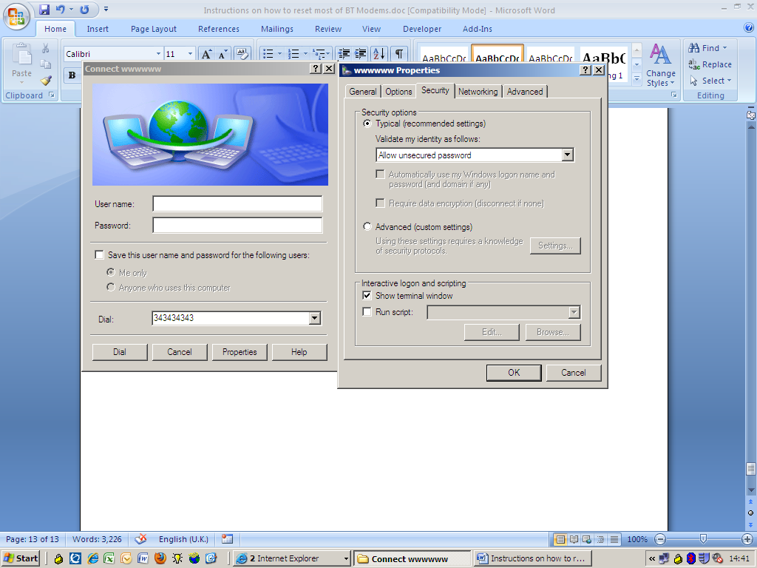

The final part is to dial the connection created. Check the User name and password is correct, Tick the check box if required for “Save this user name and password for the follow users:” and either “me only” or “Anyone who uses this computer” etc. Click the Dial button to call the site.

If it’s successful, then you will get this screen appear below.

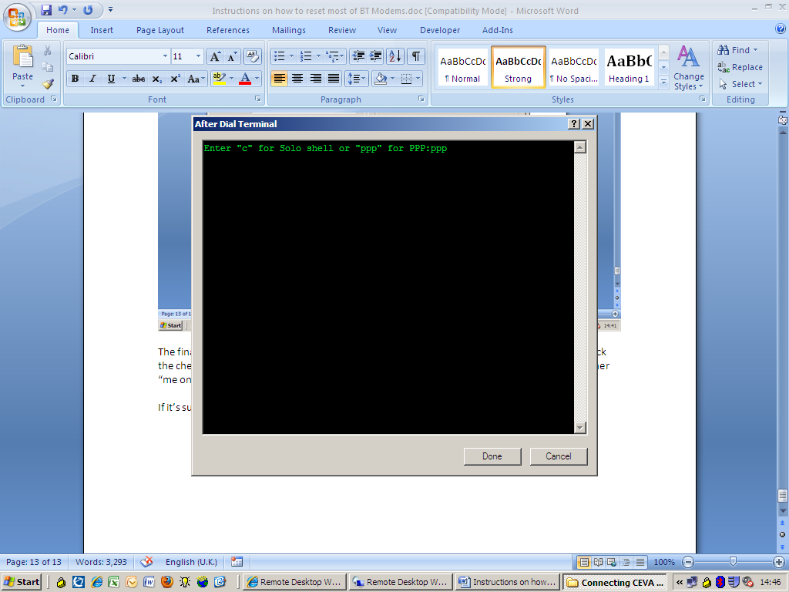

Enter in “ppp”, followed by “Done”. Within a few seconds, you will be connected via a data call onto the Solo box and onto the customer’s data network.

Disconnection is usually carried out by..

From the Start menu, select “Control Panel”, followed by “Network Connections”. A window will appear. Select the name that shows you to be connected and then select from the “Network Tasks” the “Disconnect this connection” option.

The instructions given above should be sufficient in enabling you to configure these modems.

