

Nortel CS 1000 IP Telephony Design Rules and Guidelines

Version 1.1, 26th Jan 2006

This document gives a high level technical overview of the Nortel CS 1000 family of products, and highlights key engineering rules and guidelines including: virtual trunks, DSP resource, LAN requirements, call admission control, signalling server provisioning etc. Also included are some common pitfalls and how to engineer around them.

The target audience is BT sales engineers and Technical Consultants involved in designing CS 1000 implementations and filling out CSDS forms.
BT planners and BT IPT Sales Specialists may also find this document useful

Revision History

Revision | Date | Author | Details of Change
Draft 0.1 | 14 Sep 2005 | Donald McNelis | Initial document outline for comment
Draft 0.2 | 15 Sep 2005 | Donald McNelis | Incorporating initial comments from Chris Valentine and Scott Weatherstone on the document structure
Draft 0.3 | 22 Sep 2005 | Donald McNelis | Further sections completed.
Draft 0.8 | 7th Nov 2005 | Donald McNelis / Rhodri Griffiths | Document essentially complete from Nortel perspective. Passed to BT for comment.
Draft 0.9 | 15th Nov 2005 | Donald McNelis | Incorporation of some comments from Andy Simmonds
Draft 0.12 | 2nd Dec | Andy Simmonds (BT)
Issues 1.0 | 13th Dec 2005 | Donald McNelis | First published version of this document
Issue 1.1 | 26th Jan 2006 | Donald McNelis | Incorporate comments from BT, including changes to suggested QoS settings.

Contents

Revision History 2
Contents 3
CS 1000 Introduction and 4.5 Software 6
Messia 7
CS 1000 Release 4.5 Product Bulletin 7
Nortel Technical Publications (NTPs) 7
Upgrades to CS 1000 Release 4.5 8
CS 1000 Product Portfolio 9
Meridian 1 PBX (Base TDM platform) 9
Option 11C 9
Option 61C and 81C 10
Meridian 1 with IP Line and IP Trunk (IP Enabled) 10
IP Trunk (ITG Trunk) 10
IP Line (ITG Line) 11
CS 1000 Systems 14
Voice Gateway Media Cards 14
Signalling Servers 14
IP Peer Networking 15
Communication Server 1000E 17
Call Servers 17
Terminal Server 17
Media Gateway 1000E 18
TDM calls on CS 1000E 18
PRI Trunk access on CS 1000E 18
Media Gateway 1000T 19
MG 1000T Hardware 20
MG 1000T Operation and Configuration 20
Communication Server 1000S (CS 1000S) 22
Call Server 22
Small System Controller card 22
Media Gateway 1000S SSC card 23
Media Gateway 1000S 23
SLAN (SIPE) Connections 23
CS 1000S Redundancy 24
Communication Server 1000M (CS 1000M) 26
Branch Office (MG1000B formerly SBO) 26
Branch Office configuration and operation 27
Branch Office licensing 27
SRG 1.0 (based on BCM 200 and 400) 28
SRG 50 (based on BCM 50) 30
System Management (Configuration) 31
OTM 31
Telephony Manager 3.0 32
Element Manager and NRS Manager 32
CS 1000 Engineering 33
Signalling Servers 33
Signalling Servers Small System Example 35
Signalling Servers Large System Example 36
TPS failover to Voice Gateway Media Cards 36
Voice Gateway Media Cards 37
Virtual Trunks – How many are required ? 38
Virtual Trunks for Branch Office and SRG 39
Conference for IP phones 39
Bandwidth requirements for conference 40
RAN and Music 42
RAN and Music for CS 1000S and CS 1000M 42
RAN and Music for CS 1000E / Branch Based Music 43
Campus Redundancy 43
Geographic Redundancy 45
System Compatibility 45
Patching 46
Codec Recommendations 46
Call Admission Control (Zones) 46
LAN requirements 52
BT LAN recommendations summary 52
Common Pitfalls and Specific Applications 54
IP Call Recording 54
Analogue fax over VoIP 57
Modem over VoIP 57
ISDN Video over VoIP 57
Virtual TN address space on CS 1000S and Small CS 1000M 58
3rd party analogue gateways (e.g. for fax) 59
Interfacing to 3rd party VoIP systems (Avaya, Cisco) 60
CallPilot / Symposium “Give Controlled Broadcast” on CS 1000E 60
Virtual Office Licensing 60
Virtual Office Call Admission Control 61
Operator Consoles (including Datapulse IP Operator Console) 62
References 63
Appendix A: IP Telephones (including softphones and wireless IP phones) 64
Nortel IP Phone 2001 64
Nortel IP Phone 2002 65
Nortel IP Phone 2004 66
IP Phone 2007 67
Nortel IP phone 1110 68
Nortel IP phone 1120E 68
Nortel IP phone 1140E 70
IP Audio Conference Phone 2033 71
IP softphone 2050 72
IP Mobile Voice Client 2050 for PDAs 73
IP Phone PoE requirements 76
Appendix B LAN and DHCP requirements 77
The Server Subnet 77
The ELAN Subnet 77
The TLAN Subnet 78
The SLAN Subnet 78
The HSP 79
The Customer LAN 79
Numbers of LAN ports required on CS 1000 systems 79
LAN port requirements for CS1000S 79
* Signalling Servers providing NRS service only do not require an ELAN interface 80
LAN port requirements for a CS1000E 80
LAN port requirements for a CS1000M 81
LAN port requirements for a MG1000B 82
SRG 82
LAN, QoS,Bandwidth and IP Addressing requirements for CS 1000 subnets 83
Server LAN 83
The ELAN 83
The TLAN 84
The HSP 85
The SLAN 86
The customer LAN 86
Dedicated voice VLAN 87
Shared VLANs. 87
LAN PoE considerations 88
DHCP options 89
Static configuration 89
Partial DHCP 89
Full DHCP 90
DHCP auto-discovery 91
DHCP for WLAN handsets 93

CS 1000 Introduction and 4.5 Software

CS 1000 release 4.5 is Nortel’s current software for all CS 1000 and Meridian 1 systems. (Systems without signalling servers are branded as Meridian 1).

It is supported on the following system types:
- Meridian Option 11C Chassis (Mini) with MSC or SSC processors
- Meridian Option 11C Cabinet with SSC processor
- Meridian Option 61C with CP3, CP4, CP-Pentium II and CP-Pentium IV processor (
- Meridian Option 81C with CP3, CP4, CP-Pentium II and CP-Pentium IV processor (IGS and FNF supported. Pentium IV processor also requires FNF)
- CS 1000S with SSC processor
- CS 1000M Chassis (11C Chassis with signalling server)
- CS 1000M Cabinet (11C with signalling server)
- CS 1000M Single Group (61C with signalling server and CP3, CP4, CP-Pentium II and CP-Pentium IV processor)
- CS 1000M Multigroup (81C with signalling server - CP3, CP4, CP-Pentium II and CP-Pentium IV processor (IGS and FNF supported. Pentium IV processor also requires FNF)
- CS 1000E with CP-Pentium II and CP-Pentium IV processor
- MG 1000T (Media Gateway 1000 for Trunks usually sold with CS 1000E)
- MG 1000B (Media Gateway 1000 for Branches (formerly known as SBO))

Systems sold as new are the following subset of the above:
- Meridian Option 11C Chassis (Mini) with SSC processor
- Meridian Option 11C Cabinet with SSC processor
- Meridian Option 61C with CP-Pentium IV processor
- Meridian Option 81C with CP-Pentium IV processor and FNF
- CS 1000S with SSC processor
- CS 1000M Cabinet
- CS 1000M Single Group (with CP-Pentium IV processor )
- CS 1000M Multi group (with CP-Pentium IV processor and FNF)
- CS 1000E with CP-Pentium IV processor
- MG 1000T
- MG 1000B

The maximum number of IP and TDM extensions supported varies by system type and processor type. Details are listed in the CS 1000 product bulletin (reference below) pages 39 and 40.

CS 1000 software is priced on a per user basis (Analogue, Digital and IP Users) combined with the software feature level on that system. The software levels are
- L4 Premium Network Services (NACD, QTN)
  - Includes 3A and 3B
- L3B Advanced Network Services
  - E.g. Network speed call, NMS, NAS, VNS, Feature Group D, Network Call Transfer, QSIG GF
- L3A Advanced Call Centre Services
  - Symposium (SCCS and Express)
- L2 Enhanced Business
  - E.g. Multi customer, Virtual Office, Call Park Network, Advanced ISDN services, CLID in CDR, Net Auth Code, ACD C1 & C2, ISL, QSig, Branch Office, IP Peer Trunking
- L1 Business Services
  - RAN, Basic ACD, Call Pilot, Net Alt Route Selection, Call Pilot, Meridian Mail, M3900, Internet Telephones

Full details of what packages are included in each feature level are listed in the CS 1000 product bulletin (reference below).

Messia

All of these systems are ordered via the BT ordering tool known as Messia which links back into engineering systems at Nortel.

Messia is more than simply a pricing tool. It performs various calculations and provides useful output such as:
- How many signalling servers are required to meet the customer requirement
- How much DSP resource (media cards) are required
- How many media gateways will this system require
- Power summary

CS 1000 Release 4.5 Product Bulletin

The Communication Server 1000 Release 4.5 Product Bulletin (number P-2005-0267-Global) is an essential reference document for sales engineers and consultants specifying CS 1000 Solutions. It can be found on the Nortel PIC (Partner Information Centre) www.nortel.com/pic under Partner Bulletins -> Product Bulletins -> 2005 Bulletins, or by pasting the following URL into your browsers address bar

https://app12.nortelnetworks.com/cgi-bin/mynn/home/NN_bulletinDetails.jsp?DC=0&DY=2005&curOid=12460&whereClause=10&progSrcID=-8461

The bulletin contents include:
- Capacity of the various platforms and processors
- Compatibility between CS 1000 4.5 and other Nortel products (CallPilot, Symposium, Meridian Mail etc)
- Software package contents
- New features introduced in release 4.5

Nortel Technical Publications (NTPs)

Another essential source of information are the CS 1000 Release 4.5 NTPs. There is a full suite of these documents covering all aspects of CS 1000 planning, installation and maintenance, and there are several references to specific NTPs in this document.

NTPs can be found at www.nortel.com/support, or by pasting the following URL into your browsers address bar.

https://app49.nortelnetworks.com/cgi-bin/HelmExpress/srchlite?Collection=R4_5&SEARCH=Power+Search&PF=m&srchTerm=&boolSelection1=AND&srchTerms1=&sl=&CollCount=1&SearchType=2&ShowMeta=1&ShowDates=2&SortOrder=1&startDoc=1&sl=@31.0/

Upgrades to CS 1000 Release 4.5

BT offer a fixed price upgrade program to upgrade existing customers hardware and software to release 4.5. Also existing Meridians can be upgraded to a CS 1000M by adding one or more signalling servers and one or more media cards. Upgrades are also available via marketing programs such as IP Central that offer free of charge upgrades to customers spending a certain amount on new equipment.

For information on pricing of upgrades refer to
Upgrade Pricing: http://technet.intra.bt.com/saleszone/cs1000/sales_tools/default.htm
Generic CS 1000 Sales Details: http://technet.intra.bt.com/saleszone/cs1000/ This site also includes current Campaigns and Offers Detail

In general upgraded systems offer all the same features as an equivalent new system at the same software release and processor level. Capacities, and certain features (such as geographic redundancy) are determined by the processor type.

For a full list of hardware compatible with CS 1000 release 4.5, including minimum revisions of cards, refer to NTP 553-3001-156 “Product Compatibility”. Normally BT’s Big Switch Upgrade Centre handles upgrades to Option 61 and 81 systems.

CS 1000 Product Portfolio

This section gives a brief overview of each of the products that can run CS 1000 release 4.5 software.

Meridian 1 PBX (Base TDM platform)

Meridian 1 is Nortel’s family of digital PBXs with models ranging from a maximum of 160 to 16,000

Option 11C

Meridian Option 11C Cabinet is a 10 slot wall mounted cabinet with slots that can house any Meridian IPE card.

Meridian Option 11C Chassis (previously known as Option 11C Mini) is a 19” rack mounted PBX with a 4 slot main chassis and an optional 4 slot expander that connects to the chassis via multicore copper connections. The slots can house Meridian IPE cards (analogue or digital line cards, and PRI trunk cards, application cards etc). The 11C chassis also has a slot reserved in each chassis for a 48 port digital line card. On Option 11C Chassis systems, cards requiring a CE-MUX (e.g. PRI cards) can not be placed in the chassis expanders.

Option 11C PBXs have a two number TN format

Both 11C cabinet/ chassis have a main cabinet/chassis, which houses the system processor (SSC card or Small System Controller). Up to 4 additional cabinets can be connected to the main cabinet via a fibre connection or a carefully engineered IP connection known as SIPE (Survivable IP expansion). If fibre expansion is used (the normal solution sold by BT), then PRI cards are restricted to the main cabinet. With IP expansion PRI cards can be placed in any cabinet / chassis, but still can not be placed in the 11C Chassis expanders. Note: Option 11 SIPE is not supported by BT, however the same technology is supported by BT when used in a CS 1000S or MG 1000T.

Regardless of the connection between cabinets, Option 11C systems can be considered as non-blocking TDM systems from an engineering perspective. That is any card can talk to any other across the system back plane or to other cabinets via fibre or SIPE connection.

Normally Option 11C systems are considered as single processor machines, however if they have SIPE there is a level of survivability as each of the slave cabinets can survive in it’s own right if the main SSC card fails.

For a fuller description of Option 11C cabinet and chassis systems refer to NTP 553-3011-010
“Communication Server 1000M and Meridian 1: Small System Overview”

Option 61C and 81C

Option 61 and Option 81 are larger floor mounted PBXs that feature
- Dual processors (with no dropped calls caused by processor failure)
- TDM switching shelves or network groups (1 group in Option 61 or CS 1000M single group, 2 to 8 groups in Option 81 or CS 1000M multi group). Dual PRI cards are also inserted in the network groups.
- IPE shelves for analogue, and digital extensions, IP trunk or Line Cards, application cards, analogue trunks etc.

Unlike Option 11 PBXs, Option 61 and 81 are not inherently non blocking as there is usually concentration between the IPE shelves and the network group. Sales Engineers can specify on Messia whether extensions have to be non-blocking or standard (ie. potential for blocking) at order time. Application cards, and IP trunk and Line cards are automatically configured to be non blocking by Messia.

For a fuller description of Option 61C and 81C refer to NTP 553-3021-010
“Communication Server 1000M and Meridian 1: Large System Overview”

Meridian 1 with IP Line and IP Trunk (IP Enabled)

Since the late 1990’s customers have been able to “IP Enable” their Meridian 1 PBX by adding IP trunk and IP Line capability. This is still relevant today because of the installed base, and because some customers do not want the full suite of IP telephony features offered by CS 1000 systems. (CS 1000 systems have signalling servers and do not use IP trunk or IP Line – see later)

The following features require signalling servers, and are therefore not available on Meridian 1 with IP Trunk or IP Line
- IP Peer Networking
- SIP
- Virtual Office for IP Phones
- Personal Directory, Callers Log and Redial List for IP phones
- Branch Office (MG 1000B or SRG)
- Geographic Redundancy
- 3rd party SIP or H.323 interworking

IP Trunk (ITG Trunk)
IP Trunk (known as ITG trunk in earlier releases) allows customers to create a private VoIP network between Meridian 1 PBXs over a WAN or LAN providing full MCDN networking features. (MCDN features include centralised attendant, centralised voice mail, network ring again, network call centre, name and number display, route optimisation / anti tromboning etc.)

IP trunk runs on a single slot 32 port IPE card that provides the following functions:
- DSP resource for 32 timeslots of VoIP to TDM conversion,
- H.323 signalling.
- DCHIP daughterboard to packetise the D-Channel from a Meridian MSDL or SDI/DCH card (required to give the MCDN functionality)

Multiple IP trunk cards can be connected together to form an IP Trunk “Node”. Within an IP trunk node there can be leader, backup leader and follower cards. Where possible the DCHIP daughterboard should be placed on a follower or backup leader card.

For added resilience it is possible to have multiple IP trunk nodes, each with their own DCHIP card, however this solution is complex to configure and is not recommended. (For resilience IP Peer trunking with redundant Signalling Servers is a better solution)

With IP trunk a dialled DN is translated to an IP address of the far end system in one of two ways:
- Static lookup table on the IP trunk node
- By using the NRS (Network Routing Server) running on a Signalling Server somewhere in the customers network. (Note: A Meridian 1 with IP trunk can use an NRS without needing signalling servers at every site)

From a dial plan perspective, the IP trunk can be thought of as a tandem node. A VoIP call to any destination in the network will be passed from the Meridian 1 to any channel on the IP trunk node. The IP trunk cards then translate the DN to the correct IP address and deliver the call to the appropriate system at the far end. There is no need to dedicate IP trunk channels to a specific destination as is done with TDM leased line networks.

IP trunk is managed from Optivity Telephony Manager 2.2. There is no supported command line interface to configure IP Trunk.

When to sell IP Trunk
IP trunk should be sold to:
- Cost effectively add VoIP trunking to new or existing Meridian PBXs with TDM phones
- Bring existing Meridian systems into a CS 1000 VoIP network (Direct IP media path is maintained so long as the Meridian with IP trunk system does not have any IP Line installed)
- To connect BCMs to Meridian 1 systems over VoIP trunks

IP trunk is not recommended for:
- Deployments with a large number of channels (At current prices IP Peer (including the cost of a signalling server and media cards) is cheaper than IP trunk for 64 ports and higher)
- Deployments requiring a high degree of redundancy on the IP trunking (IP Peer with 2 signalling servers and 2 or more media cards offers excellent redundancy without complicating the system design)
- Deployments that require IP Peer networking (see discussion on IP Line below)

For further information on IP Trunk refer to NTP 553-3001-363 “IP Trunk: Description, Installation, and Operation”

IP Line (ITG Line)
IP Line (previously known as ITG Line) allows Nortel IP phones and softphones to be connected to a Meridian 1 system.

IP Line operates on a 32 port card that has identical hardware to the IP trunk card, with the exception of the DCHIP daughterboard.

IP Line cards perform 2 functions:
- DSP resource for 32 timeslots of VoIP to TDM conversion
- TPS or Terminal Proxy Server to provide Nortel Unistim signalling to 128 IP phones

IP Line operates in a leader / follower mode with multiple cards grouped together in a node (typically each Meridian 1 has 1 IP Line node). IP phones register with the node IP address (controlled by the active leader) however their registration is load balanced to the quietest card in the IP Line node.

Although phones are registered on one card for the purposes of signalling, a call to an IP phone can use any free DSP resource on any IP Line card on the PBX.

Calls between IP phones on the same Meridian 1 are point to point between the phones and do not use any DSP resource on the IP Line cards.

Calls to the PSTN, TDM phones on the PBX, or calls requiring any other TDM resource on the PBX use DSP ports on the IP line card (1 DSP port for every IP phone involved).

There is the potential for contention for DSP resource (worst case of 4:1 contention ratio if you have the maximum of 128 phones registered on a 32 ports card)), however this contention ratio is more than adequate for normal business usage. In high call volume situations, such as call centre, the contention ratio can be reduced, or eliminated, by provisioning extra IP Line cards.

To configure IP line for non blocking go the Voice Gateway and populate the “Additional Simultaneous IP to Non-IP” box with the number of users. Make sure there is 1 Voice Gateway Media Card for every 32 users in the Price Report.

IP Line is managed from Optivity Telephony Manager 2.2. There is no supported command line interface to configure IP Line.

When to sell IP Line

In general don’t sell IP Line. Instead CS 1000 (with signalling servers) should be the lead offering to the customer (Typically CS 1000M for existing customers, or CS 1000S or E for new) This is because of the following:
- IP Line does not support Peer Networking (see discussion below)
- IP Line does not support Virtual Office (often seen as a key feature for migrating to IP extensions)
- IP Line does not support Personal Directory, Redial List and Callers List for IP phones

IP Line is suitable where
- Customers are not using IP trunk on the same Meridian 1 (no need for Peer Networking)
- Customers do not require virtual office, personal directory etc. and wish to save the cost of the signalling server

A typical example where IP Line is suitable is to extend a Meridian 1 call centre to agents in a remote building, at home, or offshore.

CS 1000 Systems

Systems branded as Meridian 1 do not have signalling servers, and instead use the IP Line and/or IP Trunk cards to perform VoIP signalling.

All CS 1000 systems (CS 1000S, CS 1000M, CS 1000, as well as MG 1000B and MG 1000T):
- Have at least one Signalling Server that performs the VoIP signalling
- Have at least one Voice Gateway Media Card to act as the DSP resource for IP to TDM conversion.
- Support IP Peer Networking

The components and features common to all CS 1000 systems are described below. The various types of CS 1000 systems are described in the following sections.

Voice Gateway Media Cards

In a CS 1000 system the Voice Gateway Media Cards perform the IP to TDM conversion for both trunk and line calls. The cards are a pooled resource which is used by the system whenever a DSP resource is required. They run the same firmware as IP Line cards, and in a failure situation they can perform signalling for the IP phones. (in normal operation the signalling server performs all the signalling and media cards will not have any phones registered to them).

New systems are shipped with 32 port Voice Gateway Media Cards identical to the IP Line Cards.

Also the following installed base cards can be upgraded to the IP Line 4.5 firmware to act as CS 1000 Voice Gateway Media Cards:
- 32 port IP Line card on an earlier release
- 24 port ITG Line card (ITG-P)
- 32 port IP Trunk card (DCHIP daughterboard no longer required)
- 24 port ITG Trunk card (DCHIP daughterboard no longer required)

Signalling Servers

The Signaling Server is a Nortel supplied 19” rack mountable / 1U server running the same VxWorks operating systems used on the call server and Meridian PBX CPU.

CS 1000 release 4.5 requires 512 MB memory on the signalling server (early release 3.0 and release 2.0 systems shipped with 256 MB of memory so some systems may need upgrading)

There are a number of IP telephony services that can run on the signalling server. In a small system all of these applications can run on the same physical server, however in larger systems multiple signalling servers may be required (see Signaling Servers in the CS 1000 Engineering section)

The installation engineer determines which applications run on which signalling server at installation time. The network planner should advise the installer what applications should run on which signalling server.

The services that can run on signalling servers include:
- Network Routing Service (NRS). There is typically 1 Primary and 1 Alternate NRS in a VoIP network. The NRS holds the network dial plan (DN to IP address translation) and has the following sub-components
  - SIP Redirect Server
  - H.323 Gatekeeper & Network Connection Server (NCS)
  - SIP Registrar
- H.323 Gateway. Used for H.323 virtual trunk/ peer trunk signalling with encapsulated MCDN, equivalent to the signalling on IP Trunk with added IP Peer Networking.
- SIP Gateway . Used for SIP virtual trunk/ peer trunk signalling with encapsulated MCDN.
- Terminal Proxy Server (TPS) for IP phones. Unistim signalling to IP phones, equivalent to the signalling on IP Line with added enhancements such as IP Peer Networking, Virtual Office and NAT.
- IP Telephone Personal Directory/Redial List/Caller List (PD/RL/CL)
- CS 1000 Element Manager Web Interface
- NRS Manager Web Interface
- Echo Server for NAT (Network Address Translation)

IP Peer Networking

With IP Line calls between IP phones are always converted to TDM by the IP line card and travels across the Meridian’s TDM back plane to reach their destination.

If the destination is also an IP device this can lead to multiple transcodings (VoIP to TDM conversions or “hops”). Multiple transcodings (“hops”) should be avoided because:
- Each transcoding adds delay (frame size and jitter buffer)
- If compression is used (e.g. G.729A) each transcoding reduces voice quality
- Each transcoding needs DSP resource (e.g. IP Trunk or IP Line Cards), and may require additional bandwidth

The worst example of this problem is when and IP phone on one Meridian calls an IP phone on another Meridian using an IP trunk which is shown below.

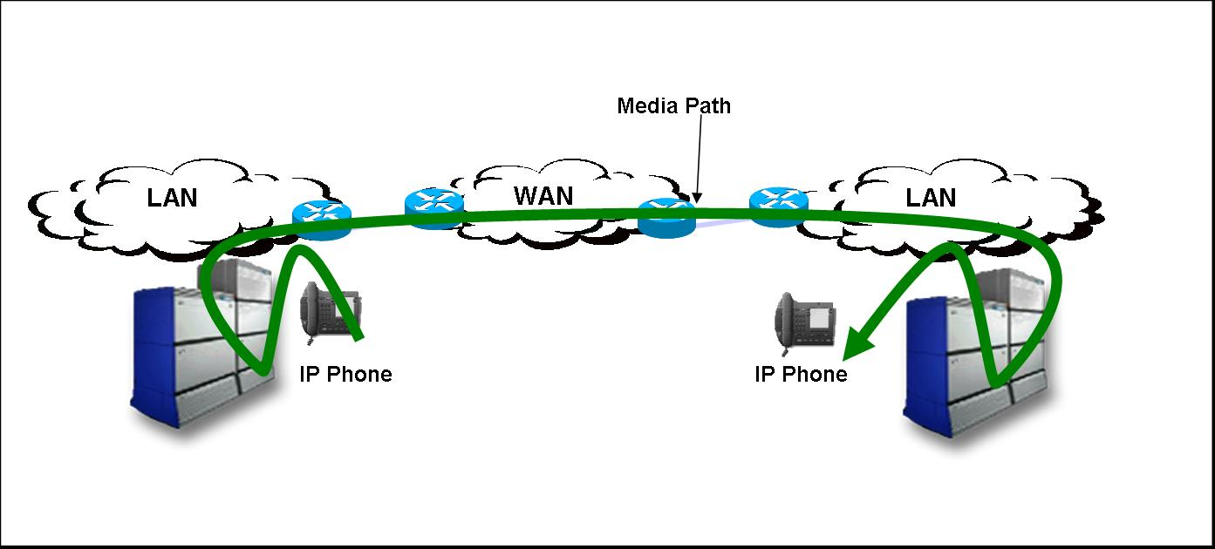Figure 1 No IP Peer Networking

The media path in this example is:
- IP phone to IP Line card (1st VoIP hop)
- Across TDM backplane on Meridian A
- IP trunk card on Meridian A to IP trunk card on Meridian B (2nd VoIP hop)
- Across TDM backplane on Meridian B
- IP line card to IP phone (3rd VoIP hop)

If one of the phones was a TDM phone then the number of VoIP hops is reduced to 2, however that is still less than ideal.

The solution to this multiple transcoding problem is a feature called IP Peer Networking which requires signalling servers to function.

With IP Peer Networking the media path between IP endpoints is direct as shown below.

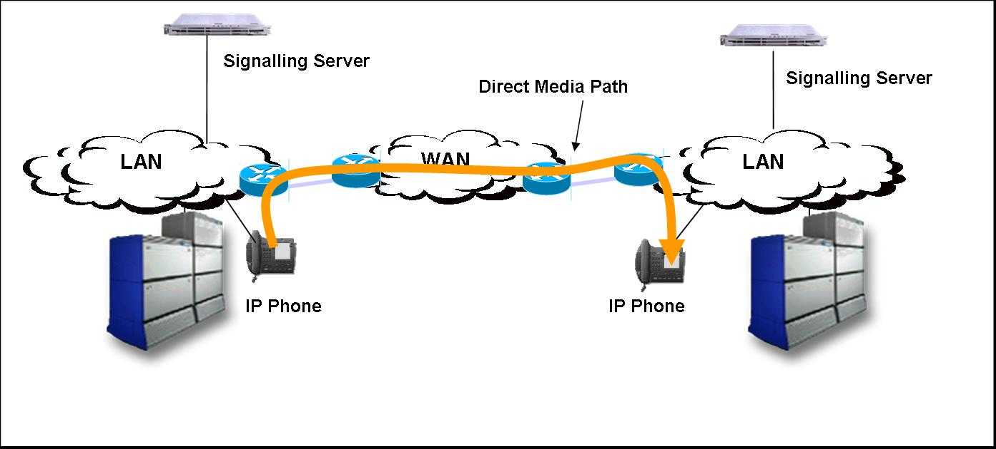Figure 2 With IP Peer Networking

In this example the systems are CS 1000Ms (ie. they have signalling servers) and are using SIP or H.323 IP Peer trunks instead of IP trunk. In this case the media path goes directly from the IP phone on system A to the IP phone on system B which requires no VGMC ports, and gives better voice quality.

Note: With IP Peer Networking the signalling for both trunk side (H.323 or SIP) and line side (Unistim) still goes to the call server (equivalent to the Meridian CPU), but the signalling does not require DSP resource, and does not impact on voice quality.

Communication Server 1000E

CS 1000E is a high capacity rack mount system supporting
- 15,000 IP extensions
- 3,000 TDM extensions
- Campus Redundancy (where the components are distributed over a LAN)
- Geographic Redundancy (where phones can fail over to an alternate system)

The CS 1000E is described in more fully in NTP 553-3041-010 “Communication Server 1000E Overview”, however a brief description is included here.

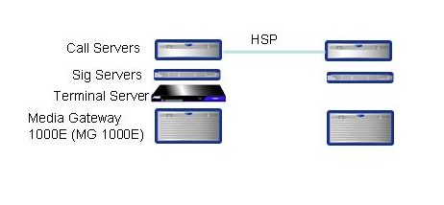
Figure 3 CS 1000E

Call Servers

A CS 1000E has two call servers which are equivalent to the Pentium II or Pentium IV CPUs found in Meridian 61/81 and CS 1000M SG/MG. The two CPUs share the same database and operate in Active/Standby mode.

The real time call state information is shared between the two processors via the High Speed Pipe (HSP). This connection can either be a cross over cable (if the processors are within 100 metres of each other) or it can run over a carefully engineered LAN (see Campus Redundancy for details on splitting call servers over a LAN)

Terminal Server

One Terminal Server is included in the CS 1000E base package which is used to provide RS 232 serial ports for the types of serial connections handled by SDI ports on a Meridian. This includes
- TTY ports for management
- Call Loggers / CDR output
- ACD C2 printers / supervisor terminal
- Printers
- PMS links (for hospitality systems)

Media Gateway 1000E

Media gateways 1000Es have identical hardware to MG 1000S, however they run different software effectively emulating Option 81 IPE shelves (TNs in a CS 1000E follow the large system TN format and the slots are directly controlled by the CS 1000E call server).

Each MG 1000E has an SSC card acting as the controller for the gateway, at least one voice gateway media card, and up to 7 other slots (total of 4 slots in the main and 4 in the expander)

Unlike the MG 1000S, these gateways have no survivable functionality, however they can be dual homed to two LAN switches and can connect to either CS 1000E call server.

These gateways can support
- Analogue and Digital line cards (including attendant consoles)
- Analogue trunk cards
- Applications (MIRAN, ICD, ICB etc) including RAN or Music broadcast
- CallPilot
- Line Side E1 (typically for IVR connection)
- Adhoc Conference (using the 64 conference ports on the IP daughterboards of the SSC)

MG 1000Es DO NOT support:
- PRI cards (these are normally housed in MG 1000Ts or MG 1000Bs instead)
- BRI cards (can be on MG 1000T or MG 1000B, however see notes on video conference and other ISDN data applications)
- DECT (these can be supported on MG 1000Ts or MG 1000Bs)
- Remote Office 9150 or 9115 (Remote Office not supported on CS 1000E systems)

MG 1000Es are designated blocking or non blocking. Non-blocking MG 1000Es (typically used for services, or for TDM call centre extensions) have 1 Media Card port for every TDM port.

TDM calls on CS 1000E

It is important to understand that nearly every call on a CS 1000E is a VoIP call. This includes calls between TDM phones on different gateways (the only exception being calls between TDM phones on the same MG 1000E).

Also note that a CS 1000E is normally more expensive than an equivalent Option 81 solution for large numbers of TDM phones, however CS 1000E call servers and Media Gateways can be split across multiple data centres / comms rooms, so users may be prepared to pay this premium. (For IP phones a CS 1000E is typically cheaper than the equivalent CS 1000M MG solution)

PRI Trunk access on CS 1000E

The CS 1000E does not directly support any PRI trunks. VoIP to PSTN/TDM gateway functionality can be provided via any IP Peer system including
- MG 1000T (see below)
- MG 1000B or SRG
- Any CS 1000S or CS 1000M
- Any Meridian with IP Trunk 3.0 or later
- Certified 3rd party trunk gateways

All of these solutions require SIP or H.323 IP Peer trunks on the CS 1000E, however they do not require any physical resources (media cards etc) on the CS 1000E. (IP to TDM conversion is done by the gateway device which is where the media cards would be placed)

For a greenfield site MG 1000Ts are typically used. If they are ordered with the CS 1000E then the customer only pays for the IP Peer trunks at MG 1000T end, and receives the corresponding IP Peer trunks on the CS 1000E free of charge. Because there is no cost associated with the IP Peer trunks on the CS 1000E they do not show up on the Messia price report, however they are taken into account when Messia calculates signalling server requirements.

Other common scenarios with CS 1000Es are MG 1000Bs in the branch sites acting as the gateway or a Meridian 1 upgraded to CS 1000M to act like a large MG 1000B using controlled load sharing. Neither of these options require MG 1000Ts, but they do require the appropriate number of IP Peer trunks to be ordered for the “gateway” and the CS 1000E.

Media Gateway 1000T
The Media Gateway 1000T (MG 1000T) platform provides the CS 1000E with digital trunk and PRI access to the PSTN and to other PBX systems. It functions as an independent resource on the network and is therefore accessible by any peer node on the network using the NRS. Given its main role as a trunking gateway, the MG 1000T cannot be provisioned with User Licenses (with the exception of DECT User Licenses).

Figure 4 MG 1000T

The MG 1000T Core and Expansions each house an SSC card and contain four slots for IPE cards. They also each support an optional MG 1000T Expander through copper connections.
The MG 1000T Core and Expansions use the same base hardware as the MG 1000E and MG 1000S.

MG 1000T Hardware

Unlike the MG 1000Es, the MG 1000T platform does not operate under the direct control of the CS 1000E Core Call Servers. Instead, the MG 1000T Core (MG 1000T 0) provides the primary processing for the MG 1000Tplatform. The MG 1000T Core SSC card controls the circuit cards in the MG 1000T Core and all cards in up to four MG 1000T Expansions The MG 1000T Core SSC card can be equipped with two dual-port IP daughterboards, providing a total of four IP ports for connections to the SSC cards on the MG 1000T Expansions. As a result, each MG 1000T Core can support up to four MG 1000T Expansions with optional MG 1000T Expanders.

An MG 1000T can have 1 or 2 signalling servers.

A “fully loaded” MG 1000T can support 20 PRIs with 20 Media Cards. It would also require 600 IP Peer access ports.

The MG 1000T Core to Expansions connection has the same characteristics as the SLAN in a CS 1000S. It is normally run on a cross over cable, however it can be stretched over a carefully engineered network.

The individual MG Expansions can be designated as survivable in the same way a CS 1000S system can. Also one of the MG 1000T Expansions SSC card can be designated as the alternate call server for the MG 1000T, but, like the CS 1000S, it takes a few minutes for the alternate call server to boot into server. In practice this means only 4 PRIs would survive the failure of an MG 1000T core.

If a high degree of resilience is required it is normally better to have multiple MG 1000Ts instead of trying to make a single MG 1000T survivable.

Note: This can complicate the NRS configuration as there will now be two (or more) gateways to choose from.

MG 1000T Operation and Configuration

The MG 1000T communicates with the CS 1000E using IP Peer Networking with Signaling Servers. The Signaling Servers run SIP and H.323 Signaling Gateway software. As a result, the MG 1000T platform can be separated from the CS 1000E across the network to provide PSTN access wherever needed.

With IP Peer Networking, any CS 1000E system in the network can access the MG 1000T using the NRS for numbering plan resolution and least cost routing. The MG 1000T can be collocated with the CS 1000E system to provide a configuration that is similar to that of a traditional PBX.

The MG 1000T does not need the configuration of any users (except DECT users), however it still requires a configuration database for the trunks. The MG 1000T may require a dial plan (particularly for trunk to trunk calls) and digit manipulation to be configured in it’s database.

CS 1000E / MG 1000T differences from Option 81 / CS 1000M

Because the MG 1000T is a separate logical system, a CS 1000E/MG 1000T has some differences from an Option 81 or CS 1000M including:
- TDM Tandem Trunk Calls
  - The CS 1000E plays no part in tandem trunk calls (e.g. PRI to PRI or BRI to PRI). These calls are controlled by a combination of MG 1000T database, and, where there is more than one MG 1000T, the NRS. CDR for tandem calls must be collected from the MG 1000Ts
- CDR
  - The CS 1000E only produces CDR for calls to / from extensions, and does not include the physical route or circuit (the virtual route and TN of the virtual IP peer trunk is produced instead).
- Call Recording and CTI
  - CTI messaging does not show the real trunk TN which means the call recorder can not identify the physical circuit (see note later on Call Recording)
- DNIS
  - IDC for DNIS should be done on the CS 1000E, not the MG 1000T
- TARG / TGAR is not a network feature and therefore does not work between CS 1000E and MG 1000T. FRL can be used instead

Communication Server 1000S (CS 1000S)

CS 1000S is a 19” rack mount system for up to 1000 IP users. It is “survivable” rather than fully redundant (better than an Option 11, but not as good as an Option 61 or 81)

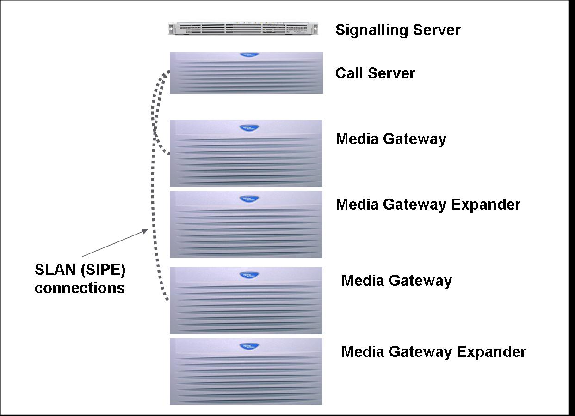
Figure 5 CS 1000S
The components of a CS 1000S are

Call Server
The Call Server provides telephony services, such as call processing, and supports trunking features. It also acts as a database server for synchronization of configuration information with all MG 1000S systems. A CS 1000S system can control a maximum of four MG 1000S systems and
Expanders.

Small System Controller card
The NTDK20 Small System Controller (SSC) card in the Call Server is the primary system processor. It controls the telephony services and call processing. Each MG 1000S is also equipped with an SSC card. The Call Server SSC controls the call-processing features of IP Phones and trunk interfaces when in normal mode of operation. The Call Server SSC synchronizes the configuration information on all MG 1000S SSC cards. The configuration data on all MG 1000S SSC cards always exactly matches the Call Server SSC configuration data. The card’s Security Device enables the activation of features assigned to the system, through the use of a series of keycodes.

Media Gateway 1000S SSC card
The SSC card in the MG 1000S controls the MG 1000S interface and application cards, and acts as a survivable call processor. All MG 1000S SSC cards are synchronized with the call processing on the Call Server SSC card. This synchronization enables an MG 1000S SSC card to take over local call processing if the primary Call Server fails to respond. If the Call Server fails to respond, each MG 1000S SSC can become its own independent call processor. This means that in the event of Call Server failure, one MG 1000S SSC does not act as a Call Server for the rest of the system; they are all independent.

Media Gateway 1000S
The MG 1000S holds Intelligent Peripheral Equipment (IPE) cards and application cards. In a normal operational state, the Call Server controls the MG 1000S. The MG 1000S processor provides low-level control of the interface cards installed in the MG 1000S slots, and communicates with the Call Server for feature operation. The MG 1000S supports a Small System Controller (SSC) card and four slots for flexible configurations of line, trunk, and application cards.

Note: You can configure the SSC in the MG 1000S for survivability to assume local call processing if the Call Server cannot be accessed. If the MG 1000S is not configured as survivable, then the MG 1000S is out-of-service until the Call Server is again accessible.

Voice Gateway Media Cards are installed in the MG 1000S. A Voice Gateway Media Card provides transcoding between IP and circuit-switched protocol. Each MG 1000S can support one MG 1000S Expander.

SLAN (SIPE) Connections

Connections between the Call Server and Media Gateways in a CS 1000S use the SLAN connection for both control and voice connections. Although the SLAN transports voice over IP, it is not a “normal” VoIP connection and does not use RTP or any standards based signalling, nor does it require and DSP resource (e.g. Media cards). Instead the SLAN connections can be thought of as connecting the back planes of the MG 1000S chassis to each other, similar to the fiber or SIPE expansion found on an Option 11.

In the majority of installations the SLAN is not actually run over the LAN, but uses point to point cross over cables between the call server and the gateway with non-routable IP addresses. (There are four physical SLAN connections on the CS 1000S call server (2 on each IP daughterboard))

If required the SLAN can be run over QoS LAN layer 2 or layer 3 LAN switches with the following QoS criteria:

• 100BaseT Layer 2 (or Layer 3) switch that supports full-duplex connection; software-based routers do not support SIPE links. The ports on Layer 2 (or Layer 3) switching equipment must be set to auto-negotiate ENABLED.

• packet loss < 0.5% (0% loss recommended)
• 100 Mbps full-duplex link (minimum)
    - bandwidth usage on an idle system is negligible
    - peak bandwidth under high voice traffic conditions (IP Phone to trunk calls) – 21 Mbps
• network delay
— Round Trip Delay (RTD) with PDV jitter buffer set to:
    - maximum: < 5 ms
    - minimum: < 12 ms
• support Port Priority Queuing (recommended, but not required)
• support VLAN configuration (recommended, but not required)

WARNING
Configure the ports on Layer 2 or Layer 3 switching equipment as Auto-negotiate.
If one side is manually configured, and the other side is configured as Auto-negotiate, the following situation occurs:
The Auto-negotiate side sets itself to the manually configured side’s speed, but always sets itself to half-duplex. If the manually-configured side is full-duplex, then a mismatch occurs, and voice quality is unsatisfactory.

Typically the SLAN is only routed over a LAN switch in a campus distributed, or campus redundancy situation. Provided the QoS Criteria can be met, the Call Server and Media Gateway can be in separate buildings.

The SLAN does not mark packet with Diffserver or 802.1p. Port or VLAN based prioritisation is recommended if the calls are transported over a LAN switch.

CS 1000S Redundancy

You can provision a CS 1000S to provide the following component redundancy:
- If the Call Server is unavailable, you can configure MG 1000S systems as survivable independent systems (automatic database synchronization). Unless TDM phones are being used there is normally no point in having more than on MG 1000S survivable

Note: If the MG 1000S is not configured as survivable, then it is out of service until the Call Server is in service again.

- If the Call Server is unavailable, the IP telephony node can re-register with one MG 1000S specified as an Alternate Call Server.

- If the signaling server fails alternate signaling servers can be used, and the TPS function can be taken over by the voice gateway media cards. (see fuller discussion on signaling servers below)

If a CS 1000S call server fails then:
- The alternate call server boots into service (up to 5 minutes) and takes over registration of all IP phones and provides service to all virtual trunks
- Trunks and TDM devices in the alternate call server gateway continue to function
- The MG 1000S gateways that do not have the alternate call server are out of service until the call server is recovered (If they are also designated survivable then they can provide service to local TDM trunks and extensions)
- ELAN applications (Symposium, CallPilot and OTM) can not work with the alternate call server (Alternate Call Server has a different ELAN IP address than the normal call server)

Tips for designing survivable CS 1000S systems

- Have at least 2 MG 1000S gateways with PRIs and media cards to facilitate PSTN access if one MG 1000S or the call server fails (for the example below this would mean provisioning an extra media gateway in Messia)
- Designate the survivable MG 1000S as the Alternate Call Server (this is an extra configuration step that is not always carried out by the installer)
- Select redundant signalling servers under System Options on Messia (for a CS 1000S this will normally result in two signalling servers sharing NRS, H.323 or SIP gateway and TPS)
- Put the call server and the Media Gateway that is non survivable in one rack with it’s own power supply or LAN switch
- Put the survivable MG 1000S with the Alternate Call Server in a separate rack with it’s own power supply and LAN switch
- Put signalling servers in separate racks, with separate LAN switches and power feeds
- Racks can be combined, provided there are separate power supplies and LAN switches.
- Use VLANs across both LAN switches for TLAN, ELAN, and if required, SLAN

An example of a survivable CS 1000S design is shown below. This can be used to provide a limited form of Campus Redundancy on the CS 1000S.

In the example below a failure of a critical component would reduce the PSTN capacity, however all IP phones, and IP peer trunks would continue to function. (2 media gateways are required to give survivability of PSTN access)

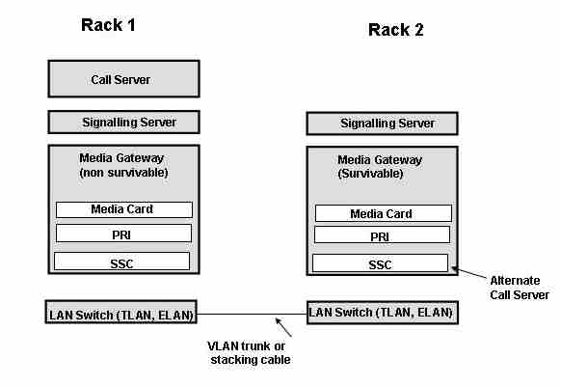Figure 6 Survivable CS 1000S

Communication Server 1000M (CS 1000M)

CS 1000Ms are sold as new systems (typically where there is a large TDM requirement) and as upgrades to existing Meridian 1 PBXs or IP enabled Meridian 1s.

CS 1000M are equivalent to the corresponding Meridian 1 with at least 1 signalling server and at least 1 media card, and at least 16 IP extensions. The range of CS 1000M systems are:

- CS 1000M Chassis (11C Chassis with signalling server)
- CS 1000M Cabinet (11C with signalling server)
- CS 1000M Single Group (61C with signalling server and CP3, CP4, CP-Pentium II and CP-Pentium IV processor)
- CS 1000M Multigroup (81C with signalling server - CP3, CP4, CP-Pentium II and CP-Pentium IV processor (IGS and FNF supported. Pentium IV processor also requires FNF)

Normally when IP enabled Meridian 1s are upgraded to CS 1000M:
- IP Line cards are upgraded to the latest firmware
- A signalling server is added to the IP Line node so that it can take over the signalling for IP phones
- IP telephone licenses are retained (same ISM is used for IP Line and CS 1000)
- Any IP trunk cards are converted to Voice Gateway Media Cards by loading the latest IP Line firmware
- IP trunk licenses are converted to H.323 IP Peer licenses

CS 1000M systems come with 1 signalling server by default. Additional signalling servers can be added manually, or added automatically based on Messia input. (See Signalling Server engineering below)

Branch Office (MG1000B formerly SBO)

The Media Gateway 1000B provides local PSTN breakout and local survivability for IP phones at a remote site that are normally controlled from a CS 1000 main office.

The Call Server at the main office provides the call processing for the IP Phones in both the main office and branch office locations. The MG 1000B Core provides call processing functionality to local digital telephones and analog devices. The MG 1000B Core also provides digital and analog trunk access to the local Public Switched Telephone Network (PSTN).

The MG 1000B platform connects to the main office over Virtual Trunks on a LAN/WAN. The main office transmits and controls IP Phone calls and IP network connections. If the main office fails to function, or if there is a network outage, the Small System Controller (SSC) card in the MG 1000B Core provides service to the telephones located at the branch office location. This enables the IP Phones to survive the outage between the branch office and the main office.

A new MG 1000B consists of 1 Media Gateway chassis (with an SSC) and optionally 1 expander. It also has one signalling server that will serve as the SIP or H.323 gateway and the TPS when the branch office is in local mode.

Existing small systems (Option 11C Cabinet and 11C Chassis (mini)) can be converted to branch office provided they only have a single cabinet. The functionality is the same in both configurations, with one additional feature (Meridian Mail) supported in the converted system.

A branch office is designed to work with a main office only if the two offices use a common dialing plan. Usually CDP is used between the main site and the branch, however it can be part of a UDP network.

More detail on the Branch Office feature is in the NTP 553-3001-214 “Branch Office Installation and Configuration”

Branch Office configuration and operation

- MG 1000B configured as SIP or H.323 gateway on the NRS
  - Appears as stand alone gateway
- Analogue and Digital sets, and attendant consoles are configured locally
  - Same as stand alone PBX
- IP phones have a virtual TN on the MG 1000B, and a TN at main site
  - S1 and S2 address on phone both point to MG 1000B sig server
  - Set registers with MG 1000B using virtual TN in the local MG 1000B database
  - Set is redirected to main using Branch User ID (BUID)/ Main Office TN (MOTN) parameters in the virtual TNs configuration. Once set is redirected it is registered with the Main Office using the virtual TN at the main office.
  - If set can not be redirected (e.g. if the WAN fails) the set remains registered with MG 1000B and uses the virtual TN on the MG 1000B
- MG 1000B base package includes 400 IP Users with Premium Network Services software. However these licenses can only be used for 30 consecutive days. Customers are expected to pay for IP Users licenses for every phone at the main site.

Inbound and outbound calls to IP phones at the branch location normally use the MG 1000B to access the PSTN.

Incoming PSTN call at MG 1000B
- DN is treated as “Vacant” if no IP phone registered locally
  - Without branch feature caller would normally get call forward no answer treatment based on the local virtual TN
- Vacant Number Routing used to query NRS for correct node for IP extension
  - Typically the Main office (CS 1000S/E/M)
- In local mode (e.g. WAN failure) the IP phone is registered with the MG 1000B so the DN is no longer treated as vacant and the call can be delivered locally

Outgoing calls from IP phones are controlled by main office
- Typically additional digits are inserted based on the zone (ZDP)
- NRS can select different gateways for different zones using the ZDP digits
  - Typically MG 1000B is the first choice for calls from phones in that zone. The MG 1000B would strip off the ZDP digits before passing the call to the PSTN.

Branch Office licensing

IP Users | 400 (time limited)
ACD Agents | 300
IP Peer Access Ports | 30 SIP and 30 H.323 (more can be added if required)
Media Cards | Practical Maximum of 4
PRI cards | Practical Maximum of 4

Branch Office Common Mistakes

Normally 1 Media card is required per PRI card. (Messia provisions media cards based on default traffic levels, which may result in fewer cards than expected)

IP phones need TNs to be configured at both the main office and at the branch office. (Telephony Manager 3.0, the next release of OTM should largely resolve this for TM 3.0 customers – see management section)

Normally 1 SIP or H.323 access port is required for each trunk (e.g. 30 per PRI). 30 licenses are included in the MG 1000B base package, but others must be added.

IP Peer Ports and IP User / Basic IP User licenses need to be added at the main office to support the MG 1000B. (Normally a SIP or H.323 port license at the main office corresponding each port at the branch offices, although this is a pooled resource i.e. you do not allocate channels to a particular branch office)

Multiple MG 1000Bs at the same site will not normally act as a single system in survivable (local) mode. They can be made to network in local mode, but this requires additional dial plan configuration. If a large branch with seamless survivability is required seek advice from Nortel as there are several alternate solutions using controlled load sharing that may be better than multiple MG 1000Bs

SRG 1.0 (based on BCM 200 and 400)
The SRG 1.0 is designed to allow survivable IP phones to be deployed in smaller offices requiring a gateway for up to 60 trunks (e.g. 2 PRIs) and survivability for up to 90 IP phones. The SRG also provides support for local analog devices (phones, faxes etc.). The SRG 1.0 is built on the established BCM200 and BCM400 hardware platforms.

Existing BCM platforms can be upgraded to SRGs as customer requirements evolve. It is not possible to reverse this process – i.e. SRGs cannot be converted to BCMs.

The SRG 1.0 base package includes
- MCDN support
- Licenses for up to 60 H323 trunk interfaces (DSP resource not included)
- Licenses for up to 90 survivable IP phones

The SRG 1.0 can support up to 90 survivable IP phones although it is more typical to use SRG1.0 for ~ 50 IP phones. Because of DSP resource, practical trunk maximums are:
- 30 Channels on BCM 200 chassis
- 60 Channels on BCM 400 chassis

The SRG 1.0 application can be supported on BCM200 and BCM400 platforms. The BCM200 can support a maximum of two MBM modules, the BCM400 can support up to 4 MBM modules (or up to a total of 10 MBMs with an expansion chassis). One (or more) MBM is required to provide PSTN connectivity using analogue, BRI or PRI interfaces. Additional MBMs can be added to support analogue devices these can be analogue MBMs or digital line MBMs with ATAs.

It is recommended that no more than 32 analogue devices are supported per SRG.

The SRG1.0 does not support digital telsets.
SRG DSP engineering

Warning: Choice of codec affects capacity of the SRG

The DSP resources on the SRG are held on “PEC” cards. Each PEC card can support up to 2 simultaneous T.38 fax call or 16 G711 calls or 12 G729 calls (or combinations thereof).
The BCM200 is supplied with a single PEC card but a second PEC card can be added. The BCM400 is supplied with 2 PEC cards and a further 2 may be added if required. It is not possible to upgrade a BCM 200 to a BCM 400.

When ordering SRG 1.0 on Messia the DSP resource is calculated based on information input by the user. This determines whether a BCM 200 or 400 chassis and how many PECs are provided.

.

Detailed capacity planning consideration can be found in product bulletin P-2004 212-global “Survivable Remote Gateway 1.0”.

SRG Operation

In normal operation the SRG redirects the IP phones to the main CS1000 which provides all the features. If connectivity with the main site is lost the IP phones revert to survivable (or “local”) mode and retain the features indicated below.

In local mode the IP phones support
- Hold
- Transfer (dedicated key on 2002, 2004)
- Call forward no answer/busy (if enabled on DN)
- Last number redial (dedicated key on 2002 and 2004)
- In box key (2002 and 2004)

SRG1 is supported from CS1000 R3.0 incorporating signaling servers. The CS1000 platform must have sufficient IP user licenses to support the survivable IP phones at the SRG site, and the appropriate number of H323 licenses to support the IP trunk interfaces. The SRG1.0 supports IP phone 2001, 2002, 2004, 2050 and WLAN phone 2010 and 2011.

The SRG incorporates 2 LAN interfaces for providing connectivity for the IP phones and to the CS1000 using existing WAN infrastructure. A WAN interface can be added to the SRG if required, an IPSec VPN capability can be added to an SRG if required. The firewall settings for the SRG are detailed in the P0609195 “SRG 1.0 Configuration Guide”.

The initial configuration of the SRG is based on the configuration requirements of the BCM200/ 400 platforms running 3.6 software P0609323 “BCM200/BCM400 Hardware installation guide”, and further details of the SRG configuration can be found in P0609195 “SRG 1.0 Configuration Guide” with details of the CS1000 settings in P0609617 “Succession 1000/M Main Office Configuration for SRG”.

SRG 50 (based on BCM 50)

The SRG 50 is designed to enable the features and benefits of the SRG 1.0 platform to be provided in to smaller offices in a cost effective manner. The SRG 50 provides local breakout and survivability for IP phones as well as local support for analog devices.

The SRG50 is based on the BCM50 hardware supporting the SRG application. This application is supported on the standard BCM50 platform only it is not currently supported on the BCM50 platforms incorporating routing interfaces (BCM50a and BCM50e).

Multiple LAN interfaces (10/100) for data connectivity are provided on the SRG platform. These can be used to provide communication with the IP phones and to the main system using the available existing WAN infrastructure.

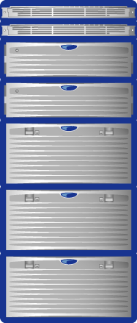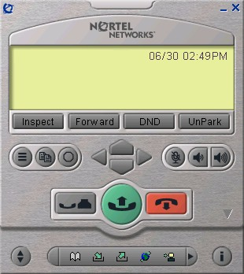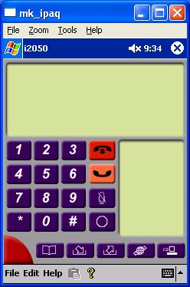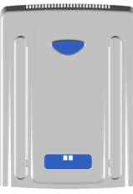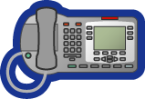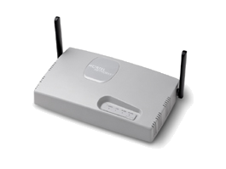
CS 1000
SRG50 branch
IP Phones 20xx
SRG
WLAN
Handsets 22xx

IP Phones 20xx

The SRG 50 base license includes
- 8 survivable IP phones
- 24 H323 IP trunks (normally only 15 available)
- MCDN / QSIG
- 12 digital telset interfaces (for use with ATAs only)

Digital telsets are not supported on the SRG50 platform.

The current SRG50 platform does not support native analogue interfaces (trunk or lines) on the main unit for the UK market. To support such interfaces MBM modules or ATAs should be used with the supplied digital licenses to support analogue phones and fax machines.

A maximum of 12 analogue devices can be supported on a single BCM50 device.

The SRG50 can be expanded in a number of ways.

Additional survivable IP phone licenses can be added in blocks of 8 to support up to a maximum of 32 IP phones. This is a difference from SRG 1.0 and MG 1000B where survivable IP phone licenses are included in the base package.

Up to two MBMs can be added (in expansion modules) to provide PSTN interfaces (analog, BRI or PRI) or to support additional analog phones using digital station modules and ATAs or directly on analog station modules. Typical SRG configurations would include one MBM for PSTN connectivity as a minimum.

The SRG50 supports the IP phones 2001, 2002, 2004, 2007, 2050, 2050MVC, and the 2210 and 2211 WLAN phones.

SRG50 is supported from CS1000 R3.0 incorporating signaling servers. The CS1000 platform must have sufficient IP user licenses to support the survivable IP phones at the SRG50 site, and the appropriate number of H323 licenses to support the IP trunk interfaces.

In normal mode IP phones are supported direct from the central CS1000 platform, but the analogue phones are hosted on the SRG50. The SRG50 acts as a PSTN gateway and can be used by other users of the CS1000 network if desired.

The SRG50 supports a maximum of 15 virtual trunks when operating in normal mode – unless G711 is used for both best quality and best bandwidth codecs – in this instance all 24 trunks can be supported. In Normal mode the IP phones do not consumed any of the virtual trunk resources; they are used to support the local PSTN gateway function and for IP communication with the analog phones.

The SRG50 does not support the G.723 codec.

When operating in survivable “local” mode – 24 IP phones can communicate simultaneously with the PSTN when using G711 codecs (recommended choice).

In local mode the IP phones support
- Hold
- Transfer (dedicated key on 2002, 2004 and 2007)
- Call forward no answer/busy (if enabled on DN)
- Last number redial (dedicated key on 2002 and 2004)
- In box key (2002 and 2004)

Full details of the SRG50 can be found in product bulletin P2005-321 Survivable Remote Gateway 50” and configuration guidelines are available in “N0060720 Survivable Remote Gateway Configuration Guide” with initial configuration information being provided in “N0027149 BCM50 initial Configuration Guide” the relevant CS1000 configuration details being provided in NTP 553-3001-207 “Main Office Configuration for the Survivable Remote Office 50”.

System Management (Configuration)

OTM

OTM (Optivity Telephony Manager) is required for customers using IP trunk and IP Line as it is the only supported way for customers (and BT engineers) to configure IP telephony elements (codec, jitter buffer etc.). OTM can manage the entire network from a central location i.e. you do not need a separate OTM server for every site.

OTM is recommended, but is not required, for systems with signalling servers (i.e. CS 1000 customers) or Meridian 1 systems without IP trunk or IP Line.

OTM Remote access
For BT to fully support the customer remotely the OTM server needs to be accessible remotely via RACE. This is particularly relevant for IP Trunk and IP Line customers as BT support have no alternative method of configuring / troubleshooting IPT configuration.

The prime purpose of OTM is GUI based management of telephone sets (IP, analogue or digital sets), however for customers without OTM this function can still be performed via overlays. OTM also offers a suite of other features (depending on the package) including: Traffic Analysis, Call Logging (OTM Billing), and Alarm Management

OTM can be deployed as “standalone” where the application is installed on a single PC, or it can be deployed in client / server mode where other client PCs can also access the system.

OTM 2.2 offers 2 types of clients:
- Windows client offers full functionality, however it requires a licenses key (dongle), and is recommended to be on the same LAN as the OTM server (
- Web Client offers limited functionality (e.g. changes to existing sets but no adds ore deletes). The web client does not require licensing (apart from IIS licenses which is part of Windows), and client PCs do not need to be on the same LAN.

OTM 2.2 is licensed based on the number of sets in the network. IP phones at a branch office are not counted against the OTM license count (this is change from previous releases), however digital and analogue phones at the branch office are counted.

OTM needs to access the ELAN port of the call servers it is managing (including the branch office)
This means the ELAN needs to be a routable subnet so that the OTM server and OTM windows client machines can talk to it. (The only exception to this is a single site system where a standalone OTM machine is directly connected to the ELAN)

For more details on OTM capabilities, and hardware / OS requirements, refer to OTM documentation on the PIC.

Telephony Manager 3.0

TM 3.0 (the next release of OTM with the Optivity name dropped) will bring several important enhancements over OTM 2.2 specifically:
- Full telephone admin capability on the web client (Web Station Admin) including adds, deletes, bulk adds.
- Automatic creation / updates of Branch Office TNs when sets are created / modified on the main office

TM 3.0 is in trial now (Oct 2005) and is due for GA in Q1 2006.

Element Manager and NRS Manager

Element Manager is a browser based tool for managing CS 1000 systems. It can run on any of the signalling servers and can be used to for
- configuration and maintenance of IP Peer and IP Telephony features (codecs etc)
- configuration and maintenance of traditional routes and trunks
- configuration and maintenance of numbering plans
- configuration of Call Server data blocks (such as configuration data, customer data, Common Equipment data, D-channels)
- maintenance commands, system status inquiries, backup and restore functions
- software download, patch download, patch activation

Element Manager does not yet provide GUI management of IP phones, however it does provide “overlay pass-through” functionality that gives access to the CS 1000 command line from a browser.

NRS Manager is a browser based tool for managing the NRS (Network Routing Server) including the configuration of network dial plans and adding peer nodes or gateways to the network.

CS 1000 Engineering

Signalling Servers

The signalling server can run a variety of logically separate applications including:
- Network Routing Service (NRS)
  - This holds the network dial plan and includes
    - SIP Redirect Server
    - H.323 Gatekeeper & Network Connection Server (NCS)
    - SIP Registrar
- H.323 Gateway (Virtual Trunk/Peer Trunk)
  - Signalling for H.323 trunks
- SIP Gateway (Virtual Trunk/Peer Trunk)
  - Signalling for SIP trunks
- Terminal Proxy Server (TPS) for IP phones
  - Registration and firmware upload for IP phones
- Database for IP Telephone Personal Directory/Redial List/Caller List (PD/RL/CL)
- CS 1000 Element Manager Web Interface
- NRS Manager Web Interface
- Echo Server for NAT

All of these applications are available on the CD, however which application is running on which signalling server is determined by the installer. (The network planner should determine which applications will be running on each signalling server and inform the installer via the IP Config Spreadsheet (the spreadsheet is an addendum to the CRF and includes information such as IP addresses of signalling servers, media cards etc) In a small system (e.g. < 1000 users and <382 IP peer trunks) all of these applications can normally reside on the same signalling server.

For larger systems multiple signalling servers may be required to meet the customer’s capacity and redundancy requirements, e.g. for systems over 10,000 users it is not unusual for 6 or 8 signalling servers to be required.

In addition the Messia user can force dedicated signalling servers to be provisioned for each application (typical example would be a dedicate NRS as it is a network resource and is not normally logically tied to an individual call server).

Messia calculates the number of signalling servers required taking into account
- Number of IP users
- Number of IP peer trunks (including the free IP peer trunks on a CS 1000E with associated MG 1000T)
- Several items from the “System Options – Signaling Servers” section of Messia including
  - Whether you specifically require dedicated signaling servers for any applications
  - Whether Personal Directory / Callers Log / Redial is being used for IP phones
  - Whether redundancy is required for each application
  - Network Size (used for sizing NRS)

This information is then used to calculate how many signalling servers are required. Note: Even if the “Do you want dedicated signalling servers” tick boxes are not selected, signalling servers may need to be dedicated on the capacity. For example the TPS must be dedicated if it is supporting more than 1000 IP phones.

Maximum limits for shared Sig Servers (this information is included in the algorithm used by Messia) are 382 IP Peer Trunks, 1,000 IP Users, and 1,000 PD/RL/CL Users. e.g. a system requiring more than 382 IP Peer Trunks will require a signaling server dedicated to a SIP/H.323 gateway

Maximum limits for a single dedicated signalling server are:
- 1,200 H.323 Trunks
- 1,800 SIP Trunks
- 5,000 IP Users
- 15,000 PD/RL/CL Users (>8,000 requires 1 GB RAM)
e.g. A system with 10,000 IP users requires 2 signalling servers dedicated to TPS, or 3 dedicated to TPS if redundancy is required.

CS 1000E includes 2 signalling servers in the base package. CS 1000S and CS 1000M systems include only one in the base package. Any additional signalling servers are shown in the Messia Price Report and for a CS 1000E the total number of signalling servers can be seen under the Messia PBX/PWR Summary.

Tips for provisioning Signalling Servers in Messia

DO NOT ASSUME you have redundancy just because 2 signalling servers are provided

On the “Signalling Servers” section of “System Options” you should normally tick the following boxes for a system requiring redundant signalling servers (typically for redundant or survivable systems e.g. CS 1000M SG or MG, CS 1000E, or CS 1000S with survivability)
- Is an H.323 Alternate Gateway required?
- Is a SIP Alternate Gateway required?
- Is an alternate NRS required? (unless the alternate NRS is at another site)
- Is redundancy required on the TPS Terminal Proxy Server for IP sets ?
- Will PD/RL/CL be used on IP sets? (unless customer has specified they do not want this feature)

Do not tick any of the “Do you want dedicated signalling servers” boxes unless there is a specific requirement to dedicate signalling servers for reasons other than capacity. (If they need to be dedicated for capacity reasons Messia will do this automatically)

Complete the NRS section
- If the NRS will not be at this site leave the Network Size as Small (the default)
- If the NRS or alternate NRS will be at this site fill out the values for NRS for the customers network
  - NRS Numbering Plan Entries are the number of steering codes on the NRS
    - Minimum value would typically be twice the number of CS 1000 /MG 1000T / MG 1000B systems in the network. This assumes a strict CDP or UDP dial plan is used with 1 Numbering Plan entry for each CS 1000 for internal or incoming calls, and 1 entry for each CS 1000 as a gateway for outgoing calls.
    - Maximum would typically be just over the number of subscribers (if a fully flexible CDP or Transferable DN number plan is used)
    - Be aware that dial plan can affect how many signalling are required
  - NRS end points are the number of SIP and H.323 end points in the network that register with the NRS
    - Each CS 1000 SIP or H.323 gateway counts as an endpoint (normally 1 per CS 1000 system)
    - 3rd party SIP or H.323 gateways count as endpoints (e.g. Audiocodes PRI or analogue gateways and i3Micro / Datapulse VOOD gateways). In some cases each port on the gateway uses a separate registration e.g. a 4 port VOOD gateway uses 4 end points
    - Each 3rd party SIP or H.323 phones counts as an endpoint

Signalling Servers Small System Example

500 IP users
100 IP Peer SIP trunks
Redundancy and tick boxes as described in tips box above

This requires 2 signalling servers which should be allocated as follows:

Sig server 1: Node Leader (Node 1)
TPS (TPS Leader)
Active SIP gateway
Primary or Alternate NRS (if configured – NRS could be at another site)

Sig Server 2: Node follower (Node 1) (will become leader if sig server 1 fails)
TPS
Standby SIP gateway
Personal Directory / Callers Log / Redial List database

In normal operation Sig Server 1 has the node IP address as well as it’s own IP address. Registration of IP phones with the TPS is balanced across the sig servers (i.e. 250 phones on each one) All SIP calls use sig server 1.
In a failure sig server 2 can take over the node leader and SIP gateway functions. It has sufficient capacity to handle all 500 IP phones.

Signalling Servers Large System Example

10,000 IP users
1000 IP Peer SIP trunks
Redundancy and tick boxes as described in tips box above

This requires 8 signalling servers which should be allocated as follows:

Sig server 1: Node Leader (Node 1)
TPS (TPS Leader)

Sig Server 2: Node follower (Node 1)
TPS

Sig Server 3: Node follower (Node 1)
TPS
Any 2 of the 3 TPS sig servers can service all 10,000 IP phones. In normal operation each will have 3333 phones registered to it.

Sig server 4: Node Follower (Node 1)
Database for PD/RL/CL

Sig Server 5: Node Leader (Node 2)
Active SIP gateway

Sig Server 6: Node follower (Node 2)
Standby SIP gateway

Sig Server 7: Node Leader (Node 3)
Primary (Active) NRS

Sig Server 8: Node follower (Node 3)
Alternate (standby) NRS

TPS failover to Voice Gateway Media Cards
If all of the TPS signalling servers the TPS on the voice gateway media cards can become the node leader and IP phones can registers with the voice gateway media cards. This is identical to IP line used in systems without signalling servers, and has the same limitations including:
- Only 128 phones can register per card
- No support for IP peer networking
- No support of virtual office or personal directory, redial list and callers log on IP phones

TPS failover to VGMC is particularly useful for small systems (eg. A CS 1000S) where additional signalling servers could not be cost justified.

This feature does not provide any failover for SIP or H.323 gateway applications. Also this feature is not available in CS 1000E systems where the MG 1000E is in a separate subnet from the signalling server.

Voice Gateway Media Cards

A DSP port on the VGMC is required every time calls are converted from TDM to IP. This includes:
- IP phones making trunk calls
- IP phones calling TDM phones
- TDM phones calling over IP peer trunks (virtual trunks)
- Services access from IP phones or peer trunks (e.g. RAN, Music, Conference, CallPilot etc). RAN and Music broadcast use a VGMC port for every broadcast channel
- Calls between TDM phones on a CS 1000E

The VGMC has 32 timeslots, and has sufficient processing power to compress all 32 channels (unlike some other systems, including BCM, there is no trade-off between codec and capacity)

Messia calculates the number of 32 port VGMCs required using a complex algorithm which considers the call mix and traffic levels on the system. (The full algorithms are included in the “Resource Calculations” section of the Planning and Engineering NTPs: 553-3011-120, 553-3021-120, 553-3031-120, and 553-3041-120.)

Messia makes assumptions about the call mix (traffic ratios), and the traffic levels. The default values can be viewed, and modified under “System Options -> Default Traffic Ratios/AHT/CCS” (AHT is average hold time and CCS is Centi Call Seconds (36 CCS equivelant to 1 Erlang). Default CCS values are shown below. Ratios (intra office calls, incoming, outgoing etc.) on the same Messia screen also have an impact on the amount of media cards.

CCS per set | 5
CCS per ACD agent | 33
CCS per trunk | 28
CallPilot CCS (per CallPilot port) | 26
Table 1 Default Traffic Values

For a CS 1000E the algorithm is more complex as each MG 1000E has to be considered individually. Each MG 1000E will either be non-blocking (normal configuration for services such as conference, RAN, CallPilot as well as non-blocking TDM extensions) or blocking (for standard TDM extensions). Messia allocates cards (and resources such as conference bridges) to each MG 1000E, and then allocates the appropriate number of media cards using an iterative algorithm.

Users of Messia can override the Media Card calculation under “Voice Gateway Media Cards”. This can be used to allocate extra media cards, or remove cards not required.

Tips for provisioning Media Cards in Messia
- Ensure number of IP ACD agents is provisioned under Extensions and Agents
- For a CS 1000E ensure TDM extensions are configured appropriately as blocking (standard) or non-blocking
- Be aware that VGMCs are needed to access services, including conference. This means a CS 1000E with no TDM phones and no applications still requires Media Gateways and VGMCs to access conference.
- Adjust traffic ratios if appropriate to the customer
- Increase VGMCs if required for the customer
- Make sure the implications are fully understood before reducing the VGMCs

Virtual Trunks – How many are required ?

Virtual Trunks (SIP or H.323 IP Peer access ports) are required for any calls between CS 1000 peer systems.

For example every VoIP call between a CS 1000S at site A, and a CS 1000M at site B uses a virtual trunk license at A and virtual trunk license at B. It makes no difference if the originating devices are IP phones, TDM phones, or TDM trunks, VoIP calls between peer systems always require IP Peer Access Ports.

IP Peer access ports are also required for calls to other SIP or H.323 systems including BCM, MCS 5100, 3rd party gateway devices (such as i3Micro / Datapulse VOOD analogue adapters), and 3rd party IP telephony systems.

IP Peer access ports are not required for calls within the same CS 1000 system. This includes calls between IP phones, calls between IP and TDM phones, and calls between IP phones and TDM trunks.

IP Peer access ports are normally a pooled resource. Unlike TDM tie trunks, there is no need to dedicate particular access ports to a particular destination. As an example, in a 3 node network, if site A has 100 SIP access ports it can have 100 simultaneous calls to site B, or 100 simultaneous calls to site C, or 50 calls to B and 50 calls to C or any combination up to the max of 100 calls.

Deciding how many IP Peer access ports are required is a bit like deciding how many Featurenet 1000 channels would be needed. There is no magic formula to calculate this, however Erlang B formulas can be used if you know how much IP Peer traffic each user will generate, and what service level (potential for blocking) you want to offer.

As with TDM tie trunks, and voice VPN services such as Featurenet 1000, NARS and BARS can be used to select alternate routes if the IP route can not be used. This can happen because:
- All virtual trunk licenses have been used
- Available bandwidth has been exceeded (In release 4.5 the bandwidth available can be varied dynamically in response to quality degradation – see Adaptive Bandwidth Management in the NTPs for details)

Virtual Trunks for Branch Office and SRG

A lot of confusion on virtual trunks comes in a branch office environment.

In a Branch Office environment all of the IP phones (including those at the branch sites) are normally registered at the main office CS 1000. The MG 1000B is treated as a SIP or H.323 peer system providing access to TDM trunks and local analogue and digital terminals.

Therefore:

- Calls between IP phones registered to the same main office, but at different branch sites, do not need IP peer access ports to call each other.

- Calls between IP phones and TDM trunks on the branch office require IP Peer access ports at both the MG 1000B and CS 1000 end.

- Calls between IP phones and TDM phones, consoles, or other devices on the MG 1000B require IP Peer access ports at both the MG 1000B and CS 1000 end.

Conference for IP phones

Normally sales engineers do not need to worry about provisioning conference hardware on the CS 1000; however the bandwidth implications of conference must be understood.

For adhoc conference (initiated via the AO3 or AO6 conference key on a users phone) conference bridge resources are required to link the calls together. Conference bridge circuits are also used for ACD Observe Agent and Remote Agent Observe. Voice Gateway Media Cards are required for all IP phones and virtual trunks to access the conference bridge (With the CS 1000E for all phones need Voice Gateway Media Cards to access conference)

For large systems (61, 81, CS 1000M Single Group and Multi Group) conference circuits are provided NT8D17 Conference / TDS cards. 30 conference circuits are provided on each card with 2 cards in each network group.

On small systems (11C, CS 1000S) conference is provided on the small system controller card in the main cabinet (32 ports) with an additional 32 ports on each of the SSC IP daughterboards. (total of 96 ports on a fully loaded CS 1000S)

On CS 1000E systems conference is provided by two conference (CON) loops (32 ports) on the SSC card and a further two CON loops on the SSC IP daughterboard in the MG 1000Es. This gives a maximum of 64 ports, or 4 conference (CON) loops in each MG 1000E. Although the hardware exists in every MG 1000E, only specified MG 1000Es should have their conference loops enabled.

For large systems and small systems there are adequate conference ports for standard business requirements, including call centre operations. Messia automatically takes account of conference requirements when it calculates how many Voice Gateway Media Cards are required in the system (for conference this is based on the numbers of IP phones.)

For a CS 1000E Messia calculates the number of conference ports required based on the total number of telephones, and then automatically allocates the correct number or MG 1000Es and Voice Gateway Media Cards.

For the curious: Messia multiplies the total number of telephones on the CS 1000E by 0.028 (this includes TDM phones on an MG 1000E). Messia then calculates how many conference loops (CON loops of 16 ports each) are required and allocates these ports to non blocking MG 1000Es.

Example conference calculation:
- 10,000 IP phones on CS 1000E
- Conf ports required 10,000 x 0.028 = 280
- Conf loops required 280 ÷ 16 = 17.5 (round up to 18)
- MG 1000Es required for conference 18 ÷ 4 = 4.5 (round up to 5)
- Media cards required for conference 280 ÷ 32 = 8.75 (round up to 9)

Purely for conference 5 MG 1000Es with a total of 9 Media Cards are required.

Note: in this example there were no other uses of the MG 1000E. Other applications (e.g. RAN or Music, CallPilot etc) can share the same MG 1000Es that are being used for conference.

Bandwidth requirements for conference

As described above, IP phones access conference via media cards. The codec used is determined by the zone of the phone and the zone of the media card being used.

This needs to be taken into account when planning a WAN to support remote IP phones.

All calls taking part in the conference require a media stream (RTP stream) to the CS 1000 system with the conference resource. This is best illustrated by example as seen below. Obviously if one of the parties was connected on a trunk or telephone at the core site then the number of RTP streams across the WAN is reduced.

Conference calls are accounted for properly in call admission control calculations (i.e.. interzone bandwidth), so new calls should be blocked before they cause any voice QoS issues.

Warning on Conference provision

Adhoc conference and ACD observe agent for remote sites use conference resource on the core CS 1000. Ensure adequate bandwidth is provisioned for users requiring the conference feature.

This is particularly relevant where there is large branch site with very limited bandwidth to the core site.

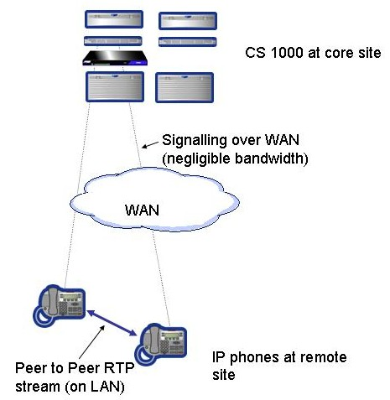
Figure 7 Peer to Peer call at remote site

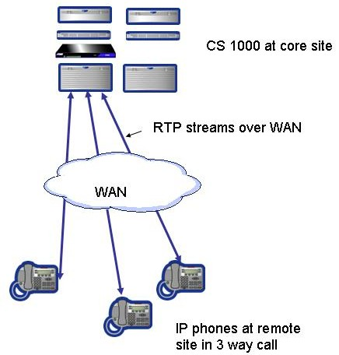
Figure 8 Conference from remote site

RAN and Music

RAN and Music require special consideration when ordering CS 1000 systems and planning the bandwidth required. This is typically an issue in an IP call centre where calls are being delivered to multiple locations but controlled from a central CS 1000, however it may apply in other situations e.g. where music on hold is played to external callers or users with IP phones.

RAN and Music are delivered via RAN and Music routes in the CS 1000 (typically on a MIRAN card, although universal trunk cards can also be used). The RAN and Music broadcast features allow a single RAN or Music port to be broadcast to multiple destinations across the TDM backplane.

MIRAN cards are IPE cards and can be located in
- Large System IPE shelf (non blocking slot)
- Option 11C
- MG 1000S (on a CS 1000S)
- MG 1000E (on a CS 1000E system)

In a VoIP network media card ports are required to convert RAN and Music to VoIP. This is required for IP phones, or callers on IP peer trunk connections. (In a CS 1000E it is required for every call not on the same MG 1000E as the MIRAN card)

RAN and Music for CS 1000S and CS 1000M

CS 1000S and CS 1000M systems can only play RAN and Music from the core site / main office.

Calls from trunks at the main office receive RAN and Music treatments in the same way as on a Meridian 1. There is no VoIP component to these calls receiving RAN or Music and no special engineering is required. (With a CS 1000S these calls might traverse the SLAN, but the SLAN is not considered a normal VoIP connection, and would not traverse a WAN.)

Calls from a branch office, or other IP Peer gateway, will receive RAN and Music treatment from the core site and will use bandwidth across the WAN (one RTP stream for each call) Such calls use the interzone codec, which may force these calls to be compressed.

Note: It is not recommended to play music across a compressed VoIP path.

These calls also require a media card port on the CS 1000 for every call.

When ordering RAN and Music for a CS 1000S or CS 1000M based IP call centre:
- Order MIRAN as if it was a single TDM system
- Calculate how many IP Peer callers will be listening to music or RAN simultaneously
- Add media cards to cater for the remote IP peer callers. 1 ports is needed for every call even if broadcast is being used (this must be done manually – Messia does not take account of this requirement)
- Allow sufficient WAN bandwidth to cope with calls getting RAN and Music centrally

RAN and Music for CS 1000E / Branch Based Music

A CS 1000E used with Symposium (or with some limitations basic ACD) can deliver RAN and Music locally in a branch by specifying different music / RAN routes depending on the incoming route. This requires an MG 1000E with a MIRAN card in each branch that needs to deliver music. Refer to BT CS 1000 specialists or Nortel for more information on this deployment.

For other purposes CS 1000E may still have to deliver RAN and Music from a central location (dependant on the feature it is not always possible to have different RAN and Music routes dependant on incoming route)

In a CS 1000E RAN and Music are almost always delivered over IP. Media cards are required in the MG 1000E hosting the MIRAN card to convert the RAN or Music streams to VoIP. (one media card port for every caller)

When ordering RAN and Music for a CS 1000E:
- Order MIRAN and RAN/Music broadcast as if it was a TDM system
  - Be aware that only 120 broadcast slots are available per MG 1000E
- Messia automatically adds media cards ports for RAN and Music broadcast (1 port for every MIRAN port plus 1 for every RAN and Music Broadcast license – this can amount to a lot of media cards)
- Allow sufficient WAN bandwidth to cope with calls getting RAN and Music centrally
  - Not always required if local RAN or Music is provided via a local CS 1000E

Campus Redundancy

A CS 1000E can be split across multiple sites using a feature known as Campus Redundancy. (This is also possible to a more limited extent with a CS 1000S, however this section purely discusses the CS 1000E feature.). Refer to NTP 553-3001-307 “System Redundancy” for a full overview of Campus and Geographic redundancy.

With Campus Redundancy a single CS 1000E system can be split across multiple comms rooms or multiple sites, however the data network needs to be good enough to support it. The Call Servers and Signalling Servers will be split across two comms rooms. Gateways (MG 1000T, MG 1000E etc can be distributed around the network)

Campus Redundancy Network Requirements

Campus redundancy requires at least 200Mbps between comms rooms (100 Mbps for the HSP, plus additional bandwidth for TLAN and ELAN)

In practice this will normally mean Gigabit LES, 2 LES 100 connections running as a multi link trunk, Wavestream / DWDM, dark fibre, or similar services with VLANs “stretched” between sites.

Layer 2 connections are required between comms rooms (i.e. the TLAN, ELAN and HSP subnets need to span both comms rooms). Layer 3 routing can be used between the comms rooms and MG 1000Es at remote sites. (It is always recommended that IP phones are in a separate subnet from the ELAN and TLAN, so they can be anywhere on the data network.

IP Clear or a single LES 100 circuit are not good enough for connecting the two CS 1000E processors with Campus redundancy (although these types of networks may form part of the solution)

LAN Requirements for Call Servers / Signalling Servers

HSP between processors requires layer 2 connection with at least 100Mbps available for the HSP VLAN. This is supported on any LAN switch / network that supports the following characteristics:

- The HSP must be on separate VLAN, and cannot be shared with any other application.
- The HSP requires a minimum bandwidth of 100Mbit/s full duplex.
- Maximum roundtrip delay is 30msec.
- Maximum packet loss of 0.1%.

ELAN and TLAN subnets for must be “stretched” between the two comms rooms. ELAN and TLAN can use the same VLAN trunk port as the HSP provided the HSP has 100Mbps dedicated to it.

LAN requirements for MG 1000E

MG 1000E can be separated from the CS 1000E call servers / signalling server via a layer 2 or layer 3 data network.

When connecting the MG 1000E to the ELAN through a Layer 3 switch:
- the connection from the Call Server to the MG 1000E must have a round trip delay of less than 30 msec and have a packet loss of less than 0.5 %.
- The media cards in the MG 1000E can not run the TPS

Bandwidth consumed by the MG 1000E ELAN connection is minor. Only signalling to / from the cards in the MG 1000E to the CS 1000E takes place over it. Voice bandwidth is dependant on traffic levels.

Note: These parameters are within IP Clear Class 1 service level guarantees, which means MG 1000Es can be separated from the main CS 1000E with an IP Clear network.

LAN requirements for MG 1000T and MG 1000B

There are no special LAN requirements for the MG 1000T and MG 1000B when used with Campus Redundancy. They act as independent network resources and the bandwidth / latency requirements are determined by how many voice calls they will be handling, and the voice quality requirements.

Campus Redundancy Pricing / Engineering

There is no special software package required to enable campus redundancy, however care must be taken with the hardware engineering. (The “Campus Redundancy Required” tickbox under system options of Messia is an overhang from CS 1000 release 4.0 and is purely used to provisions two Baystack 470s (without GBIC fibre connections) for the HSP. DO NOT use this tick box)

For full campus redundancy, where either comms room could run the entire network, it is necessary to understand exactly what gateways and signalling servers will be provisioned and where they will be placed.

It is often necessary to manually over ride the calculations in Messia to get the desired result, for example:
- for 7,500 IP users with redundant TPS Messia will provision 3 signalling servers (any 2 of the 3 sig servers could handle the load of 7,500 users). In a campus redundant design you normally would want an extra signalling server for TPS so each comms room would have 2 TPS servers and either comms room could run the entire network)
- For 1000 IP users only 1 MG 1000E is required for conference. This would mean no conference would be available from the second comms room. Additional MG 1000Es and Media Cards can be manually ordered to meet this demand

Geographic Redundancy

CS 1000 systems support several forms of Geographic Redundancy. Unlike campus redundancy, specific packages and ISMs may be required for Geo Redunancy. Refer to NTP 553-3001-307 “System Redundancy” for a full overview of Campus and Geographic redundancy.

1+1 Geographic Redundancy

This consists of a primary system and a secondary system. Unlike campus redundancy the entire system is replicated with the database of the primary automatically replicated on the secondary

1+1 Geo Redundancy is normally used where:
- The WAN is not good enough to support campus redundancy
- Customer has dual processor CS 1000Ms (although great care is required to ensure the hardware matches)

The GRPRIM (Geo Redundancy Primary) package (404) is required on the primary and GRSEC package (405) required on the secondary. Full price licenses (ISMs) are required on the primary with reduced cost licenses on the secondary.

In Messia a primary and it’s secondary can be ordered using the “Standby with Site Sync” tab.

Controlled Load Sharing and 1+N redundancy

There are two other “flavours” of geo graphic redundancy described in the NTPs that use a combination of S1 / S2 addresses, and NUID prompt to redirect sets.

This can enable primary CS 1000 systems to act as backups for each other, and can also be used to make a CS 1000M or CS 1000S act as a “large SBO/ MG 1000B”.

In BT’s own IP call centre, existing Meridians were upgraded to CS 1000M / Pentium II to act as “large SBOs” for the IP phones, but continue to serve the TDM phones in the building.

Controlled Load Sharing does not require any special packages, but IP user ISMs are required at the main system and the branch for every configured phone.

System Compatibility

Compatibility of CS 1000 release 4.5 with other Nortel products is listed in the Communication Server 1000 Release 4.5 Product Bulletin (number P-2005-0267-Global). . It can be found on the Nortel PIC (Partner Information Centre) www.nortel.com/pic under Partner Bulletins -> Product Bulletins -> 2005 Bulletins, or by pasting the following URL into your browsers address bar

https://app12.nortelnetworks.com/cgi-bin/mynn/home/NN_bulletinDetails.jsp?DC=0&DY=2005&curOid=12460&whereClause=10&progSrcID=-8461

CS 1000 hardware compatibility (e.g. which vintages of which cards are supported ) are found in NTP 553-3001-156 “Product Compatibility”

Patching
All devices MUST be patched up to the latest level as recommended by the MSTC, the BT Patching process document can be found at the URL below.

http://solutions.intra.bt.com/gcs/teams/tech_service/ssc/patchinfo/

Codec Recommendations

On the LAN, LES circuits, or other high bandwidth networks:

- G.711
- 20 ms sample
- VAD off
- 40 ms jitter buffer

On the WAN or other bandwidth restricted network:

- G.729A
- 20 ms sample
- VAD off
- 40 ms jitter buffer

For networks with SRG / BCM use 30 ms sample instead of 20ms (SRG/BCM do not support 20 ms)

All configured codecs should use the same sampling period.

The jitter buffer settings and codec packetization values should be the same across the network.
It multiple codec settings are used there is a possibility of all traffic defaulting to G711, or not working at all.

VAD (voice activity detection) should not be incorporated into any CS1000 solution without engineering signoff

Call Admission Control (Zones)

Call Admission Control is required if the VoIP traffic might exceed the available bandwidth. For example if there is only 256K of class 1 IP Clear bandwidth to a site, then Call Admission Control is required to restrict the number of VoIP calls attempting to use that WAN connection. (In IP Clear and other similar networks, VoIP packets will be discarded if the subscribed bandwidth is exceeded). Call Admission Control is not normally required on a LAN or LES network where the VoIP traffic could not exceed all the available bandwidth (QoS is still required for these networks to ensure VoIP is prioritised over data traffic)

CS 1000 Sales Engineers need to inform the planners whether Call Admission Control is required, and how much bandwidth is available at each site.

CS 1000 uses the concept of zones to control codec selection, and to block calls if the available VoIP bandwidth has been exceeded.

All the CS1000 IP endpoints can be allocated into zones, which are logical groupings of such devices in a similar environment. Normally all devices in a single LAN should be defined as a single zone, and devices in a different building / LAN defined as a different zone.

This is shown diagrammatically below:-

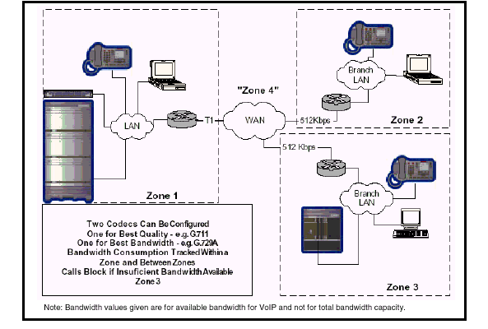

In the example above, the IP phones local to the main site company LAN, and the media cards in the main CS 1000, have been put in Zone 1 The distant Branch Offices (MG1000B), and the IP phones at these sites have been put into separate zones 2 and 3.
Zone 4 is the WAN.

The zone configuration is held in the call servers database and can be set up via element manager or overlay 117

If no zones are configured the system defaults to using zone 0. Zone 0 does not support bandwidth management. Zone 0 must be configured before all other zones.

Each zone must be configured with the available interzone and intrazone bandwidth.

The zone is identified by the zone number (0-255) and the VPNI (Virtual Private Network Identifier 1-16283) of the Call Server. When a VoIP call is being set up, the call servers check the zone and VPNI of the two end points. If both the zone and VPNI match the call is treated as an Intrazone call. If either is different then the call is treated as an Interzone call.

Normally each CS 1000 network will have the same VPNI throughout the network.
Specifically:
- Branch Office (MG 1000B) and SRG have the same VPNI as the main call server (required so phones at the branch site can be treated as the same zone as the MG 1000B or SRG)
- An MG 1000T on the same site as a CS 1000E will usually have the same VPNI and zone as the CS 1000E (so that local VoIP calls are treated as Intrazone)
- 2 Call servers on the same site will usually have the same VPNI and zone (so that local VoIP calls are treated as Intrazone)

If more than 250 zones are required in the network (or it is anticipated that the network will grow to 250 zones), then a different VPNI must be used for each call server. (each VPNI can only have 255 zones)

Bandwidth management / Call Admission Control

The CS1000 uses the interzone and intrazone bandwidth parameters of the zone to limit the number of concurrent calls on IP infrastructure and hence maintain the quality of the calls carried. Configuration details can be found in NTP 553-3001-213 “IP Peer Networking” in NTP 553-3001-214 “Branch Office Installation and Configuration” and in 553-3001-207 “Main office Configuration for the SRG 50”.

The bandwidth values configured for bandwidth management should be the bandwidth available for voice only – it should not include WAN bandwidth used for other applications.

The underlying WAN technology can have a considerable effect on the amount of bandwidth used by a VoIP call. Since the CS1000 does not have visibility of the WAN technologies used it assumes worst case (half duplex Ethernet) and bases all its bandwidth calculations on the TLAN bandwidths tabulated. As a result the bandwidth values used for admission control may exceed the actual WAN bandwidths; basing the bandwidth management values on the actual WAN bandwidth is likely to result in premature call blocking. The actual WAN bandwidth required depends on the WAN technologies used – see NTP 553-3001-160 “Converging the data network with VoIP” for example calculations or use the VoIP Bandwidth Calculator spreadsheet available on the PIC.

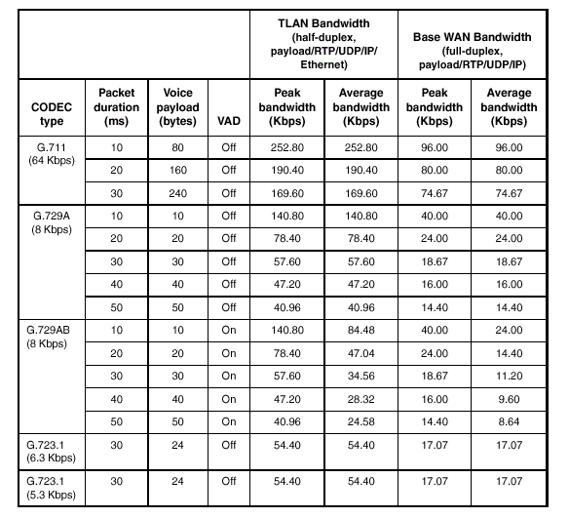
Bandwidth management within a zone (intrazone) is not generally required. This can be achieved by setting the available bandwidth to a high value e.g. 1Gbit/s.

Bandwidth management can be disabled by setting the VPNI to 0 and setting the zone to 0. Alternatively the available bandwidth can be overestimated to prevent call blocking (maximum value – 1Gbit/s or 1000000Kbit/s).

Care must be taken when using the network wide virtual office feature as the actual location of the phones may differ from that indicated by the zone – See later note on Virtual Office with Call Admission Control.

Adaptive Bandwidth management

CS1000 Release 4.5 introduces the concept of adaptive bandwidth management on IP links between zones. This feature is particularly useful where the available bandwidth changes, e.g. in a failure condition when the backup link is of smaller bandwidth than the main link.

Adaptive bandwidth management builds on Bandwidth Management but adds two new functionalities. The first is that adaptive bandwidth management automatically changes the Interzone bandwidth limit depending upon the Quality of Service (QoS) in the network. The second is that the bandwidth limit is automatically adjusted on a zone-to-zone basis. So if there are QoS problems reported between a Call Server in zone 3 and another in zone 5 then the bandwidth limit is reduced for calls between zone 3 and zone 5.

The Call servers react to the type and number of QoS alarms generated by the supported IP phones and when these indicate a degraded performance the CS1000 automatically decreases the available interzone bandwidth to limit the number of calls carried and hence maintain call quality. The quality of the link is periodically tested by the system and when the link performance improves the link bandwidth is progressively increased back to the preconfigured bandwidth limits.

Changes to the available bandwidth are reported as alarms.

Adaptive management is not applicable to zone 0 as this zone does not support bandwidth management.

It is recommended that any mobile workers (such as 2050 soft phone home workers) are placed in zone 0 to prevent adverse impact on bandwidth management.

Adaptive management is applied on a zone by zone basis on each call server. (i.e. it needs to be enabled on the call server)

Alternate Call routing for Bandwidth Management

Release 4.5 introduces the concept of “branch alternate routing”. This allows alternative routes such as MCDN trunks or the PSTN to be used between the branch offices (MG1000B or SRG) and the main CS1000 system and for calls between branch offices hosted from the same CS1000.

It is possible to configure branch alternate routing to be invoked for all calls regardless of available bandwidth or to be invoked only when all the available IP bandwidth is consumed (i.e to carry overflow traffic only). This feature is not required for virtual trunk calls (trunk calls already have NARS/BARS alternate routing), and is not available for conference calls and ACD agents.

CS 1000 sales engineers must inform the planner if Alternate Call Routing is to be used.

Home Workers

Then a CS1000 solution includes a number of IP phone using home workers (or mobile workers) it is convenient to configure all these workers to be in a single “home worker” zone (different to the HQ or branch sites). This simplifies administration and consumes only one of the 256 “zones” available however many home workers are deployed.

For this (home workers) zone both intrazone and interzone calls should use the “best bandwidth” codec choice as all calls will traverse a WAN link.

When using adaptive bandwidth management it is recommended that home workers are placed in zone 0 to disable bandwidth management on these devices.

WLAN handsets

It is recommended that all WLAN handsets are placed in a dedicated zone. If multiple IP Telephony managers 2245 groups are used each group should be assigned its own zone.
This simplifies management and can aid in the reporting of currently registered devices.

WLAN handsets support G.711 and G.729A and G729.B codecs, they do not support G.723 codecs.

If non WLAN IP phones share the same LTPS as WLAN phones they must be configured with the subset of codecs supported by all phones (i.e do not configure the G723 codec).

LAN requirements

CS 1000 requires multiple LAN ports and multiple subnets to function properly. The CS 1000 sales engineer should inform the customer (or the BT data specialist if BT are supplying the LAN) of the LAN requirements.

Details on the various subnets, the QoS characteristics of each subnet, and how to calculate how many ports are required for each subnet are in Appendix B of this document, and in NTP 553-3001-160 “Converging The Data Network with VoIP” (previously called “Data Networking for VoIP”)

A summary of key LAN recommendations is below.

BT LAN recommendations summary

LAN design needs to be properly documented in CSDS. This needs to include what LAN switches will be used (and who is supplying them e.g. BT or the customer), the numbers of subnets needed, stretched VLANs if required (e.g. where a subnet is “stretched” between sites for Campus Redundancy)

LAN infrastructure must be switched. QoS is highly recommended for TLAN and required for SLAN and HSP.

All LAN cables must be Cat 5 or better.

For a resilient CS 1000 the TLAN/ELAN must also be resilient (e.g. call servers and media gateways spread across different blades or different switches in a stack). There is little point having resilient call servers and signalling servers if they are all in connected to a single LAN switch. Recommend Nortel ERS 5510 or 5520 however other products can fit the need if required.

Note: Running the ELAN on the Ethernet Switch 425 often included with CS 1000 systems does not meet this requirement. You either need 2 ES 425s, or a VLAN spread across a LAN switch such as ERS 5510 or ES 470.

All Ethernet ports should set to auto-negotiate. If speed / duplex settings must be forced then take advice from BT Technical services to avoid duplex mismatch. Forcing the settings for rate and duplex may result in a duplex mismatch, causing packet loss and voice quality issues.

Subnets / VLANs

LAN needs to provide separate subnets for ELAN, TLAN, Nortel Server LAN and client subnets (see more detail on these subnets in Appendix B) Separate subnets for SLAN or HSP will also be required if the SLAN or HSP connections need to be run over a LAN (e.g. in a campus redundancy solution)

Client subnets (e.g. for IP phones) should be separate from customers data subnets used for PCs (normally use VLAN tagging so voice and data VLANs can share single cable)

Systems on the same site (e.g. MG 1000T and CS 1000E) can share same ELAN and TLAN subnets, however separate ELAN and TLAN subnets for each CS 1000 offer better protection against broadcast storms, and are therefore recommended for large sites (e.g. More than 1000 IP phones)

For very small systems (< 150 devices in the subnet) it is acceptable (although still not recommended) for TLAN, Server LAN and client subnets and customers PCs to share the same subnet. This is only acceptable if the PCs are not running any protocols that generate a lot of broadcast traffic. If in any doubt on whether this is acceptable check with Technical Services or Nortel Sales Engineering.

Both ELAN and TLAN should be configured to restrict broadcast traffic to 150 pps and multicast traffic to 150 pps. (On some LAN switches (e.g. Nortel ES 425/460/470 and ERS 5500 series it is only possible to limit broadcast and multicast traffic to a percentage of traffic. Limit the multicast traffic to the minimum levels configurable (1% of Ingres traffic on Nortel LAN switches)

Layer 3 routing is required between subnets (particularly TLAN and Client Subnets). This must be factored in to the LAN design.

Where possible all edge LAN switches should have dual (resilient) links to core Ethernet switches.

Where possible all new LAN edge switches deployed should support 802.3af power over LAN. (See appendix for power requirements of IP phones)

DHCP Recommendations

Where possible use full DHCP with auto VLAN discovery as this saves work and reduces configuration errors.

Any standards based DHCP server can be used, however the DHCP server must be able to support DHCP Options for Full DHCP mode (any DHCP server can support Partial DHCP mode)

Recommendation is to use the customers existing DHCP server, but be aware configuration work on this server will be required. Instructions on how to configure specific DHCP servers (eg. Windows 2000) are included in NTP 553-3001-160. BT also have a DHCP configuration document that can be shared with the customer.

Quality of Service

Strongly recommend QoS for all LAN infrastructure carrying voice.
Any network not using QoS will need sign off via the BT IP Networking Bid Process.

Recommend DSCP (DiffServ Code points) to be used to designate QoS in the LAN. The DSCP markings to be used differ depending on the LAN vendor

QoS for Nortel LAN

- All TLAN ports set to “trust” DSCP markings.
- All Customer LAN phone ports set to “trust” DSCP markings.
- The DSCP code point to be set to 46 (EF) for voice traffic in CS 1000 Element Manager (default).
- The DSCP code point to be set to 40 (CS5) for signalling traffic in CS 1000 Element Manager (default).
- For IP clear WAN connections, the LAN switch closest to the IP clear router should remark signalling packets from DSCP 40 to DSCP 24.
QoS for Cisco LAN

- All TLAN ports set to “trust” DSCP markings.
- All Customer LAN phone ports set to “trust” DSCP markings.
- The DSCP code point to be set to 46 (EF) for voice traffic in CS 1000 Element Manager (default).
- The DSCP code point to be set to 24 (CS3) for signalling traffic in CS 1000 Element Manager (this is a change from the Nortel default).

Other QoS methods (e.g. 802.1p and policy based), and different DSCP marking can be used where required, however they are not recommended for normal customer installations.

Common Pitfalls and Specific Applications

IP Call Recording

Call Recording Summary recommendations
Don’t use trunk side call recording on CS 1000E or any system where the trunks are not directly controlled by the call server (e.g. MG 1000B with CS 1000M).

Use duplicate media stream IP call recording for IP Lineside call recording.

There are several methods of recording calls in a CS 1000 environment which are described below.

Trunk Side Recording on Meridian, CS 1000S or CS 1000M

Call recorder taps the incoming E1 for media
Information on the call is received via the D-Channel or via monitoring CDR or MLS (CTI) feed. (CDR or MLS required for call centres as the call recipient can not be identified from the D-Channel)

On Meridian with IP Line, CS 1000S or CS 1000M trunk side recording works the same for IP phones as for TDM phones.

For CS 1000E/MG1000T, or other solutions where the trunks are not directly controlled by the call server trunk side recording will not work. This is because the trunk TN in the MLS or CDR messages is the virtual TN of the virtual trunk, and the call recorder can not match this to a physical channel. Recommendation is to use IP Lineside duplicate media stream recording instead.

Agent Observe Recording

For quality monitoring (where only a limited number of calls need to be monitored) then Agent Observe call recording can be used where the call recorder emulates a digital supervisor set.

This method works for IP phones in the same way as it does for TDM phones. (note: This feature uses conference resources, so may impact on bandwidth and DSP usage)

IP Lineside Recording – SPAN ports / Port Mirroring

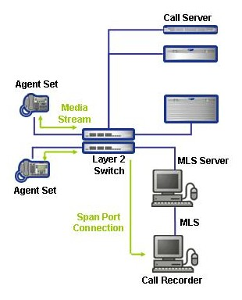
Figure 9 IP Lineside Recording

Since release 25.40, Meridian 1 IP Line and CS 1000 have supported IP Lineside recording using port mirroring in the customers data network.
The LAN switch mirrors the RTP streams (media streams) to the call recorder (this is sometimes called a SPAN or RSPAN port) This solution requires MLS (On Symposium) to provide DN to IP address translation, and a compatible call recorder.

Port mirroring can be complex to set up, and may not even be possible in some data networks. In a WAN environment it can lead to slave call recording servers being deployed at each site. Therefore Nortel recommends Duplicate Media Stream is used instead.

Duplicate Media Stream IP Call Recording

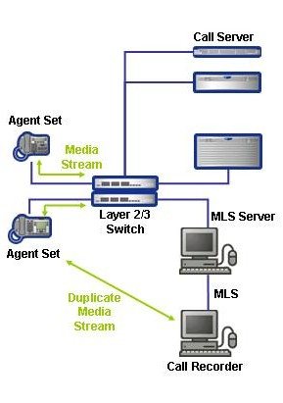
Figure 10 IP Lineside Duplicate Media Stream

Duplicate Media Stream is a new feature in CS 1000 4.5 supported on Phase 2 IP phones and the new 1100 series. This is much easier to set up and maintain, particularly in a WAN or other complex environment.

With this method no special configuration of the LAN is required, however bandwidth implications must be considered.

The duplicate media stream is sent directly from the phones to the call recording server. The RTP stream is identical to the streams being sent/received by the phones (same codec, frame size etc), however the duplicate stream is marked with DSCP 0x00 as you normally do not want to prioritised the duplicate stream.

This solution requires:
- CS 1000 4.5
- Phase 2 or 1100 series phones
- SCCS 5.0 with the appropriate service update
- A compatible call recorder

Analogue fax over VoIP

CS 1000 supports T.38 Fax over IP. This codec demodulates the fax signal and sends the information as digital information. The signal is reconstructed as a fax signal at the remote end.

T.38 fax is supported on all relevant CS 1000 IP telephony components including IP Trunk, IP Peer trunks, BCM, SRG and 3rd party gateways such as the i3Micro analogue adapter.

Analogue lines on any of the CS 1000 gateways or main systems are suitable for fax. Where this is not practical 3rd party gateways such as i3Micro can be supported.

Modem over VoIP

CS 1000 does not support any “modem over IP” codecs, however acceptable modem performance on VoIP trunks can be normally be achieved using G.711 codec if there is low latency packet loss.

Also note that there are no problems with modems if the call path does not have a VoIP component or if the only VoIP component is SIPE (SLAN). (e.g. analogue card on MG 1000B, CS 1000M or CS 1000S breaking out on local trunk)

Acceptable modem performance on VoIP trunks can be achieved with the following characteristics:
• Media Card configuration:
— G.711 codec
— 20 msec packet size
• one-way delay less than 5 msec
• low packet loss

Provided these characteristics are met modems should also work over other analogue devices (such as SRG and i3Micro adapters), however this can not be guaranteed, and data rates may not be what customers expect.

Important
Modem Performance degrades significantly with packet loss.
Nortel has conducted extensive but not exhaustive tests of modem-to-modem calls, data transfers, and file transfers between a CS 1000E and MG 1000T, using Virtual Trunks and PRI tandem trunks. While all tests have been successful, Nortel cannot guarantee that all modem brands will operate properly over all G.711 Voice over IP (VoIP) networks. Before deploying modems, test the modem brand within the network to verify reliable operation.

ISDN Video over VoIP

Many customers continue to use ISDN for video conference or other data applications.
ISDN data requires special handling to ensure no loss plan or echo cancellation is applied (for voice calls the bit stream is often modified for different trunks types dependant on loss plan). This applies to TDM (e.g. ISDN) networks as well as VoIP networks.

CS 1000 release 4.5 supports a special codec (G.711 Clear Channel) for H.323 trunks that bypasses normal loss plan settings. This codec is required for ISDN data calls (including video calls) running over VoIP trunks. Note: This has not yet been tested by BT or Nortel in this scenario, so please consult with Nortel Sales Engineering or BT CS 1000 Technical Services before deploying in a customer network.

CS 1000 release 4.0 did not support G.711 Clear Channel and therefore ISDN video would not work in this scenario.

Similar to modems, there is no problem with ISDN data applications (including video) if the call path does not have an VoIP component or if the only VoIP component is SIPE (SLAN). (e.g. analogue card on MG 1000B, CS 1000M or CS 1000S breaking out on local trunk)

Virtual TN address space on CS 1000S and Small CS 1000M
Small Systems based on the SSC processor (CS 1000S or CS 1000M Cabinet / Chassis) have limited address space available for virtual and phantom TNs. This can cause issues with small systems requiring large numbers of IP users (e.g. if more than 600 IP users then this warning may apply)

Warning:
Small Systems (CS 1000S or CS 1000M Cabinet / Chassis) only have 1248 virtual TNs available. This may not be sufficient for small systems with high numbers of IP extensions (e.g. more than 750) that also use phantom TNs
Phantom TNs are not normally chargeable however they consume limited system resources. Phantom TNs are consumed by applications such as CallPilot Fax, Symposium Call Centre agent roaming, and DECT.

Virtual TNs and Phantom TNs are similar in that they represent a telephone set or trunk configured in software but are not directly tied to physical hardware (e.g. no digital line card with a phone connected). Although they only exist in software, phantom and virtual TNs follow a similar addressing scheme to physical TNs.

Virtual TNs are used for:
- IP Telephones (IP users)
- IP Peer trunks (virtual trunks)
- PCA (Personal Call Assistant)
- M3900 virtual terminals (Unlikely to be used in IP Telephony environment, however this feature is not chargeable so can not be picked up in the order tools.)

Phantom TNs are used for:
- DECT (chargeable)
- Phantom analogue sets (this feature is not chargeable so can not be picked up in the order tools.) Phantom Analogue sets can be used for a variety of applications including:
  - CallPilot Fax and other CallPilot applications
  - Symposium Call Centre Agent Roaming (where agents personal DN follows the agent)
  - Integrated Call Director (where calls are sent directly to the call director card)

On small systems there are five user-programmable superloops available for use by either
phantom or virtual TNs, giving a total of 1248 TNs.
A superloop cannot have both phantom and virtual TNs defined on it. A phantom loop has only phantom TNs and a virtual loop has only virtual TNs.

Each phantom/virtual superloop consists of 7 or 8 virtual cards, and each card has 32 TNs.
The superloops and the corresponding number of TNs for each one are shown below

Superloop | Number of TNs
96 | 256
100 | 256
104 | 256
108 | 256
112 | 224

This means that if superloop 96 is configured as a phantom superloop (e.g. for use with CallPilot Fax) then there are only 992 virtual TNs available for IP telephones, IP peer trunks etc.

There is a further restriction in that each virtual card can only have one type of TN on it. E.g. a virtual TN for an IP phone can not share the same virtual card as the virtual TN for an IP Peer trunk.

The lack of virtual TN space is normally only an issue when systems are near the 1000 IP users limit of small systems. In many cases this issue will be caught by Messia prior to orders being placed, however phantom analogue sets and M3900 virtual terminals are not charged for in Messia so it can not catch all occurrences.

Usually a work around can be found (for example using dummy ACD DNs for CallPilot, or using M3900 virtual terminals instead of phantom analogue sets)

For more information refer to NTP 553-3021-120 “CS 1000S Planning and Engineering” or NTP 553-3011-120 “CS 1000M and Meridian 1 Planning and Engineering”.

TN address space is unlikely to be a problem for large systems (CS 1000M SG, CS 1000M MG, Option 61, Option 81, and CS 1000E). On large systems virtual superloops contend for the same range of loops with phantom, standard and remote superloops, digital trunk loops and all service loops. Virtual superloops can reside in physically-equipped network groups or in virtual network groups (i.e. network groups with no actual hardware)
- Systems without the FIBE package (i.e. without FNF – 61/CS 1000M SG and older 81) have a total of 39 superloops which can be real or virtual
- Systems with the FIBE package (ie. 81/CS 1000M MG with FNF) and CS 1000E systems have 63 superloops which can be real or virtual
- Each virtual superloop has 128 time slots and 1024 virtual TNs (The timeslots are virtual, however it means each virtual superloop can only support 128 concurrent calls)

3rd party analogue gateways (e.g. for fax)

Nortel has certified a number of 3rd party analogue and BRI gateways (including i3Micro) via it’s developer program which use SIP or H.323 to communicate with the CS1000 which are useful where a Nortel gateway (MG 1000B, SRG etc) is too large or too expensive. These are commonly used for fax machines in a VoIP network, however they can also be used for other purposes.

Nortel will support CS 1000 interworking with any certified product, a full list of which can be found at:
http://www.nortel.com/prd/dpp/product/ip_clients.html http://www.nortel.com/prd/dpp/product/gateways.html.

BT have one of these adapters (i3Micro “VOOD”) analogue to VoIP adapters in portfolio. (BT order these via Datapulse). This is the recommended solution for remote fax machines etc in a VoIP Other gateway devices (e.g. a Cisco router with analogue ports) may work but is not fully supported by Nortel.

Note: All these devices require SIP or H.323 access port licenses to communicate with the CS 1000 (although they can share access ports with other devices). Ensure there are sufficient access port licenses on the CS 1000 to handle these devices.

Interfacing to 3rd party VoIP systems (Avaya, Cisco)

Theoretically CS 1000 can inter work with any SIP or H.323 system, however Nortel only support 3rd party interworking with products that have been tested via the developer program or on a project basis (i.e. with special agreement and testing for a specific project).

Cisco, Avaya and other competitive vendors have not been through Nortel developer program, and therefore are only supported by Nortel on a project basis.

BT will only support mixed vendor VoIP interworking for solutions that have gone through the IP Networking bid process and have been signed off by BT Technical Services.

CallPilot / Symposium “Give Controlled Broadcast” on CS 1000E

The “Give Controlled Broadcast” feature of Symposium Call Centre Server is similar to RAN Broadcast and it allows up to 50 callers to listen to the same CallPilot port for an announcement. On Meridian 1, CS 1000M, and CS 1000S this feature requires no additional hardware if the inbound trunks are directly connected to the M1, CS 1000S or CS 1000M.

On CS 1000E this feature would require additional media card ports in the MG 1000E hosting the CallPilot server or MGate cards. Unlike RAN broadcast, there is no specific ISM for Give Controlled Broadcast, and therefore it is not possible for the order tools to determine how many media card ports are required. (Messia assumes 1 Media Card port for every CallPilot port, which does not cater for Give Controlled Broadcast.).

It is therefore not recommended to use this feature, on a CS 1000E but instead use Open Voice Session / Play Prompt / Collect Digits. Open Voice Session is limited to one caller per CallPilot port, however it has more flexibility than Give Controlled Broadcast.

Recommendation
Do not use SCCS “Give Controlled Broadcast” on a CS 1000E.
Instead use Open Voice Session / Play Prompt / Collect Digits or RAN Broadcast.

Virtual Office Licensing
For a hot-desking environment additional IP User licenses may be required if virtual office is being used.
Normal CS 1000 system (no virtual office)
In a normal CS 1000 system you need 1 IP user license for every configured IP phone. The license is actually applied to the virtual TN (with an IP phone (2002, 2004, 2050 etc.configured on it)
For basic phones (2001, 2033, and 1110) there is also a cheaper "Basic IP User" license, but the basic phones can not participate in virtual office.
Virtual Office "using another's desk"
With virtual office users can log in to each others phones without any additional licenses.
Example: Donald can sit at Calum's desk and log in to Calum's phone. The phone then becomes Donald's for the day. Calum could then sit at someone else’s desk and log in there.
This needs no additional licenses over the "normal" CS 1000.
Virtual Office "true hotdesking"
In a true hot desking environment where users do not have their own phone then additional licenses may be required.
In this environment customers typically want phones sitting there with no DDI incoming calls and restricted (or no) outbound dialing until someone logs on using virtual office.
This requires 1 "dummy" licenses for every phone, and 1 licenses for every user.
Example:
If you have 500 phones and 1000 users you need 1500 IP user licenses.
Note: These "dummy" licenses are actually full licenses which can still be used to make and receive calls, including emergency calls, without users having to be logged in.

Virtual Office Call Admission Control

Call admission control is triggered by the zone setting in the TNs of the IP sets and Media Cards.

With a virtual office login users dynamically change the TN of the “host telephone” to the TN of their own telephone for the period of the login. (The users are not aware of TNs, but that is how the feature works under the hood).

This causes a problem with call admission control and codec selection as the CS 1000 uses the users virtual TN to determine the zone. Example: If a user who is normally at site A does a virtual office login to a phone site B the system will still think he is at site A. This could lead to calls on the LAN being compressed and calls on the WAN being uncompressed. It could also lead to class 1 IP clear bandwidth being over subscribed.

If all the IP phones are hosted on the same CS 1000 then Nortel have a solution for this available in a product improvement patch (MPLR18853) that changes the call admission control so that is uses the zone of the physical phone (host telephone), and NOT the zone of the users TN. (A version of this solution that works with multiple calls servers is intended to be delivered in CS 1000 release 5.0, but this is not yet committed content.)

Recommendation for Virtual Office where CAC is required
Where possible host all IP phones on the same CS 1000 call server and apply patch MPLR18853.
If this is not possible then be aware of the implications. This can potentially be worked around by putting all virtual office IP phones in the same zone and over engineering the WAN

Operator Consoles (including Datapulse IP Operator Console)

Operator Consoles (Console Interface Units (CIUs) and 2250 consoles) still connect to the CS 1000 using digital line cards. They can be hosted from any CS 1000 system that supports digital lines including CS 1000S (in an MG 1000S), CS 1000M, CS 1000E (in an MG 1000E), and MG 1000B.

If consoles are not directly connected to the main CS 1000 then NAS (Network Attendant Service) is used to extend console functionality. (NAS has some restrictions related to console queuing etc – refer to NTPs for more details). For this reason it is preferable to put remote consoles on MG 1000Es instead of MG 1000Bs.

Datapulse have recently introduced an IP Console for CS 1000. This consists of an operator gateway that connects to the DLC card and a completely software based console running on a PC with USB headset adapter as shown below.

Note: In many call scenarios the Datapulse IP console will result in multiple transcodings. For this reason compression should not be used on the IP console and sample sizes should be kept as low as possible.
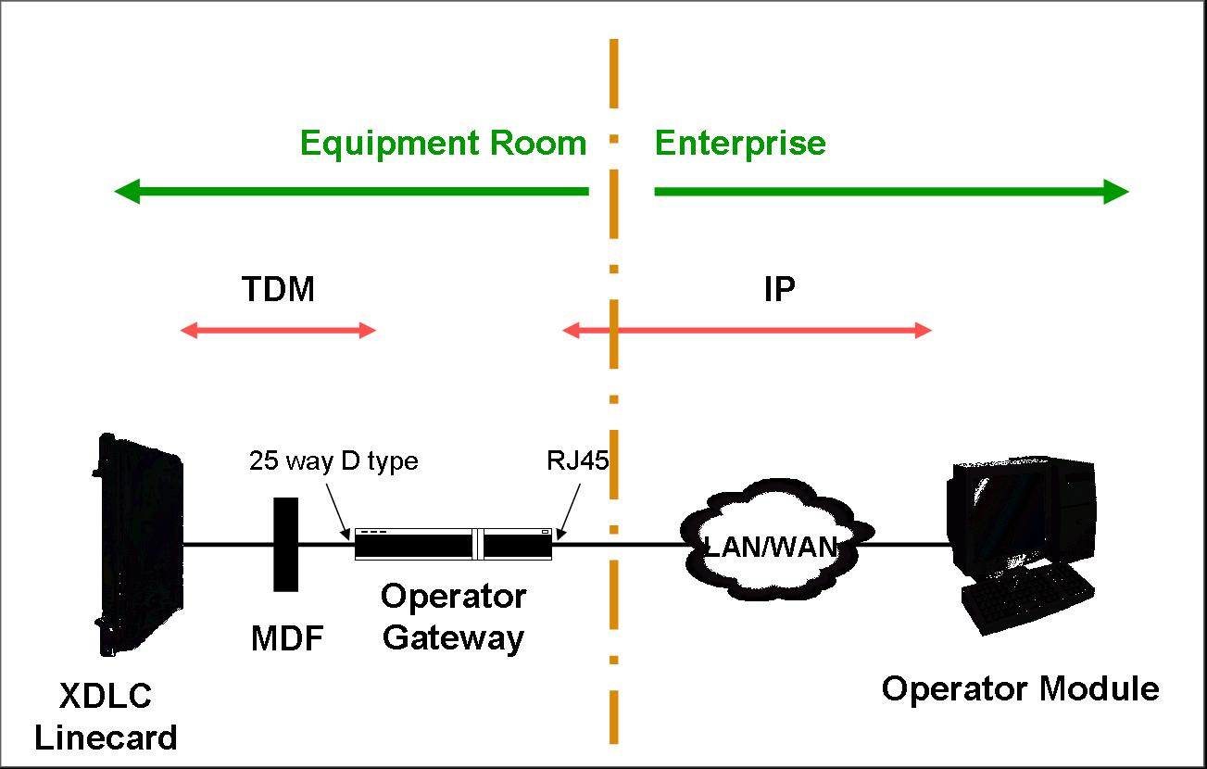

Alternative to Operator Consoles

For customers that do not require full console functionality than a CAP (Central Answering Position) can be configured to use an IP phone 2004 as an ACD agent to answer and transfer calls.

BT professional services have developed a CTI based operator screen that works with a CAP (similar products are also available from a number of Nortel partner companies)

References

Nortel PIC (Partner Information Centre) www.nortel.com/pic

Nortel CS 1000 release 4.5 NTPs
https://app49.nortelnetworks.com/cgi-bin/HelmExpress/srchlite?Collection=R4_5&SEARCH=Power+Search&PF=m&srchTerm=&boolSelection1=AND&srchTerms1=&sl=&CollCount=1&SearchType=2&ShowMeta=1&ShowDates=2&SortOrder=1&startDoc=1&sl=@31.0/

Nortel Support Site (including NTPs for all products)
www.nortel.com/support

Technical Services Configuration Guides / CS1000 Case Studies can be found at –

http://technet.intra.bt.com/techzone/nortelvoice/public/drag/

BT Technical Services for CS 1000 can be engaged via the Tech Services Portal via the following url or by calling 0113 306 4011.

http://technet.intra.bt.com/teamzone/technicalservices/capabilities/contact_us.htm

Appendix A: IP Telephones (including softphones and wireless IP phones)

Nortel IP Phone 2001

The IP Phone 2001 is a single-line, entry-level set optimized for low call volume requirements such as lobbies, other common areas. The IP phone 2001 has a compact footprint and a “listen only” hands free capability.

The IP Phone 2001 can use a basic IP user license or a full IP user license.

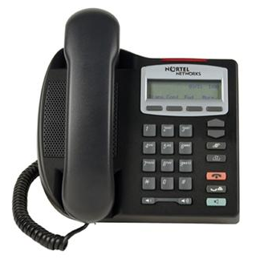

The IP 2001 is a class 2 802.3af PoE device, it also supports Cisco legacy Cisco PoE and operation has been verified on a number of Cisco switches see Technical Reference Bulletin DTR-2005-0112 for details. An AC power supply is available as an option for this phone

When powered by an 802.3af compliant switch the typical power draw on the 2001 is 3.4 Watts when idle and 4.6 Watts when ringing.

The IP phone 2001 does not include a “three port switch” and a dedicated 10/100 LAN interface is required to support this phone – this cannot be shared with another device e.g. a PC.

The IP phone 2001 was introduced as a “phase 2” phone in the IP phone 2000 family, and a special cost reduced “basic IP user license” was introduced in release 4.0 to support the IP phone 2001 in a cost effective manner.

Further details on this phone can be found in the relevant section of NTP 553-3001-368 “IP Phones”.

Nortel IP Phone 2002

The IP Phone 2002 is a multiline set optimized for intermediate call volume requirements. It incorporates a 10/100 switch to allow a single Ethernet switch port to be shared with a PC, and has a mid sized display.

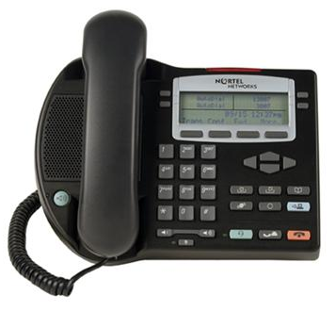
The IP 2002 is a class 2 802.3af PoE device, it also supports Cisco legacy PoE and operation has been verified on a number Cisco switches see ttechnical reference bulletin DTR-2005-0112 for details. An AC power supply is available as an option for this phone

When powered by an 802.3af compliant switch the typical power draw on the phase 2 2002 is 3.4 Watts when idle and 4.6 Watts when ringing.

The IP phone 2002 was introduced as a “phase 1” phone in the IP phone 2000 family. All new deployments should be “phase 2” however an installed base of “phase 1” phones may be encountered on established IPT deployments. The sets can be distinguished by the product code (all phase 2 devices start NTDU91).

Whilst retaining the same basic features the phase 2 phone has a number of enhancements when compared to the phase 1 device and these should betaken into account when considering the older devices. Details can be found in product bulletin P-2004-0286-Global. Phase 1 phones require a specific power splitter to support powering from LAN switches, the phase 1 (see sales and marketing bulletin SM-2004-0380 for details of part numbers and Ethernet switch compatibility) phones have reduced proactive voice monitoring support, limited VLAN support and will not support media encryption, 802.1x and duplicate media stream IP call recording.

Further details on this phone can be found in the relevant section of NTP 553-3001-368 “IP Phones”.

Nortel IP Phone 2004

The IP Phone 2004 is a multiline set optimized for high call volume requirements The IP Phone 2004 supports UNIStim protocol and thus, provides delivery of Nortel’s suite of telephony features. It incorporates a 10/100 switch to allow a single Ethernet switch port to be shared with a PC, and a large display.

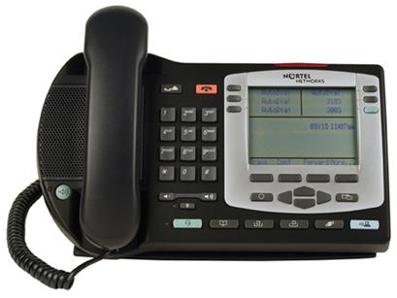
The IP 2004 is a class 2 802.3af PoE device, it also supports Cisco legacy PoE and operation has been verified on a number Cisco switches see technical reference Bulletin DTR-2005-0112 for details. An AC power supply is available as an option for this phone

When powered by an 802.3af compliant switch the typical power draw on the phase 2 2004 is 3.5 Watts when idle and 4.6 Watts when ringing. Note. A phase 0 phone with external switch will require significantly more power that phase 2 phone see (Technical Reference Bulletin DTR-2005-0112)

The IP phone 2004 was introduced as a “phase 0” phone in the IP phone 2000 family. All new deployments should be “phase 2” however an installed base of “phase 1” and “phase 0” phones may be encountered on established IPT deployments. The sets can be distinguished by the product code (all phase 2 devices start NTDU91), and phase 0 phones only have a single Ethernet port.

Whilst retaining the same basic features the phase 2 phone has a number of enhancements when compared to the phase 1 device and these should betaken into account when considering the older devices. Details can be found in product bulletin P-2004-0286-Global. Phase 1 phones require a specific power splitter to support powering from LAN switches (see sales and marketing bulletin SM-2004-0380 for details of part numbers and Ethernet switch compatibility), the phase 1 phones have reduced proactive voice monitoring support, limited VLAN support and will not support and will not support media encryption, 802.1x and duplicate media stream IP call recording.
Phase 0 phones do not have a built in 2 port switch but can be provided with an external switch to provide this functionality.

Further details on this phone can be found in the relevant section of NTP 553-3001-368 “IP Phones”.

IP Phone 2007

The IP Phone 2007 is Nortel's 12-line touch screen colour display phone it has a single USB port allowing the use of an external keyboard (in addition to a "soft" keyboard integrated within the touch screen display) or mouse. The IP Phone 2007 provides all the telephony features of a 2004 and in addition acts as an “application portal”, with its ability to interact with application servers such as the MCS 5100 or Citrix.

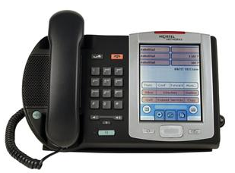
The IP 2007 is a class 3 802.3af PoE device, it also supports Cisco legacy PoE.

When powered by an 802.3af compliant switch the typical power draw on the 2007 is
8 Watts when idle and a maximum of 13 Watts.

The IP phone 2007 was introduced as a “phase 2” phone in the IP phone 2000 family and is supported from R3.0 of the CS1000.

Further details on this phone can be found in the relevant section of NTP 553-3001-368 “IP Phones”.

Nortel IP phone 1110

The IP phone 1110 is due to be launched in Q1 of calendar year 2006.

The IP phone 1110 is a single-line, entry level phone roughly equivalent to the IP phone 2001 but with a new look and feel and a number of features not supported in the 2001 including:
- Integrated 10/100 Ethernet switch (as in 2002/2004 etc)
- 4 way Navigation cluster to improve usability
- a high resolution backlit pixel display.

Like the 2001 the 1110 has a compact footprint and a “listen only” hands free capability.
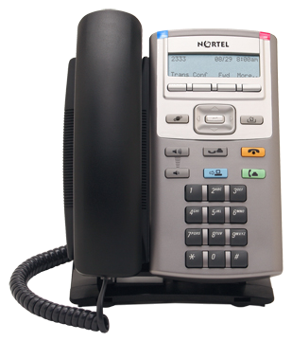

The IP 2001 is a class 2 802.3af PoE device, it also supports Cisco legacy Cisco PoE and operation has been verified on a number of Cisco switches see Technical Reference Bulletin DTR-2005-0112 for details. . An AC power supply is available as an option for this phone – the same supply as specified for the IP phone 2007.

This device is provisioned on the CS1000 as a 2001 phone (basic IP user license or a full IP user license) and is supported on CS1000 R3.0 software (and later).

The 1110 is not currently supported on the SRG platform.

Nortel IP phone 1120E

The IP phone 1120E is a multi-line (4 programmable line/feature key) intermediate phone designed to compliment the continuing IP phone 2002 and provide a number of features not supported in the established product. These included support for Gigabit LAN interfaces which allows Gigbit Ethernet interfaces to be extended through the phone to attached PCs, USB port to allow connection of external devices, the 4 way Navigation cluster to improve usability and a high resolution backlit pixel display.
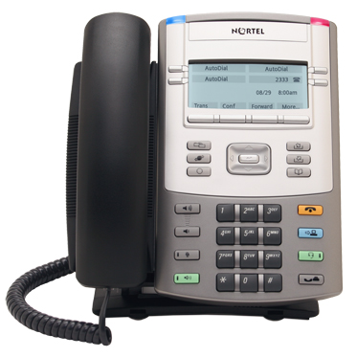

Due to the increased power required to support the Gigabit capability of this device is classified as a class 3 802.3af device (up to 12.5watts). Support for legacy Cisco PoE is also provided for select Cisco switches. An AC power supply is available as an option for this phone – the same supply as specified for the IP phone 2007.

The 1120E typically requires 8 Watts of power but peak requirements may be as high as 12.49 Watts.

This device is provisioned on the CS1000 as a 2002 phone and is supported on CS1000 R3.0 software (and later).

The 1120E is not currently supported on the SRG platform.

Further details on this phone can be found in the relevant section of NTP 553-3001-368 “IP Phones”.

Nortel IP phone 1140E

The IP phone 1140E is a multi-line (12 programmable line/feature key) professional phone designed to compliment the continuing IP phone 2004 and provide a number of features not supported in the established product. These included support for Gigabit LAN interfaces which allows Gigbit Ethernet interfaces to be extended through the phone to attached PCs, USB port to allow connection of external devices, the 4 way Navigation cluster to improve usability and a large high resolution backlit pixel display.

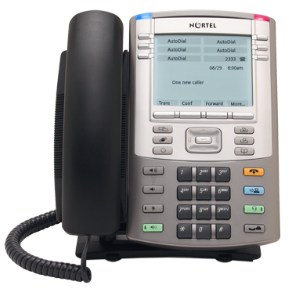
Due to the increased power required to support the Gigabit capability of this device is classified as a class 3 802.3af device (up to 12.5 watts). Support for legacy Cisco PoE is also provided for select Cisco switches. An AC power supply is available as an option for this phone – the same supply as specified for the IP phone 2007.

The 1140E typically requires 8 watts of power but peak requirements may be as high as 12.49 watts.

This device is provisioned on the CS1000 as a 2004 phone and is supported on CS1000 R3.0 software (and later).

The 1140E is not currently supported on the SRG platform.

Further details on this phone can be found in the relevant section of NTP 553-3001-368 “IP Phones”.

IP Audio Conference Phone 2033

The IP Audio Conference Phone 2033 delivers a fully-functional IP based Audio Conferencing solution based on market-leading technology from Polycom in conjunction with the business telephony features and user interface of the IP Phone 2001. The 2033 has a backlit high-resolution LCD display, offers high quality audio, supports local AC power,

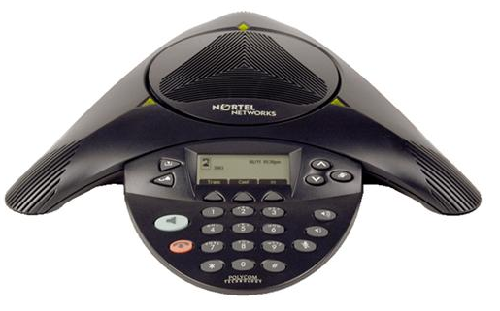

The IP Phone 2003 is supplied with an AC power supply and power cord as standard. Power Over Ethernet is not currently available on this product.

As with an IP Phone 2001, the IP Phone 2033 can use a basic IP user license or a full IP user license.

The IP Phone 2033 is supported from Release 3.0 of the CS1000 and is not currently supported on the SRG platform.

Further details on this phone can be found in the relevant section of NTP 553-3001-368 “IP Phones”.

IP softphone 2050

The IP soft phone is designed to replace the hardware based IP phones with a software application running on a PC together with a suitable USB headset to maintain suitable audio quality. The IP soft phone is mimics the capabilities of the IP phone 2004 and in addition includes directory integration capabilities for PC applications such as Outlook or ACT and corporate directories such as LDAP.
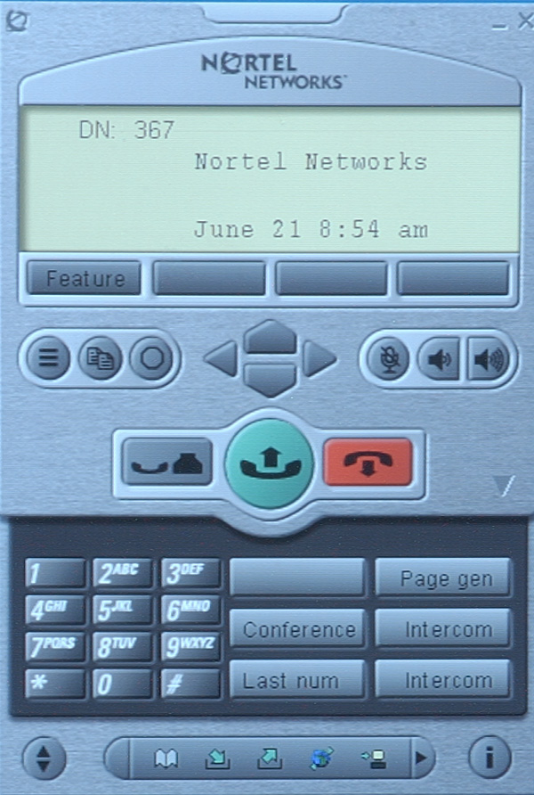
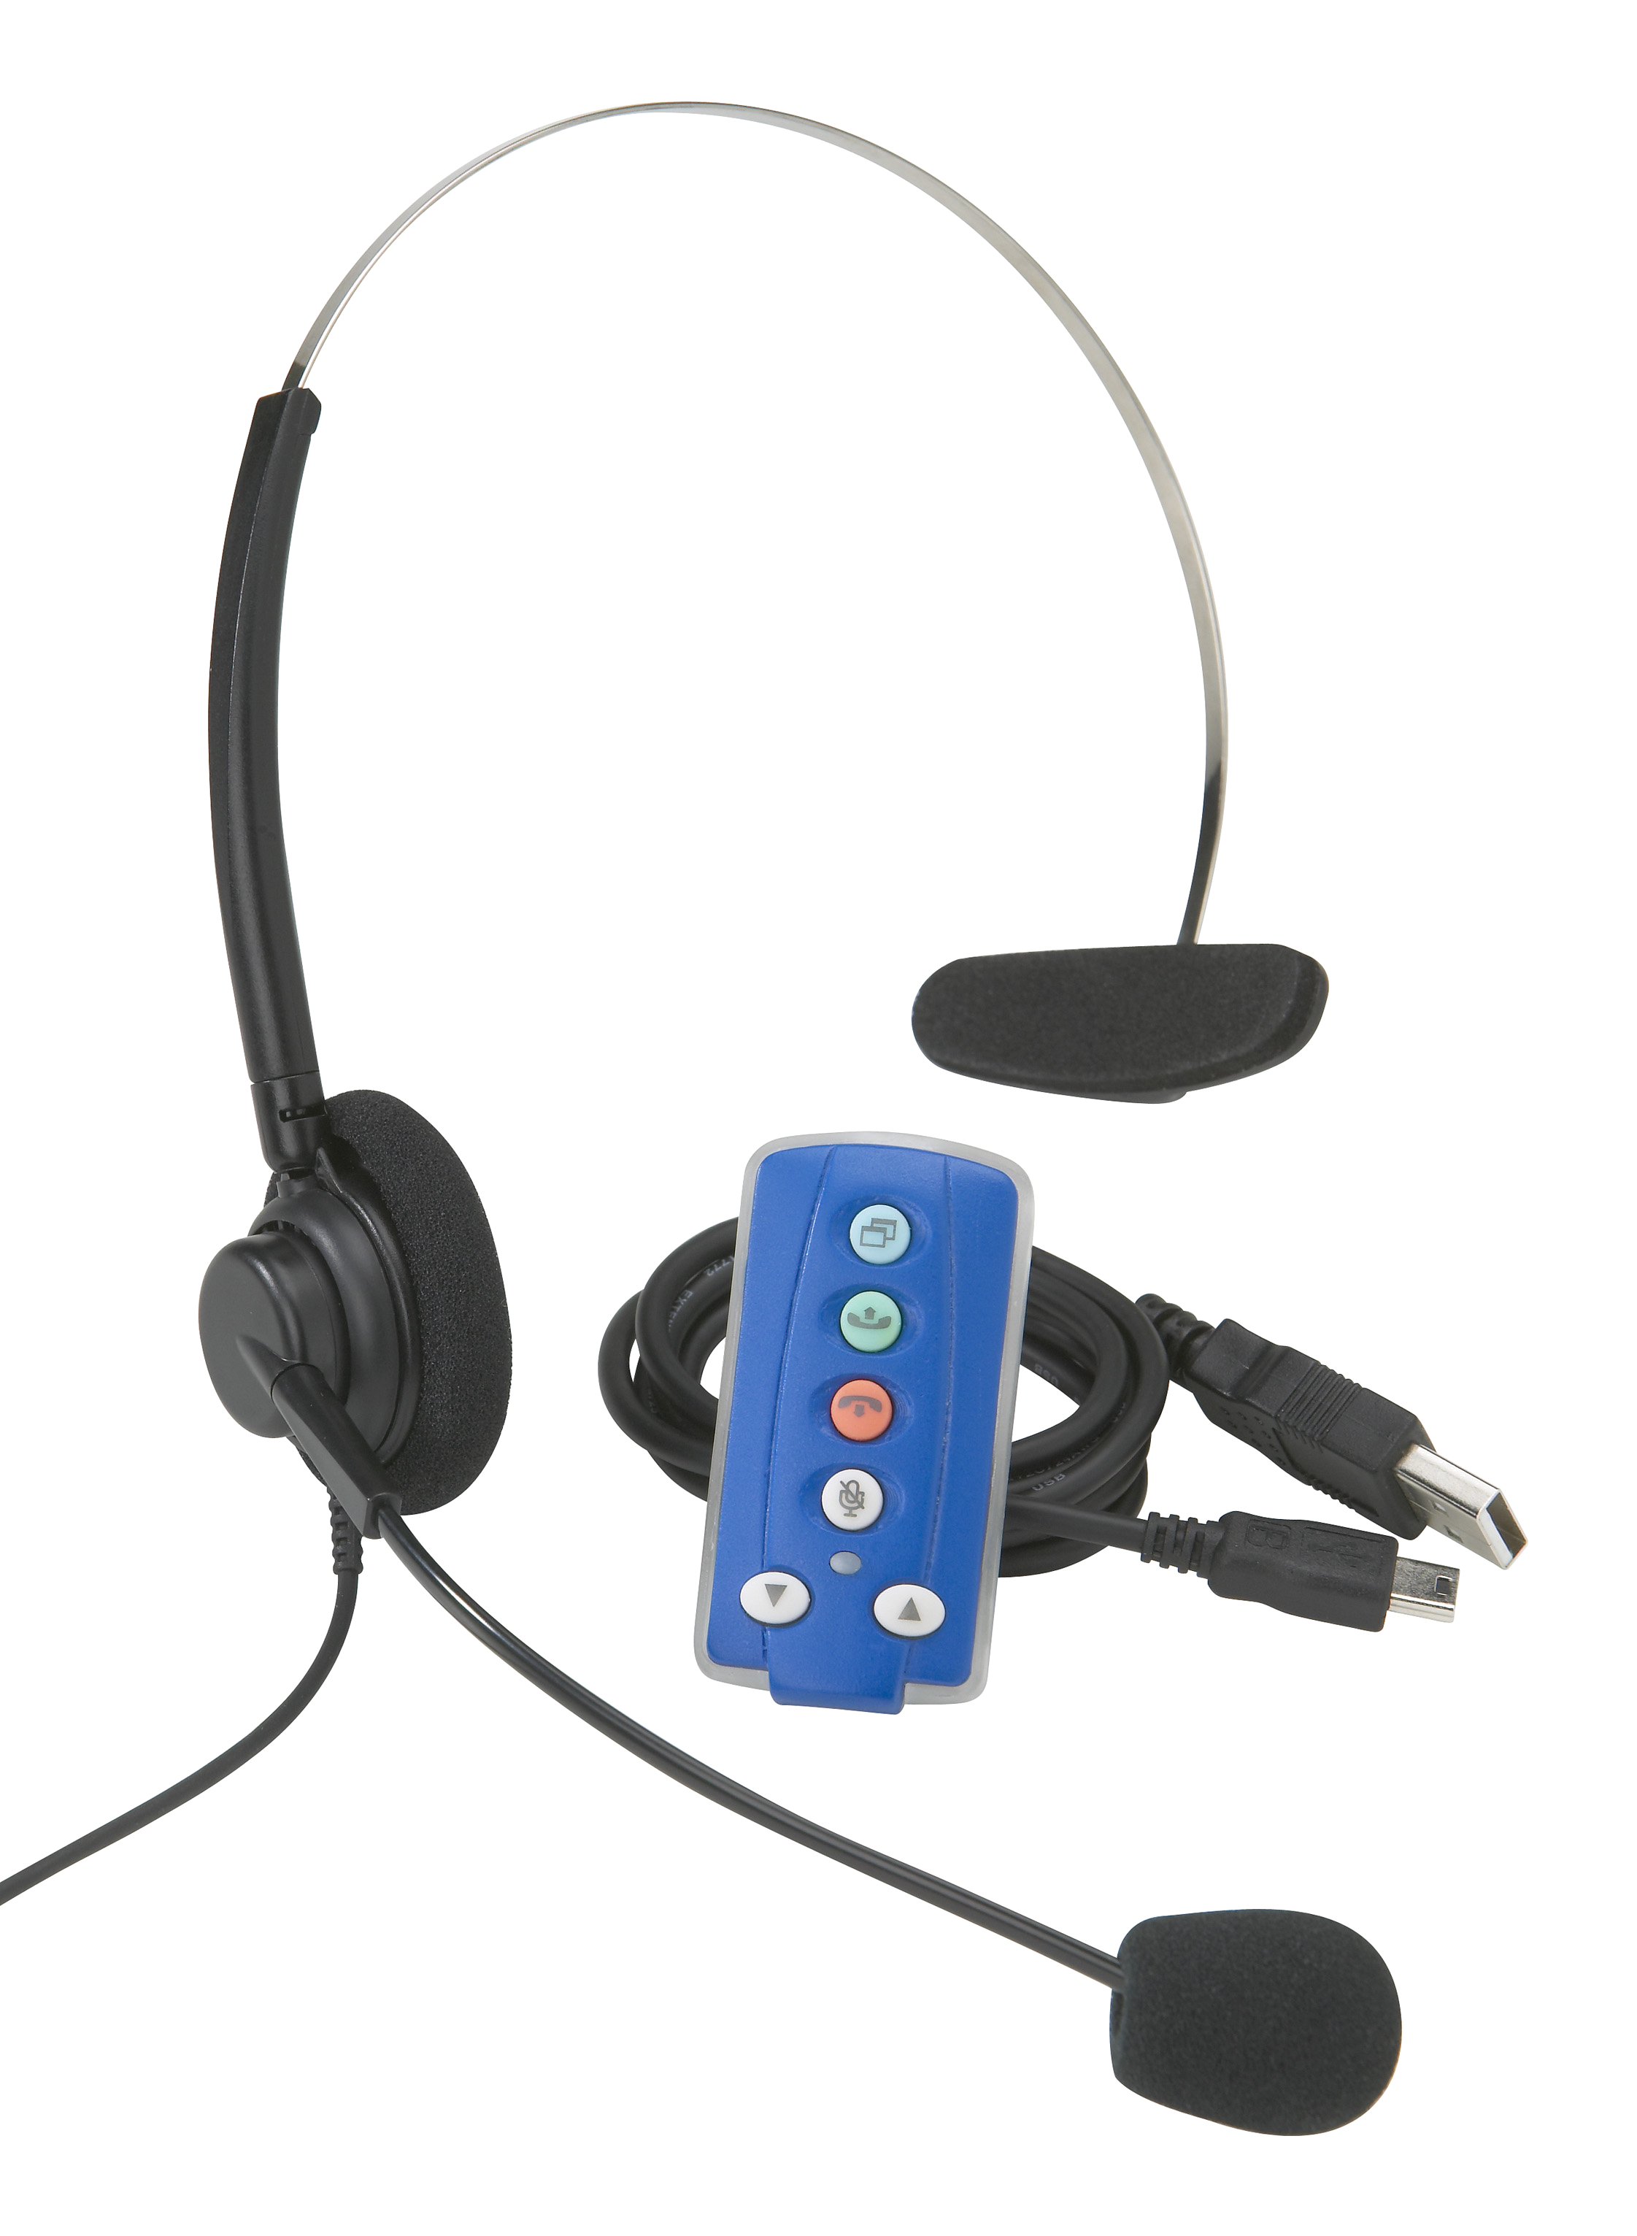

The 2050 is supported on standard Windows operating systems, 98, 98SE, 2000, XP home and XP pro. It requires a Pentium class processor (200MHz or faster), and in excess of 128Mbytes of RAM (for Windows 2000) and 55Mbytes of storage on the hard disk.

The soft phone supports diffserv for prioritising voice traffic on all the PC platforms indicated above, in addition 802.1p prioritisation is also supported on the Windows 2000 and XP platforms provided that the Nortel IP soft phone 2050 QoS service has been installed.

The soft phone does not support VLAN 802.1Q VLANs, and the soft phone is only accessible from the “data” VLAN ie the VLAN that the PC interface is assigned to.

For correct operation it is essential that an USB headset is used with the soft phone as the inbuilt audio capabilities in business PCs are not suitable for this application. Nortel has developed suitable USB headsets specifically for this application, these incorporate basic controls of soft phone (pickup call, drop call, mute, and volume controls) and includes a message waiting light, thereby increasing the usability of the soft phone application.

Further details on this phone can be found in the relevant section of NTP 553-3001-368 “IP Phones”.

IP Mobile Voice Client 2050 for PDAs

The Nortel MVC (Mobile Voice Client) 2050 is designed to provide an IP softphone on a customer provided PDA platform. The MVC can also support a customer supplied headset if required. An example of the user interface is shown below.

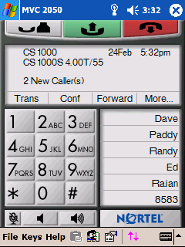

The MVC2050 is supported on a range of PDA platforms; Dell Axim X3/X3i and X5, HP iPAQ h5550/h5555 and Toshiba e800/e805 and e750/e755. The recommended minimum processor is the Intel Xscale PXA255 running at 400MHz, the PDA should also be equipped with 48Mb or ROM and 64Mb of RAM.

The MVC 2050 is supported on Windows Mobile 2003.

Due to hardware (PDA) limitations the MVC2050 does not support QoS. However Global IP Sounds NetEQ software is included with the client to provide packet loss concealment.

Communication with the CS 1000 is via a wireless network (802.11b). To provide secure networking IPSec clients can be used in conjunction with the MVC2050 to provide an encrypted communication path – these would require an external IPSec device (such as a Nortel VPN router) to terminate the IPSec session before passing the traffic to the CS1000.

Although it is Wireless LAN VoIP solution, the MVC 2050 does not require the Wireless LAN IP Telephony manager 2245.

WLAN handset support

The CS1000 platform supports the use of dedicated WLAN (Wireless LAN) handsets. These allow IP based wireless (802.11b) infrastructure to support fully functional multi line IP telephony handsets. Each WLAN handset requires a standard IP Telephony license on the CS1000.

To support WLAN handsets a Wireless LAN IP Telephony manager 2245 is required, this acts as a gateway between the CS1000 and the handsets. The 2245 has a single 10/100 Mbit/s LAN interface to communicate with both the wireless network and the CS 1000 platform. A single 2245 can support up to 500 handsets and up to 80 simultaneous calls (this reduces to 10 simultaneous calls if the LAN interface is running at 10Mbit/s). Multiple 2245s can be grouped together to increase capacity this is detailed in NTP 553-3001-30 “WLAN IP Telephony, Installation and configuration”.

There is a requirement for the 2245 to be in the same subnet as the WLAN handsets. This means that to minimise complexity all the WLAN handsets need to be kept in the same subnet whilst roaming on the WLAN. If this is not possible multiple WLAN IP telephony manager 2245 devices would be required, one (or more) per subnet.

The 2245s are configured with a pool of IP addresses, an IP address within the 2245 is required for every registered WLAN handset – this means that 2 IP addresses from the same subnet are required for each WLAN handset.

The 2245 communicates with the WLAN handsets and provided a number of value added features including QoS over WLAN using SVP (Spectra Link Voice Prioritisation) and WLAN handset power management. The latest handset firmware release supports WMM (Wi-Fi Multi Media) as an alternative QoS to SVP. To provide QoS over the wireless infrastructure SVP or WMM must be supported on all the AP (Access Points); an up to date list of compatible APs and configuration notes can be found at www.spectralink.com. The WLAN handsets require a 802.11b wireless infrastructure.

The 2245 does not mark voice traffic with the relevant wired LAN QoS markings (Diffserve, or 802.1P) and the LAN switch onto which the 2245 is connected should be configured to prioritise (and mark) the traffic appropriately.

The 2211 handset has a “push to talk” functionality, this feature depends on multicast being supported between the 2245(s) and the relevant WLAN handsets.

The WLAN handsets do not support partial DHCP configuration; this means that either the handsets must be given a static IP address or the DHCP must provide vendor specific options as detailed in NTP 553-3001-30 “WLAN IP Telephony, Installation and configuration”.

The WLAN handsets also support bidirectional text messaging. Details of achieving this and the 2246 gateway required to support this functionality can be found in NTP 553-3001-30 “WLAN IP Telephony, Installation and configuration”.

A network schematic is provided below:-

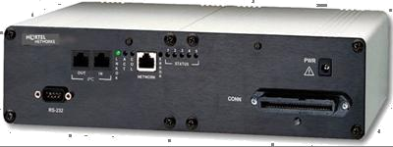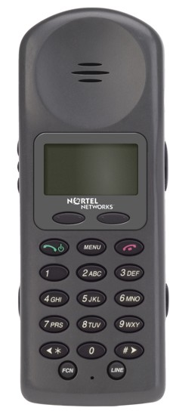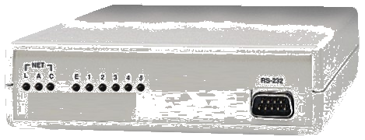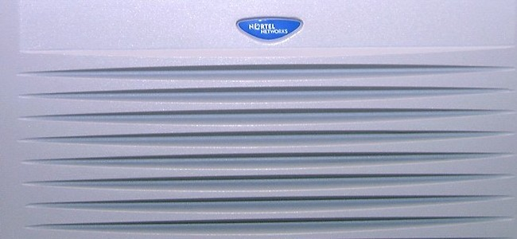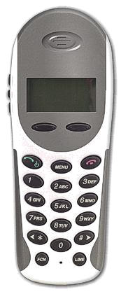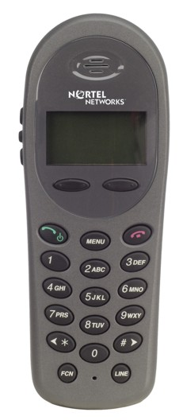
WLAN Handset
2212
WLAN / LAN
Network
WLAN Handset
2211
Manages QoS and optimizes voice performance in wireless domain
Provides text interface between IP handsets and 3rd party applications
WLAN Application Gateway 2246
Flexible range of IP Handsets
Communication Server 1000
WLAN AP
WLAN Handset
2210
WLAN IP Telephony Manager 2245

All three wireless LAN handset types support WEP (40 & 128 bit encryption) and with the latest firmware WPA and WPA2 using preshared keys. For prioritization WMM (Wi-Fi Multi-Media) is supported in addition to SVP. If WMM is used traffic is allocated to the highest priority “Voice access” category. Even if WMM is used, the 2245 is still required in the installation to provide the essential none QoS features.

The Nortel WLAN Handset 2210 is a small, lightweight wireless LAN telephone designed for general business users working in typical office environments.

The WLAN Handset 2211 is a ruggedized set designed to meet the most demanding environmental requirements, and includes the push-to-talk functionality which allows communication imitate communication with up to 8 user groups on 2211 handsets.

The WLAN Handset 2212 is based on the WLAN Handset 2210 but includes an integrated VPN client (IPSec compatible with the Nortel VPN router family) for added end to end security, a wipe clean (liquid proof) surface for use in medical environments, a vibrating alert feature and a back-lit display for 24-hour use.

To simplify the ordering process kits have been put together for each of the handset types, this includes the relevant handset, the required battery and a desktop charger. The required 2245(s) must be ordered separately.

The initial (phase 1) firmware on the 2210/2211 phone did not support a number of the features indicated above such as WMM, WPA and WPA2 – neither did it support virtual login, corporate directory, personal directory, callers list and redial list. These phones can be upgraded to the phase 2 firmware to take advantage of these new features.

The WLAN portfolio requires CS1000 R3.0 software or later.

IP Phone PoE requirements

Nortel IP Phone | IEEE Power Classification | Heavy Load | Normal Load**
IP Phone 2001 | Class 2 (max 6.49 W) | 5.0 W | 3.2 W
IP Phone 2002 | Class 2 (max 6.49 W) | 5.0 W | 3.2 W
IP Phone 2004 | Class 2 (max 6.49 W) | 5.0 W | 3.3 W
IP Phone 2007 | Class 3 (max 12.95W) | 13 W (maximum) | 8 W (typical)
IP Phone 1110 | Class 2 (max 6.49W) | Exact value TBC. | Exact value TBC.
IP Phone 1120E | Class 3 (max 12.95W) | 12.5 W (maximum) | 8 W (typical)
IP Phone 1140E | Class 3 (max 12.95W) | 12.5 W (maximum) | 8 W (typical)

* Heavy load – all LEDs on and 1kHz tone on speaker
** Normal load – set powered up.

Appendix B LAN and DHCP requirements

The CS1000 system makes use of a number of distinct LAN ports and LAN domains (VLANs) to communicate between components. Communication between these VLANs takes place over a layer 3 switch.

In general the LAN interfaces provided on Nortel CS1000 components are standard 10/100 Mbit/s interfaces and should be set to auto negotiate (both on the IPT components and the LAN switches). Gigabit Ethernet interfaces are provided on the 1120E and 1140E IP telephones – this is to provide gigabit services to any attached devices (such as a PC) and are not required for correct operation of the phone. In addition the Pentium 4 based processors available on the larger systems (option 61/81 single group/multigroup and the CS1000E) have Gigabit Ethernet interfaces – however 100Mbit/s is sufficient for current applications.

All the LANs specified should be constrained to a single CS1000 system. If connectivity between CS1000 systems (e.g. between a CS1000E and a CS1000T) this should be done over a layer 3 connection (via an Ethernet Routing Switch) rather than over a layer 2 (VLAN) link.

The reference architecture is shown below:-

The individual LANs are considered below

The Server Subnet

The Server LAN provides communication between Nortel applications servers and client PCs on the customers LAN (e.g. Call Centre supervisor display, CallPilot Desktop Messaging client). The server LAN is used to communicate between Optivity Telephony Manager, Contact Centre and CallPilot. In previous releases of these products the term CLAN or Curstomer LAN was used, however as the name has been changed to better reflect how it is usually deployed.

The ELAN Subnet

The ELAN (Embedded LAN) carries signalling traffic between the CS1000 elements and associated applications. This subnet must be isolated from customer traffic. It is recommended to support this VLAN on a layer 2 switch with broadcast and multicast limits enabled (to keep such traffic below 300pps).

ELAN interfaces can be found on call servers, VGMC cards, signalling servers, and applications such as CallPilot and Nortel Contact Centre. Most applications do not require the ELAN to be routed, ie. it can be completely isolated subnet on the customers network.

OTM requires access to the ELAN port of CS 1000. The recommended mechanism of achieving this is to make the ELAN routable on the customer’s network. The OTM server and every OTM “thick” client requires access to the CS 1000 ELAN port.

In small implementations where a single OTM server (no thick clients) it is possible to provide a “dual nic” configuration where the OTM server had direct link to both the ELAN and the server VLAN. Details and recommendation can be found in NTP 553-3001-230 Optivity Telephony Manager Installation and Configuration.

An ELAN interface is also available on the terminal server provided as part of the CS1000E system.

A signalling server acting as a dedicated NRS does not require an ELAN connection.

The TLAN Subnet

The TLAN (Telephony LAN) carries the actual voice media and signalling traffic between CS1000 systems (Peer Trunks) and between the CS 1000 and the IP handsets. Voice traffic on the TLAN should be prioritised by the use of DiffServ or 802.1P markings.

TLAN interfaces can be found on VGMC and signalling servers.

IP handsets are usually on the customer LAN and not directly connected to the TLAN.

The SLAN Subnet

The SLAN is used for communication between components of the MG1000T, CS1000S and CS1000M (Option 11 based “small systems”).

The main chassis/cabinet in a CS1000M system, (or call server in a CS1000S) or (main media gateway in a CS1000T) can be equipped with four 10/100 LAN interfaces. These can be connected to a maximum of 4 expansion cabinets/chassis (media gateway in a CS1000S) or (expansion media gateways in a MG1000T). This LAN interface carries all the communication between individual components.

When the components are collocated it is convenient to connect the units using a cross over cable. However it is possible to extend this over the LAN if required, however care must be taken when achieving this as the link must have low loss and low latency.

Traffic within this VLAN is not tagged and should be prioritised by the LAN switches based on the physical port (e.g. mark the packets with DiffServ at the first LAN switch). See further description under CS 1000S section of product description.

The HSP

The HSP (High Speed Pipe) is only externally accessible on the 1000E systems; it provides synchronisation between the two call servers to ensure stateful failover. In a standard implementation the High Speed Pipe is implemented as a cross over cable between the two call servers. With Campus Redundancy the High Speed Pipe can operate over a stretched VLAN that meets the high bandwidth and stringent QoS requirements. (See fuller discussion under Campus Redundancy above)

This link cannot be routed.

This link is also provided on the Option61/81 CS1000M single group/multi group however this is held within the single “Meridian” cabinet and does not require external LAN connection.

The Customer LAN

The customer LAN houses all the customer devices e.g. IP phones, PCs, servers etc. The Nortel solution gives the customer flexibility as to how this domain is configured – provided that suitable priority is given to the voice signalling and media traffic.

The Nortel IP phones (including ones with integral 3 port switch) can place the voice traffic in dedicated voice VLANs if required, allowing segregation from the underlying data traffic. If a single voice and data VLAN is required then this is also supported and the voice traffic is automatically QoS marked by the phone. This combined VLAN configuration is commonly used when PC based soft-phones are deployed, but like hard phones soft phones can prioritise the voice traffic to allow QoS.

Numbers of LAN ports required on CS 1000 systems

The Server LAN design section of NTP 553-3001-160 Converging the data network with VoIP recommends how each system should be connected over a LAN and how LAN resilience can be incorporated into the solution when multiple LAN switches, a resilient stack or multiple line cards in a chassis LAN switch are used.

The basic connectivity requirements for each switch type is summarised below:-

LAN port requirements for CS1000S

The CS1000S Call Server has 4 dedicated 10/100 Mbit/s interfaces for connecting to the 4 MG1000S Media Gateways (this is known as the SLAN). These are normally direct cross over cables, and are therefore not included in the table below, however the SLAN can be run over the LAN where required.

An ELAN interface is required from the call server, one for every CS1000S Media Gateway (provided by the SSC), one for every VGMC card installed and one for each signalling server.

One TLAN interface is required for every VGMC card and one for each signalling server.

The table below indicated the number of LAN interfaces of each type required by components of a CS1000S.

CS1000S component | ELAN interfaces | TLAN interfaces
Call Server | 1 | N/A
Signalling Server | 1* | 1
MG1000S | 1 | N/A
VGMC card | 1 | 1

* Signalling Servers providing NRS service only do not require an ELAN interface
ELAN interfaces for OTM, CallPilot, Contact Centre etc are in addition to those tabulated above

LAN port requirements for a CS1000E

An ELAN interface is required on each of the call servers, all the media gateways (MG 1000E), for every VGMC within a gateway and for every signalling server.

As an additional level of resilience each media gateway can be equipped with a second ELAN connection connected to another LAN switch or blade. (The BT recommendation is that every MG 1000E is connected to 2 LAN ports on separate LAN switches/bladed) ELAN ports are also required for the terminal server provided with the CS1000E, the BT SOLO box, and other applications such as Symposium and CallPilot.

TLAN connectivity is required for all the VGMC cards and for all the signalling servers.

If both call servers are in the same comms room the HSP will normally be a cross over cable and does not require any LAN ports. For campus redundancy the HSP will require LAN ports (see Campus Redundancy section for more details)

CS1000E component | ELAN | TLAN | HSP | Nortel Server Subnet (previously CLAN)
Call Server | 1 |  | 1
Signalling Server | 1 | 1
MG1000E | 2
VGMC | 1 | 1
Terminal Server | 1
CallPilot | 1 |  |  | 1
SCCS / CCMS | 1 |  |  | 1
MIRAN |  |  |  | 1
MIPCD |  |  |  | 1
MICB |  |  |  | 1
BT RACE box (SOLO) | 1
Additional applications not listed here will also require LAN ports if they are being used eg. OTM, Call Loggers, other Symposium Applications (CCT, Symposium Web Client/CCMA, Multimedia/Outbound, Nortel Contact Recording etc)

LAN port requirements for an MG1000T

The ELAN and TLAN for the MG1000T can be separate subnets to the ELAN and TLAN of the main system (CS1000E) (It is possible for different call servers to share the same ELAN and TLAN subnets, and this is typical if an MG 1000T is located next to a CS 1000E)

The LAN requirements of a CS1000T are very similar to that of the CS1000S. The main media gateway has 4 SLAN interfaces for connecting to 4 MG1000T expansion Media Gateways. These are normally direct cross over cables, and are therefore not included in the table below, however the SLAN can be run over the LAN where required.

ELAN connectivity is required from every MG 1000T, whether main or expander, provided by the SSC, one for every VGMC card installed and one for each signalling server.

One TLAN interface is required for every VGMC card and one for each signalling server.

CS1000T component | ELAN interfaces | TLAN interfaces
Main MG1000T  (SSC card) | 1
MG 1000T (Alternate call server SSC card in 2nd chassis) | 1
Signalling Server | 1* | 1
VGMC | 1 | 1

*Signalling Servers providing NRS service only do not require an ELAN interface.
ELAN interfaces for OTM etc. are in addition to those tabulated above.

LAN port requirements for a MG1000B

The ELAN and TLAN for the branch office solution should be separate to the ELAN and TLAN of the main system – there is no need (and it is not recommended) that multiple CS1000 systems share the same ELAN and TLAN.

The CS1000 B (Branch) requires one ELAN connection for the cabinet and an additional ELAN connection for each VGMC, each signalling server also requires an ELAN connection.

A TLAN connection is required for each media card and for each signalling server.

Note IP phones local to the 1000B must have routed access to the TLAN of the 1000B solution and that of the main CS1000 system.

CS1000B component | ELAN interfaces | TLAN interfaces
Signalling Server | 1 | 1
MG1000B (SSC Card) | 1 | N/A
VGMC | 1 | 1

ELAN interfaces for OTM, CallPilot etc are in addition to those tabulated above.

LAN port requirements for a CS1000M

The CS1000M is built on a traditional Meridian platform with additional IPT functionality (peer networking etc.) being provided by the external signalling server(s).

ELAN connectivity is required for all CS1000 processors (1 for Option11, 2 for single group and multigroup). Further ELAN connections are required for every VGMCs and for every signalling server.

A TLAN connection is required for every VGMC and for every signalling server.

CS1000M component | ELAN interfaces | TLAN interfaces
Single group Multigroup | 2 | N/A
Small system main | 1 | N/A
Small system expansion | 1 | N/A
Signalling Server | 1* | 1
VGMC | 1 | 1

* Signalling Servers providing NRS service only do not require an ELAN interface
ELAN interfaces for OTM, CallPilot, Contact Centre etc are in addition to those tabulated above

SRG

Being a single device with no separate signalling servers or media gateways the SRG does not require Ethernet ports for communicating between different components. As such the only Ethernet components on the SRG are for connecting onto the customer LAN to allow communication with the IP phones and to communicate to external CS1000 switches – generally in remote locations accessible over a routed WAN infrastructure.

The SRG 1.0 (BCM200 and 400 based) incorporates (optional) serial WAN interfaces. It is therefore possible to use the inbuilt QoS enabled router within the SRG to provide the data (routing) infrastructure for the branch network. If a suitable data router is already in place the SRG 1.0 can use this rather than providing the routing functionality.

The initial SRG50 implementation does not provide routing functionality but will fully integrate into the existing data infrastructure.

LAN, QoS,Bandwidth and IP Addressing requirements for CS 1000 subnets

Server LAN

The Server LAN is used to exchange information between the applications supporting the CS1000 system, and for these applications to talk to client PCs. In some cases these applications will also talk to corresponding severs on other CS 1000 sites (e.g. Network Symposium or Network CallPilot). Applications found on the server LAN include CallPilot, the Contact Centre and OTM.

Since this LAN is primarily used to communicate between standard server platforms the constraints on this LAN are minimal. It can be shared with other (non CS1000) traffic if required.

Note: Symposium may require Multicast to be supported on the server LAN. This is typically required if Network Symposium is deployed (for the real time displays) or RSM applications such as IEX TotalView work force management is required).

The ELAN

The ELAN carries signalling traffic between key components of a single CS1000 solution.

It is possible to configure the CS1000 to use a combined ELAN and TLAN. This can result in performance degradation and is not recommended for general deployment.

An ELAN should consist of a single VLAN to provide a single broadcast domain.

The ELAN has strict limits on the amount of multicast and broadcast traffic that should be present and should not be extended to other elements of the customer LAN (e.g to the IPT telsets on the customer LAN, or to other CS1000 systems) other than by using a Layer 3 (IP routed) link.

The ELAN link should be supported on an Ethernet switch (not a HUB) and configured to keep the broadcast and multicast limits below 300pps (if multicast and broadcast limits are specified separately specify 150pps each). If possible multicast traffic should be disabled.

All ELAN interfaces should be set to auto-negotiate. If this is not possible Table 21 in NTP 553-3001-160 Converging the data network with VOIP has a comprehensive list of ELAN interface speed and duplex.

All interfaces on the ELAN require static IP addressing.

BootP is required on the ELAN subnet – it is used by the follower signalling servers and the VGMC cards.

The ELAN requires low loss (<0.5% and 0% if possible) and low latency – 30ms maximum roundtrip delay for a distributed MG1000E solution.

The ELAN traffic should be prioritised to support QoS to assist in supporting the specified low latency and low loss requirements.

In Release 4.5 of the CS1000E it is possible to distribute the media gateways throughout an IP network and there is no longer a need to link all the media gateways, the signalling servers and the call servers in a single VLAN. ELAN communication is still required between all the components but this can be provided over a layer 3 (IP link) provided that the QoS, packet loss and round trip delay limits are not exceeded.

All the ELAN interfaces in a single media gateway (SSC cards and VGMC) must reside in a single VLAN – to provide a single broadcast domain, even for the distributed CS1000E system.

The volume of traffic on the ELAN is very low and bandwidth engineering for this segment is not required.

It is recommended that, where possible, spanning tree is disabled for the ELAN subnet.

Where the ELAN is distributed among 2 or more LAN switches (or interface cards) it is recommended that like devices are shared across multiple devices. For example if the VGMC are shared among 2 LAN devices then failure of one of the LAN devices will reduce the DSP capacity of the system rather than eliminate this capability completely. Similar deployments should be considered for the 2 ELAN ports on a MG1000E, where dual call servers (or processors) are deployed and when multiple signalling servers fulfil the same role (such as TPS). See the Server LAN design section of NTP 553-3001-160 Converging the data network with VoIP.

The TLAN

The TLAN is used to carry voice media and signalling traffic between the CS1000 elements – but should not have direct connectivity to the IPT telsets.

All interfaces on the TLAN require static IP addressing. A further TLAN subnet address is required to act as the “node IP” address – traffic to this address is processed by the lead signalling server.

The TLAN link should be supported on an Ethernet switch (not a HUB) and configured to keep the broadcast and multicast limits below 300pps (if multicast and broadcast limits are specified separately specify 150pps each). If possible the multicast traffic should be prohibited on this VLAN.

The QoS between an IPphone and the TLAN interface requires an average packet loss of less than 1%, and a short term loss over any 10sec of <5%. This includes any losses in the customer LAN and the TLAN.

Traffic prioritisation is required on the TLAN.

DiffServ is the recommended mechanism for providing end to end QoS through the IPT infrastructure.

Class of Service (802.1p) is disabled by default, however it can be enabled if DiffServ is not supported on the LAN equipment. Care must be taken if the traffic traverses non Ethernet links to map the QoS to support end to end QoS. The recommended Class of Service is 6 if used.

Policy marking is not required on the TLAN ports as the TLAN interfaces priority mark traffic appropriately.

It is recommended that where possible spanning tree is disabled for the TLAN subnet.

Whilst the load on any single TLAN interface is limited, for example a single VGMC card can support a maximum of 32 simultaneous calls consuming ~3Mbit/s the total TLAN bandwidth can be significant on large systems (up to 100k full duplex per supported call (G.711 20ms sampling rate)) and needs to be appropriately traffic engineered, to provide the appropriate QoS and resilience.

Where the TLAN is distributed among 2 or more LAN switches (or interface cards) it is recommended that like devices are shared across multiple devices. For example if the VGMC are shared among 2 LAN devices then failure of one of the LAN devices will reduce the DSP capacity of the system rather than eliminate this capability completely. Similar deployments should be considered when multiple signalling servers fulfil the same role (such as TPS). The Server LAN design section of NTP 553-3001-160 Converging the data network with VoIP

The HSP

The High Speed Pipe (HSP) provides a communication between the two call servers on a CS1000E system. The interfaces (one per call server) are provided from the processor card, CPII card has a 10/100Mbit/s HSP interface, CPIV has a 10/100/1000Mbit/s HSP interface.

The HSP must be on separate VLAN, and cannot be shared with any other application.

The HSP requires a minimum bandwidth of 100Mbit/s full duplex.

Maximum roundtrip delay is 30msec.

Maximum packet loss of 0.1%.

If the call servers are collocated the HSP should be provided by a cross over Cat5 (CPII only) or Cat5e (CPII and CPIV).

If the link needs to be extend over a LAN infrastructure then great care must be taken to engineer the solution. A list of tested LAN switches is provided in NTP 553-3041-120 Communication Server 1000E Planning and Engineering., the LAN MUST support QoS and it is recommended that the HSP traffic is classified as 802.1p level 7 (Network Control & OAM).

Where possible the HSP link should be supported on MLT (Multi Link Trunks) between the LAN switches to provide resilience.

The HSP must be supported on a single VLAN – routed communication between the two call servers is NOT supported. If a routed link is the only option the HSP traffic must be tunnelled to preserve the single VLAN working.

Prior to Release 4.5 the only LAN switch capable of supporting the HSP was the Nortel Ethernet Switch 470, with fibre links being provided between the 2 Ethernet switches to ensure transparency.

The SLAN

The SLAN is generally supported on a crossover cable. The main unit has 4 interfaces, one for each media gateway or expansion gateway – this allows a system to be connected using crossover cables rather than use a LAN switch. This provides a simple cost effective connectivity solution to support inter system communication – however each link is limited to a maximum length of 100Meters.

To extend the range beyond the SLAN can be supported over a LAN infrastructure.

The LAN must be supported on a single VLAN – cannot be routed –there possible the SLAN should be implemented on dedicated links.

However implemented, the SLAN packet loss should be less that 0.5% and the round trip delay of less than 5ms with maximum jitter buffer settings, or 12ms round trip delay with minimum jitter buffer settings for these links. Further details of the QoS profiles for these links can be found in the NTP 553-3001-160 Converging the Data Network with VoIP.

To support these QoS requirements it is recommended that all traffic within the SLAN is prioritised. Nortel does not differentiate between traffic in the SLAN by the use of priority markings.

Under heavy load (e.g. 256 simultaneous voice calls) an SLAN link may have to support 21Mbit/s of traffic.

The customer LAN

The Nortel IP phones are designed to integrate into an existing customer LAN. The only constraints are the QoS requirements to support IP telephony.

The QoS between an IPphone and the TLAN interface requires an average packet loss of less than 1%, and a short term loss over any 10sec of <5%. This includes the losses in the customer LAN and the TLAN.

All the IP handsets that do not use WLAN can be configured to automatically mark the telephony traffic with the appropriate DSCP (or 802.1p markings). DiffServ is the recommended mechanism for prioritising traffic as this provides end to end marking. If required, 802.1p can be used rather than DSCP although care must be taken if this traffic traverses any none Ethernet infrastructure.

If WLANs are used (2050MVC) or 221x handsets, QoS markings are not provided for the wired infrastructure. It is possible to use the LAN switches to mark the traffic (DSCP or 802.1p) by matching all flows destined for the TLAN subnet.

Care must be taken in large deployments to ensure that sufficient bandwidth is available. Whilst any single voice conversation is unlikely to require more than 100k full duplex per supported call (G.711 20ms sampling rate). However care must be taken in designing the network as a large number of simultaneous calls result in significant traffic flows which need to be prioritised.

All Nortel IP phone (apart from the soft phones) require a dedicated IP addresses. The IP addresses for the IP phones do not need to be static addresses, in general, DHCP is used to provide dynamic addresses.

In terms of customer LAN design there are various architectures that can be used.

Two main solutions are possible with the Nortel IP phones:-

- IPT traffic placed in a dedicated voice VLAN segregated from customer data traffic.
- IPT traffic share same VLAN as data traffic.

Dedicated voice VLAN

The dedicated VLAN simplifies administration of the customer VLANs.

Any existing data VLANs can be left intact and a new VLAN is specified to carry the traffic.

This solution increases the security on the overall solution as end users do not have direct layer 2 access to the IP phones. Access to the phones from the end users is only possible via a layer 3 device (Ethernet routing switch) and filters can be placed to limit (or totally prevent) such communication.

In this scenario it is also easy to eliminate any communication between the data VLAN and the TLAN subnet.

Filters can be used in the phone VLAN to ensure that only valid IPT traffic is carried – for example any extraneous multicast or broadcast traffic can be filtered.

Any future debugging is likely to be simplified as the two traffic types (voice and data) have dedicated VLANs.

This solution is possible for all the Nortel hard phones directly connected to the LAN, even if the 3 port switch is used to support data traffic.

This solution is not possible to achieve with 2050 soft phones.

This solution is not always appropriate when using WLAN (2050MVC or 221x handsets) unless the WLAN is only exclusively for voice.

Shared VLANs.

The shared VLAN can be used to provide maximum flexibility in the deployment and minimise the LAN configuration required (no new VLANs required).

This option gives maximum flexibility in terms of phone deployment – a phone can be deployed anywhere on the data VLAN.

This solution can use IP filtering to control the flow of data traffic into the TLAN.

This solution is supported by all Nortel IP phones, including soft phones and all WLAN devices.

QoS is supported in this implementation by DSCP and 802.1p.

LAN PoE considerations

In a Nortel CS1000 deployment standards based PoE (Power over LAN) can optionally be used to power the IPT telsets. No other component of the Nortel CS1000 can take advantage of PoE however they can still be connected to a PoE port if that is operationally expedient.

Different LAN vendors have historically used proprietary PoE implementations; although today the established standard is 802.3af which is the preferred implementation selected by Nortel. To ensure compatibility with legacy LAN deployments Nortel also support the Cisco proprietary powering. Nortel Phones also support Power Design’s powered patch panel which provides power when the existing LAN switches cannot provide such functionality, the continuing price erosion of the PoE LAN switches generally make this an unattractive option.

The table below indicates the power requirement and IEEE classification for Nortel IP phones. IP phones not mentioned do not support PoE.

Nortel IP Phone | IEEE Power Classification | Heavy Load | Normal Load**
IP Phone 2001 | Class 2 (max 6.49 W) | 5.0 W | 3.2 W
IP Phone 2002 | Class 2 (max 6.49 W) | 5.0 W | 3.2 W
IP Phone 2004 | Class 2 (max 6.49 W) | 5.0 W | 3.3 W
IP Phone 2007 | Class 3 (max 12.95W) | 13 W (maximum) | 8 W (typical)
IP Phone 1120E | Class 3 (max 12.95W) | 12.5 W (maximum) | 8 W (typical)
IP Phone 1140E | Class 3 (max 12.95W) | 12.5 W (maximum) | 8 W (typical)

* Heavy load – all LEDs on and 1kHz tone on speaker
** Normal load – set powered up.

All the Nortel phones indicated above can also accept power from a standard AC source if required – this requires the purchase of a separate power supply for each phone (power supplies are not provided by default).

The exact method of engineering a PoE solution depends on the LAN equipment and how the PoE management / limits have been implemented on the device.

Care needs to be taken to ensure that an individual port can provide sufficient power for the phone attached. In addition a number of Ethernet switch vendors also limit the total power delivered over a number of ports; for a standalone switch (or stackable) this is likely to be the total amount of PoE delivered from all the switch ports, for a chassis solution this may be the total power over an individual line card. Other factors which may impact the maximum power available could be the number and choice of power supplies etc.

Care needs to be taken to ensure that none of the limits are exceeded, individual port, collection of ports, per power supply (if applicable) etc.

The method of allocating power also varies per vendor for example some only work on the “class” assignment within 802.3af – they will allocate 6.49Watts for every class 2 device, 12.95Watts for every class 3 device etc. Other switch vendors (including Nortel) will work on the actual power required rather than the artificial class boundaries – this will allow more efficient use of Ethernet ports.

To make the most efficient use of the PoE devices it is generally best not to concentrate all the devices with high power requirement on the same Ethernet switch as these might exceed the average PoE power available across the ports. In this case some ports should not be used due to lack of available power, by adding devices with a lower power requirement, more efficient use of the switch ports can be.

PoE can be used to power none IPT devices such as wireless access points. None IPT devices should also be taken into account when properly planning and dimensioning the PoE installation

DHCP options

The Nortel phones have a number of methods of being configured with operational parameters. This gives flexibility in the method of deployment and how the phones are integrated into a customers LAN. The functionality of the phones is not impacted by the choice of configuration method.

Full details of the options can be found in NTP 553-3001-160 Converging the data network with VOIP.

BT do not normally supply a DHCP server, but there is a BT document with instructions on how to configure a Windows DHCP server for Nortel IP phones.

BT Technical Services DHCP Deployment Guide for Nortel IP Sets can be found at the following URL - http://technet.intra.bt.com/techzone/nortelvoice/public/drag/

The 3 main options are summarised below:-

Static configuration

In static configuration all phone parameters are manually configured into the phone during initial configuration and are not changed. This includes details such as the phones IP address, subnet mask and default gateway.

This method of configuration is not very scalable (all the parameters must be manually entered into every phone), prone to error (incorrect parameter provided during configuration), and difficult to change (any changes must be conducted on every phone by hand). As such this option is generally used at the proof of concept stage and is not used in large scale deployments.

Nortel does not recommend using this configuration methodology for large deployments.

Partial DHCP

In partial DHCP mode all the voice specific parameters are manually configured into the phone however the IP parameters – IP address, subnet mask and default gateway are provided by the DHCP server. This reduces the configuration requirements on the phones, and makes integration into an existing LAN infrastructure easier.

Since the DHCP server is only providing traditional IP parameters (IP address, subnet mask and default gateway etc.), this is straightforward to incorporate into an existing DHCP server implementation – the only thing that needs to be checked is that sufficient IP addresses are available in the DHCP scope to provide all the IP phones with IP addresses in the VLANs where the phones will be located.

In such deployment it is still possible to configure separate voice and data VLAN on the phones – these can be defined manually on the phone. In this instance the DHCP server must be accessible from the voice VLAN and have a suitable scope for this subnet. If a combined voice and data VLAN is used the DHCP scope within the combined VLAN must be large enough to cater for both the phones and all other IP endpoint e.g. PCs etc.

This option is suitable where the customer DHCP server has limited capability or where customer DHCP configuration is not possible or desirable.

Full DHCP

In full DHCP mode the DHCP server provides voice specific parameters as well as the IP parameters. This reduces the manual phone configuration tasks to providing the Virtual TN, node ID and password during initial configuration, all other parameters are configured via DHCP.

When using full DHCP mode the server must provide voice specific parameters as well as the traditional DHCP parameters, IP address, subnet mask, default gateway, lease time etc. If a phone is configured for full DHCP it will not accept offers from DHCP servers that do not include the Nortel class identifier “Nortel-i2004-A”.

The voice specific parameters can be provided using a range of site-specific and vendor-specific attributes. Multiple site-specific and vendor-specific attributes are supported to allow flexibility of deployment and to accommodate specific DHCP server limitations (e.g. NT based servers cannot use the Vendor specific attribute to support Nortel IPT). Prior to implementation care must be taken to ensure that a suitable option is selected which does not interfere with other services provided by the DHCP server. The Nortel configuration options used are the same wherever option code is selected.

To support full DHCP the DHCP server must be able to support

Option 60 Class identifier
And either:-
Option 43 Vendor specific option
Or
Option 128 or 144 or 157 or 191 or 251 Site specific option

The class identifier “Nortel-i2004-A”, is used by the DHCP server to identify that this information is for a Nortel IP phone. The DHCP server can return information for either 1 or 2 servers (either S1 only or S1 and S2) as required for the deployment. An example string is provided below for when both S1 and S2 are required.

“Nortel-i2004-A,iii.jjj.kkk.lll:ppppp,aaa,rrr;iii.jjj.kkk.lll:ppppp,aaa,rrr.”

Where:-

iii.jjj.kkk.lll - IP address of the lead signalling server
pppp - port number for communication with the lead signalling server
aaa - action code for server (currently must be “1”)
rrr - retry count for the server

(if only S1 is to be specified – the “;” separator is replaced by a “.” and the S2 is omitted)

If required, the IP address of an exchange application server (e.g. the Citrix information server) can be appended to the S1, S2 information. The configuration provided is the IP address of the application server, and the port number (always 5000) only, the action code and retry count are not required.

If is not possible to configure for an application server when only S1 is defined. If only S1 is required then a “dummy” S2 must also be configured when supporting an application server under full DHCP.

Further details of this method of configuration can be found it in appendices C and D of NTP 553-3001-160 Converging the data network with VOIP.

DHCP auto-discovery

When using Full DHCP it is often convenient to use DHCP to specify which VLAN the phone should be placed in. This can be achieved using the “DHCP auto-discovery” feature.

It is assumed that the default VLAN is the data VLAN. The DHCP server in the data VLAN is configured to return a VLAN ID to the phone using site specific code 128,144,157, 191, or 251. Up to 10 VLAN Ids can be sent back by the DHCP server in the format indicated below.

VLAN-A:xxx+yyy+zzz.

Where:-

VLAN-A The Nortel DHCP discovery identifier (-A is the version identifier)
“+” is the separator,
“.” signifies the end of the structure
xxx,yyy,zzz indicates the individual VLAN IDs (numeric) – up to 10 can be specified.
The string “none” or “NONE” can be returned to indicate that the phone is to use the default (data) VLAN.

Once the phone has received the VLAN information it releases the offered IP address (for the data VLAN) and reboots. The phone then sends a DHCP request with the first VLAN ID provided, if this is not successful the phone systematically tries all the indicated voice VLANs in turn.

The DHCP server accessible from the voice VLAN will provide full DHCP support for the phone and provide all required configuration parameters when the phone enters the voice VLAN.

The scope of the DHCP server on the default (data) VLAN must include an allowance for the IP phones which must use this VLAN during initial bootup – even though the IP addresses are immediately released by the phones.

In this scenario both the DHCP server in the voice VLAN and in the data VLAN must be able to respond with vendor specific/site specific information.

DHCP auto discovery is not appropriate for soft phone clients as these are always in the same VLAN as the PCs.

DHCP for WLAN handsets

The DHCP requirements for WLAN handsets are different to those of other IP telsets and must be considered when deploying WLAN handsets.

Static addressing of each of the WLAN handsets is supported and may be appropriate for small WLAN handset deployments.

Partial DHCP is NOT supported on the WLAN handsets therefore if DHCP is to be used on a WLAN deployment full DHCP must be used. Further details of this can be found in NTP 553-3001-304 WLAN IP Telephony, Installation and configuration.

Full DHCP support requires that the following options are supported on the DHCP server.

Standard DHCP request parameters, client IP addresses, subnet mask and default gateway must be defined.

Option 60 – Class identifier the wireless handsets use class identifier “Nortel-221x-A” to identify the fact this request is for a WLAN handset

Option 151 – IP address of the WLAN IP Telephony manager. If this is not configured the handset will do a DNS lookup for “SSLNKSVP2” provided that option 6 (DNS server) and option 15 (Domain name) have been specified.

If multiple WLAN IP Telephony managers (2245s) are deployed for large installations the static IP address of the master 2245 is required. The slave devices need not be referenced in the DHCP request and can have dynamic IP addresses if required.

In addition the CS1000 signalling server leader IP address and UDP port number must to be specified using options 43,128,144,157,191 or 251 – see section on full DHCP for IPT handsets for further details.

If is possible to configure a backup server address (S2) on the WLAN handsets but this is not currently used.

The following parameters may also be required depending on the exact application

Option 7 – this specifies the IP address of the syslog server.

This is required if syslog messages are to be recorded from the handset.

Option 66 – TFTP server address – If this option is not configured that the handset will look at the “next Server/boot server” for the address, using vendor specific options.

This is an optional parameter as TFTP is only used to update the software on the handset and is not required for day to day operation. If a TFTP server is defined the WLAN handsets will automatically compare firmware levels with the TFTP server, and if the server has a different firmware (earlier or later) it will be automatically downloaded to the phone – this should take less than 1 minute.

Option 152 – IP address of the WLAN applications gateway (2246) –

This is an optional parameter as WLAN applications gateways are not required in all installations.

Nortel also still support Option 51C / CS 1000M Half Group, however this model is not supported by BT. Customers on Option 51C have to upgrade to Option 61C or CS 1000M Single Group.
Note: Both the Partner Information Centre and NTPs require a user ID and password for www.nortel.com.
Geographic Redundancy features (1+1, Controlled Load Sharing, or N+1) require CP-Pentium II or CP-Pentium IV processor. Controlled Load Sharing is supported on SSC processors via a special patch from Nortel that is controlled release.
TN or, Terminal Number is used to identify physical and virtual connections to the PBX, eg. Each analogue phone will have a TN, and each IP phone will have a virtual TN.
Either the fibre connection (most commonly used) or SIPE connection between cabinets effectively extends the back plane from one cabinet/chassis to 4 other cabinets. The SIPE connection can be a cross over cable, or can run over a carefully engineered layer 2 LAN.
The 32 port IP trunk card (NTVQ01 – referred to as a Media Card) uses the same base card as IP Line and CS 1000 Voice Gateway Media Cards, however it has different firmware, and the DCHIP daughterboard is unique to IP Trunk. There is also an older Pentium based (NT0961) ITG trunk card introduced with ITG Trunk 2.0 which is referred to as ITG-Pentium or ITG-P. These cards only have 24 ports and take up two slots, however they can be upgraded to the latest IP Trunk 3.01 firmware and deliver all of the functions described here.
The 32 port IP Line Card (NTVQ01 – referred to as a Media Card) uses the same base card as IP Trunk Card and CS 1000 Voice Gateway Media Cards. IP Line uses the same firmware as the Voice Gateway Media Card . There is also an older Pentium based ITG Line card introduced with ITG Line 2.0 referred to as ITG-Pentium or ITG-P. These cards only have 24 ports and take up two slots, however they can be upgraded to the latest IP Line firmware and deliver all of the functions described here.
It is possible to restrict which users access which Media Cards with the use of Private Zones, however normally all the cards are a pooled resource.
SLAN is sometimes referred to as “Call Server to Media Gateway Connections”, “Survivable IP Expansion (SIPE)” or “Distributed IP Expansion”
Strictly speaking SRG can handle more TDM trunk connections than this, but the BCM 200 can handle a max of 32 VoIP calls with a max of 64 on the BCM 400.
. The full algorithms are included in the “Resource Calculations” section of the Planning and Engineering NTPs: 553-3011-120, 553-3021-120, 553-3031-120, and 553-3041-120.
These figures are maximums for a shared configuration; however additional signalling servers will be required if all these figures are at maximum. E.g. A CS 1000M with 1000 IP users with PD, 382 SIP trunks and 382 H.323 trunks requires 2 signalling servers for capacity reasons and this is before redundancy is taken into account.
On a CS 1000E the TDM trunks are usually not on the same system, but instead are on a peer system such as an MG 1000T. In this case virtual trunks are required for phones to access trunks, however this is partially offset as customers get “free” virtual trunks on the CS 1000E when they order the MG 1000T
It is possible to dedicate access ports to specific destinations by using multiple SIP or H.323 gateways. This is not a standard configuration and advice should be sought from BT CS 1000 specialists or Nortel.
“Meet-Me” conference as provided by ICB (Integrated Conference Bridge) or MCS 5100 using the MAS server are not described in this section
Strictly speaking a CS 1000S could have MIRAN at a remote site provided there is sufficient bandwidth (>21 Mbps) between the MG 1000S and the call server.
The only exception being TDM trunks or phones on same MG 1000E as the MIRAN card.
This is a change from CS 1000 release 4.0 where the only supported connection was over Baystack 470s with dark fibre between them
This is a change from CS 1000 release 4.0 where the MG 1000E required to be in the same subnet as the call server
The Controlled Load Sharing feature that provides the NUID prompt is only available on Pentium II and Pentium IV processors as standard, however there is a PI patch that makes it available for SSC processors. It is not supported on CP3/4.
This contradicts the IP Peer Networking NTP. If in doubt contact BT Technical Services or Nortel Sales Engineering
Softphones, such as the 2050, are the exception to this rule have to use the data customer VLAN.
At the time of writing Witness, Nice, Verint and Telstrat (Datapulse) all have call recorders compatible with port mirroring.
At the time of writing Witness are in trials with Nortel for duplicate media stream IP call recording. (The Witness product will be available from Nortel as well as direct from Witness.) Nice and Verint also have the specification and are working on their implementation.
Signalling Servers providing NRS service only do not require an ELAN interface
MG 1000E can operate on 1 ELAN connection, but provision a second port for redundancy
Also applies to Symposium Express
Could be connected to TLAN or ELAN, but server subnet is recommended

