RACE Report on remote access issues on Nortel’s Callpilot and OTM applications

Authors : Chris Mumford/Stephen Rigg

Date : 19/10/04

The following is a summary of the issues outstanding for remotely supporting the Callpilot and OTM products –

Callpilot

We have not been able to access call pilot’s ‘Application Builder’ application remotely using the RACE platform. The scenario used for testing was as follows –

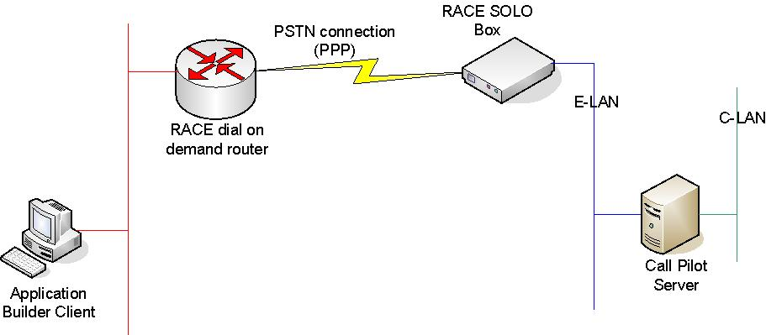

The failed test was to use the application builder client to connect to the Call Pilot Server remotely as illustrated above. To try and diagnose the fault we used the software package ethereal (http://www.ethereal.com/) to analyse the packets being sent when the Client attempts to connect to the Call Pilot Server. It appears that the client first sends ping request’s to the server and the Time To Live (TTL) is timing out before a response is received.

To ensure this was not a connection issue we successfully tested ping request’s from the client to the server. The question to Nortel is why the TTL is different from the standard ping and whether or not this is configurable?

The details of the packet dialog are available in the attached ethereal file –

OTM Server

Remote maintenance for Succession configurations that do not include a Signalling Server (and hence no Element manager) will require the use of OTM. This is needed to manage the IP enabled features that are still available via the SMC card on the media gateway (IP Trunk and IP Line applications).

Where an OTM server is accessible via the ELAN the method for remote connection is using RACE and PCAnywhere. For customer systems that do not have a remotely accessible OTM a requirement exists to provide a central BT OTM server. The following diagram illustrates this set-up.

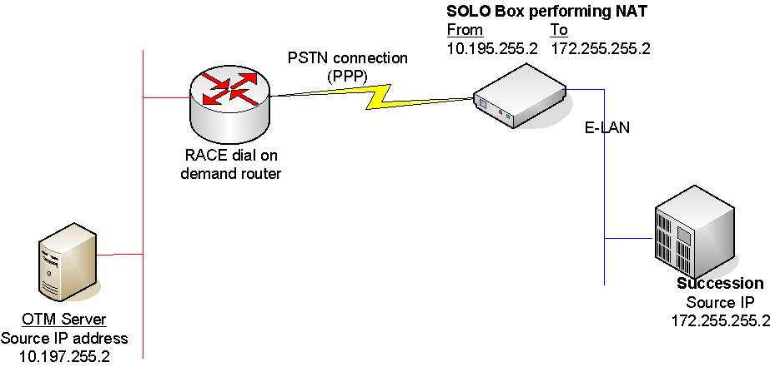

Testing was carried out using OTM server version 2. The Following tests were successful –

- Download ITG configuration to OTM server using NAT IP address (172.255.255.2)
- Login to ITG card via telnet from OTM Server
- Rlogin to Meridian via PUTTY application from OTM Server
- Download ITG configuration to Local OTM server
- Upload card and dialling plan configuration only, this was successful and did not affect the NODE configuration of the ITG card - but unable to test the functionally due to no dialling plan present on the ITG card.

The following result’s were of concern –

- When uploading the ITG configuration via the Sheffield OTM server when node, card and dialling plan was chosen, problems arise because of the NAT address for the ITG card. By altering the ITG card IP address from the OTM server in turn alters the configuration file which is uploaded. The IP address requires changing OTM side to allow the OTM server to communicate with the ITG card. A possible solution to resolve the issue would require a one to one IP addressing structure (no NAT) – this option is still to test but any feedback from Nortel on the configuration would be beneficial.
- By uploading configuration from OTM version 2 to ITG 3 affects the CODEC configuration of the ITG, which basically corrupts the configuration. To resolve the issue software version OTM 2.1 is required which is backward compatible and supports ITG 2.0, 3.0 and 3.1. It was also noted that by using OTM version 2.1 with ITG 2 which is supported, can cause connection problems with other nodes on the network. Once a node (ITG 2) has been changed with version 2.1, all other nodes would require changing to allow communication to continue.
This point raises the most concerns, as we also have field engineers with OTM on their laptops (when cust not available, or OTM on site is down) who could potentially use the incorrect version causing either corruption or incompatibility with other nodes on the network. We really need a version of OTM which is backwards compatible but can amend configuration on an ITG node without causing connection problems with other nodes on the network.

